Section2

So what is GIT u can check it from slides it is clearly given

<https://git-scm.com/>

Above is the official website of git okay. So we can find documentation, downloads And community support for the git website okay.

With the slide we can understand Clearly the explanation of it

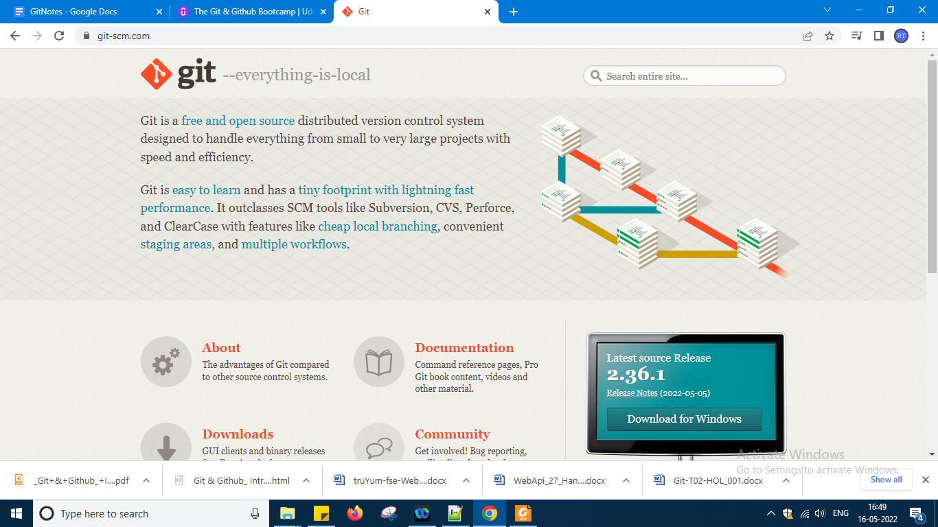

It looks like this above

So this ends section2 as section 1 is still introduction so this is end of section 2 which is again introduction only refer slide in section 2 that will be enough

Now moving to section 3

Check slides in section3

Now I want to install git how i have to use by terminal or using GUI both u can use it as git become popular many guis version came into market which u can check it here if u use gui u can use mouse and button to interact in terminal only commands u need to fire okay

<https://git-scm.com/downloads/guis>

Go to this url generally in windows we want to run git means git bash we have to install because git needs linux os so we don't have it okay so after installing bash in windows we can work with the terminal so below link open

<https://git-scm.com/download/win>

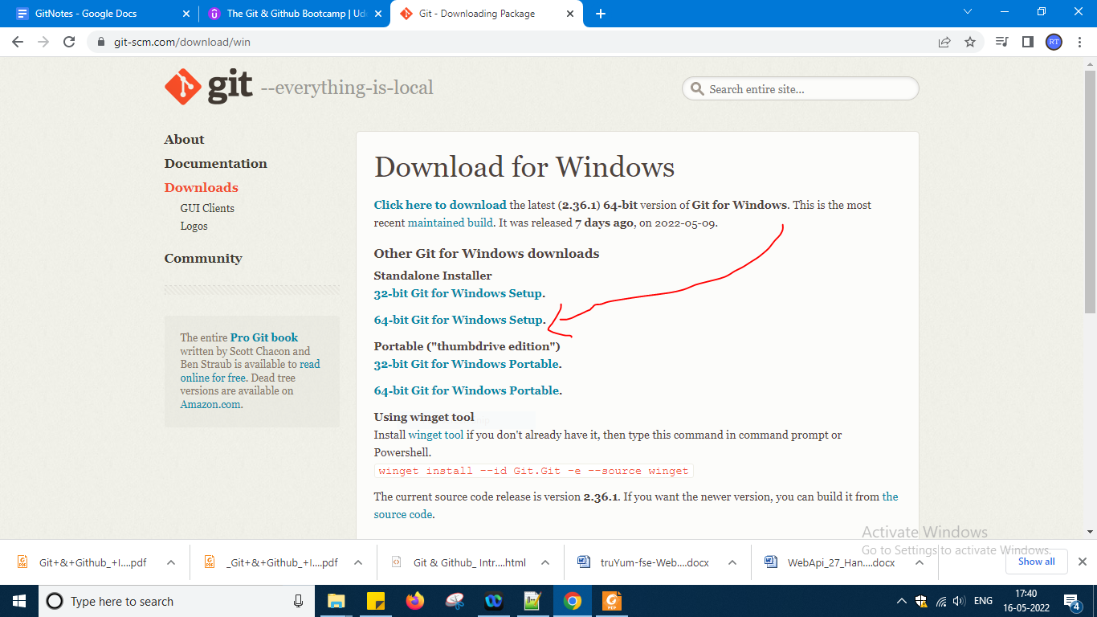

Every thing say default only in this while installing but

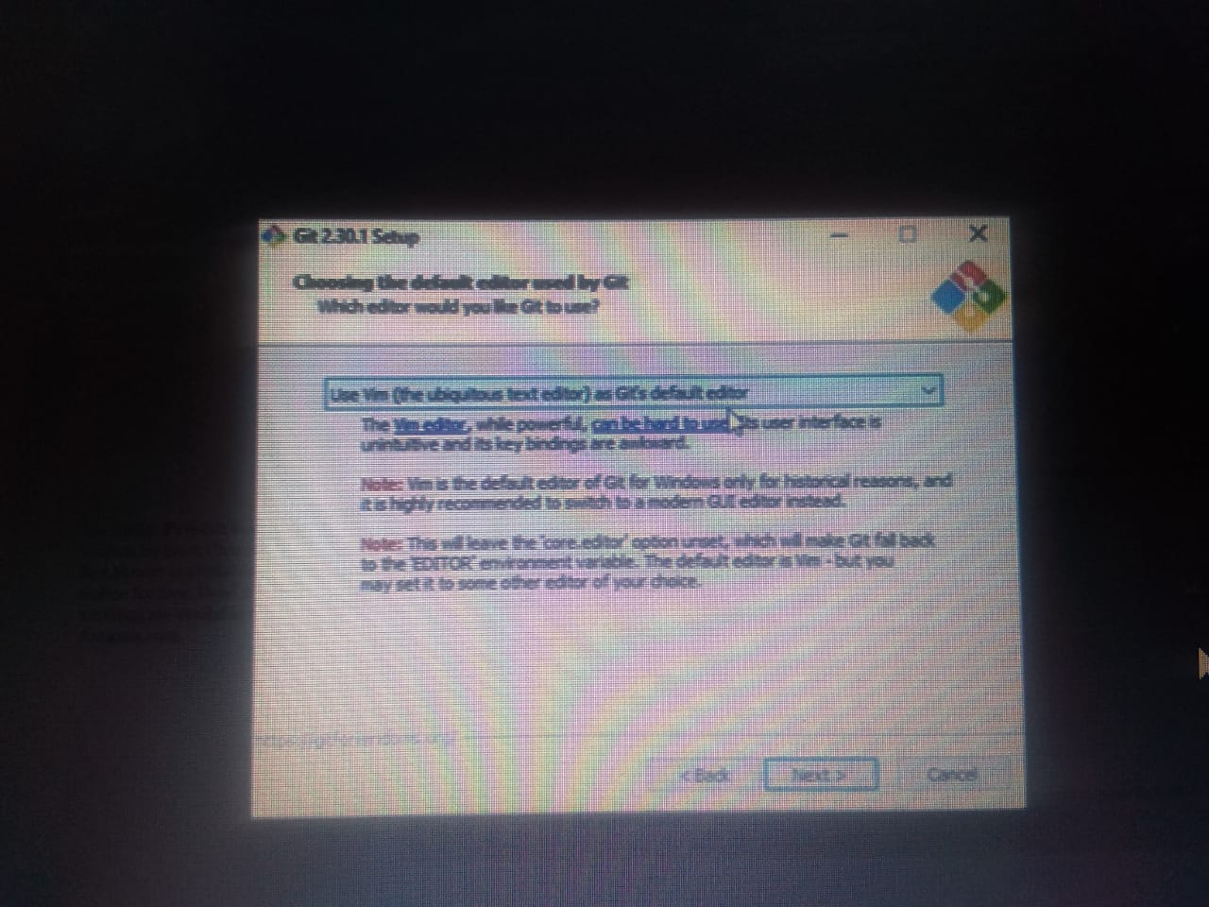

While using editor choose vs code editor okay

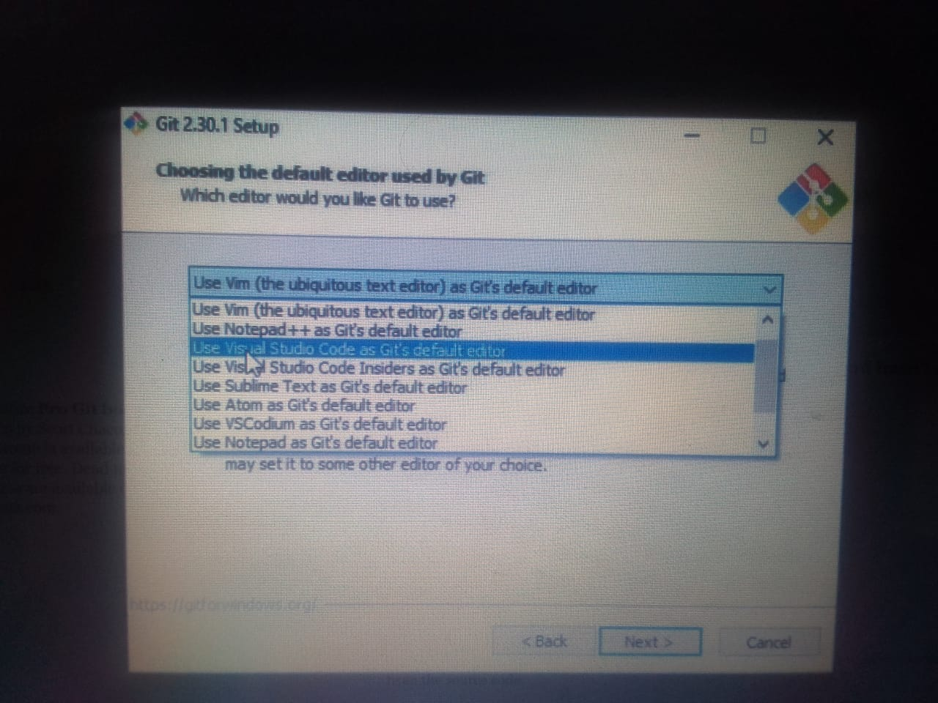

If vscode is there in your laptop it will select and move forward okay

And remaining all things keep it default what was present and install it finally okay and i am going to record this

After installed u have to say finish before clicking finish select check box option launch git bash

To know git installed or not type

$ git - - version

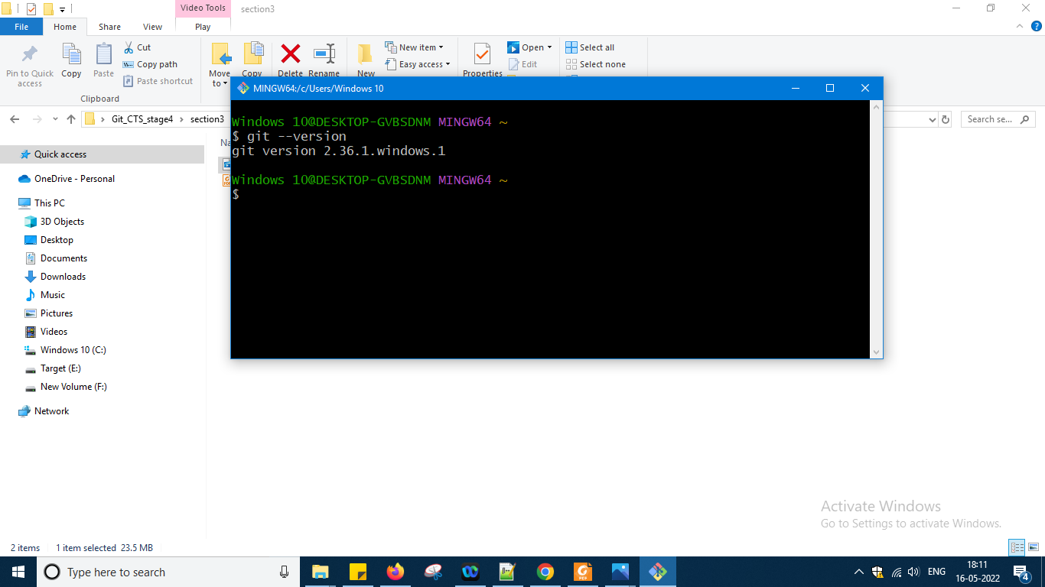

If u have closed the window type git bash in run search u will get it okay

U can check in section 3 folder installation which i have done i had kept there his version is 2.30.1 and mine version is 2.36.1 it okay fine

So git set up also i am keeping it in section 3

So now i had installed git now i need to configure my name and email okay

You have to tell git who you are so your name is needed to know that u have done the changes and email u should use that one only which u are using it for github account okay .

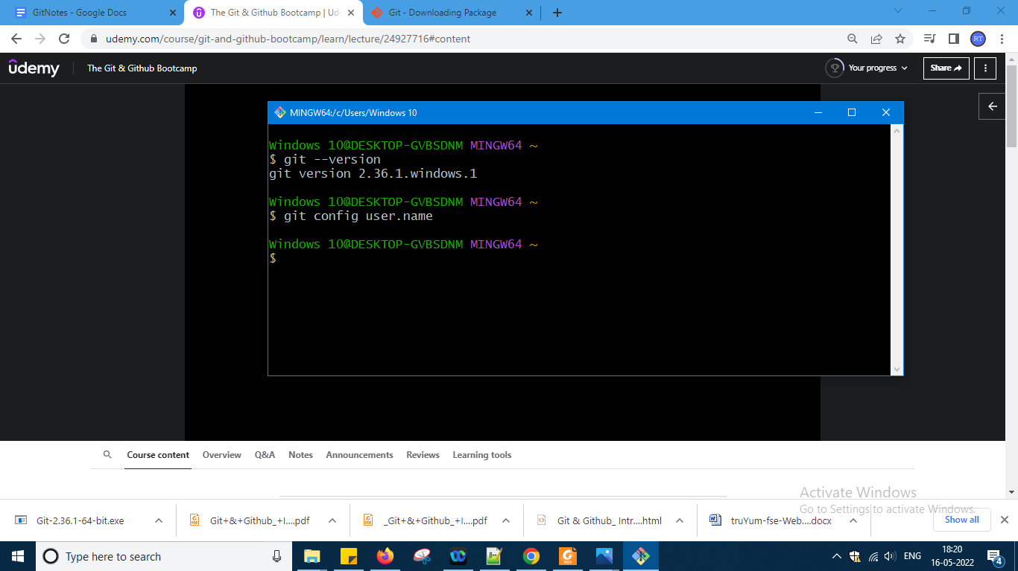

Using this command i am asking whether we have configured username or not

It is not telling anything to me so i had not configured okay

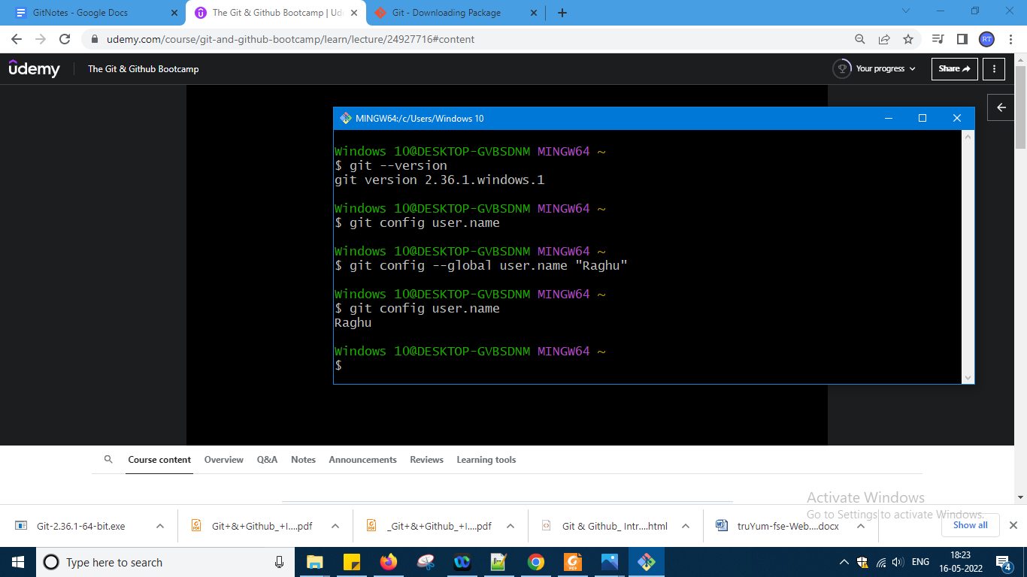

So i had configured as Raghu and it is not telling me anything but i am going and checking again do i configured name or not now it gives me the name Raghu okay

In the same manner i am creating for email also and email I am using it valid gmail id and for that id there is a link in github also

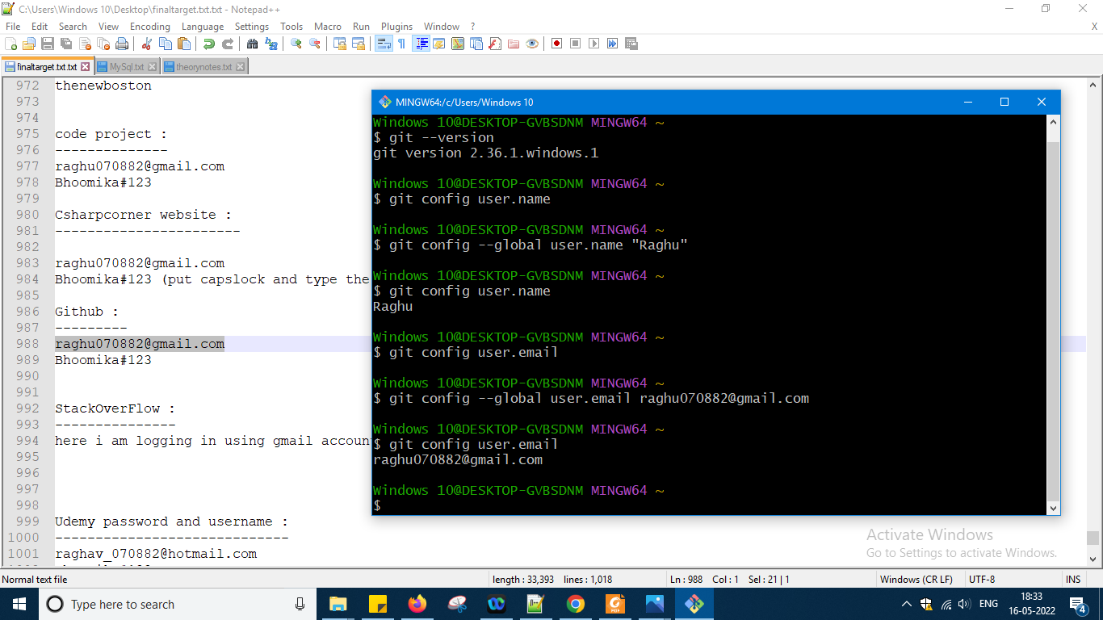

Okay Now i want to install gitkraken so go to the website link below

<https://www.gitkraken.com/>

And it looks like this

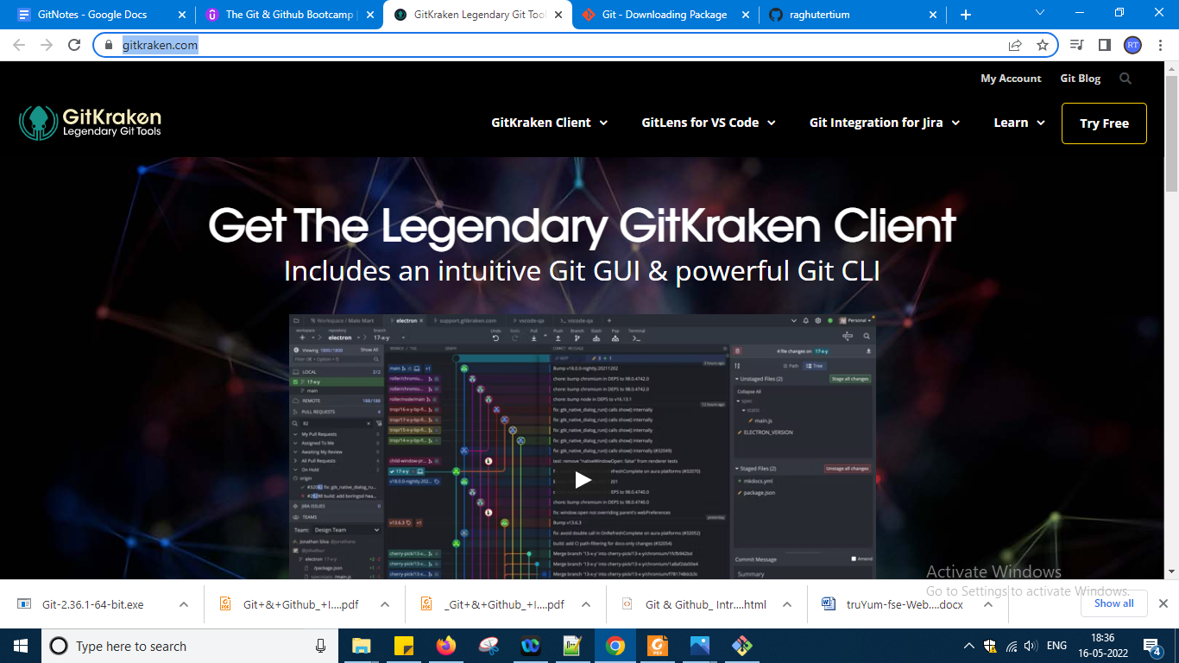

Somehow i installed git crane but I am not sure whether i will use it more or not and it is providing me 7 day of trial version only so maximum i will git terminal okay

Open gitbash and fire some commands now

When i types ls

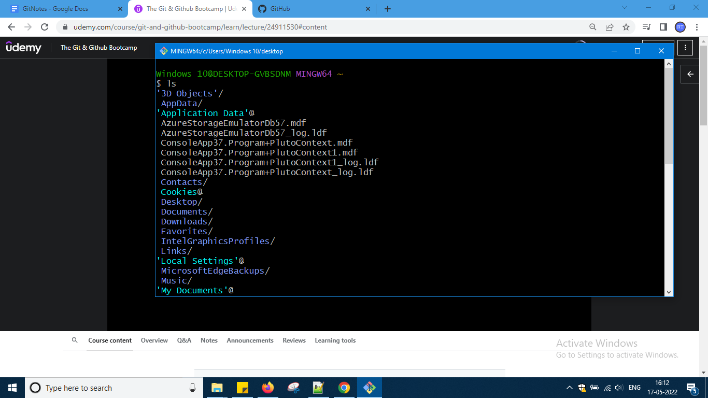

Lot of files it is showing i am moving to desktop now

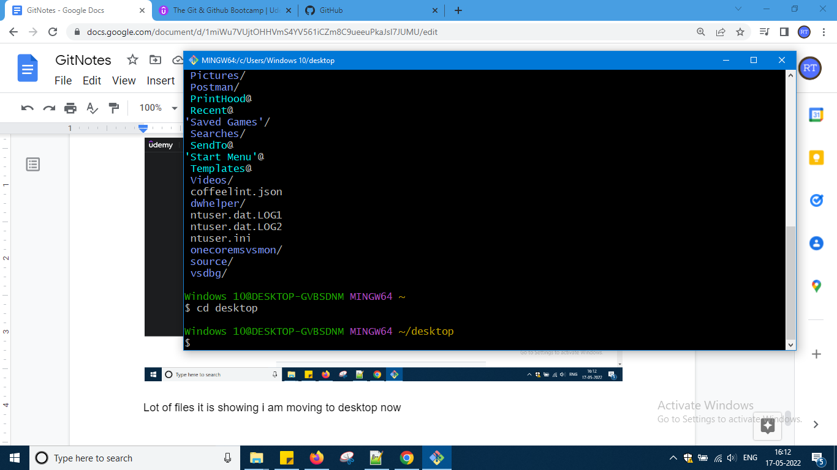

So this is home directory so showing lot of files so i moved to desktop now

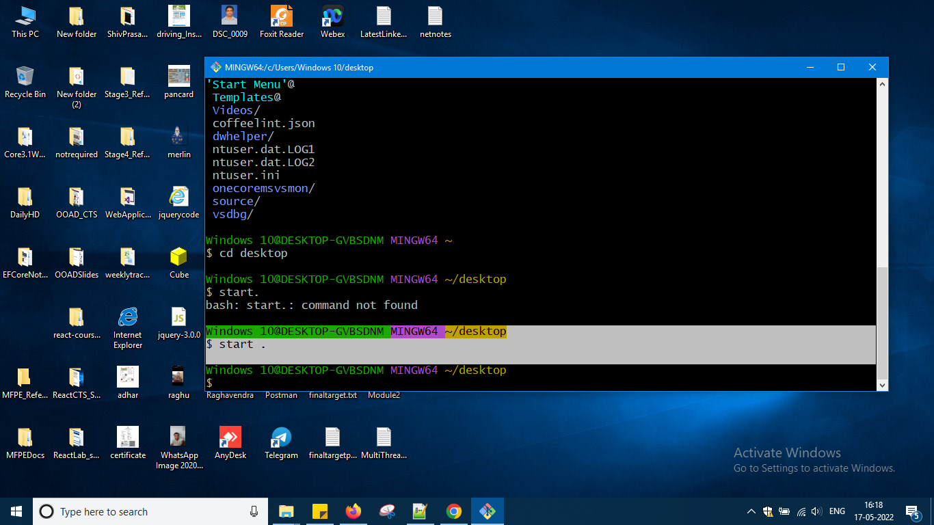

When I press start . all the folders from the directory will be shown to me

Now in desktop one folder is there stage3 references in that what is there i want to know and i want to open explorer over there again same commands with folder name like this

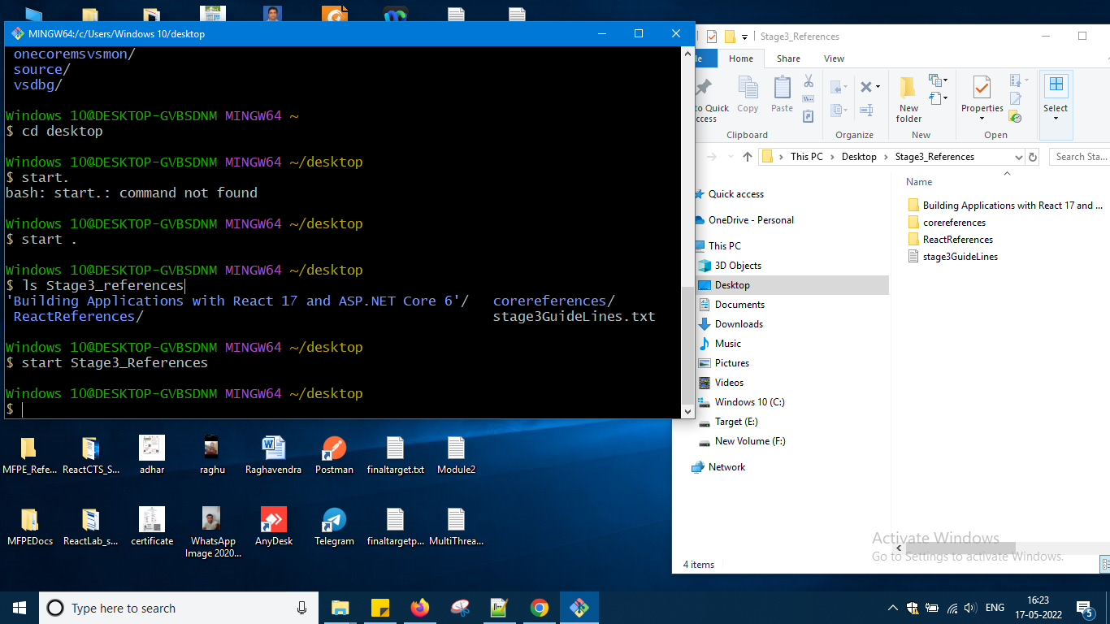

To clear the screen

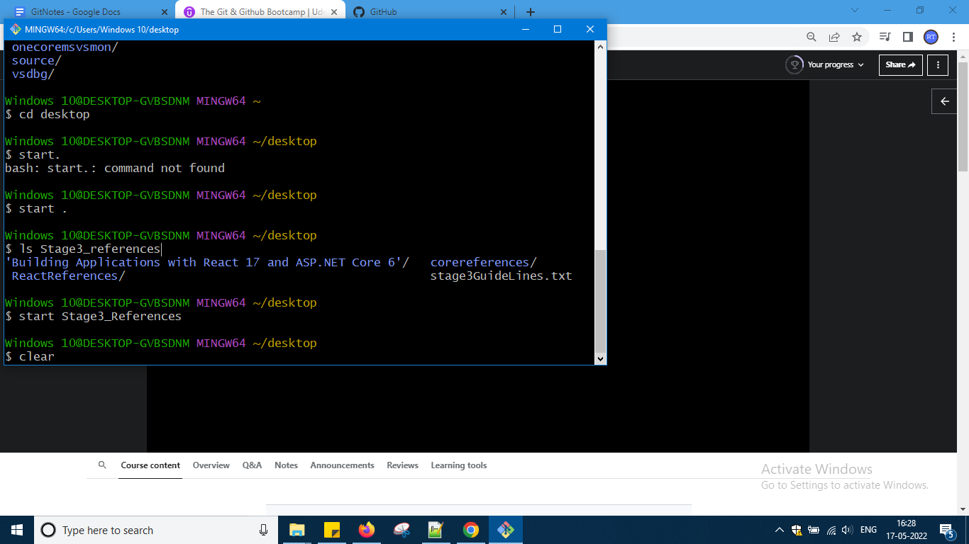

So ls on the whole will list the contents now in desktop ls applied

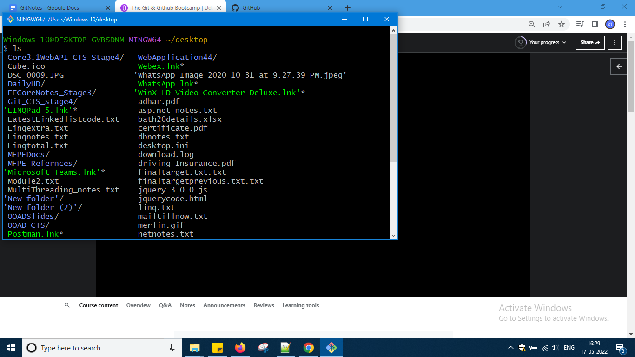

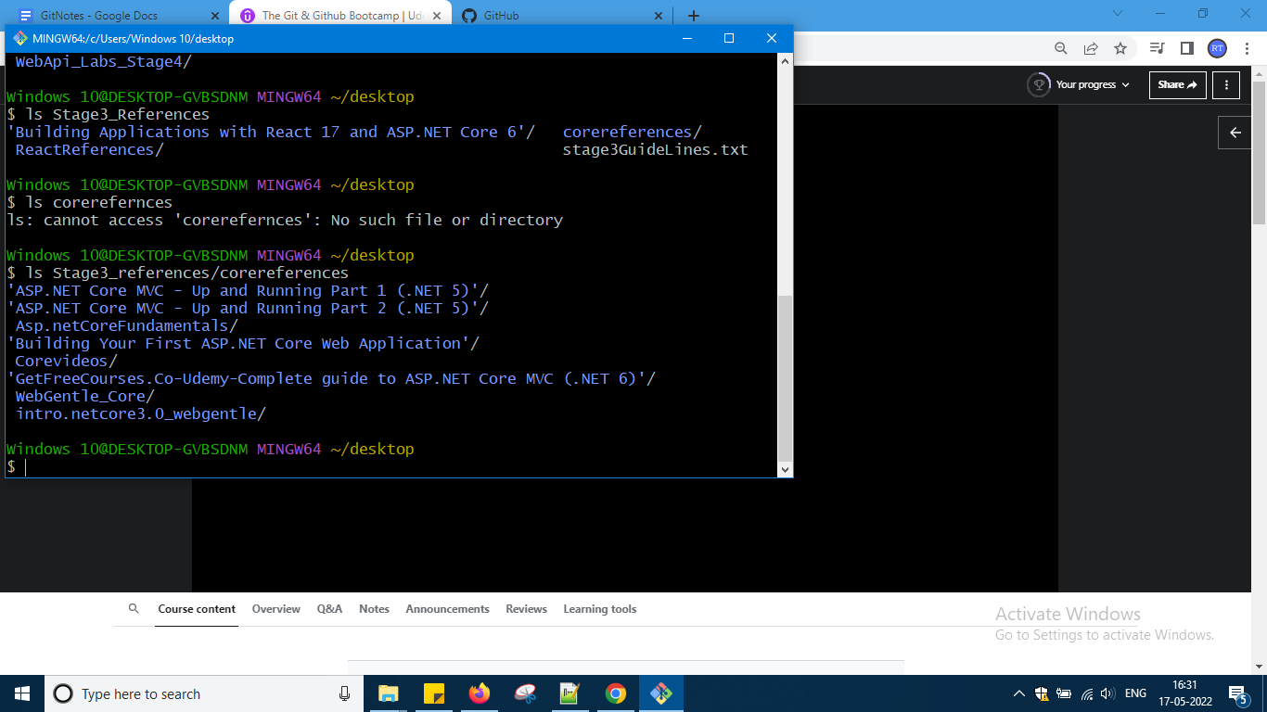

If u see above slide in stage3 references another folder content i want to see directly i cannot see the path of core references i have to provide path okay first time didn't showed cannot access second time it is giving as core references is in stage3 references okay like that it works

To know exact location where u are type pwd command

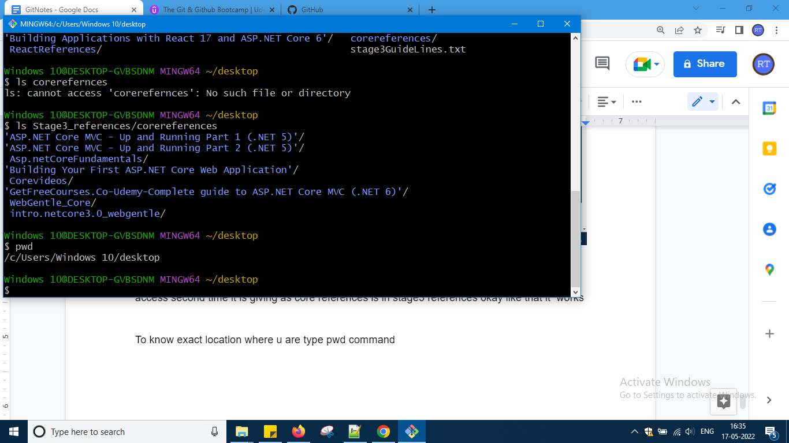

Just check last command which i had typed okay

Now to jump to one directory cd and from there u can type pwd to know where u are okay

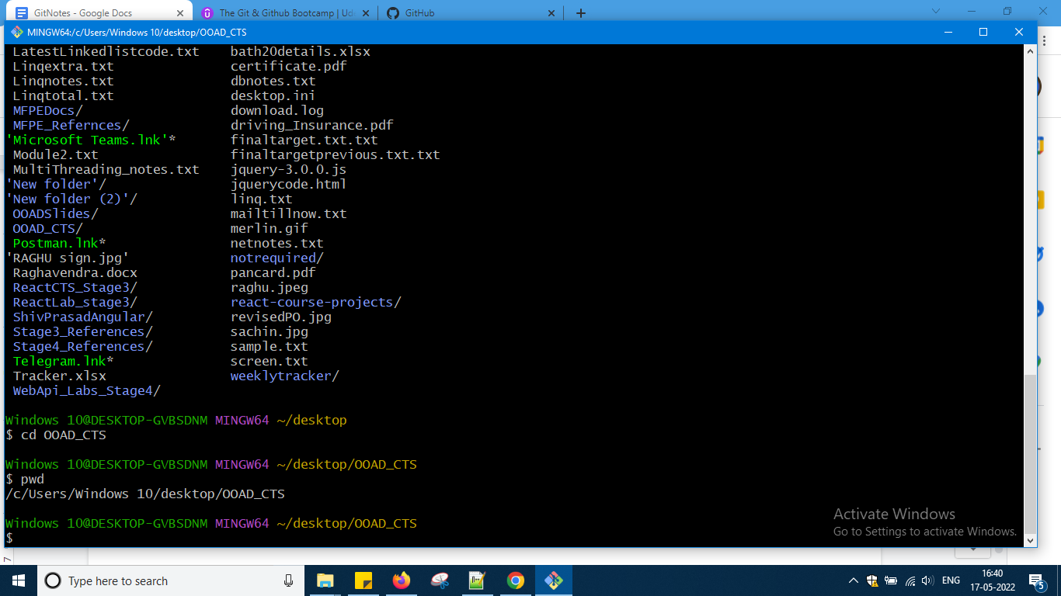

From desktop moving to OOAD_CTS folder like that okay

Ls command over there

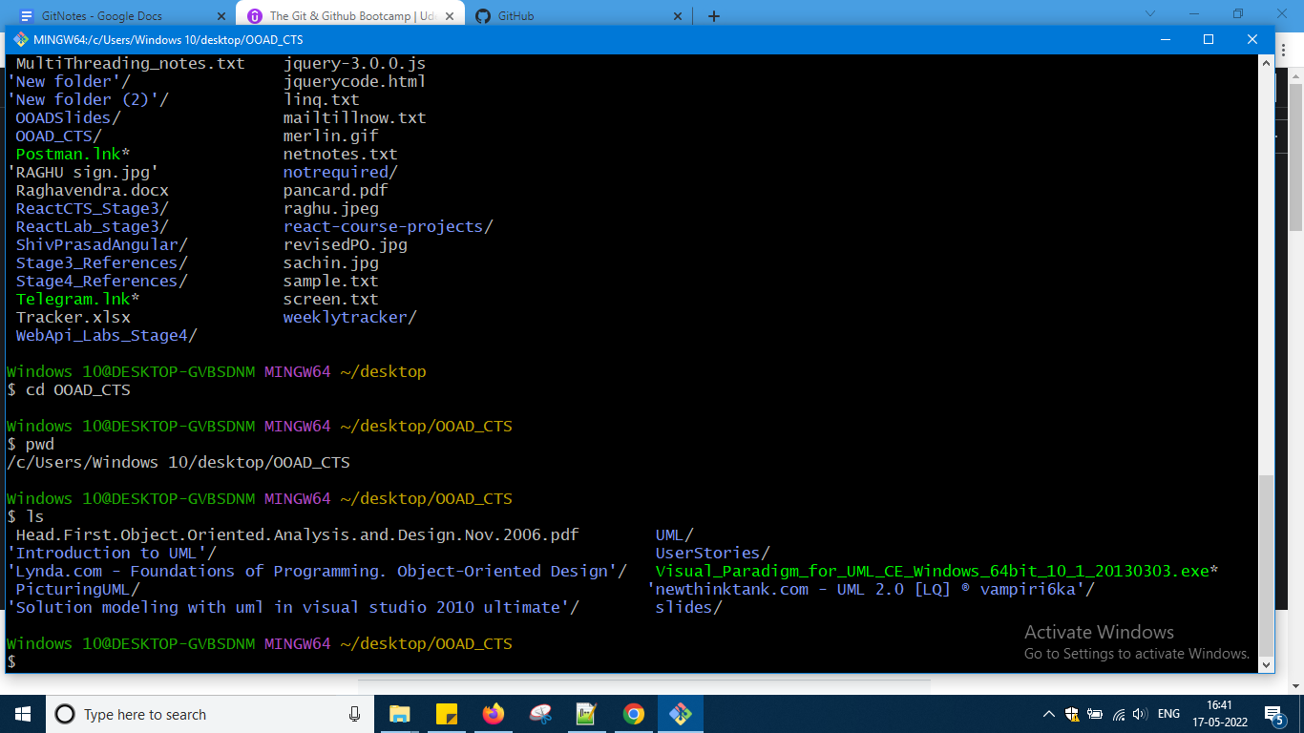

Cd .. one step backward

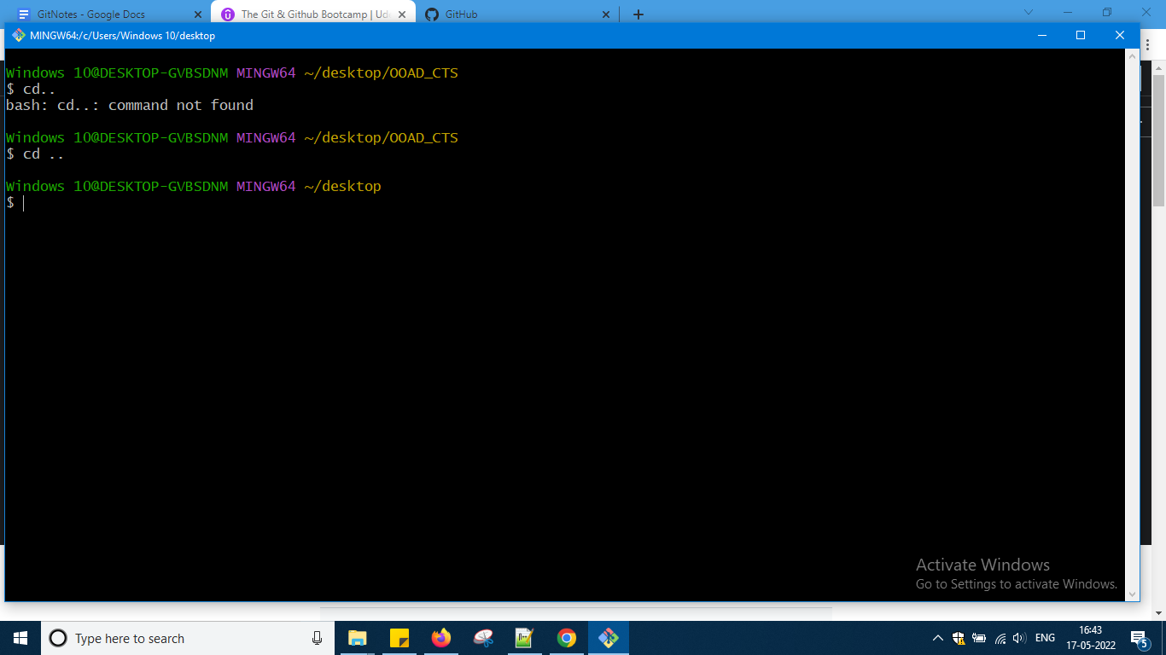

So these are some command related to navigation

Now let us go through files and folder creation and deletion of it

Now if u want to create any fle

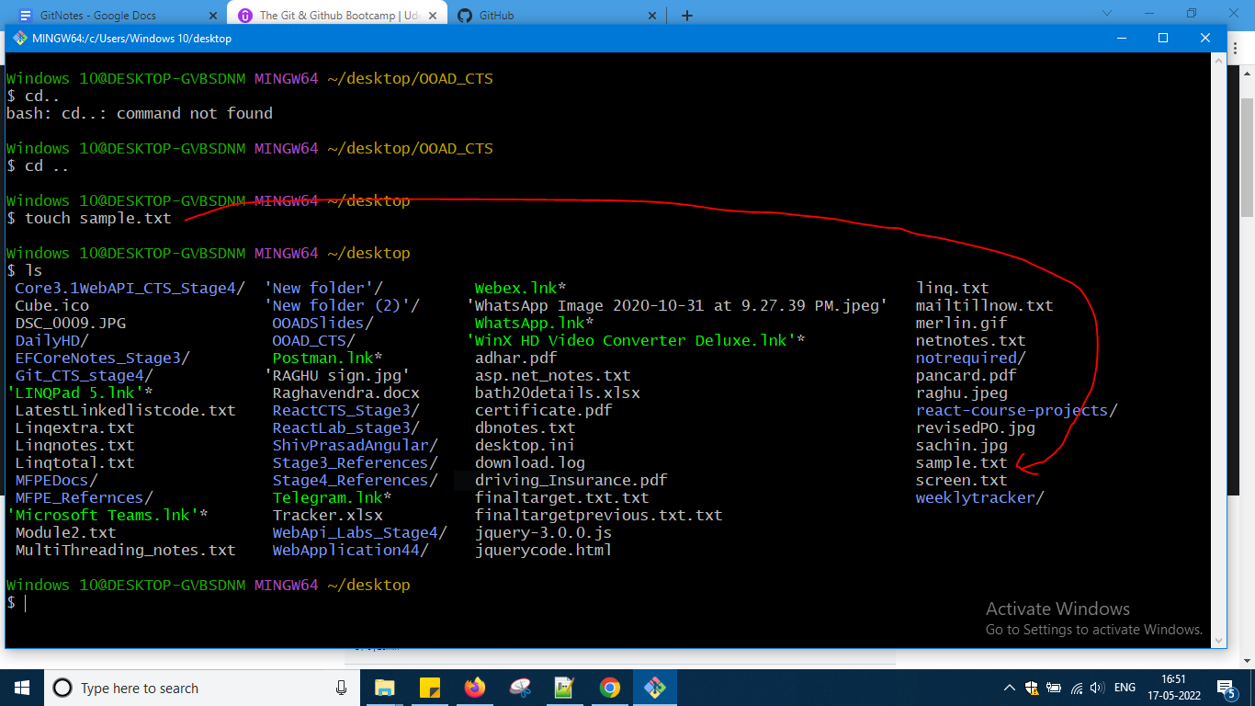

When the file is already there nothing it will do if not there means it will create it it will also not override the content as sample was there

So again sample 22 i created

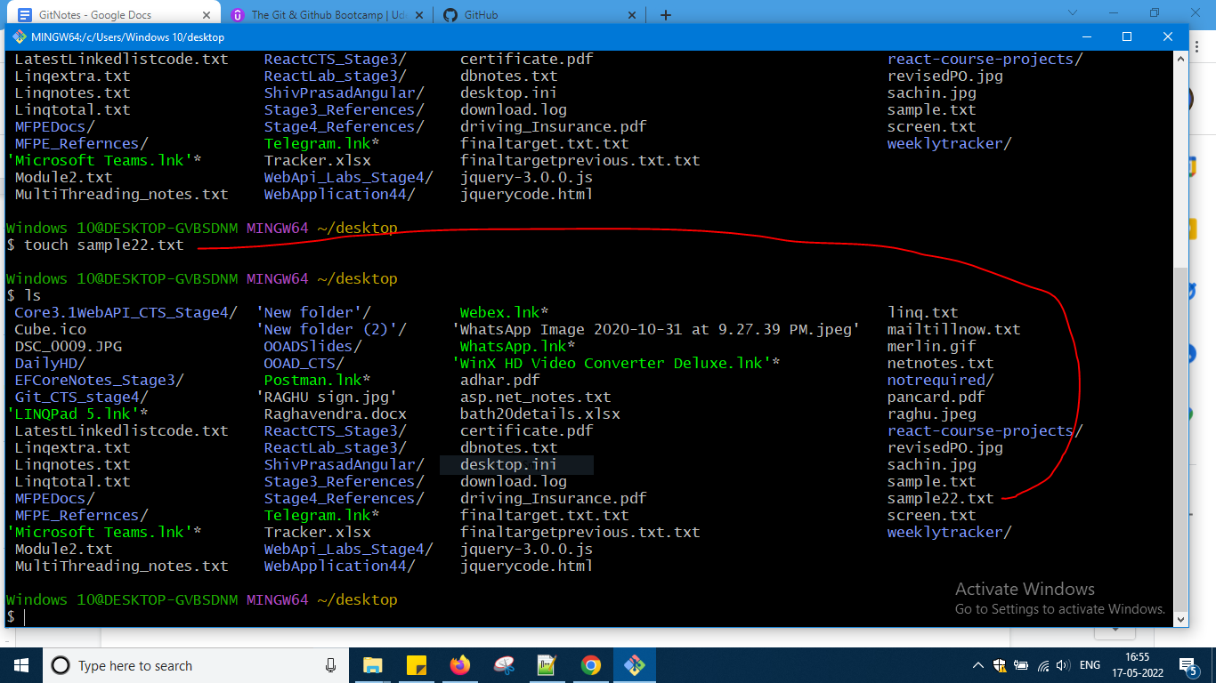

At a time more than one file and different varieties means like pdf etc u can create

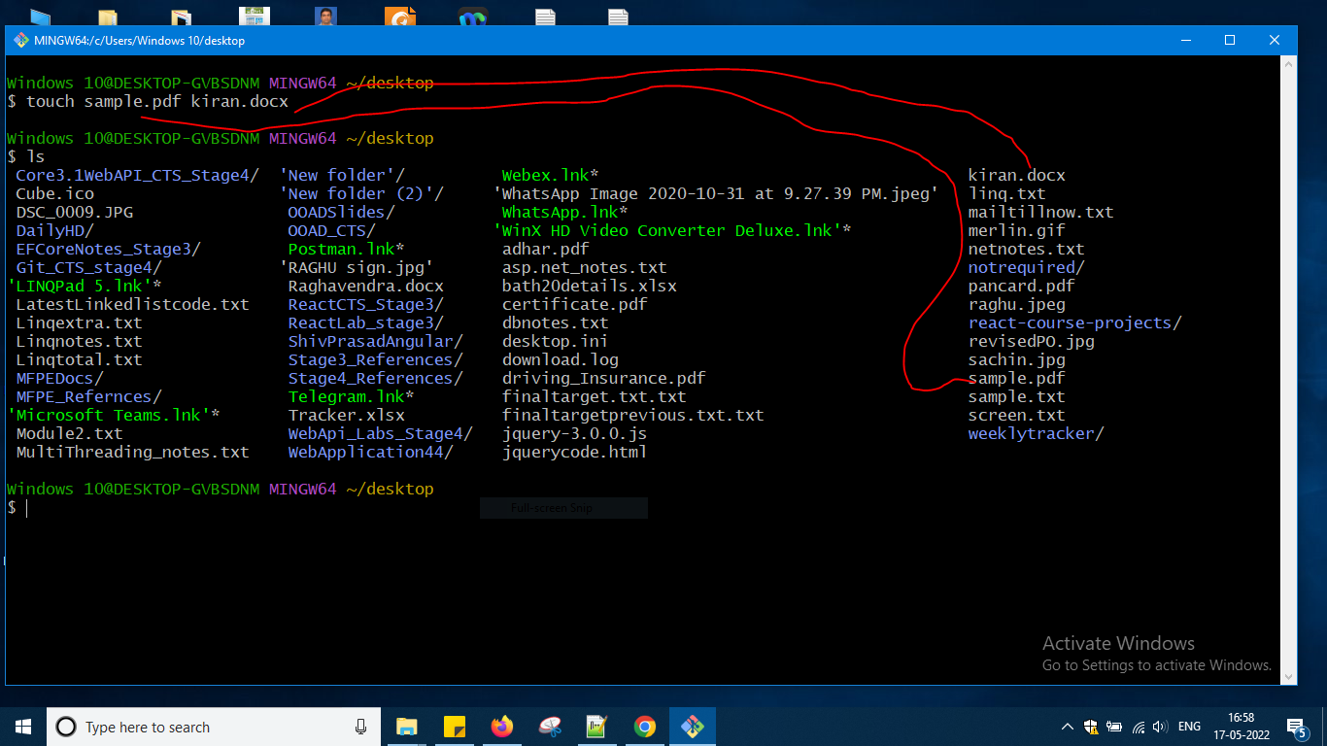

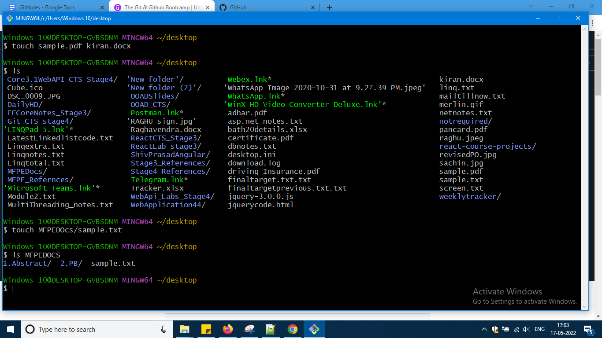

Again in MFPEDOCS I want to create file give path and create and and give path and see using ls okay like that u need to do

If u are not sure where u are creating files just check PWD and move forward okay

Now creating folders

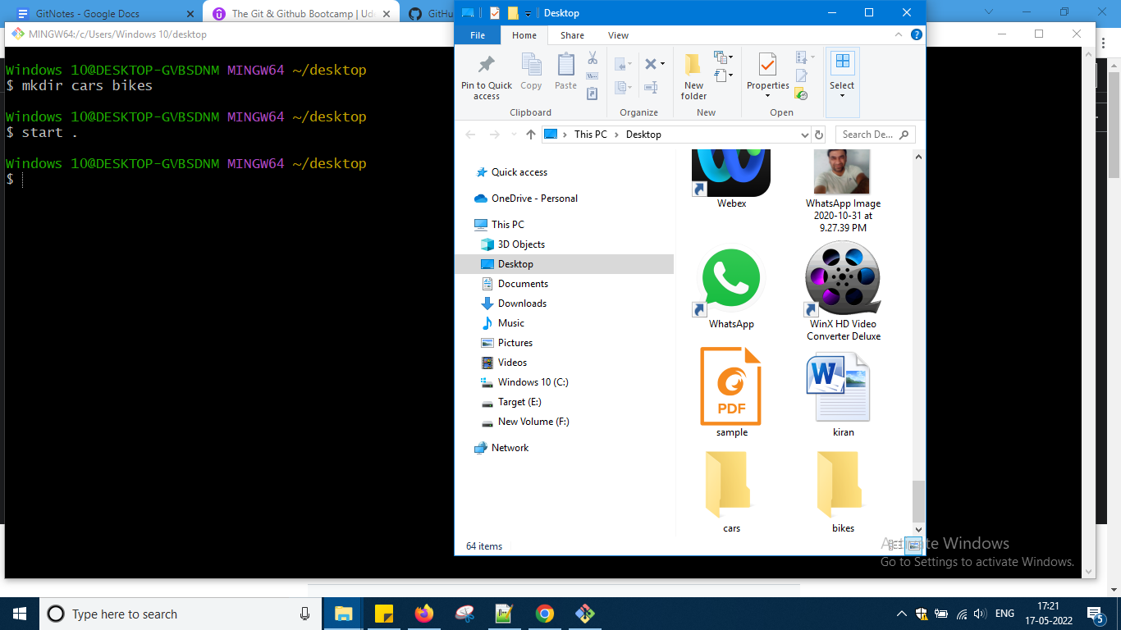

Deleted file using rm command and now it is not there sample.pdf

Okay next i want to delete folders

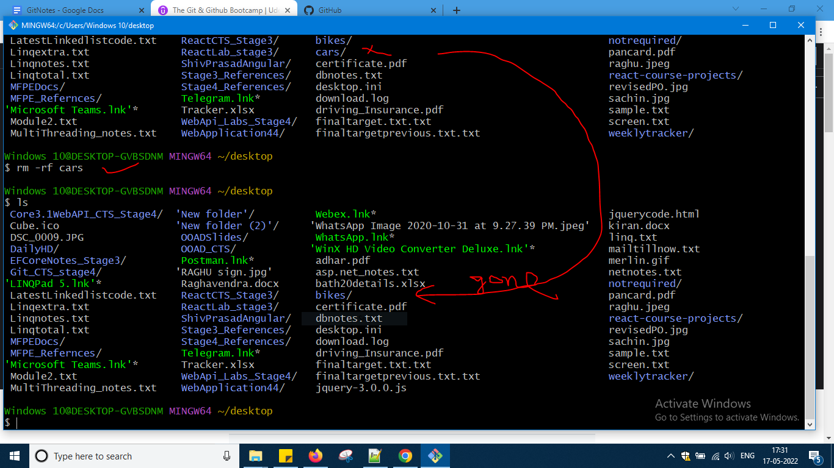

So rm -rf will delete the folder okay so this is the end of section 3

So basically GIT repository is nothing but and folder for my projects ok workspace where will be storing history of my projects what and all changes have done I will go to the folder and I'll say repository in that folder

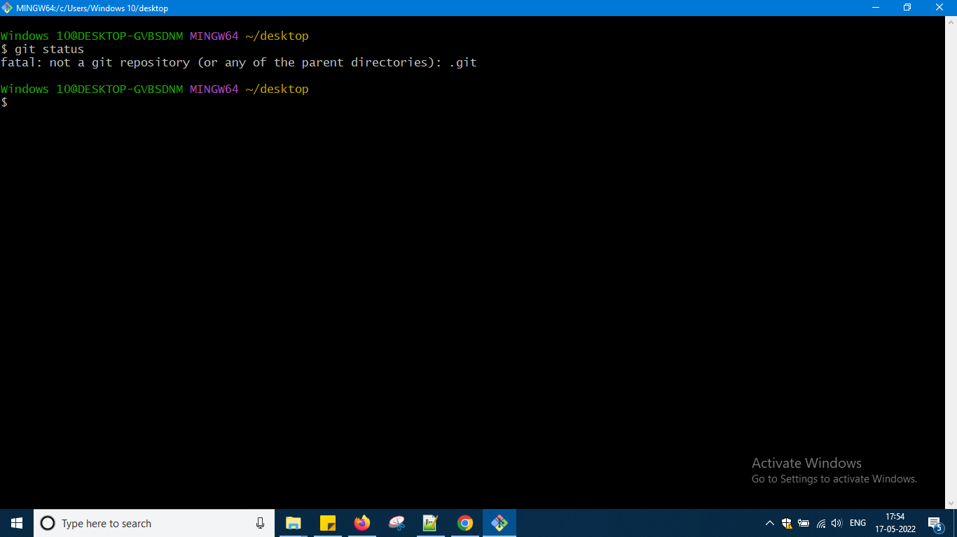

I have not created GIT repository so I am getting the error so after creating the repository only you can write the comment git status

Let me first create one folder in desktop with the name raghugit

And then go inside that folder and type this command

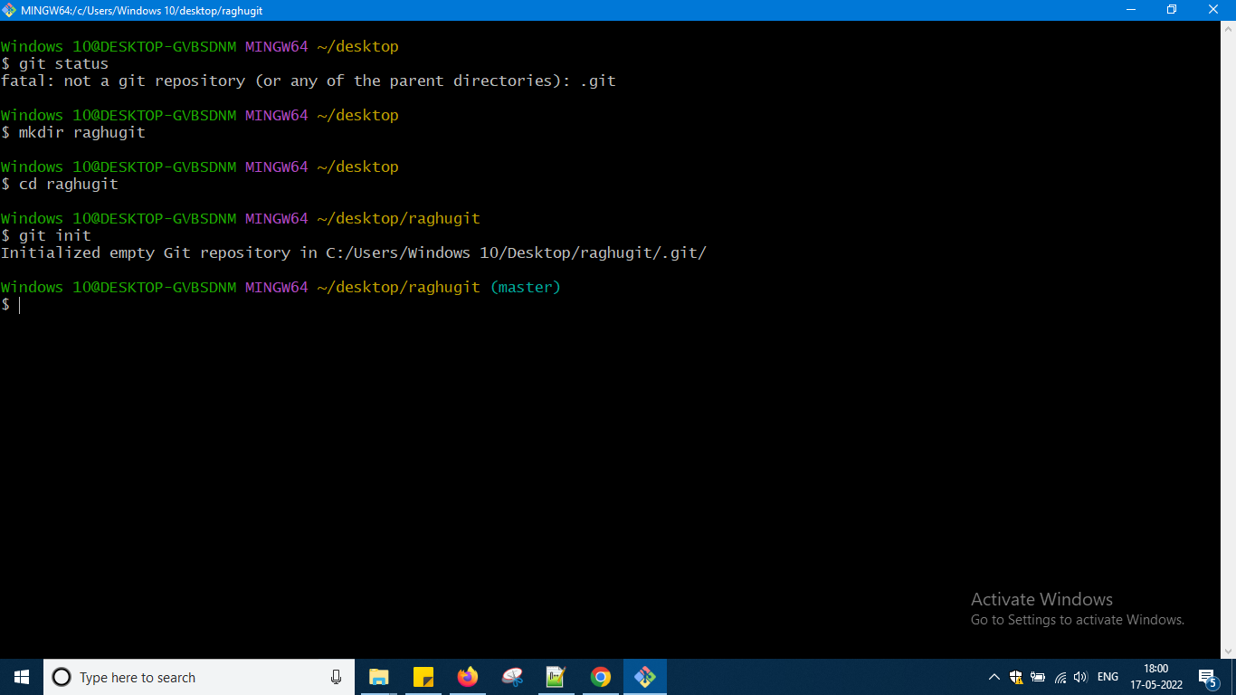

After firing the init command it is like this in that folder I am not seeing anything..it is empty and some tag has come saying master u can see

Here we will run this command only one time and again and again we will be using it that repository okay now run the git status command okay

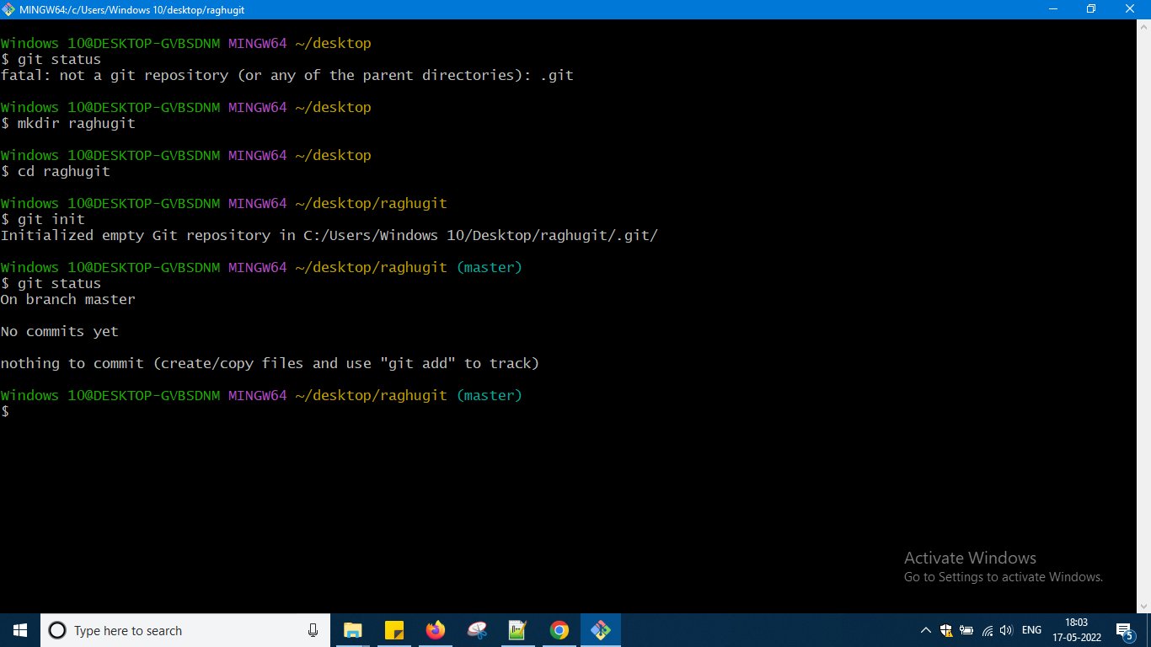

<https://git-scm.com/docs/git-init>

<https://git-scm.com/docs/git-status>

So in above links u can check some documentation for the commands which i had typed okay

Actually is hidden so type ls -a

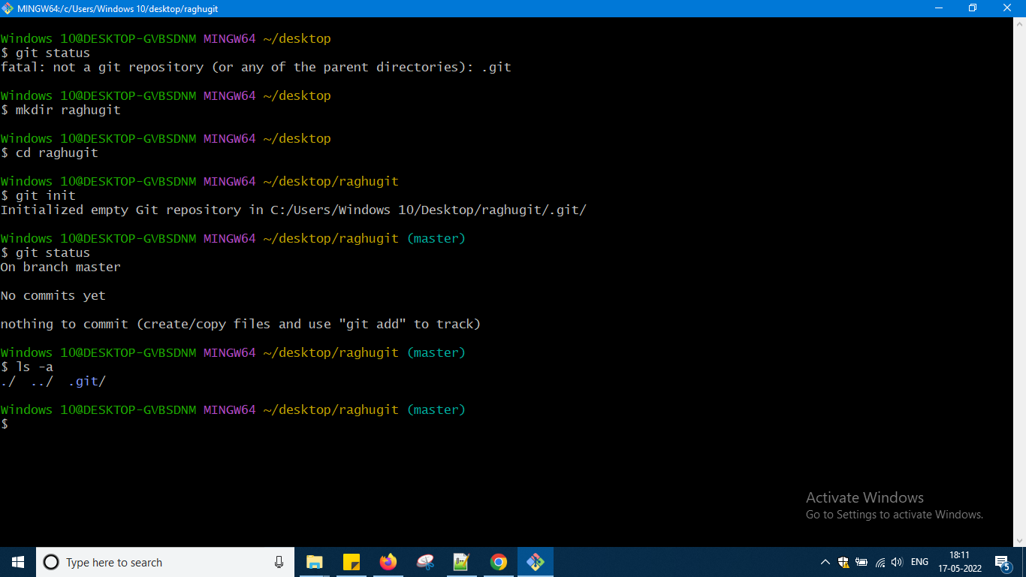

Now i am going inside that .git folder and again typing ls over there

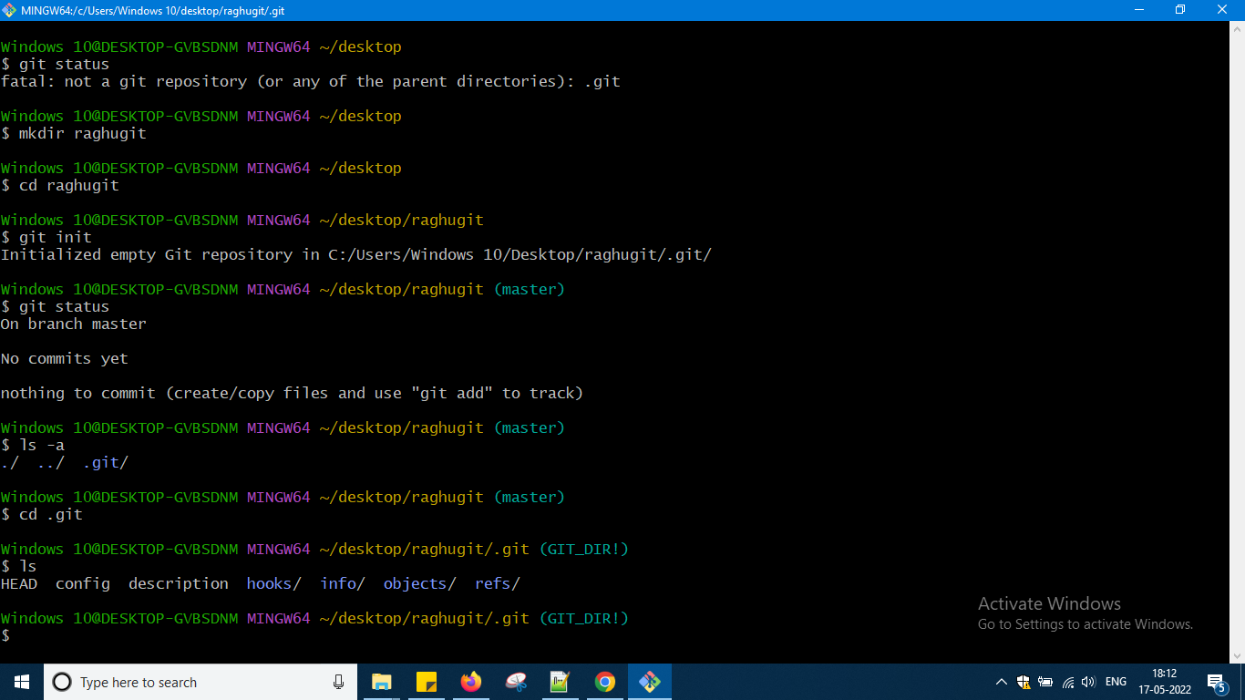

So here some stuff is there some folders are there okay if u delete it we cannot get it back so again i will come back and again there i will write git status it will tell me information and if go back again to desktop and if there i write git status it will not work hope what i am saying u can understand i had create git repo in the folder raghugit okay

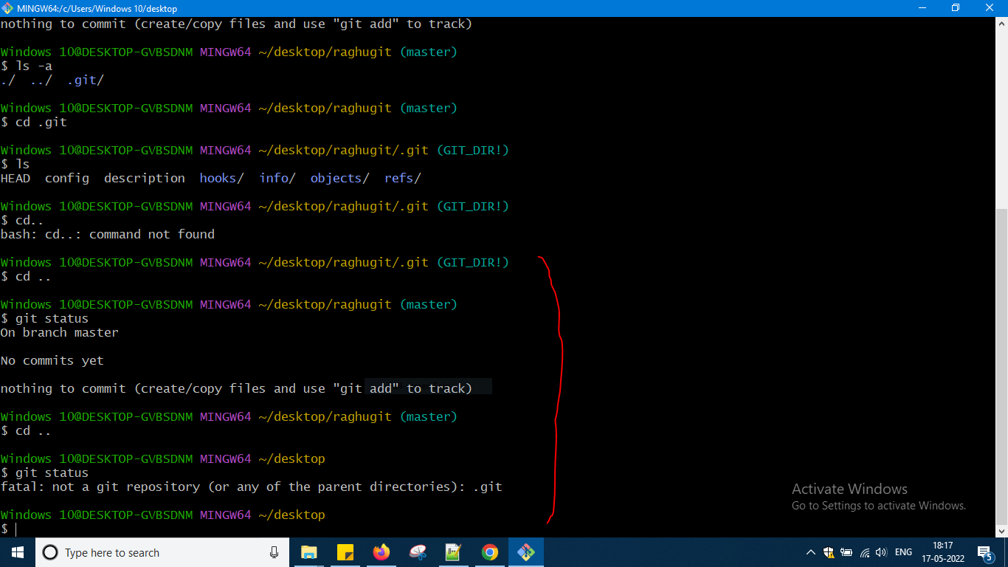

Don't try to delete the folder of .git and then if u type git status it will not show u have to agai say git init and work with git as that folder stores all history information okay

Let us see some common mistakes which we do in Git commands

GIT keeps track of not only this folder but also subfolders after going into deep subfolders if I type this status then also it will tell me the same thing let us check that

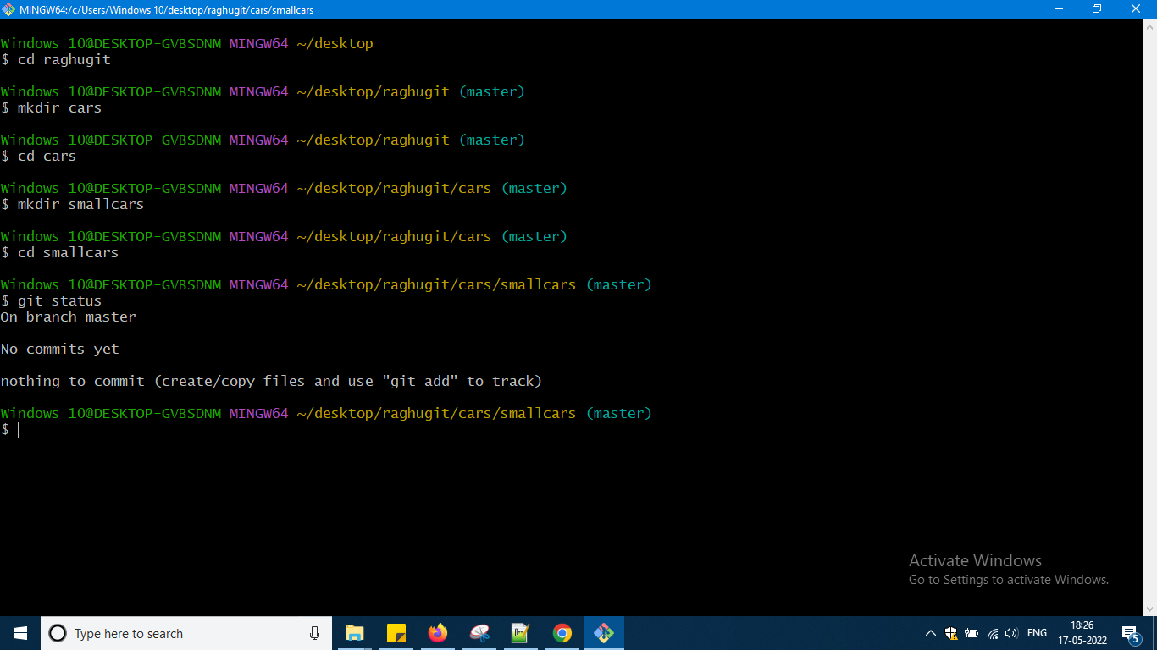

Inside a Repo dont initialize another repo Type GIT status and check it where you are whether that folder is initialized with git or not

Now let us go with commit command okay commit means what savepoints we can say directly we don't do commit we decide this things have done under one category Few more things in another category and then I will apply commit means I am telling that these are the things which are going to be put under commit when is it practical will come to know

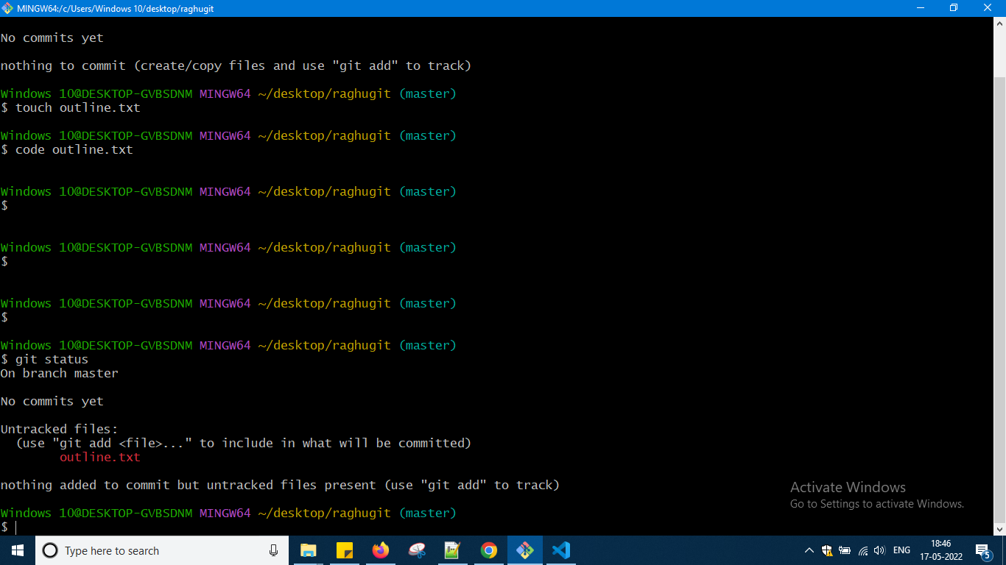

Created one file outline and done changes and then writing this command git status it is telling me like this now another file i will create there and again git status i will do okay

Here code will open in vs code

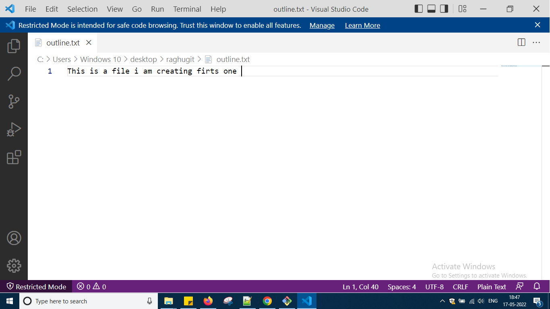

Again two files status is pending

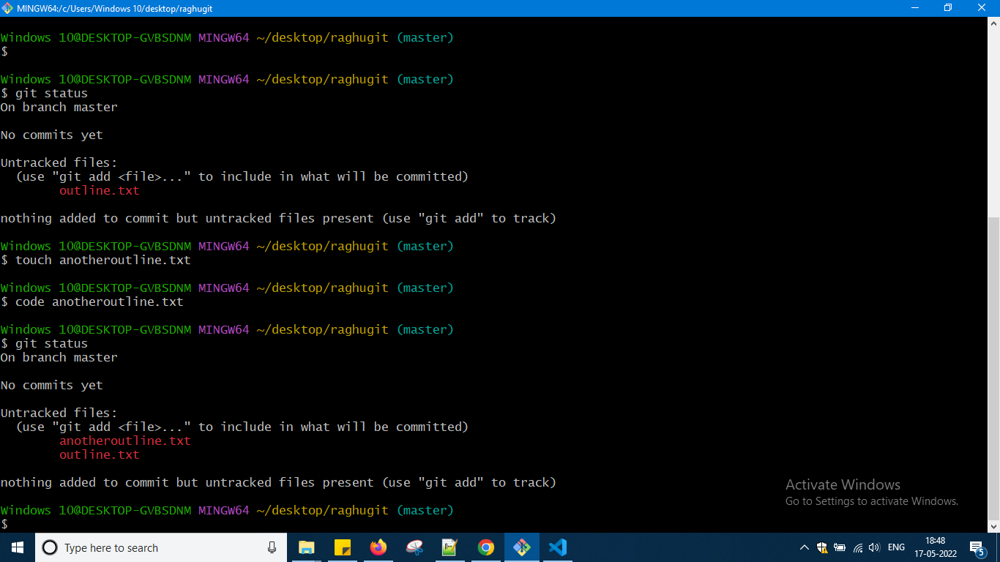

It is not tracking okay i had made some stuff okay into the raghugit folder okay

We have to use git add command to tell which one u wan to commit till now just worked now stage it means they are in future to goin commit and information of commit will be stored in .git folder okay

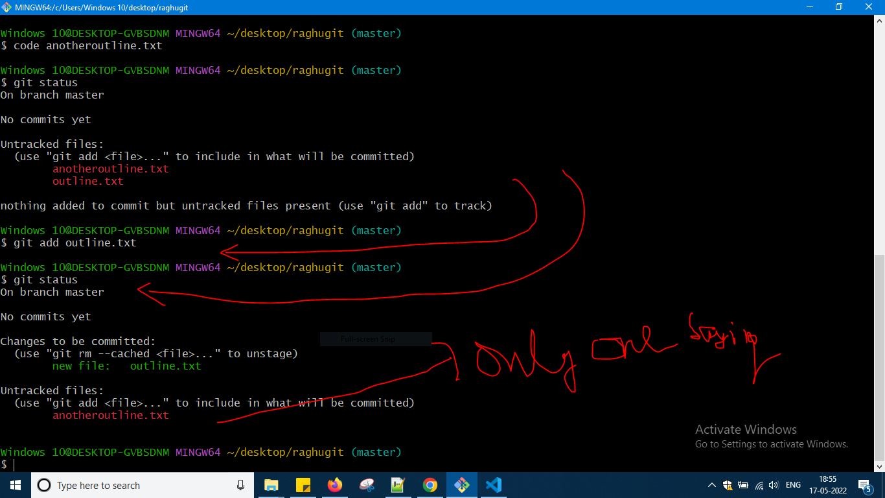

Another file also add it to staging

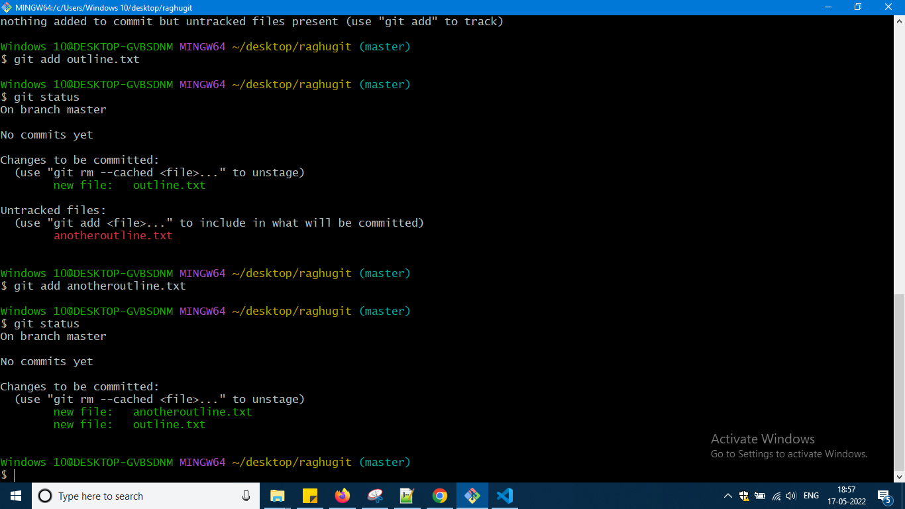

Directly don't do commit put some message like what u have done in this

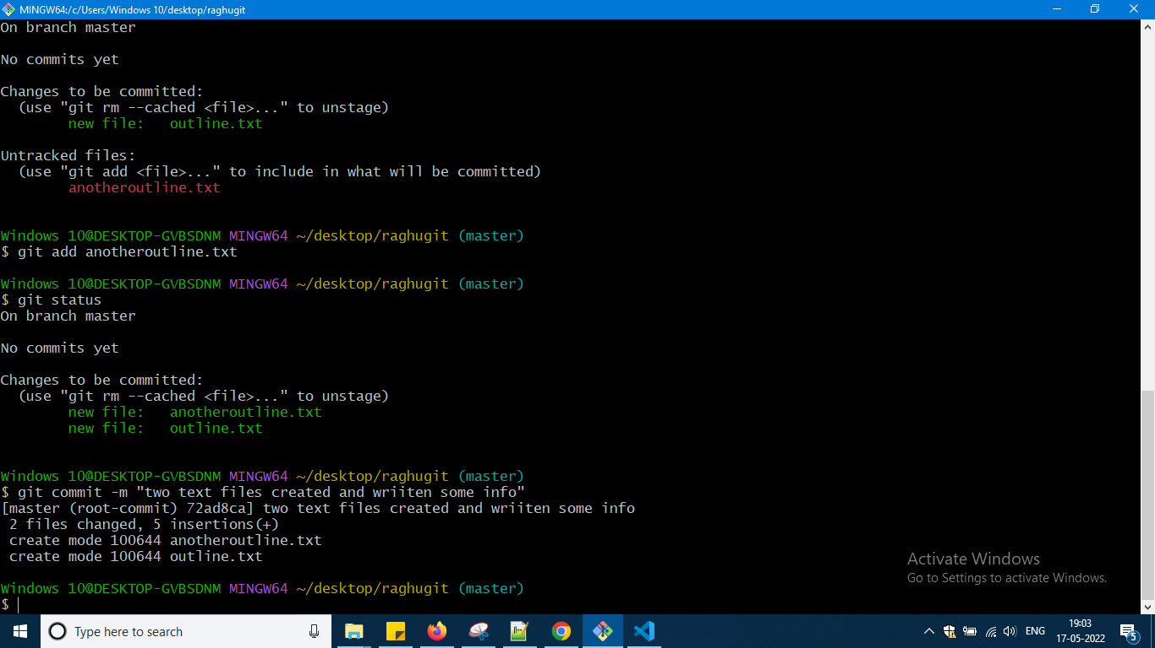

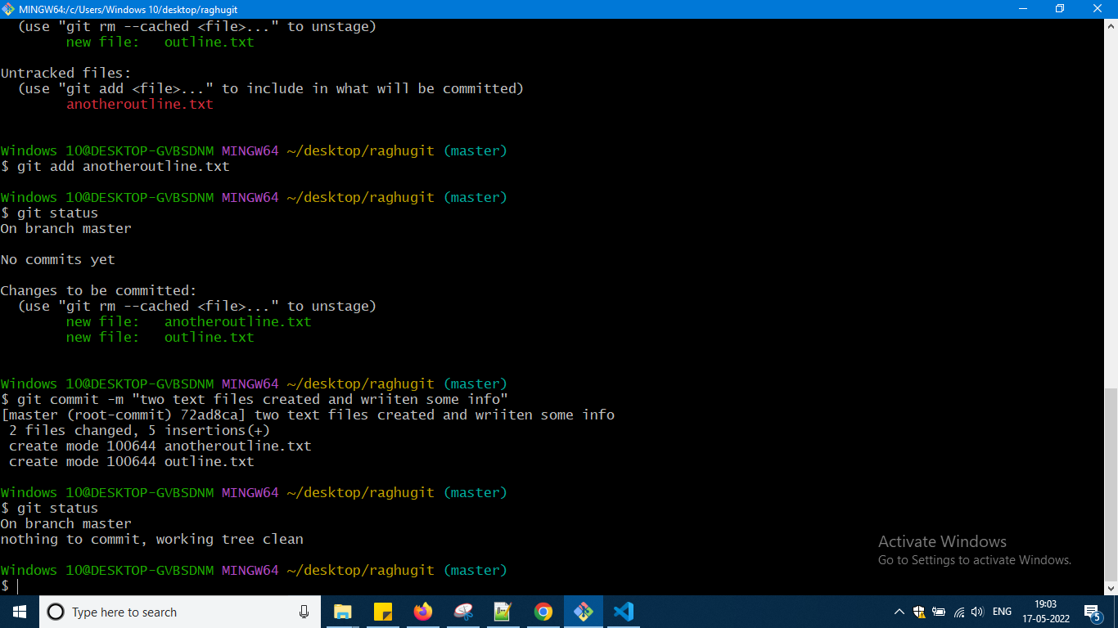

So now no commits are there okay

Some links for more information so now

<https://git-scm.com/docs/git-add>

<https://git-scm.com/docs/git-commit>

Now create another file chapter1.txt and add some contents and save and then check status and again try to modify existing files and again check status okay

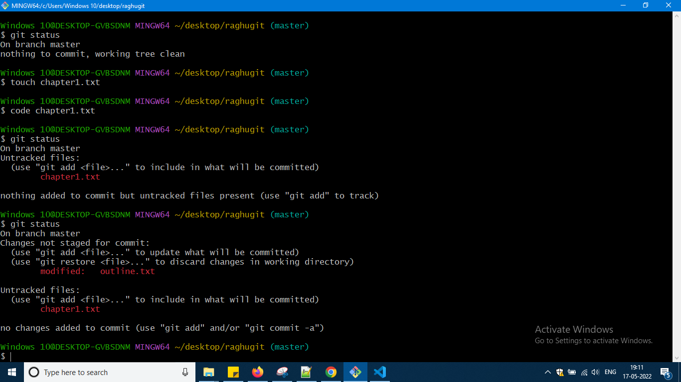

Now i am adding both to staging one in one go and again check git status okay

U need to observe here carefully okay what is telling now do git commit with message okay

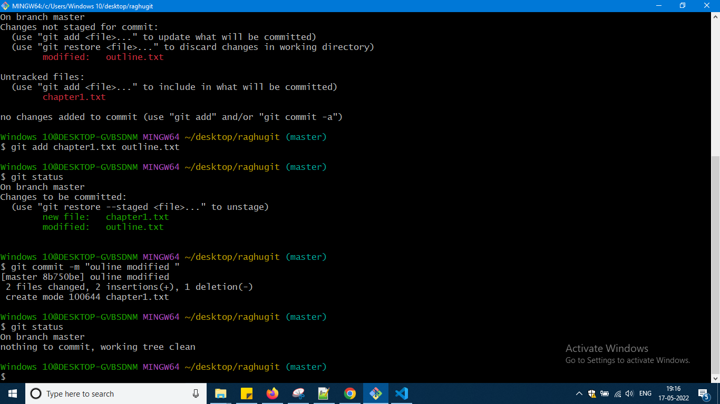

So u can see with some message I am doing okay ..

Next command is git log okay

<https://git-scm.com/docs/git-log>

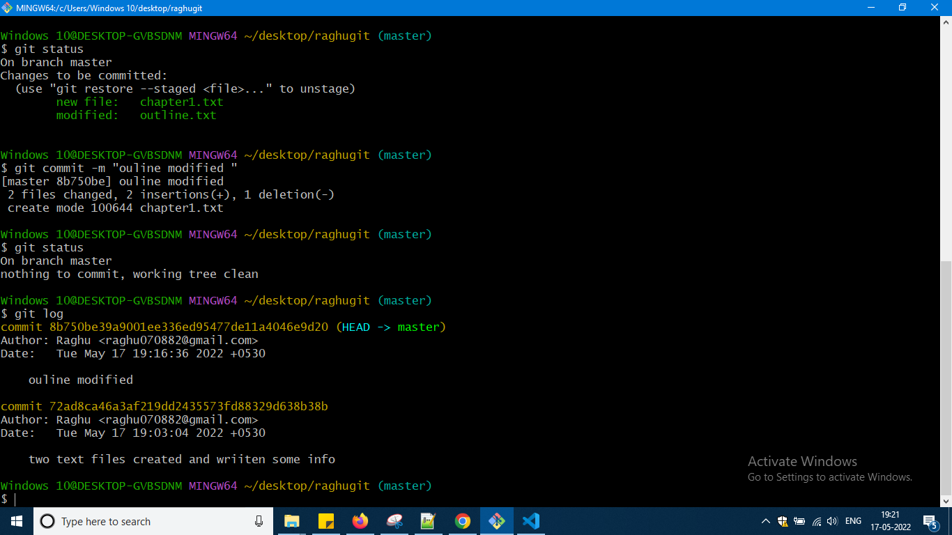

Tells information okay

If there are 50 files i changed then i can write 50 files by giving space u can use git add . command

Eg now i will do modification in two files okay and the git status i will check then gid add . will do the same thing which i had done individually for two files

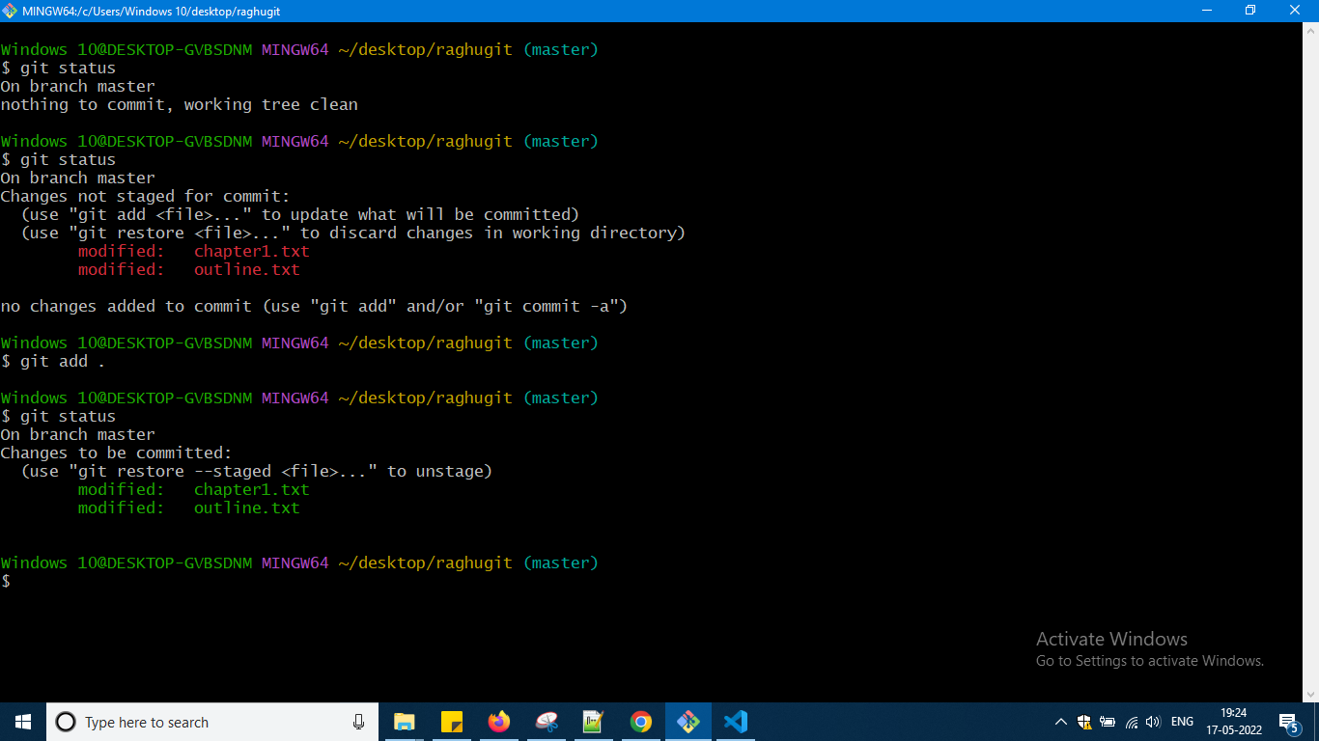

I have gone to file and done changes some command will be there to modify the files later on will check

Further commands

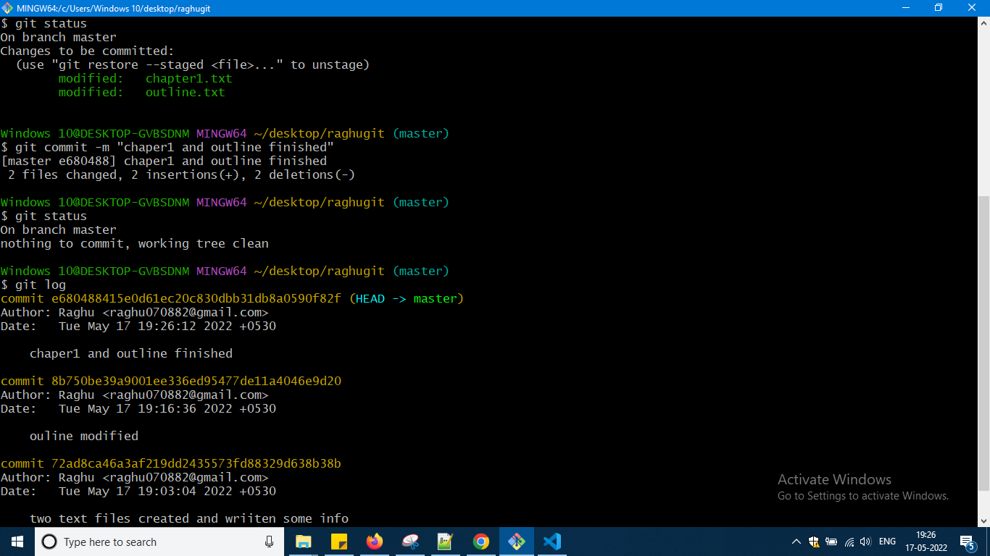

Use code . to open entire directory on which u are working okay

For practise try this for this video is available u can see how he is doing u will get knowledge okay

<https://www.notion.so/Committing-Basics-Exercise-3dc1ef1873ce45e68cedd2265710d7d8>

So this is the end of section 4 okay …

Now i am starting section 5

U can see some references here okay

<https://git-scm.com/docs>

Now u can refer to documents okay now what i am doing is atomic commit how i will do it

Now the folder which i am working is raghugit there i will go and i will modify three files into it and add one folder images and in that add some images

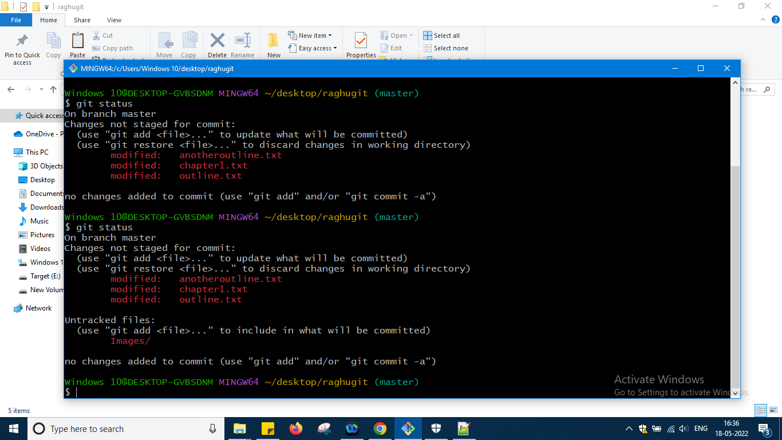

What two changes i have done it is showing me okay now

I will stage files in one atomic unit and then images in another

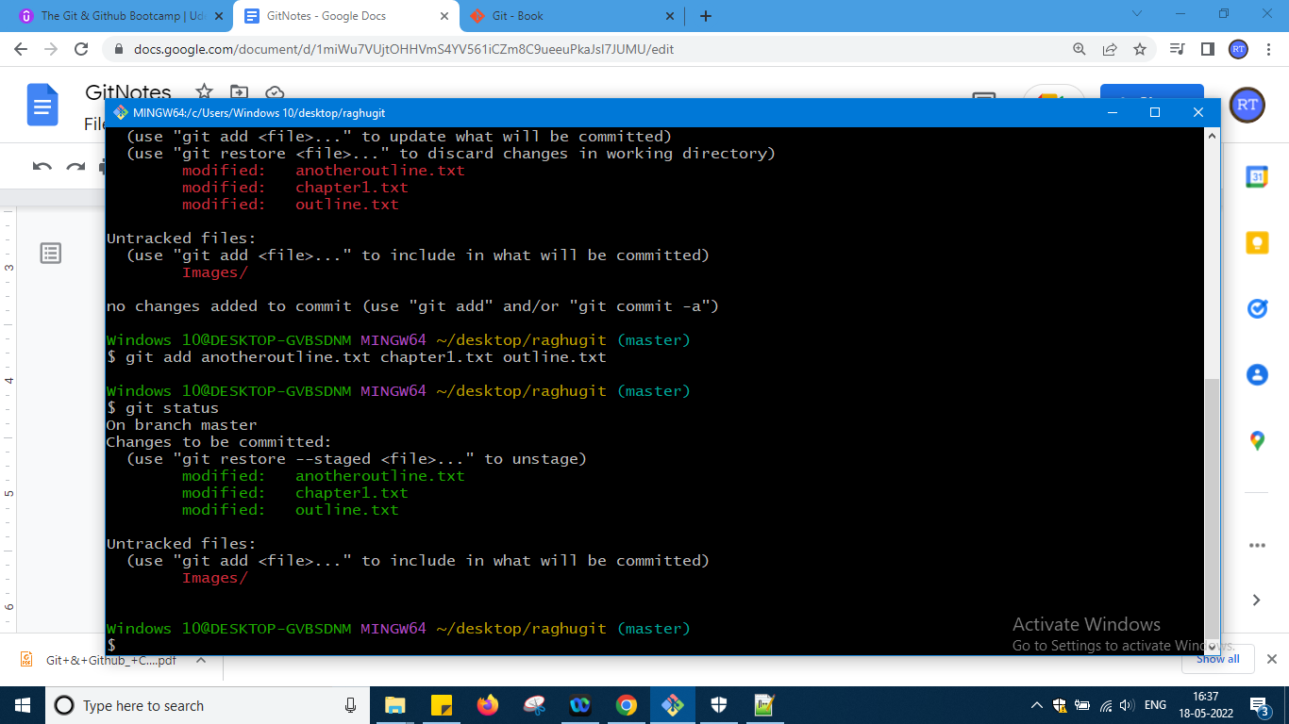

Now only 3 field gone for staging so now commit them and then will go for images

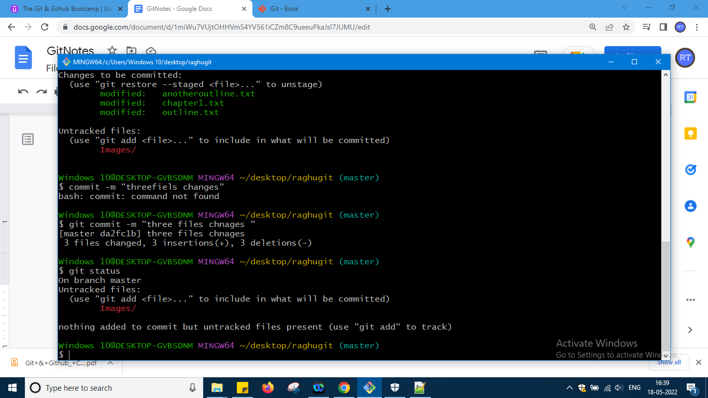

So three files done now for images i can do like this

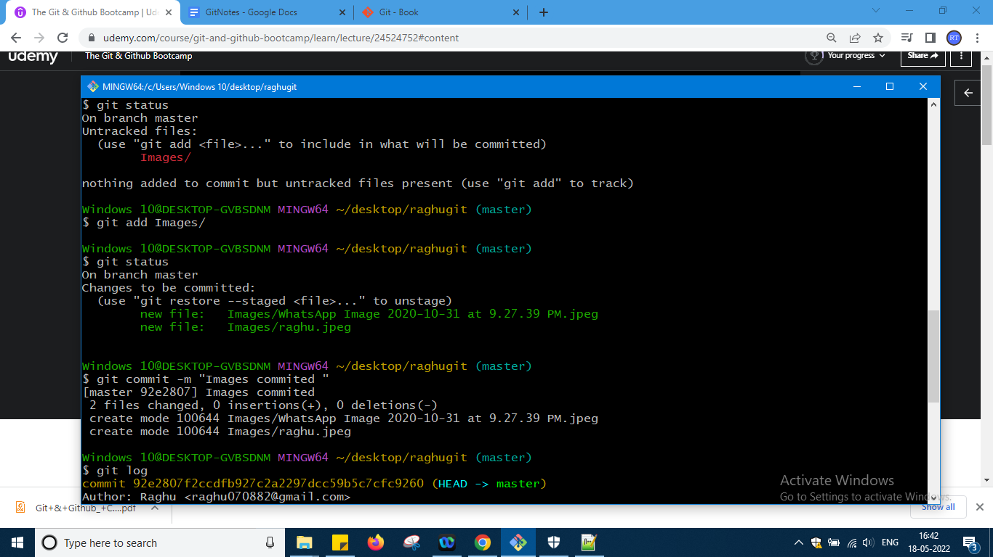

So this is all about git atomic commit okay

Next important topic is

<https://git-scm.com/docs/git-log>

Refer this url i am taking only important topics okay

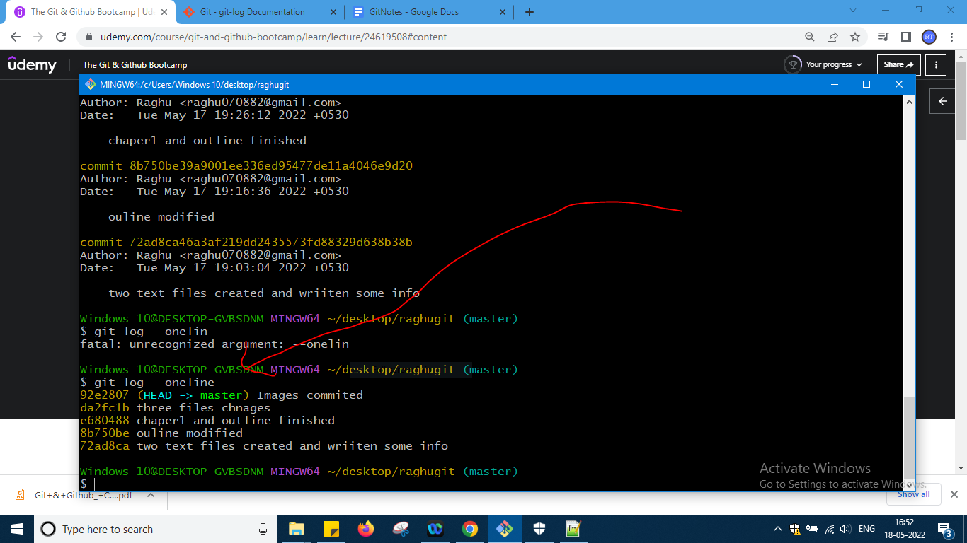

I can see only one line from my log files which i had created

There are other options are also there in documentation just check and try it okay

Now i want to amend the commit okay

This will work when u have made mistake just one commit ago like redo i want to do okay

Like i have forgotten one file to add or in typo message of commit something else i have to write so to amend those i will use this

Now i will modify three files add one heading to them all files and one heading was mistake in spelling and do staging to 2 files and do commit also again git status i came to know forgotten then

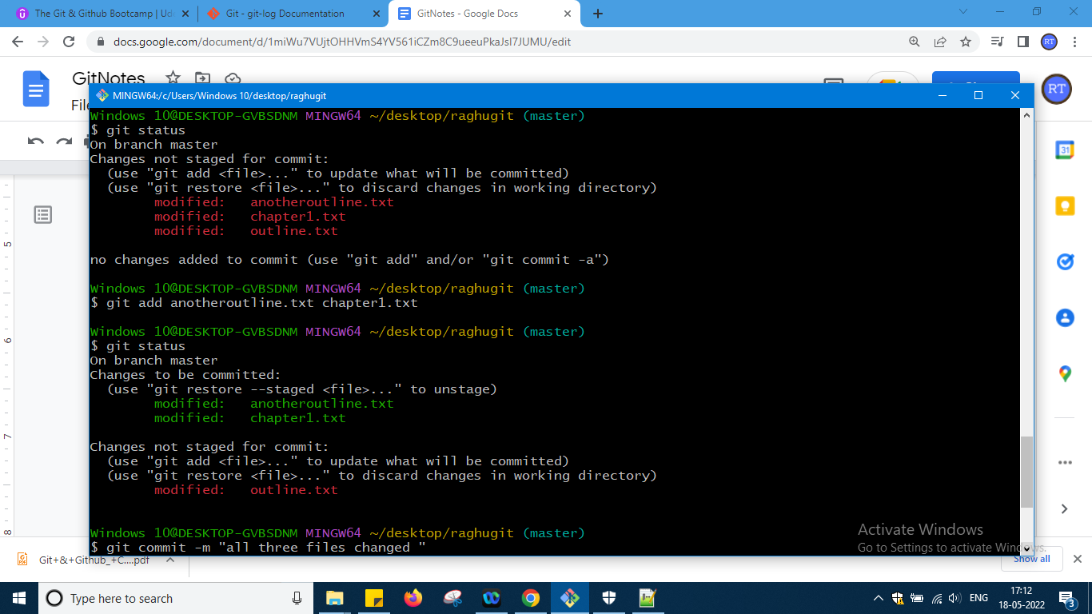

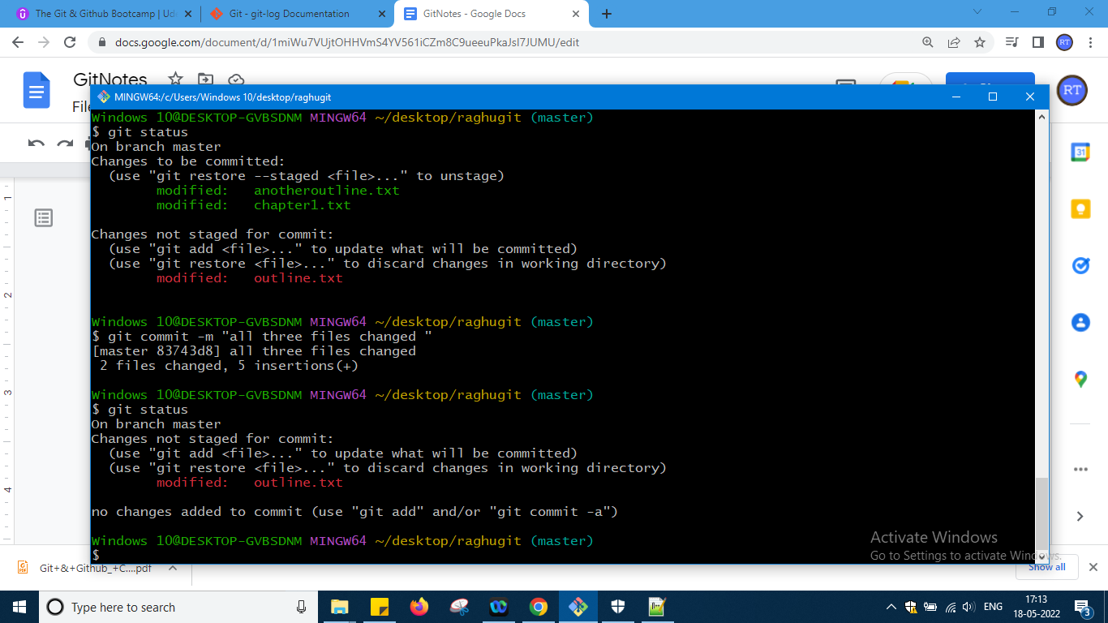

So i had written a wrong heading in outline file say and also forgotten also now write this command

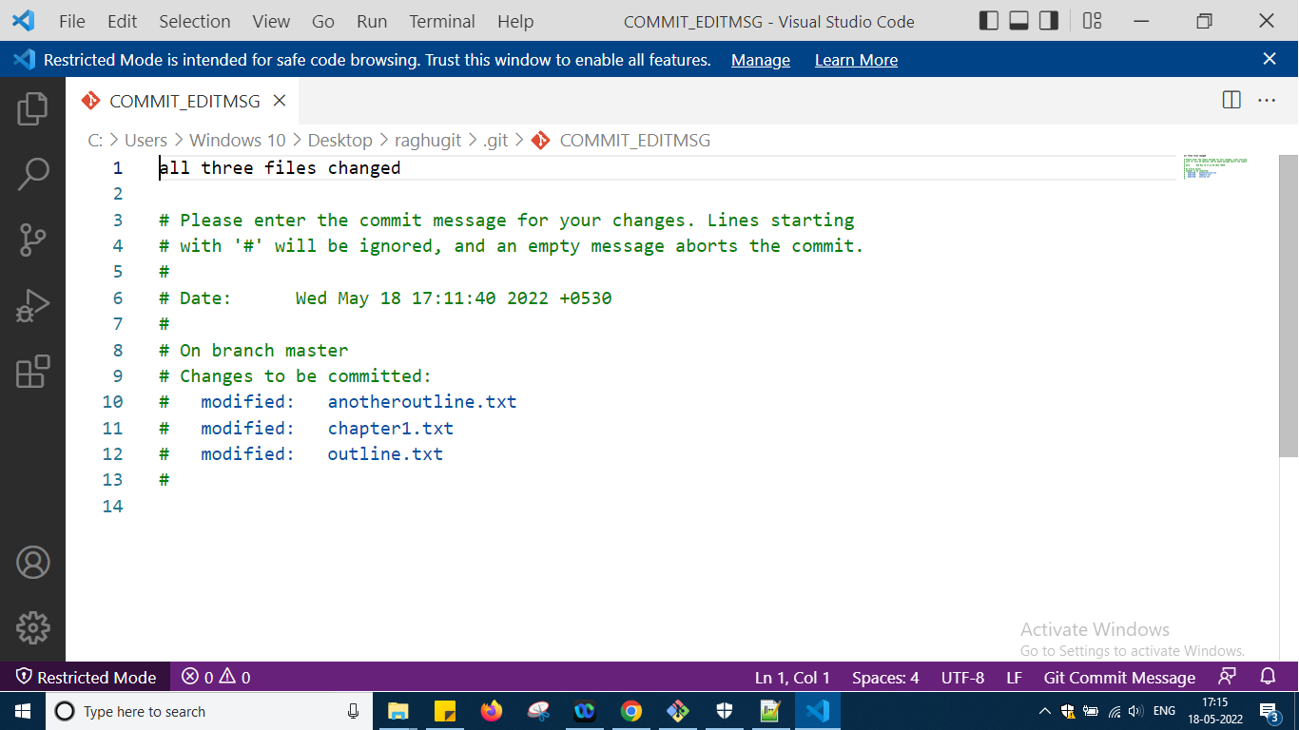

One file will come if u have to save message name anything new change it and save and the fie will be commit

Once I save it it says that 3 files changed so it will not change the Heading inside content

Now let us go with ignore file concept

U want your git to ignore or not allow git to track some files those files can be kept in git ignore okay something which u dont want to show to entire world you want to have it locally but u dont want to track it okay

Refer the video for this that will be enough

So this is the end of section 5 and now i am moving to section 6

In this we will deal with branching so every commit will have parent reference okay shown in slides okay and which is started first will not have any parent reference okay

We are by default running or working on branch that is main branch and it will say it has nothing to commit like this

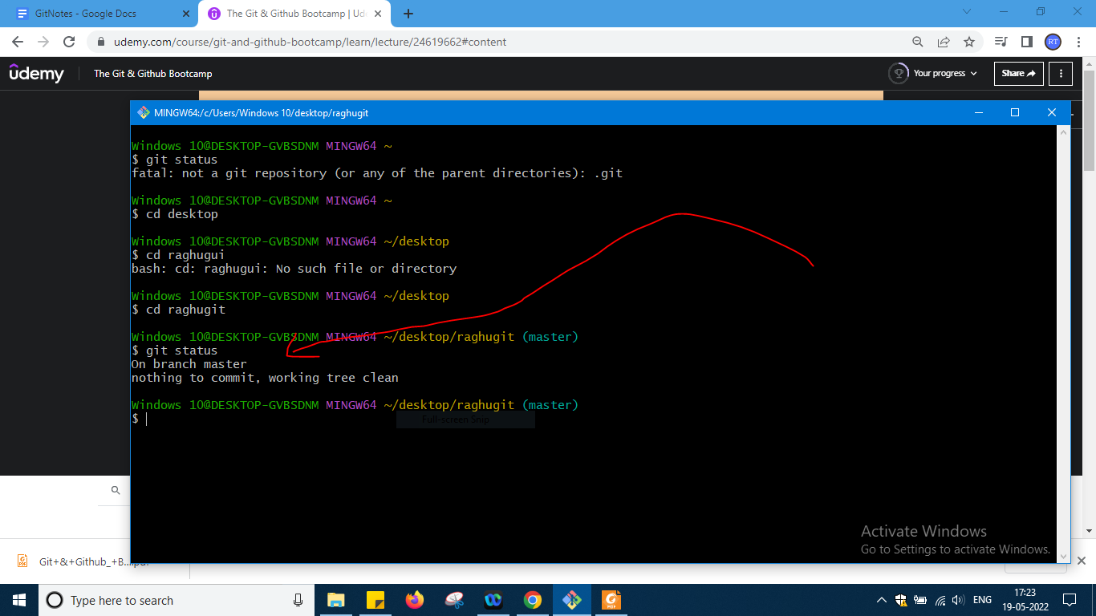

Here it is saying master okay

When i type git log i will see head what is this now

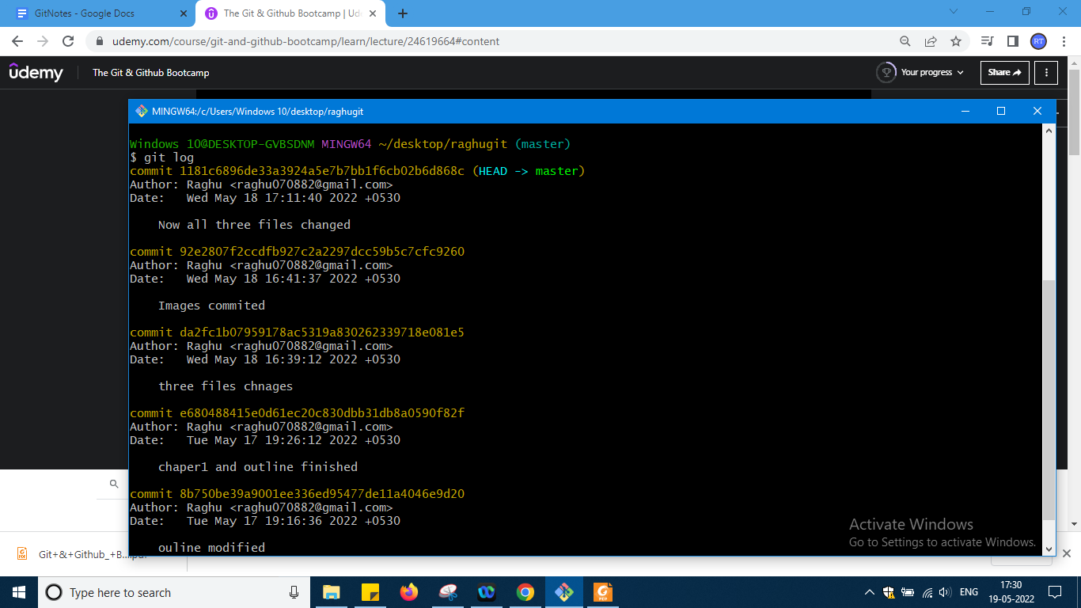

It is a pointer to current location in repository so what is head it is like bookmark repsresation at a time all i cannot open one i can open that one i head

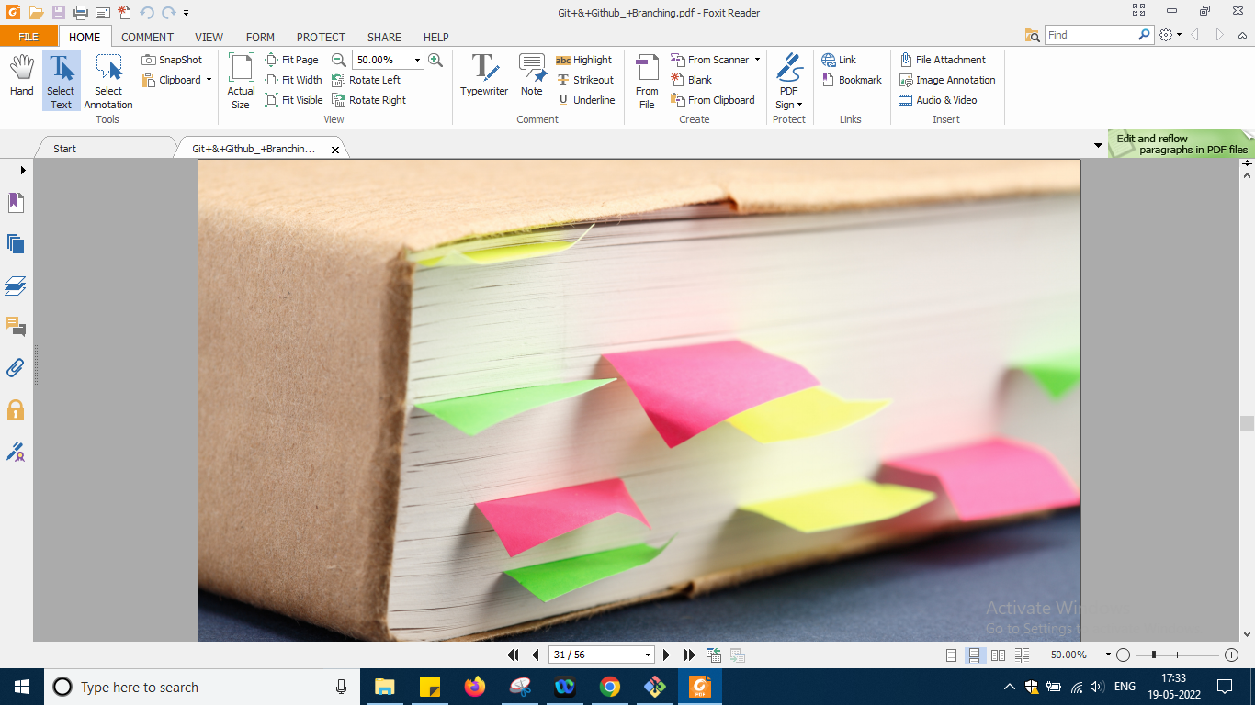

Some documentation check here

<https://git-scm.com/docs/git-branch>

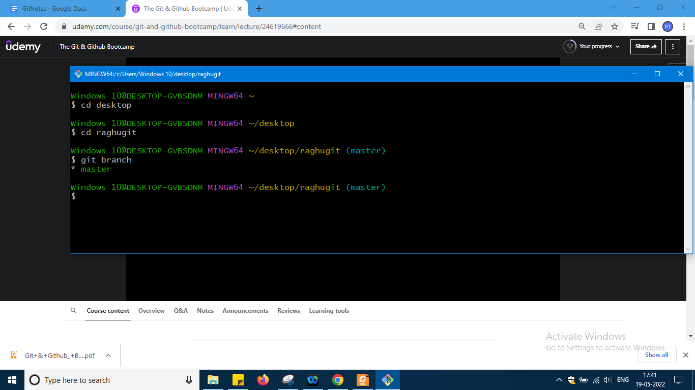

If i type git branch it will just show me main master branch which i have it okay so i had added a new folder and inthat one file and added some heading and this is steps for that

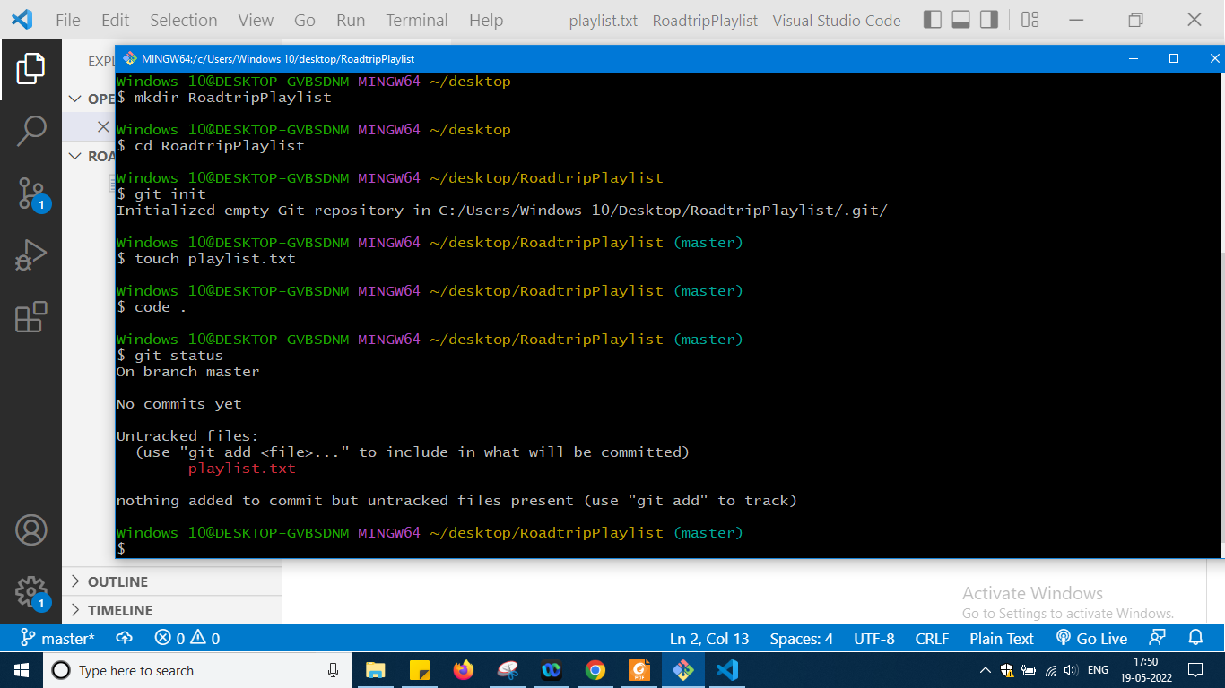

Changes just

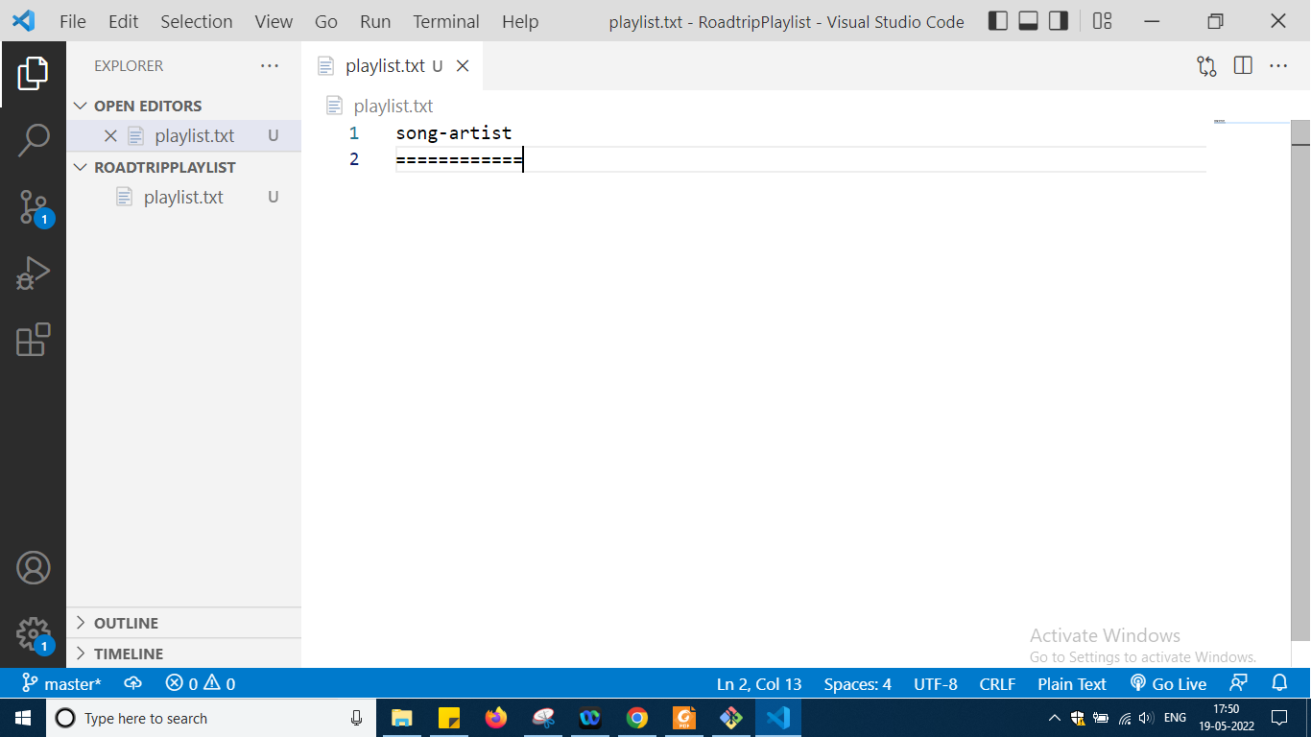

Then added for staging and finally git log

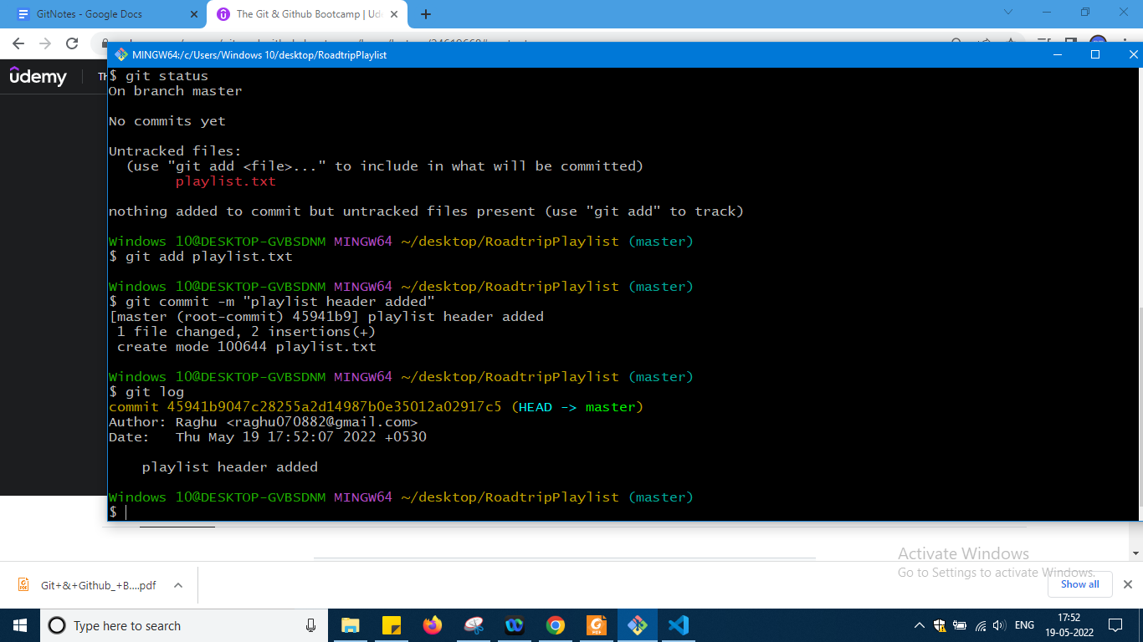

So u can see that head is still pointing to master branch only now two songs i will add

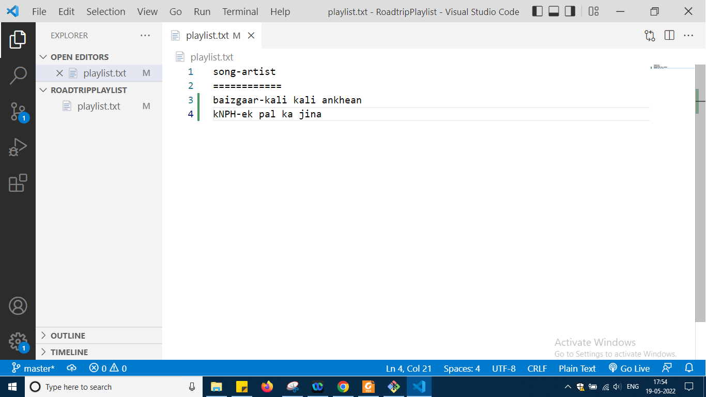

Further commands okay

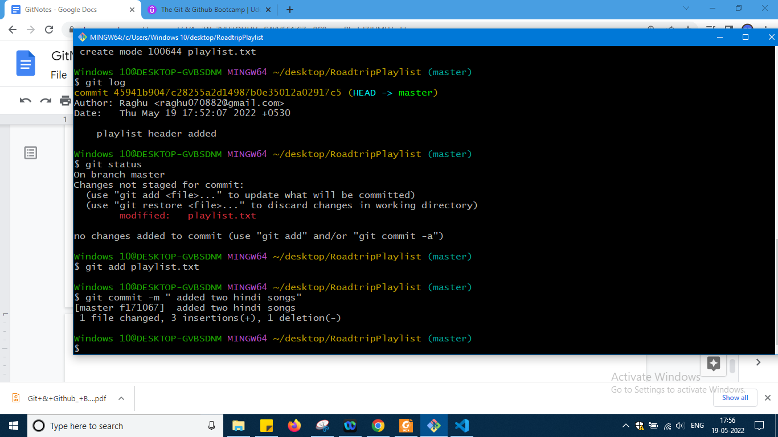

Still everything in master branch only doing okay

So two commits we have

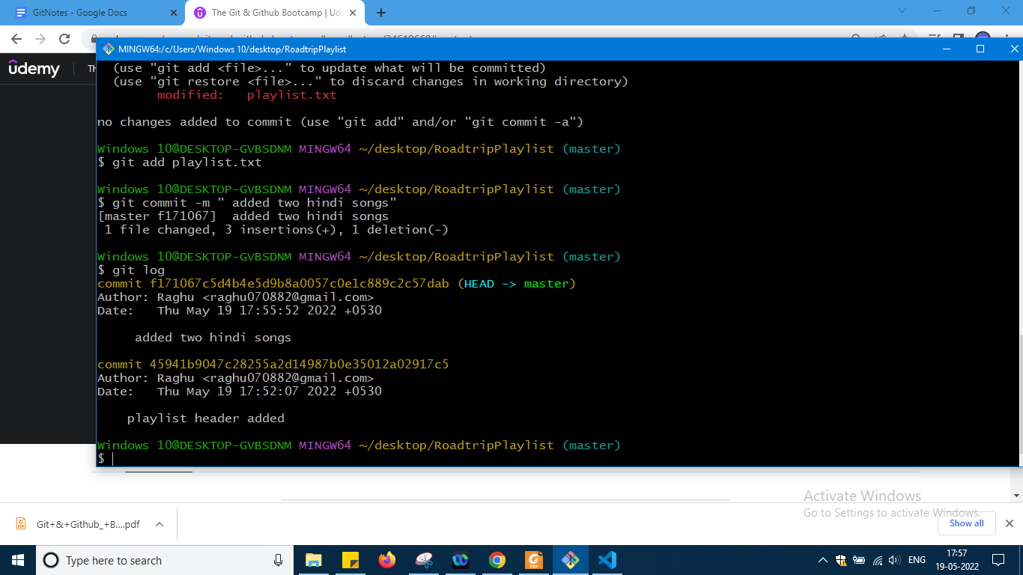

Now lets us make a new branch

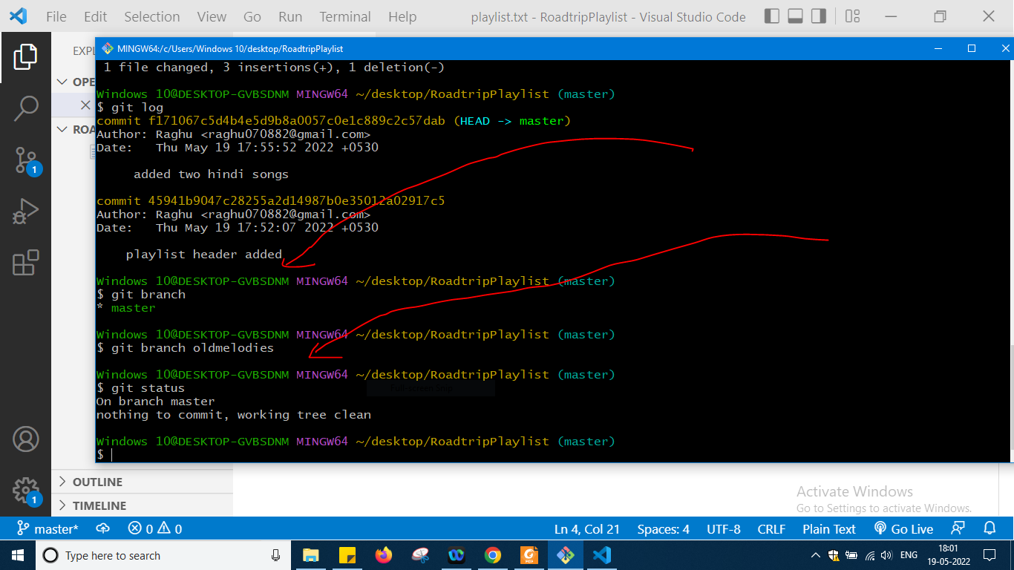

So u can see even after creating a new branch I am still in that brach okay

But after type git branch we can we have a new branch

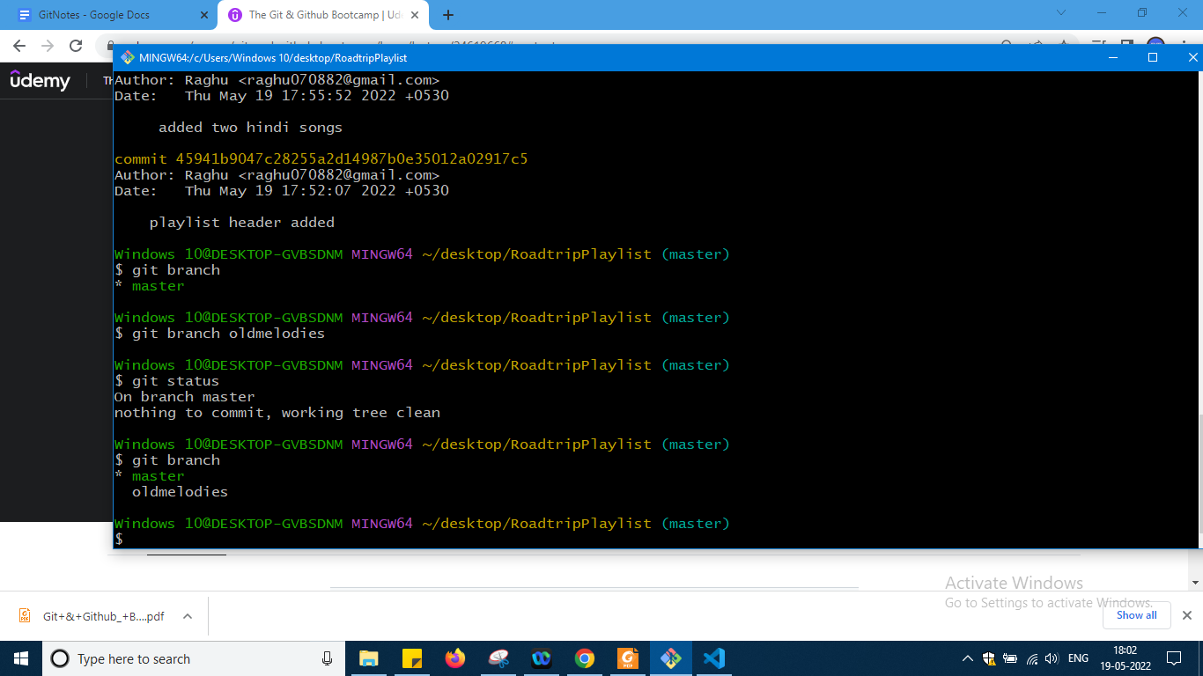

See the latest command okay

So git log

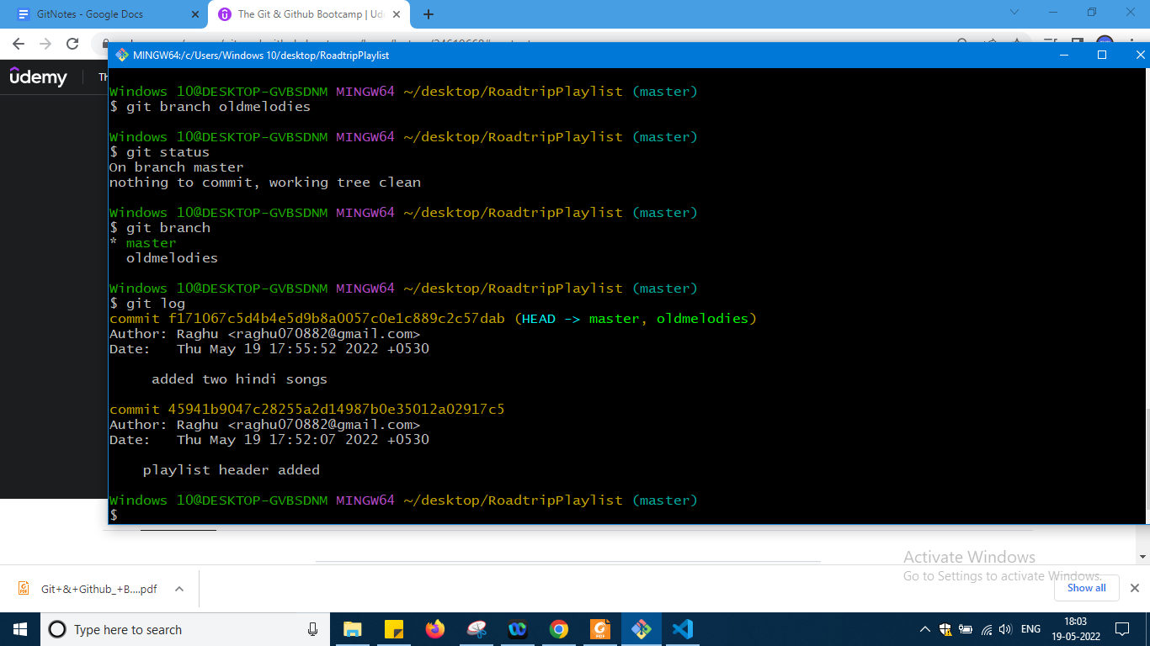

Still pointing to the master

And u can also see that two branch references are pointing to same commit but Head it okay pointing to master okay

Git status still main after comandit has changed okay just the pointer is changing

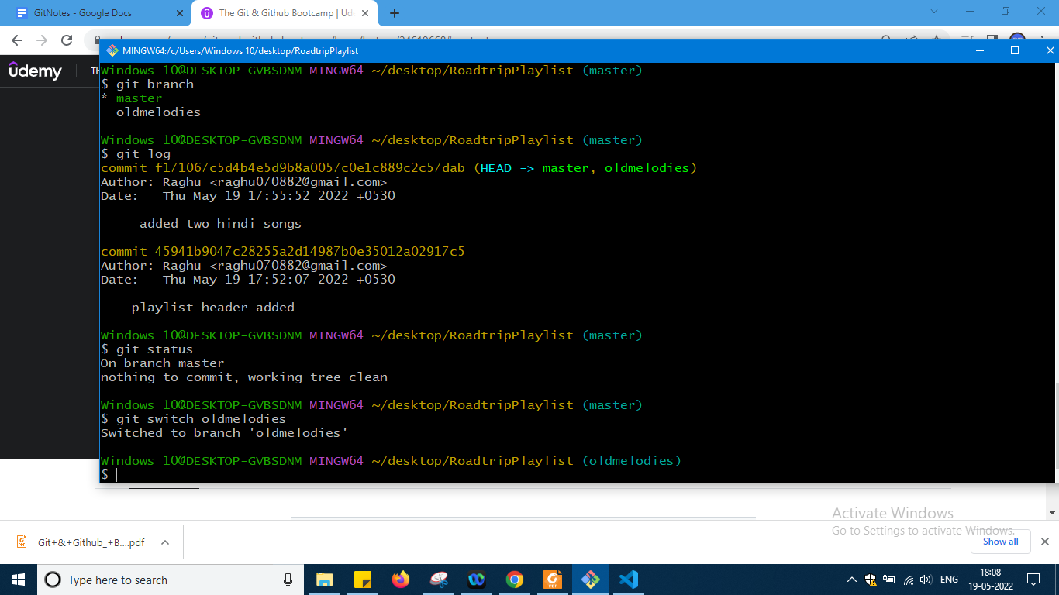

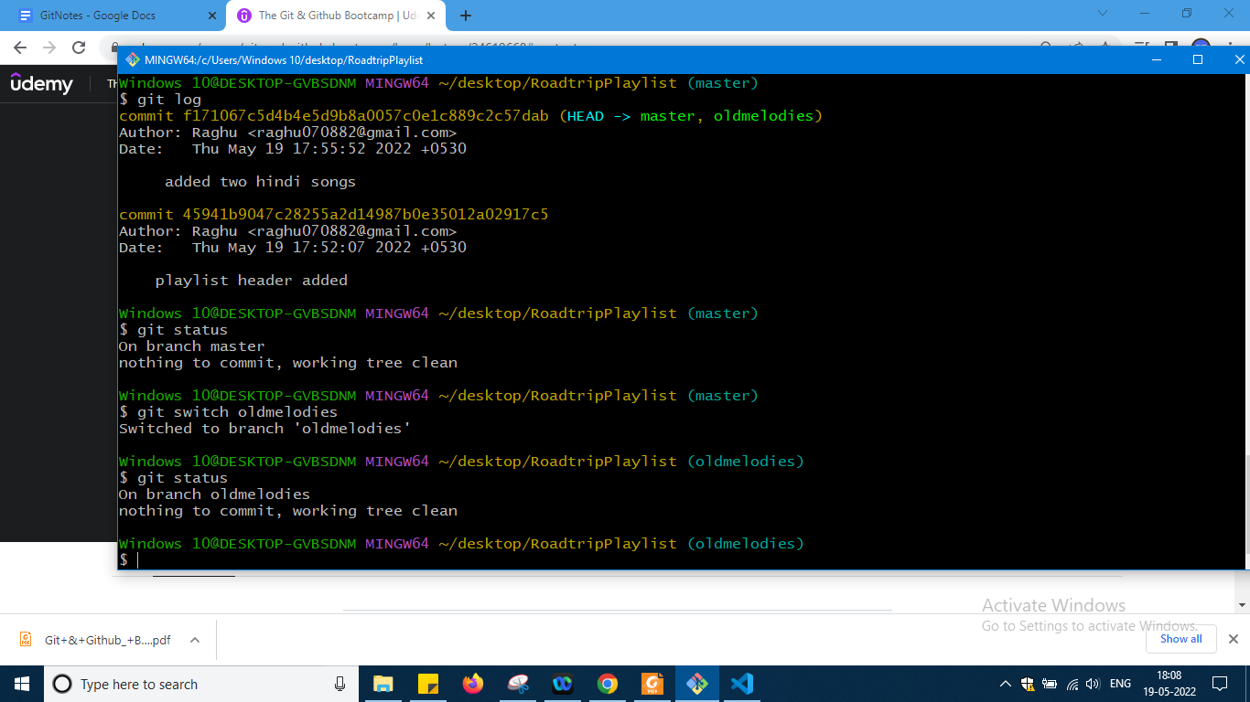

Just follow commands

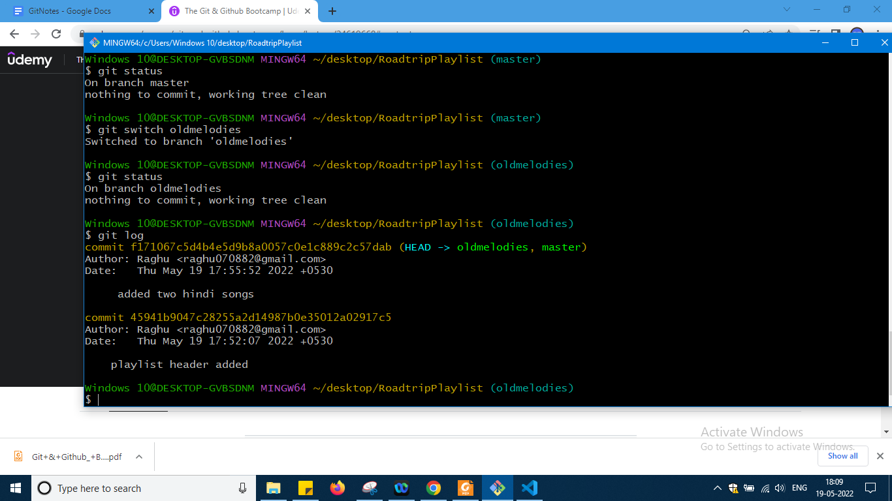

So head pointing to ollmedloies okay

Now add two more songs but old

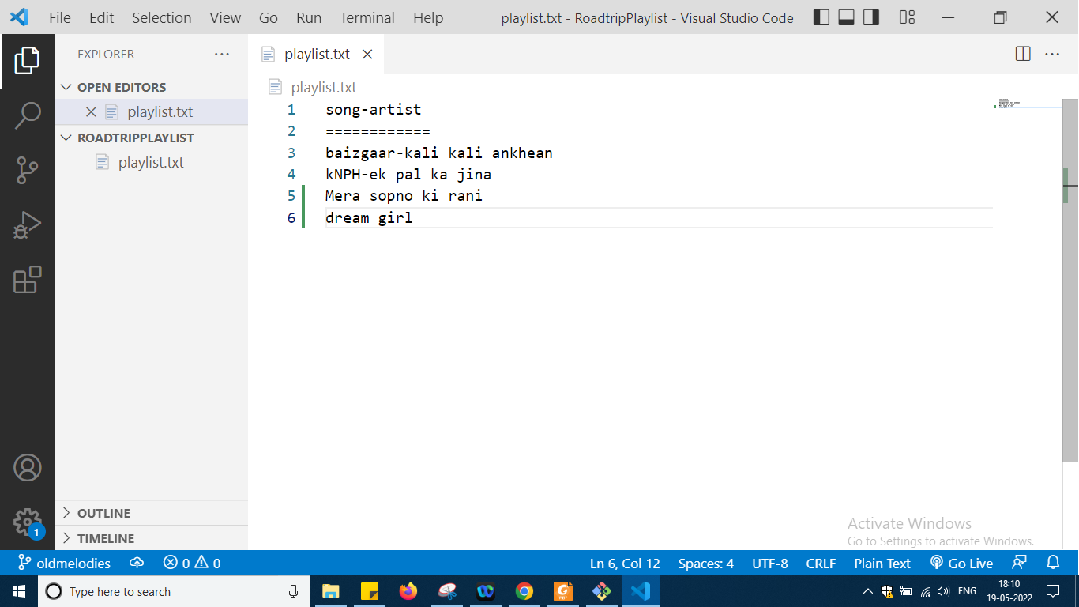

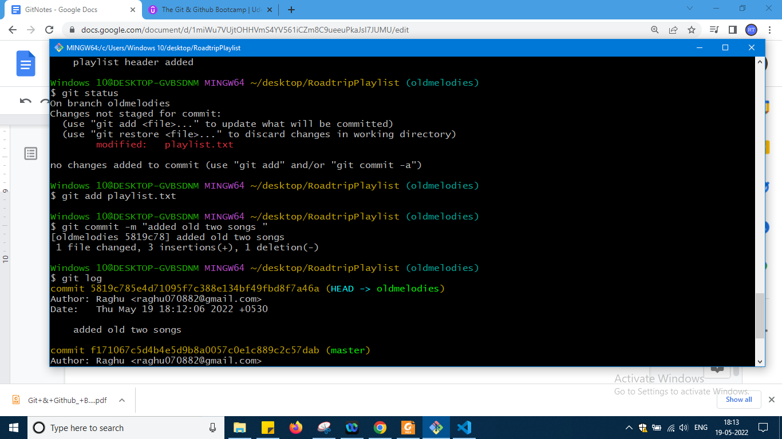

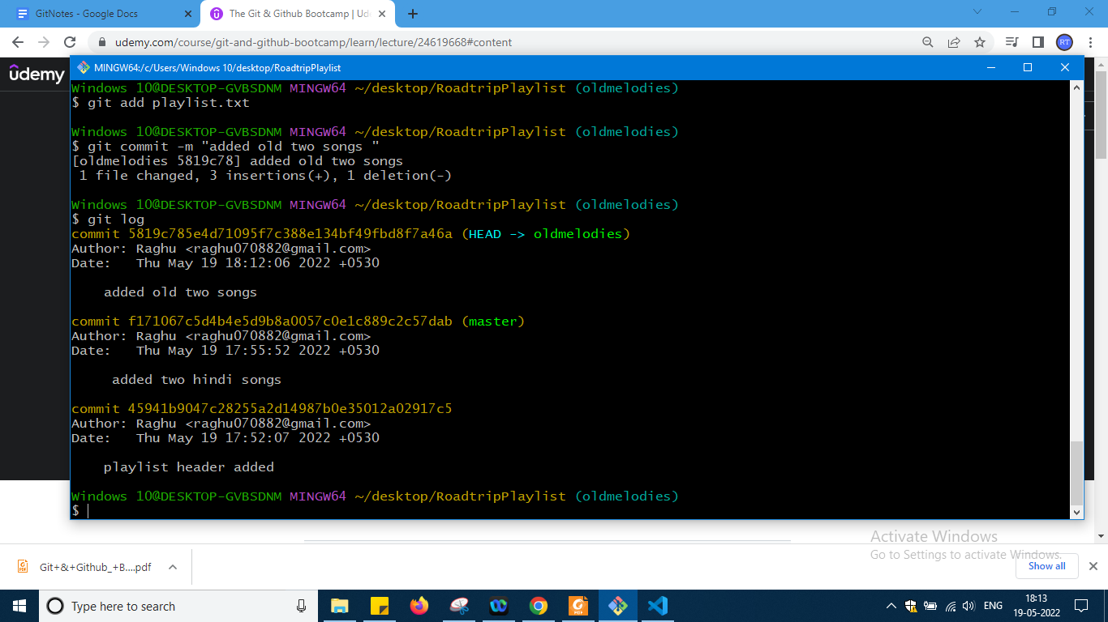

So if u see master has been left behind okay

Now i will switch again in master and then we will check the file

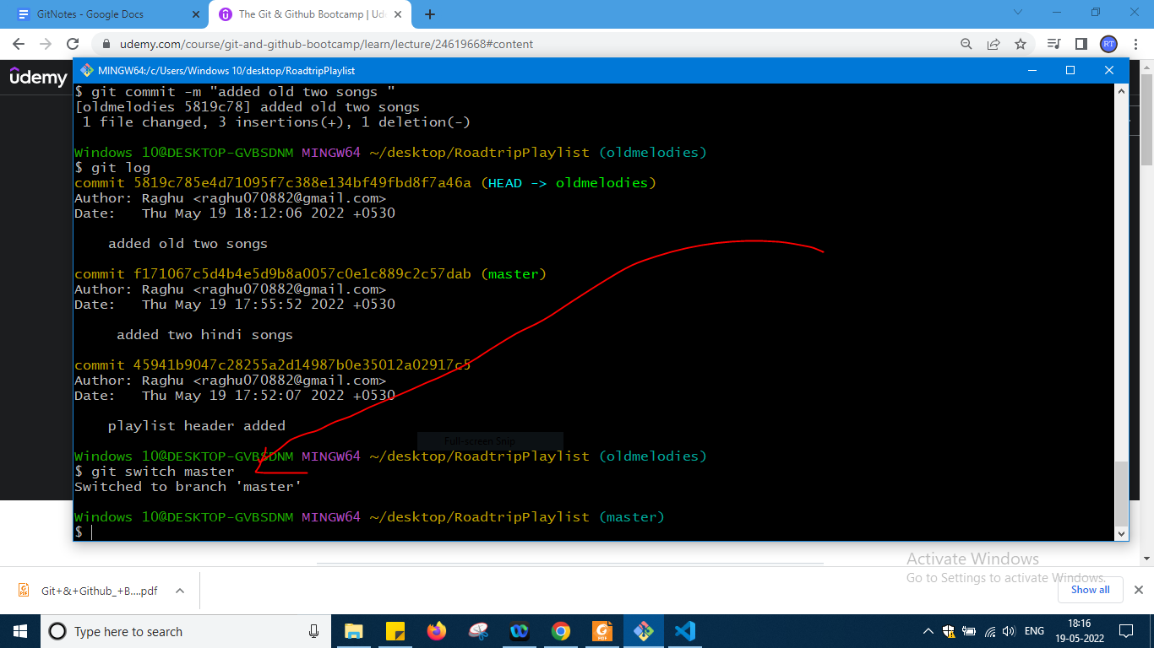

Go and check the file in code

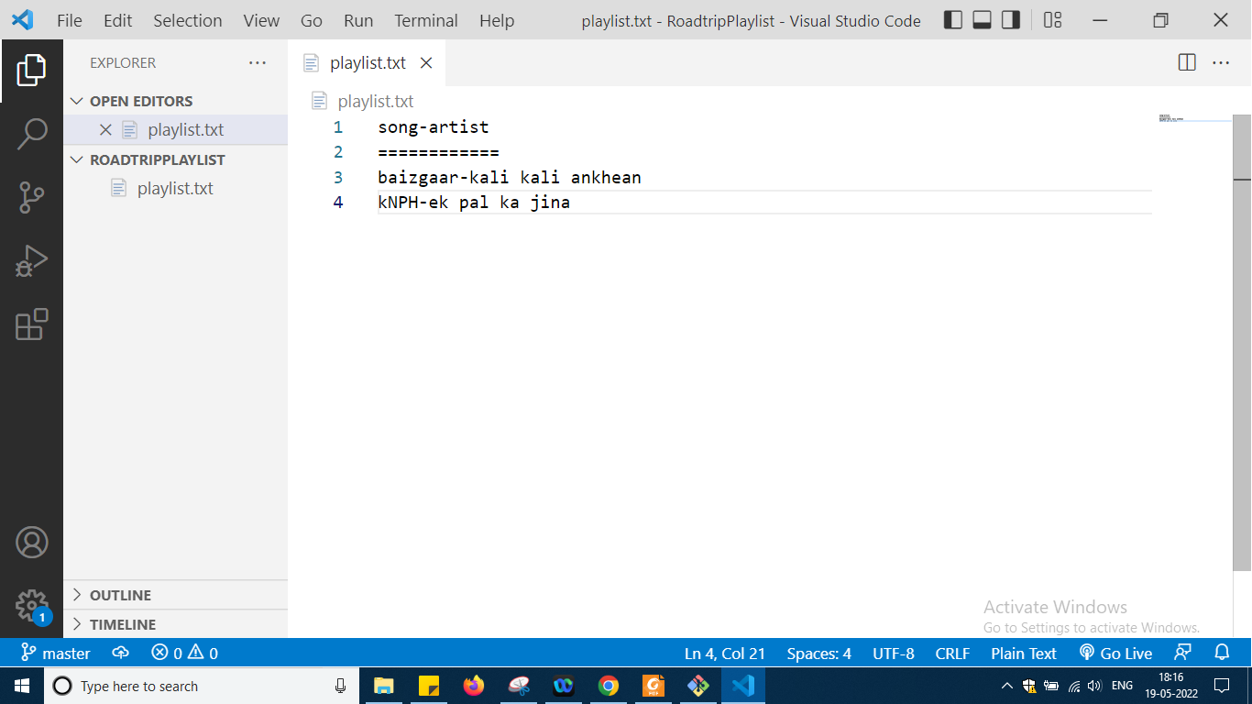

Automatically they are vanished old songs okay so only two commits i can see

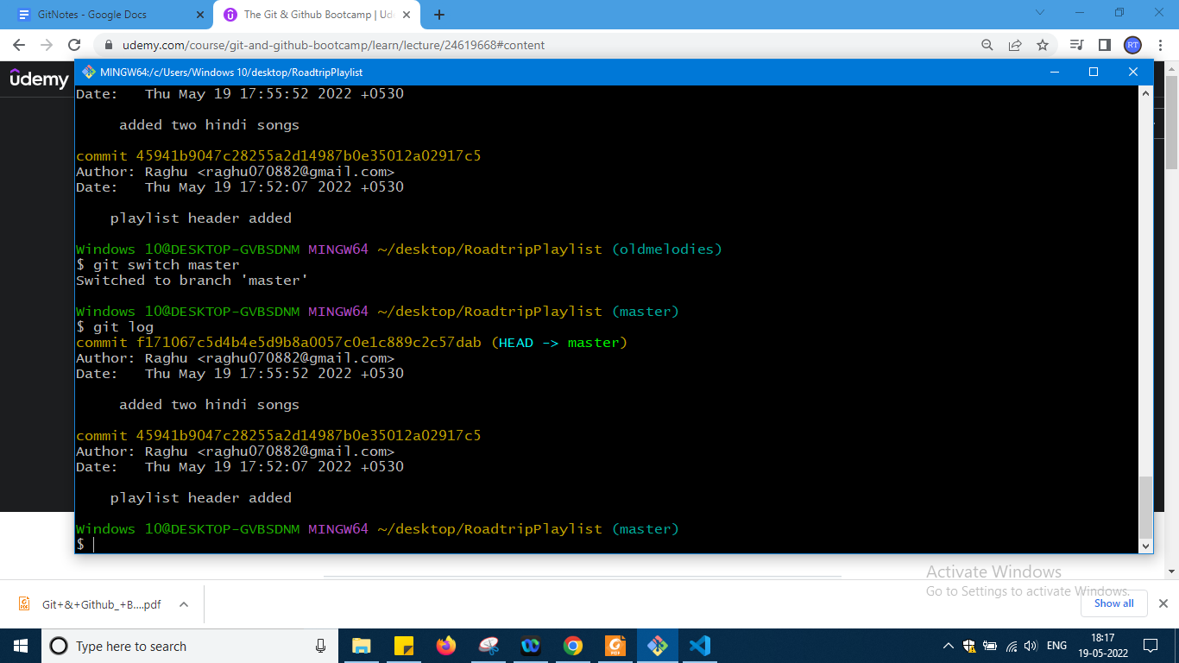

Now again switch to oldmelodies and same command u will find the files regenerated

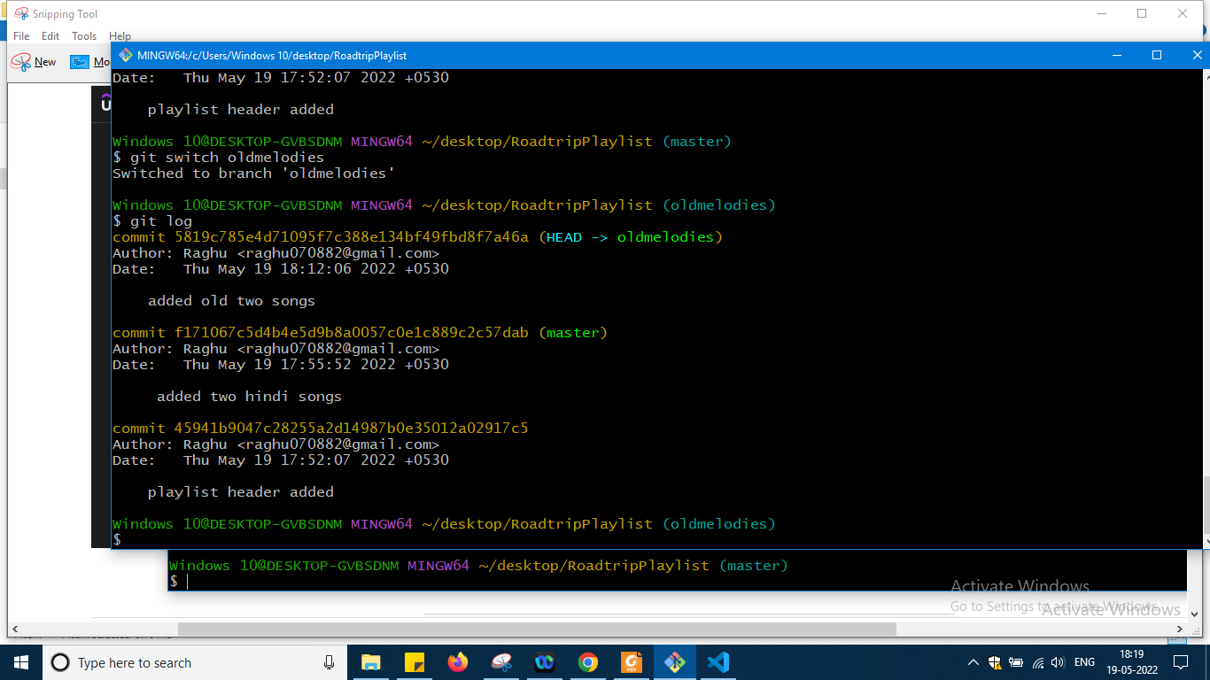

So same thing what was earlier okay

So this is basic demo on branching okay

Now i will add two more songs kannada songs

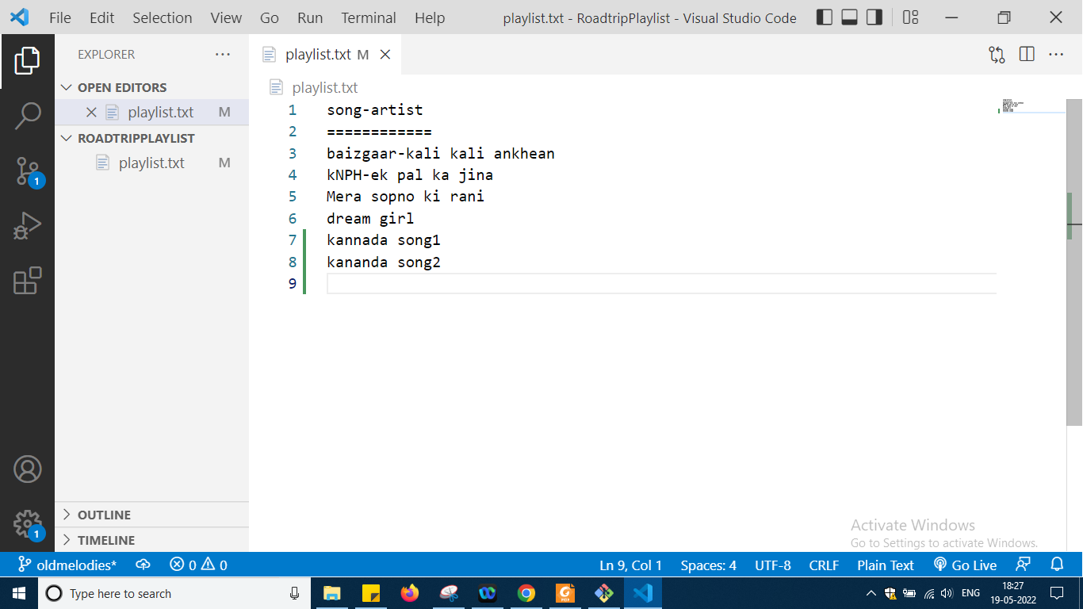

At a time doing

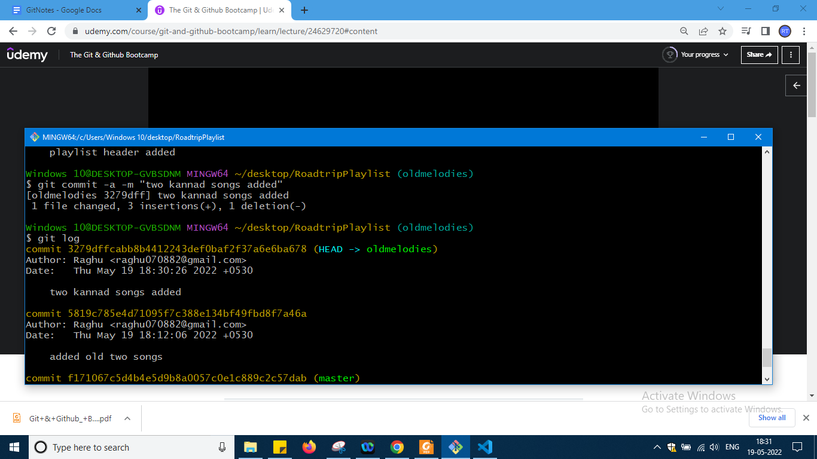

Press just q if u are struck okay

Now i am in oldies and from here i want to make another branch which is kanndabranch

After creating

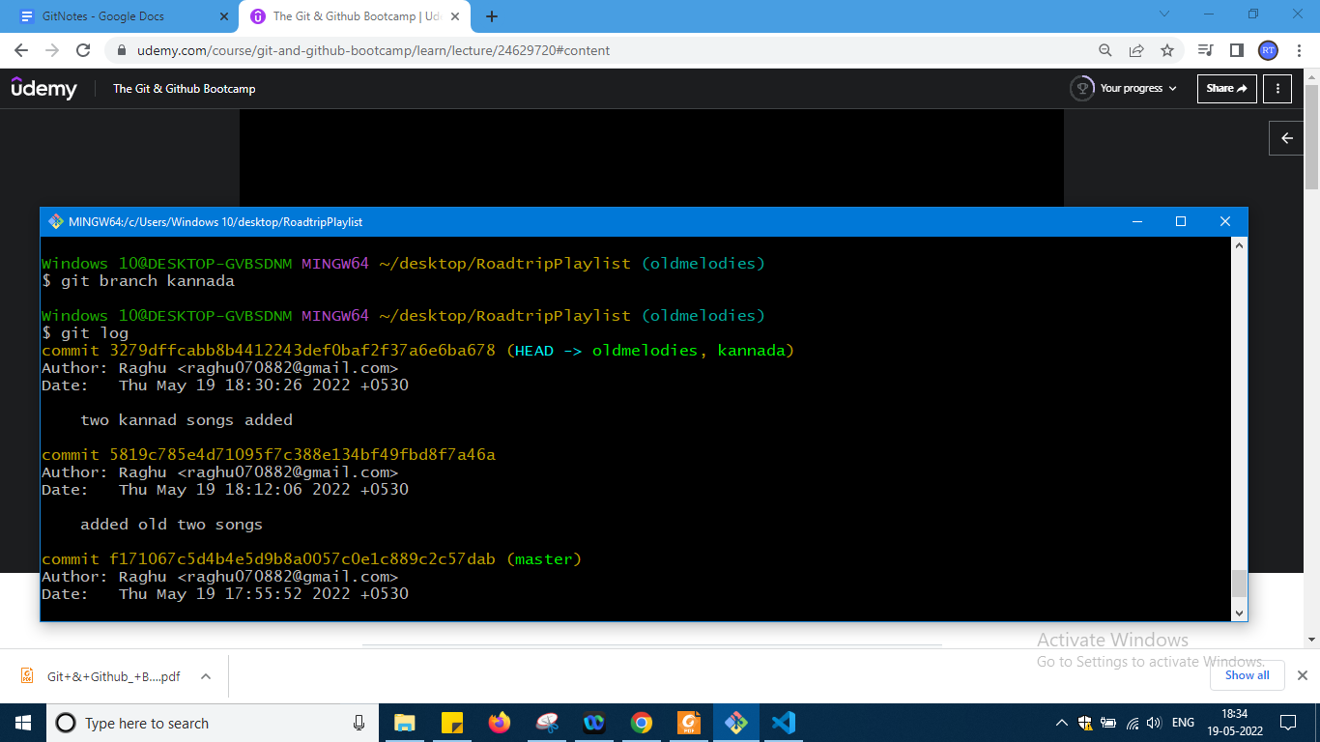

I am still on oldies

So no switch over done let me do it

So same commit two are there means at the one page two bookmarks kept not needed

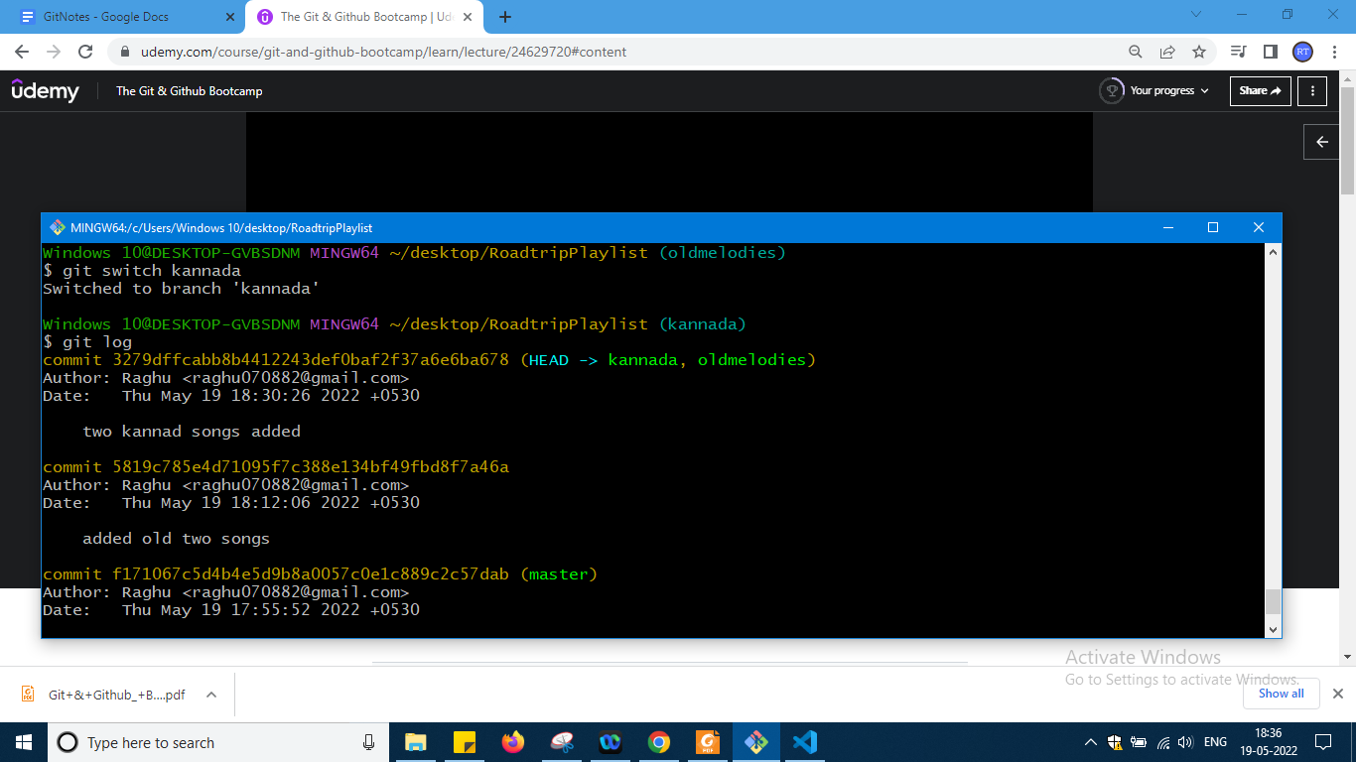

Now i will add two telugu songs here and commit them

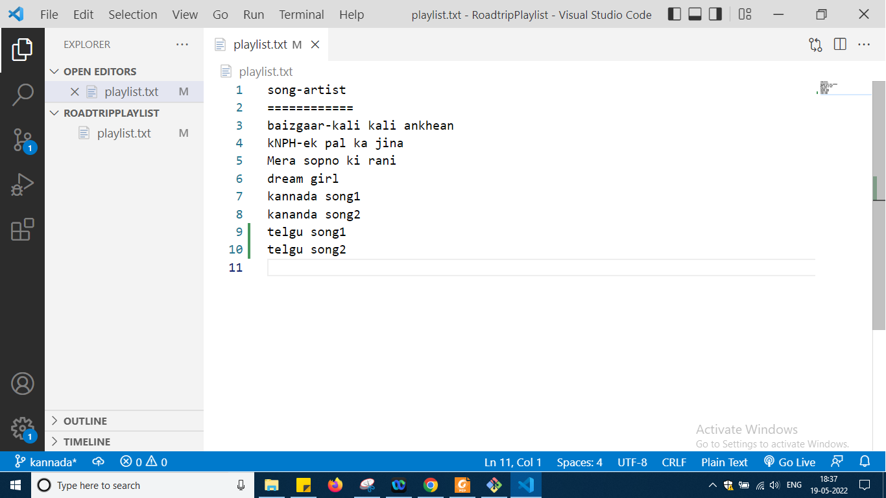

So like earlier manner in one go i have added

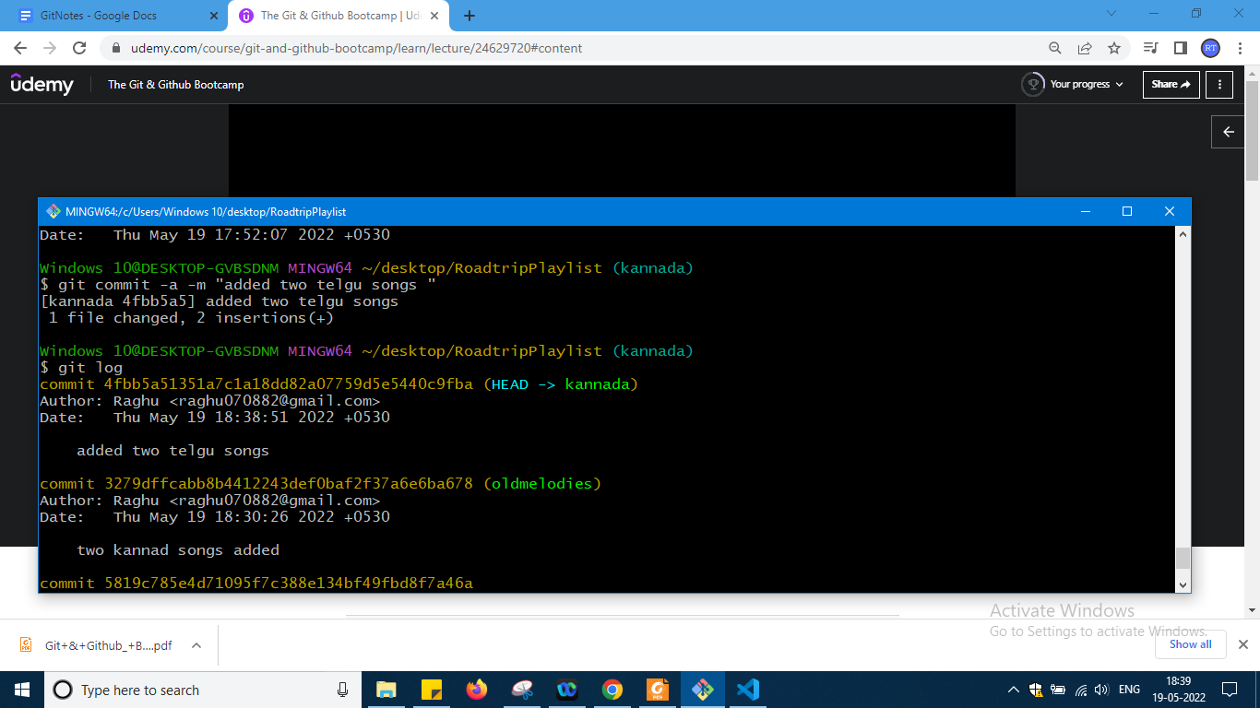

So head pointing to kannada done mistake here after adding two telugu songs i need to create branch telugu which forgotten so do it for marathi songs in kannada branch

So taking the video u can practice this okay

So if u observe the video carefully u can get it just practise okay

Next command is git checkout

<https://git-scm.com/docs/git-checkout>

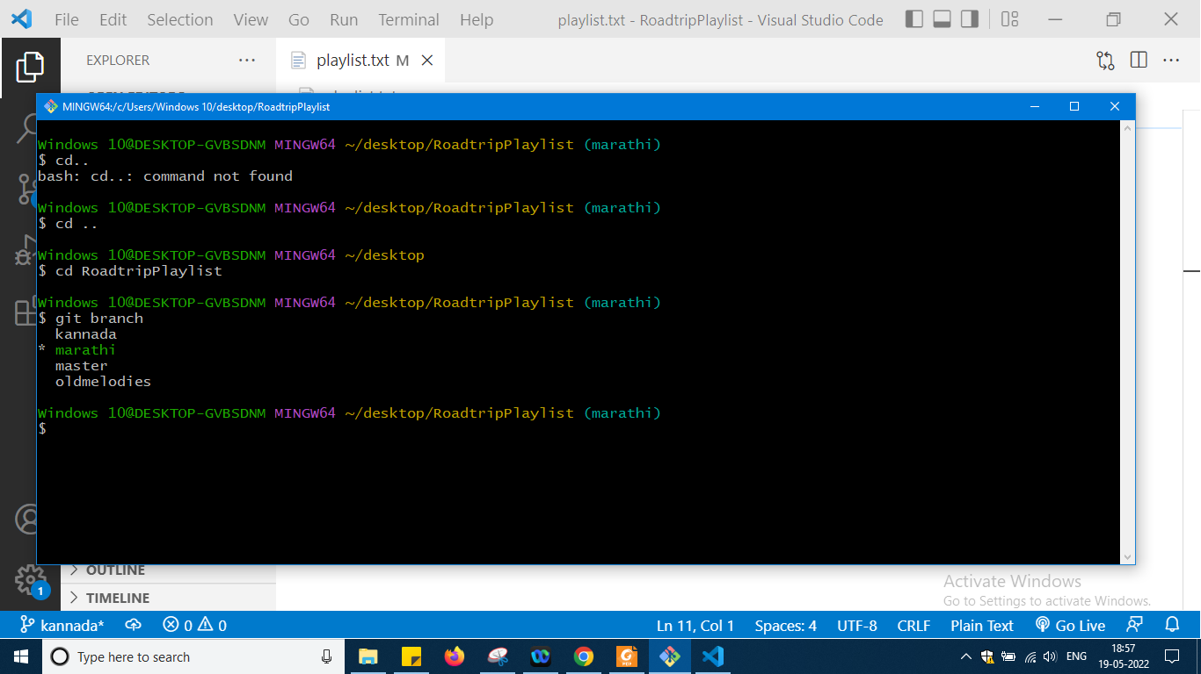

So from here i am not writing notes if i feel i will write as time is not there

U can refer video and its slide there and again practise okay

Lastly u can refer this exercise which is nice to have as complete summary of section 6 just listen to this video that will be enough

<https://www.notion.so/Branching-Exercise-b5460c881d56400cb046357d9a430bf8>

So this ends sixth section refer video okay

Now I am moving to section 7 okay which is Merging of branch

We have here two types of merging fast forward merge and git merge etc we will see that

Some link for documentation is here

<https://git-scm.com/docs/git-merge>

For merging the branch which u have created separately from main branch first u need to switch master branch so that now Head points to master and then u have to write the git merge command okay

It is take all the commits from that branch and will merge into main branch okay

Now lets us try fast forward merge now it is simple

In my previous demo I am moving to master and cheking there how many commits i have done and same thing i am chking it for melides also and there how many done so

For master

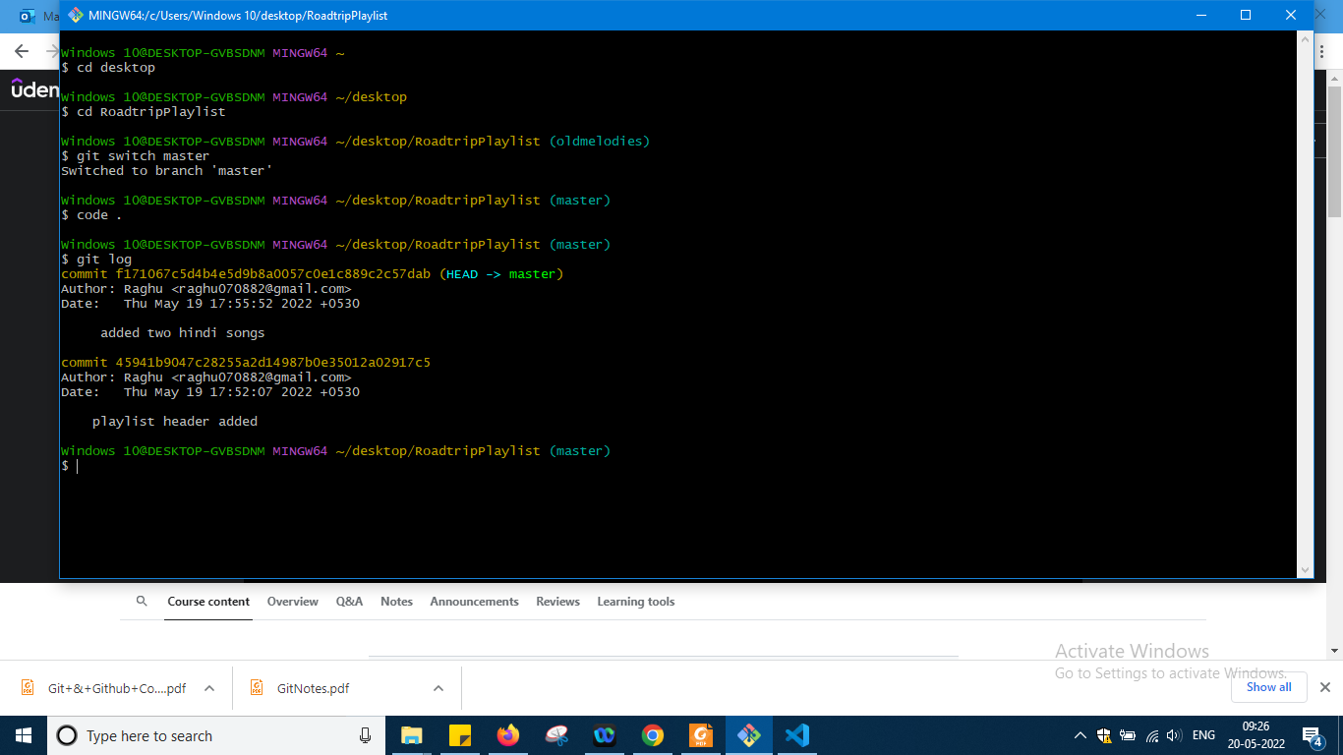

For master

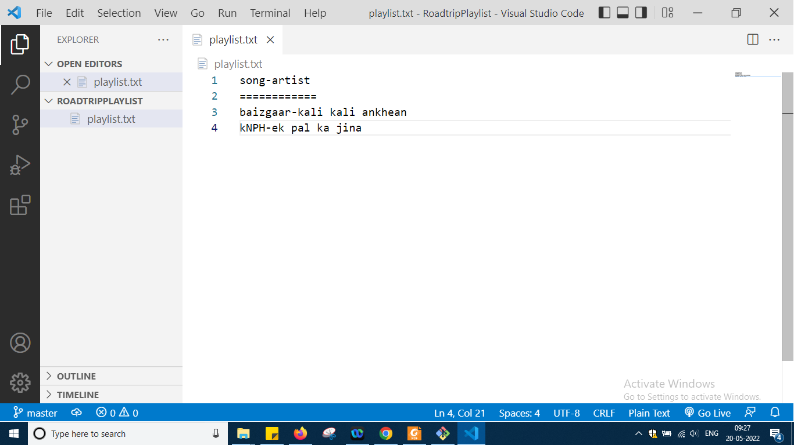

So this was the status there now

For old melodies

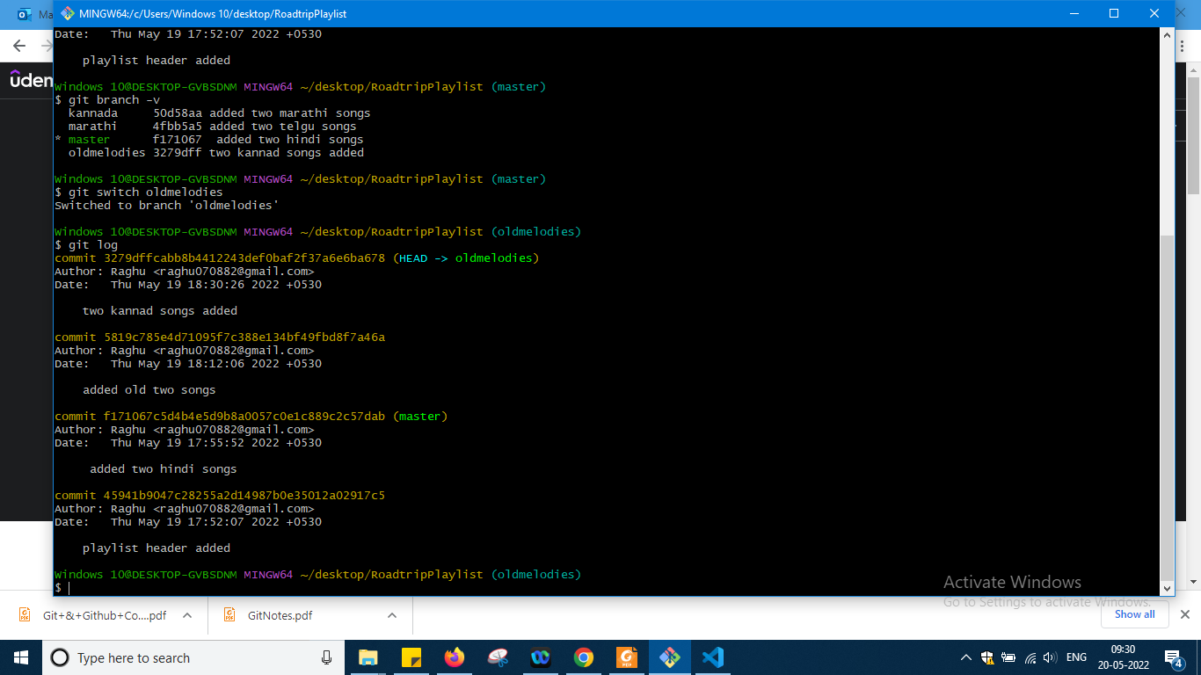

So above -v is giving more information about no of branches I am having okay then i can see that in melodies two commits i have done one another two from master okay it is showing all and if i see the file

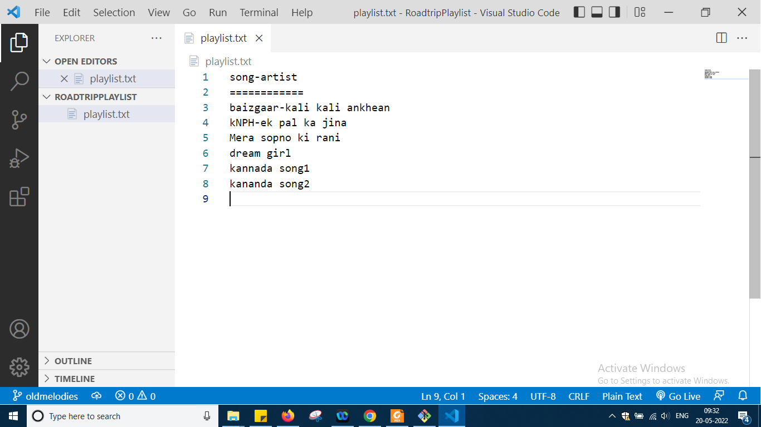

And now the changes in melodies i want to add in master

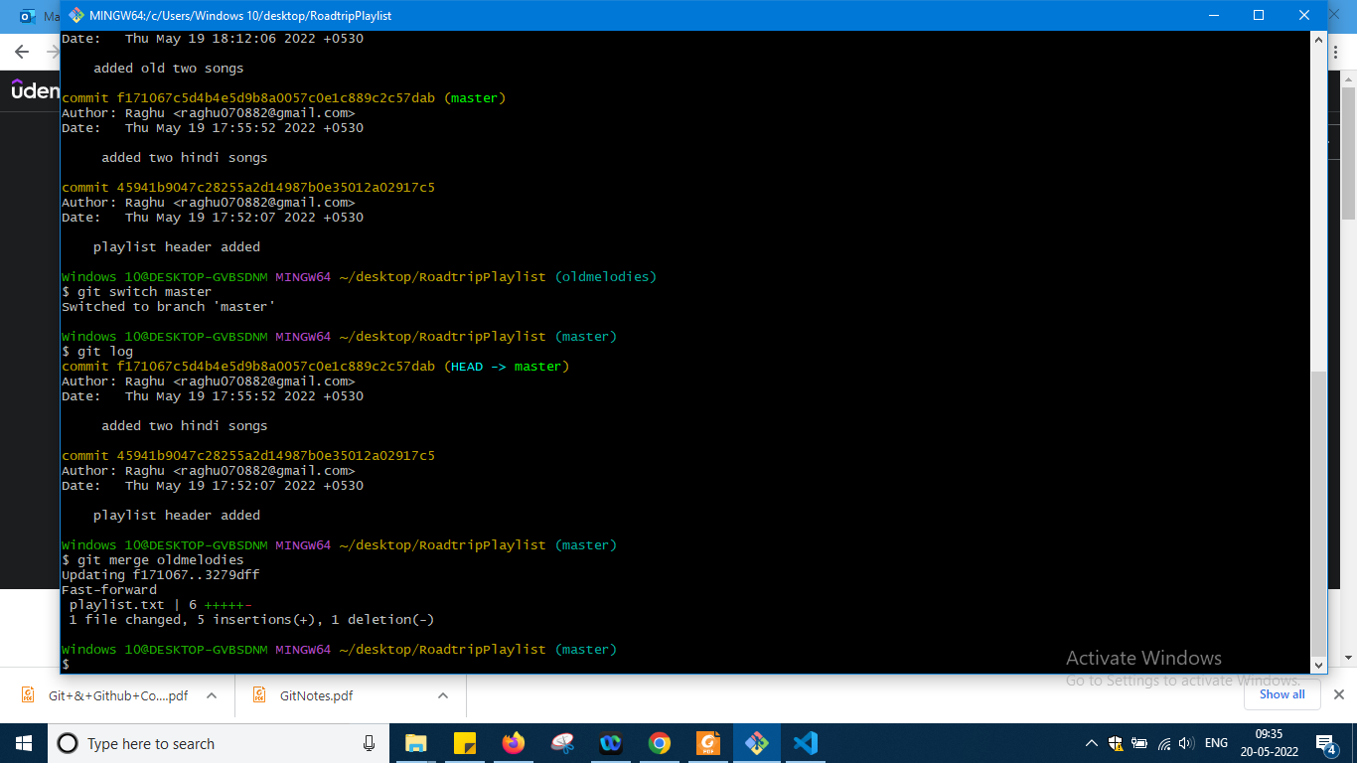

Switching to master checking log again and firing the command and it clearly says that fast forward merge is done and now see the vs code editor

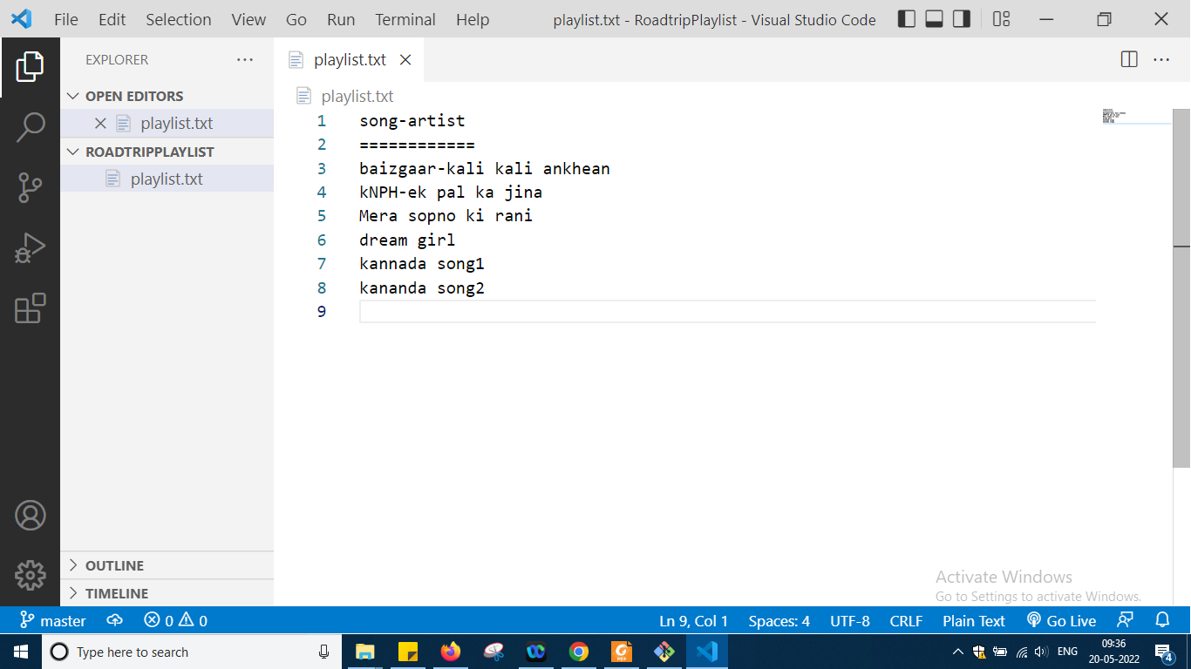

And check git log now

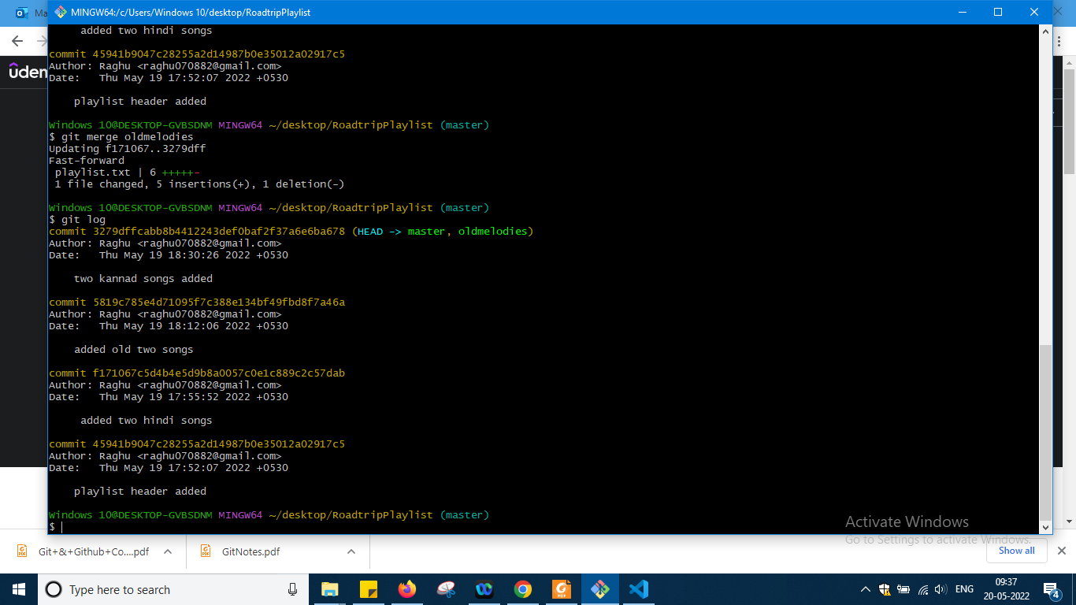

So there is a difference u can see okay

Now i will go to old melodies and see what is there over there is it empty or what

Just checking few things by my own

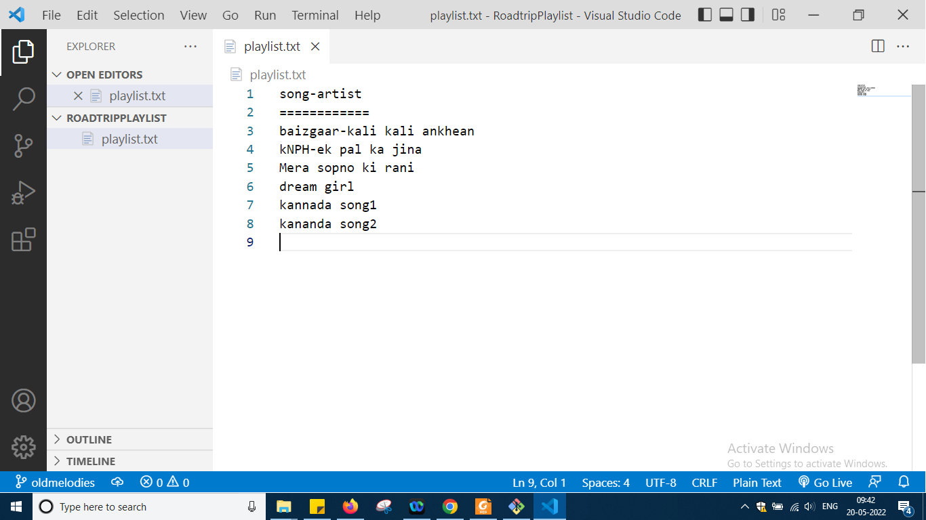

And git log

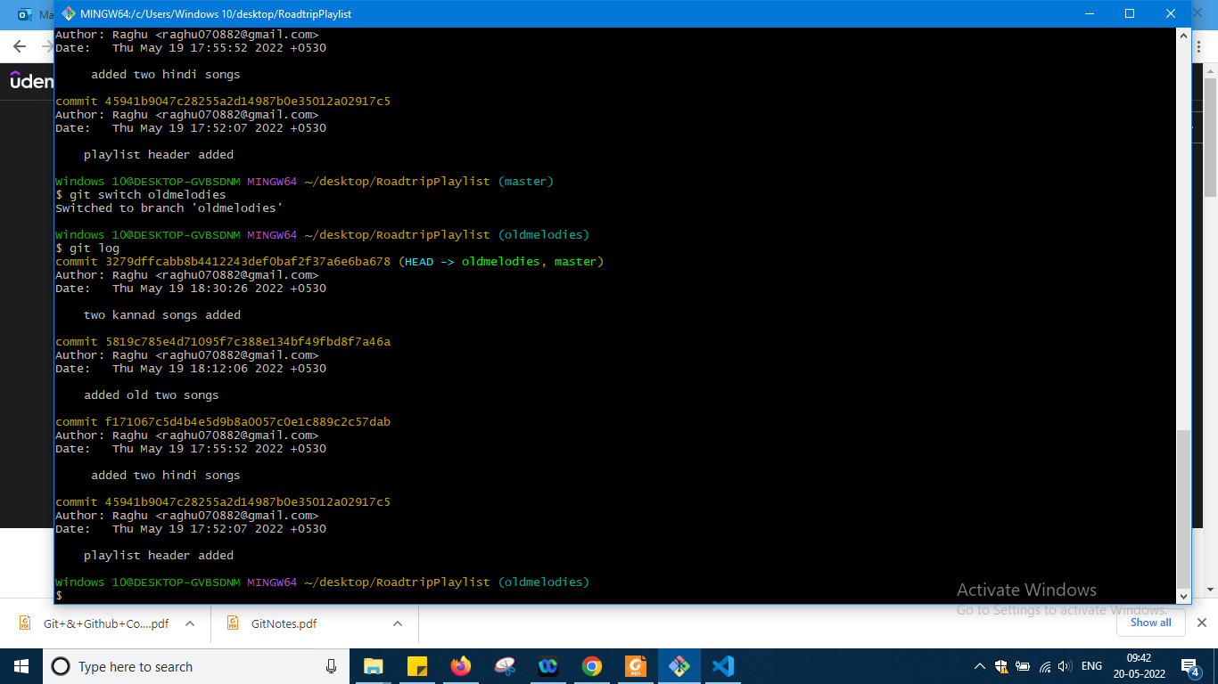

And git log also means old melodies are not deleted, they are there, cut has not done just merge has been done into master okay so this is all about fast forward merge .

Now what i will d is merge commit means before merging child to main again i will go to main and do some changes and then will fire merge command and in this situation what will happen we will see now so fresh application i am taking

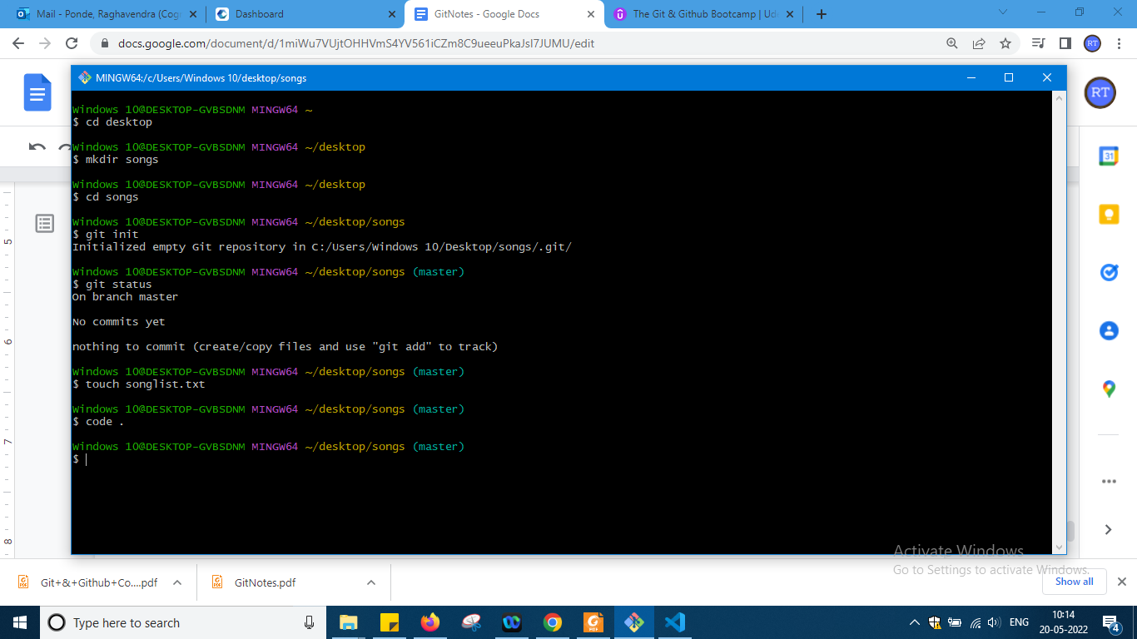

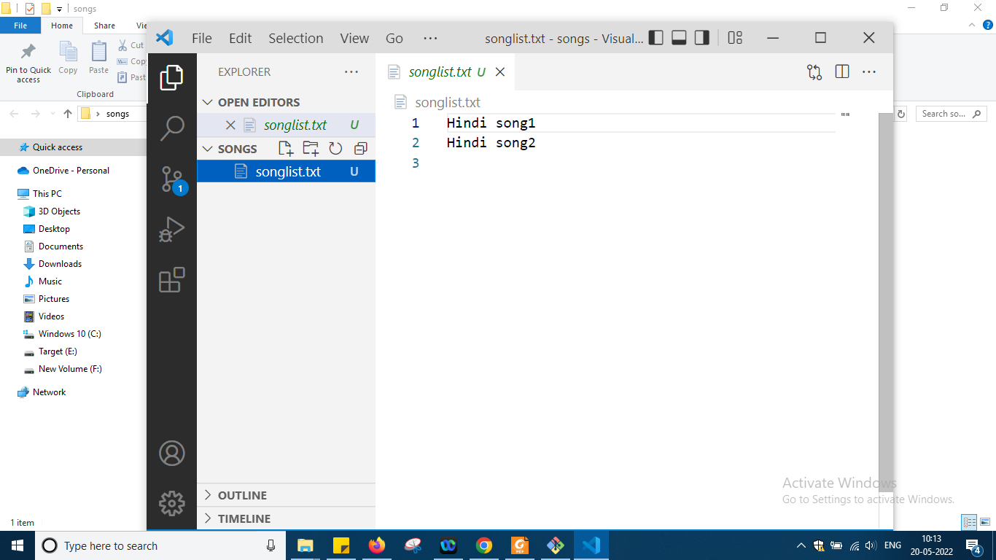

And next

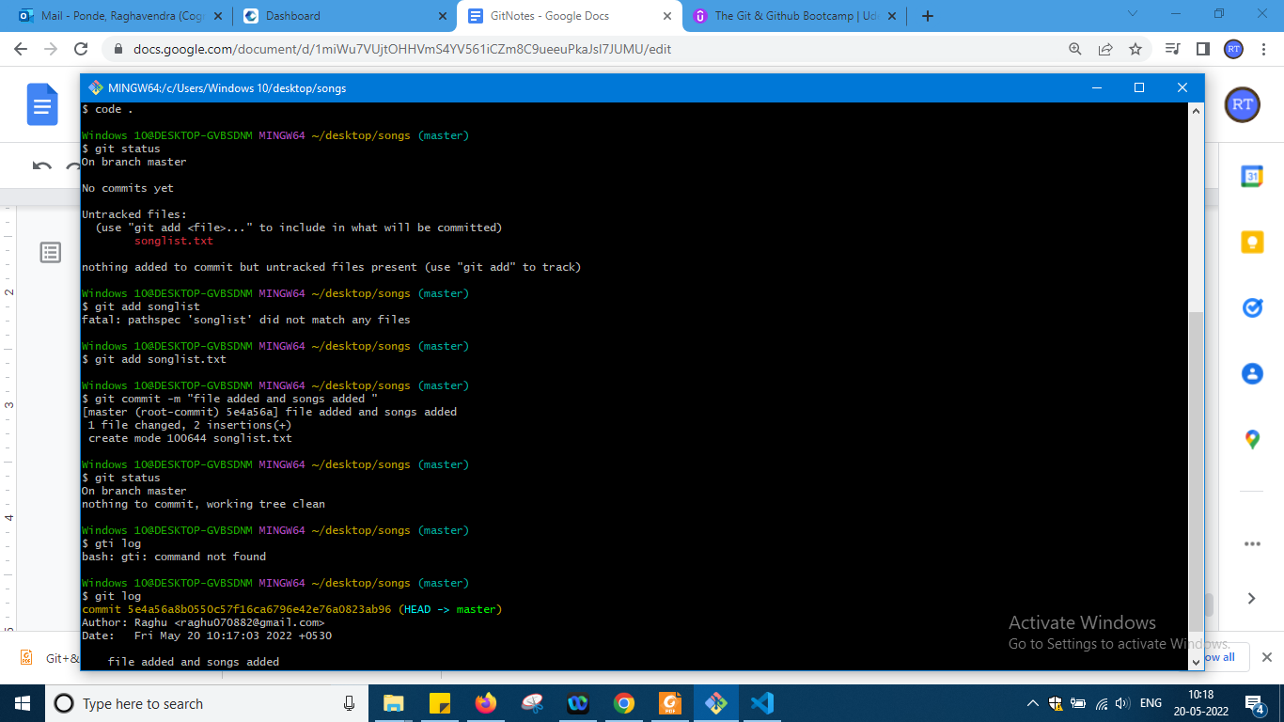

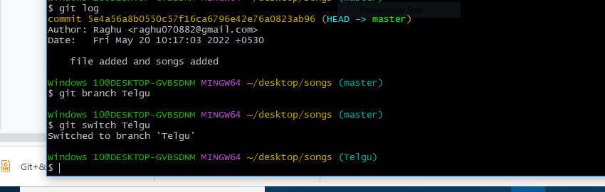

Done changes

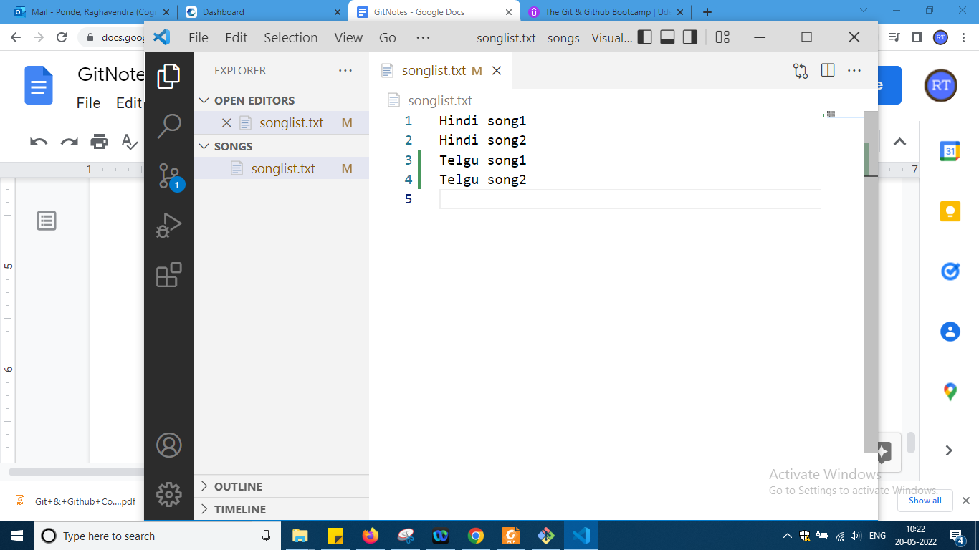

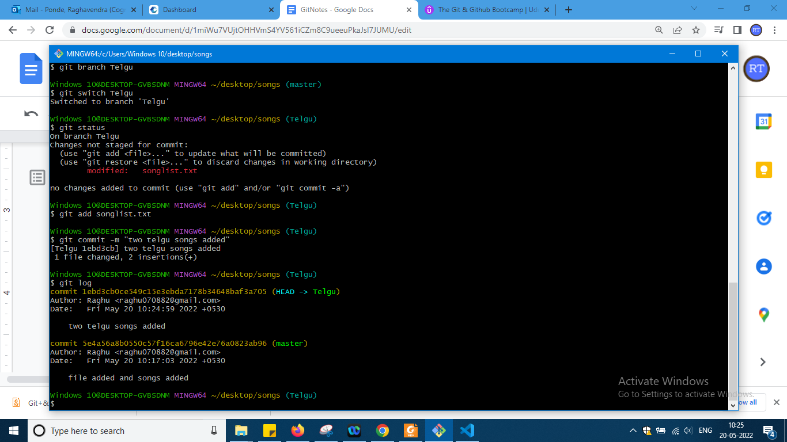

Now if i do merge it is fast forward now again i will go to master and there again some modification

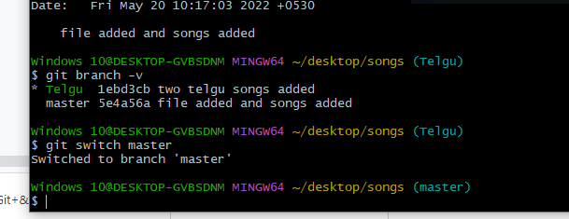

And right now

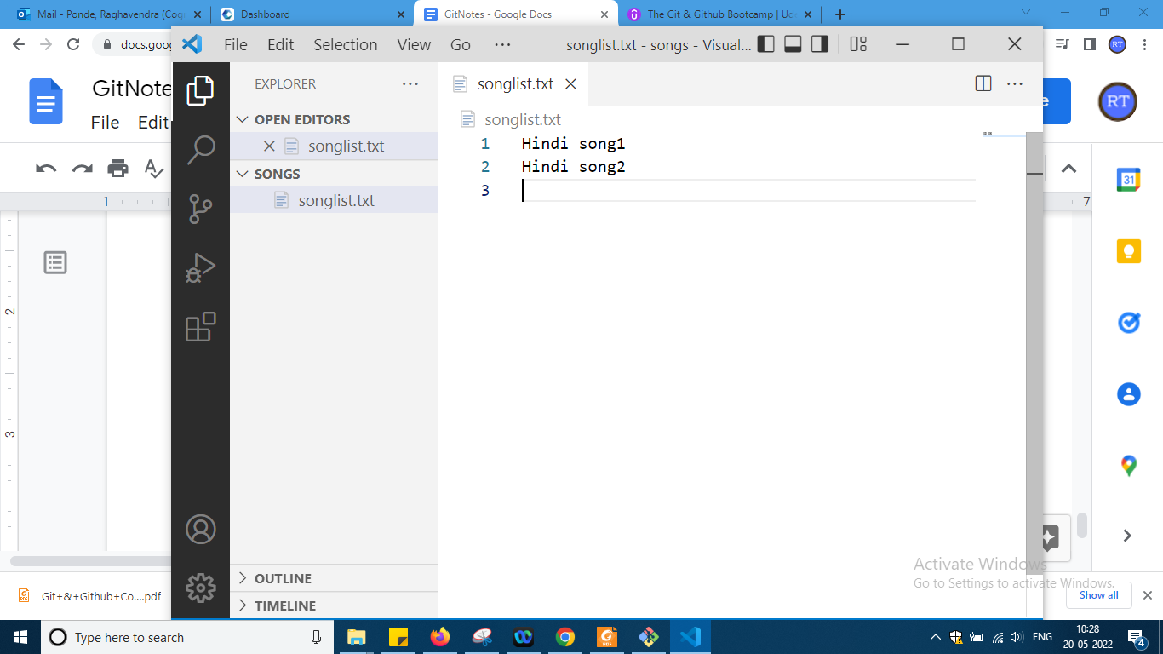

As it is master

Now add again two more hindi songs here

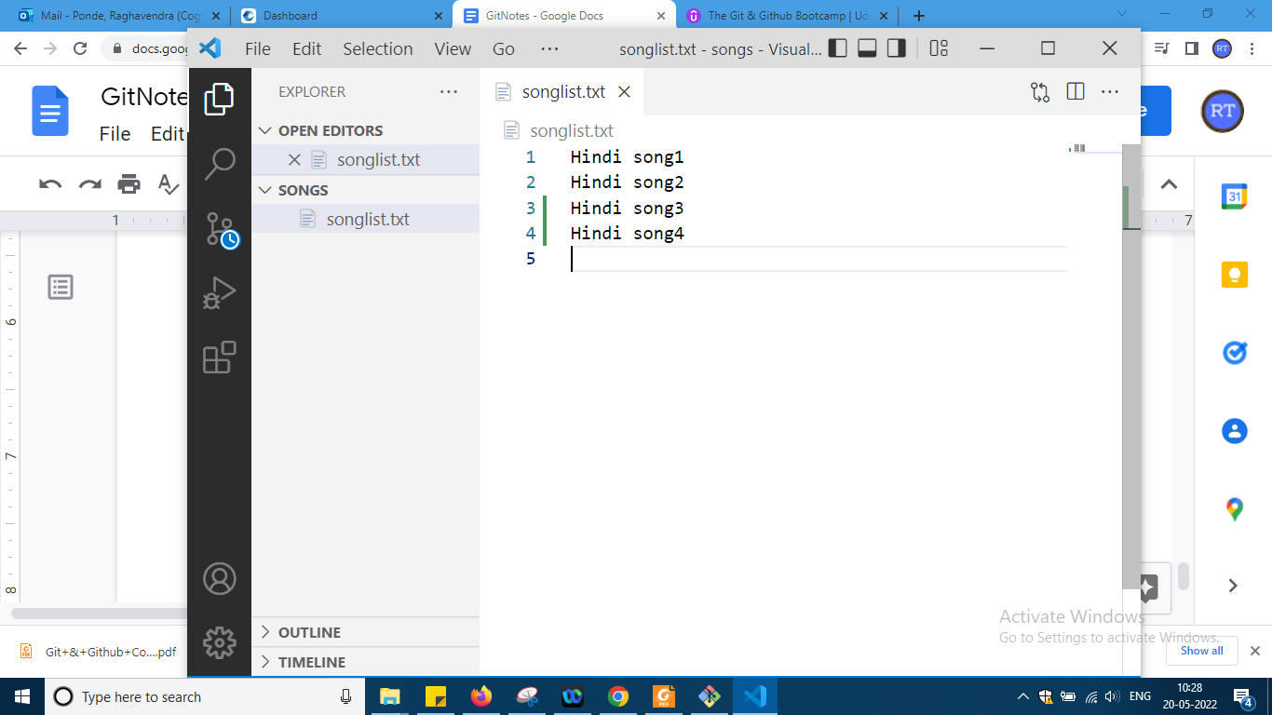

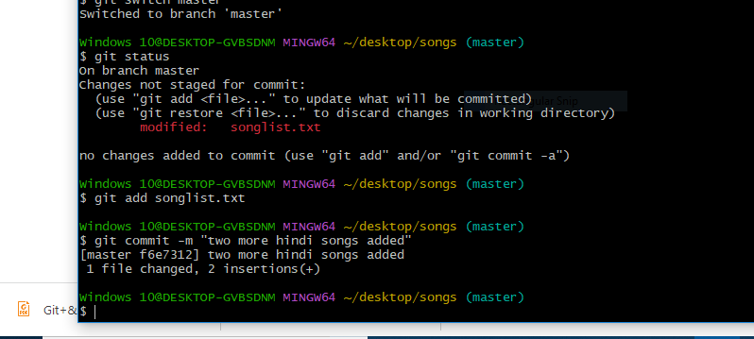

So now master dont know commits of telugu and telugu dont know master commits and u can see it from log

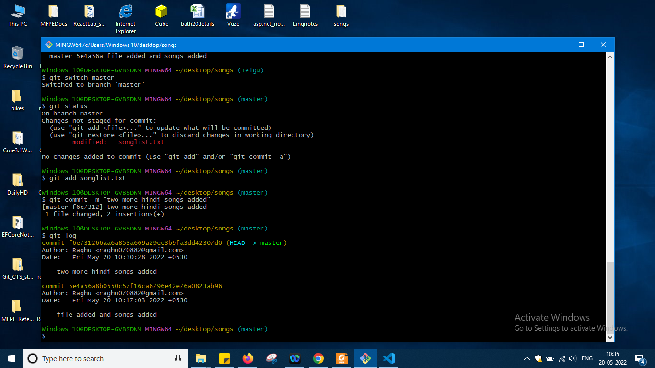

Now as i am in main branch only master branch from here i have to merge other branch telugu

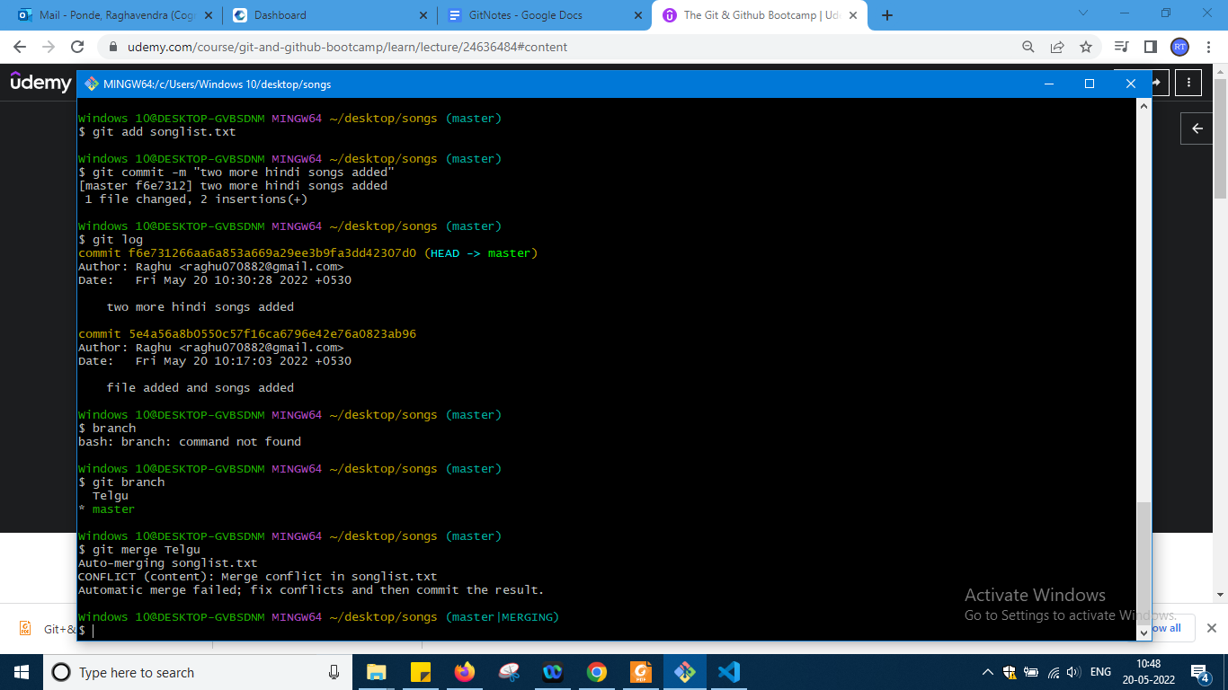

So it is showing me conflict here okay so what to do on this will check on later okay

And in the editor it is showing me like this

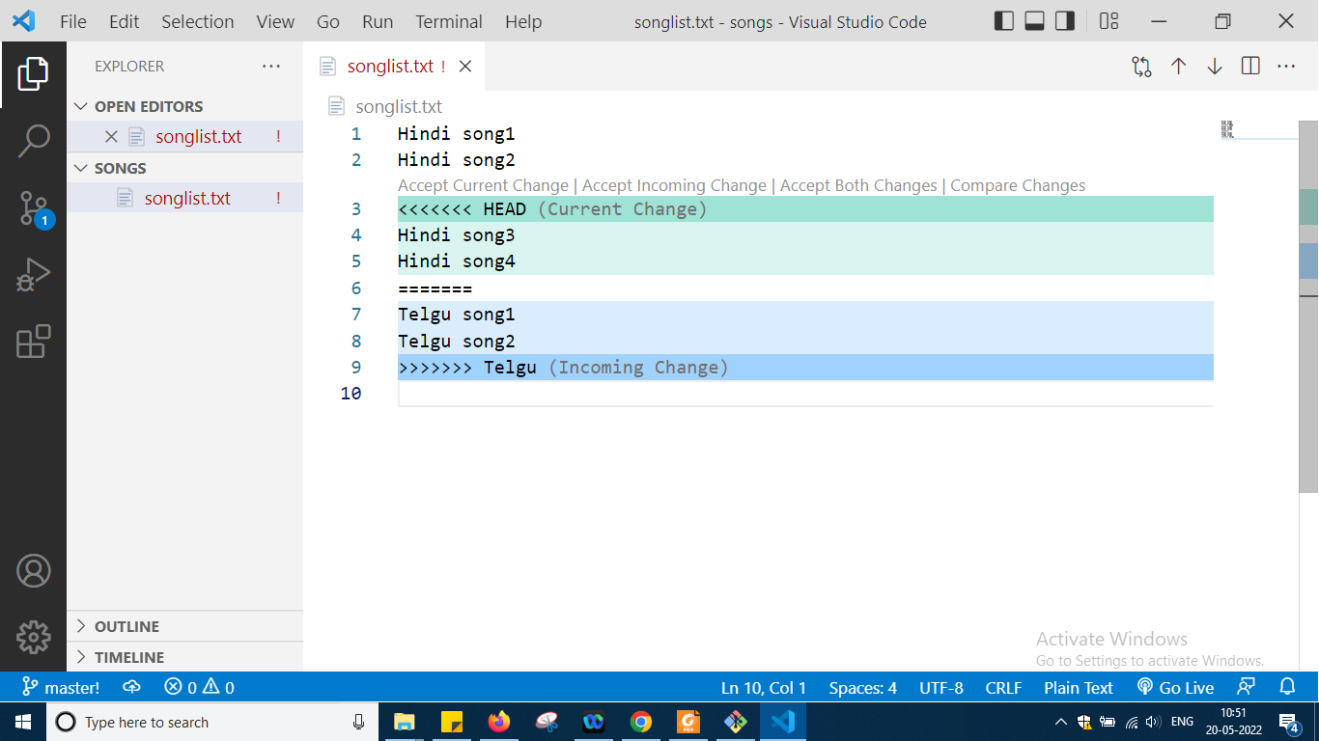

I am accepting both the changes

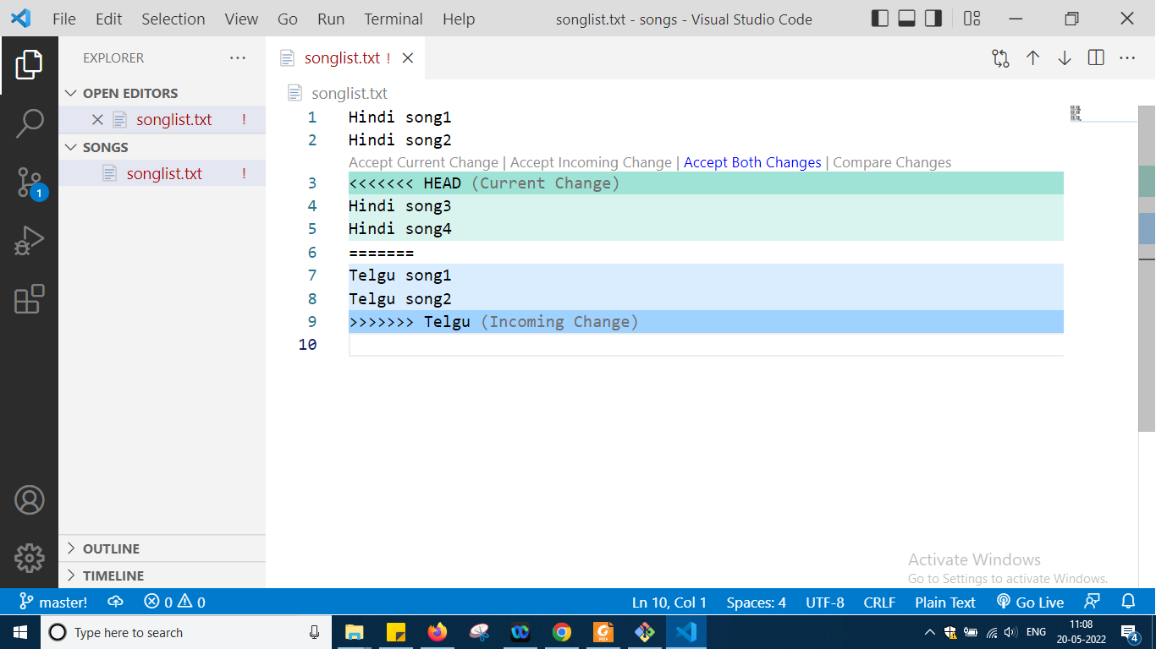

And now

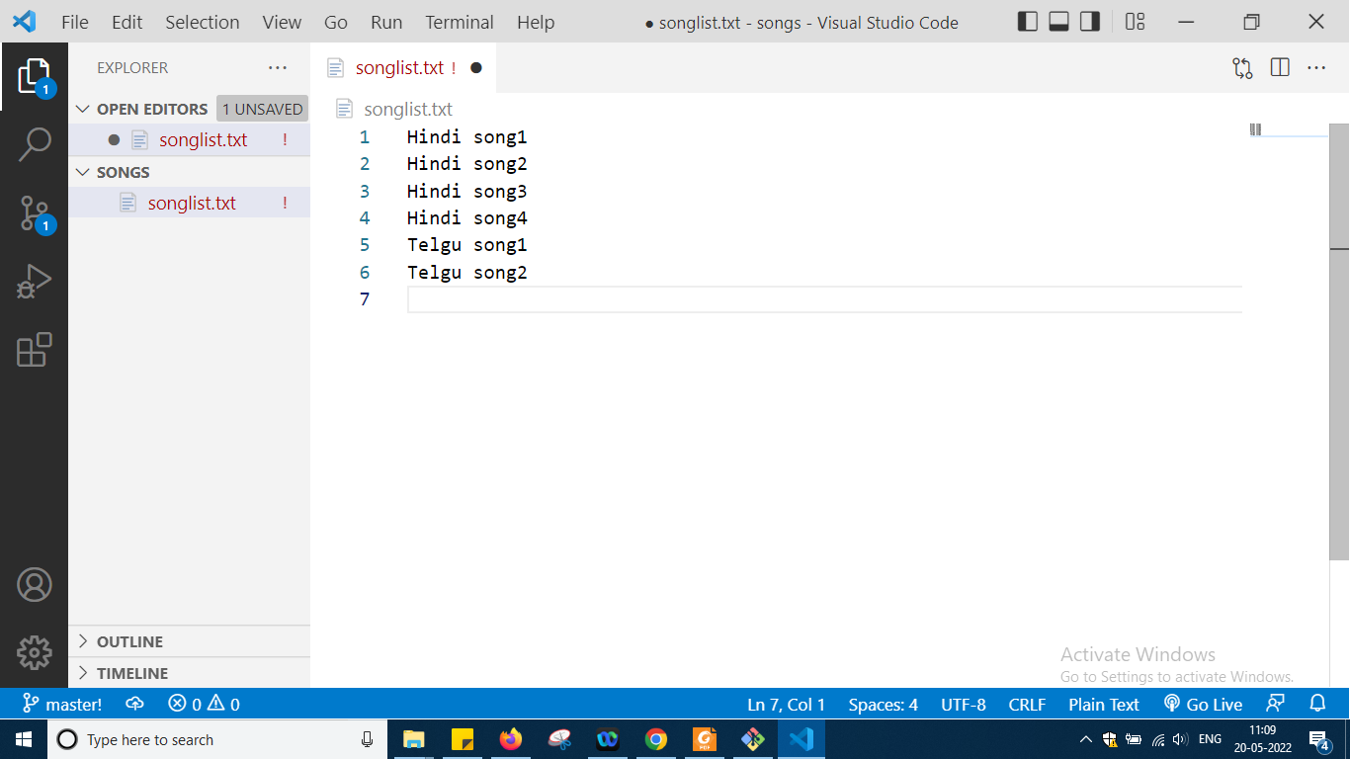

Like this i will get

So in this u can remove all header and manually modify the file as per your needs okay and save it and now it is like this

Next type git status

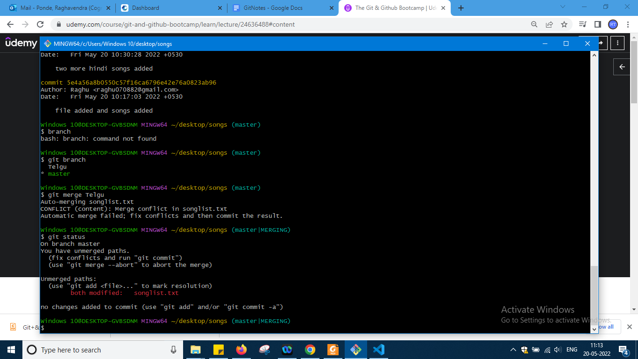

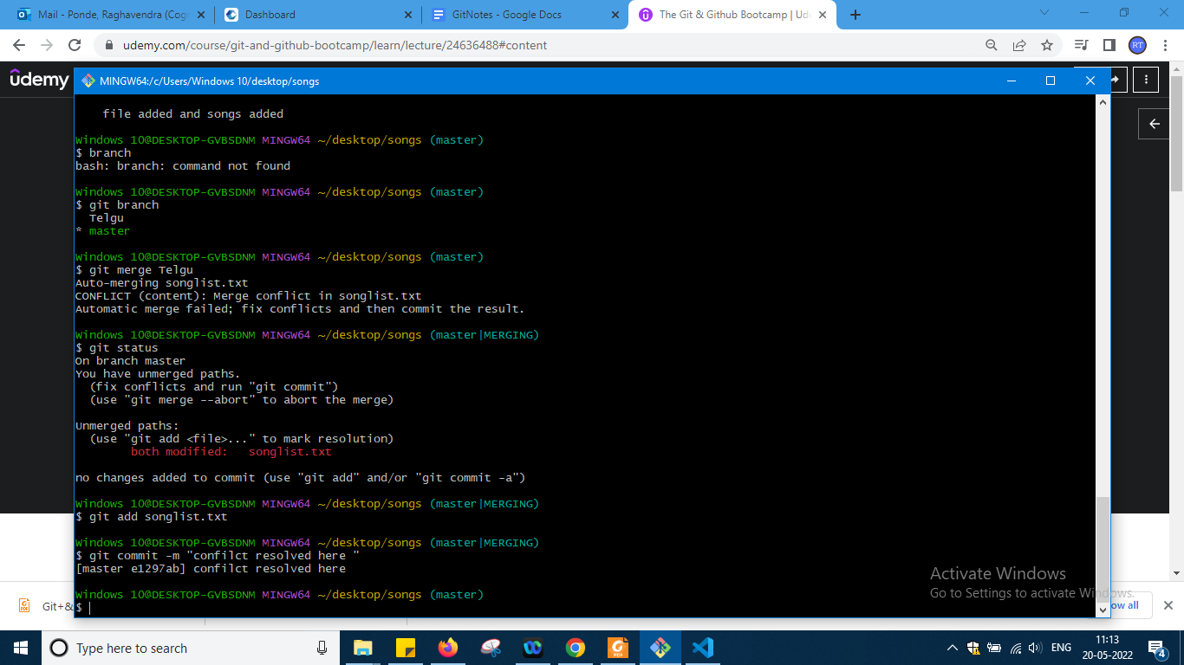

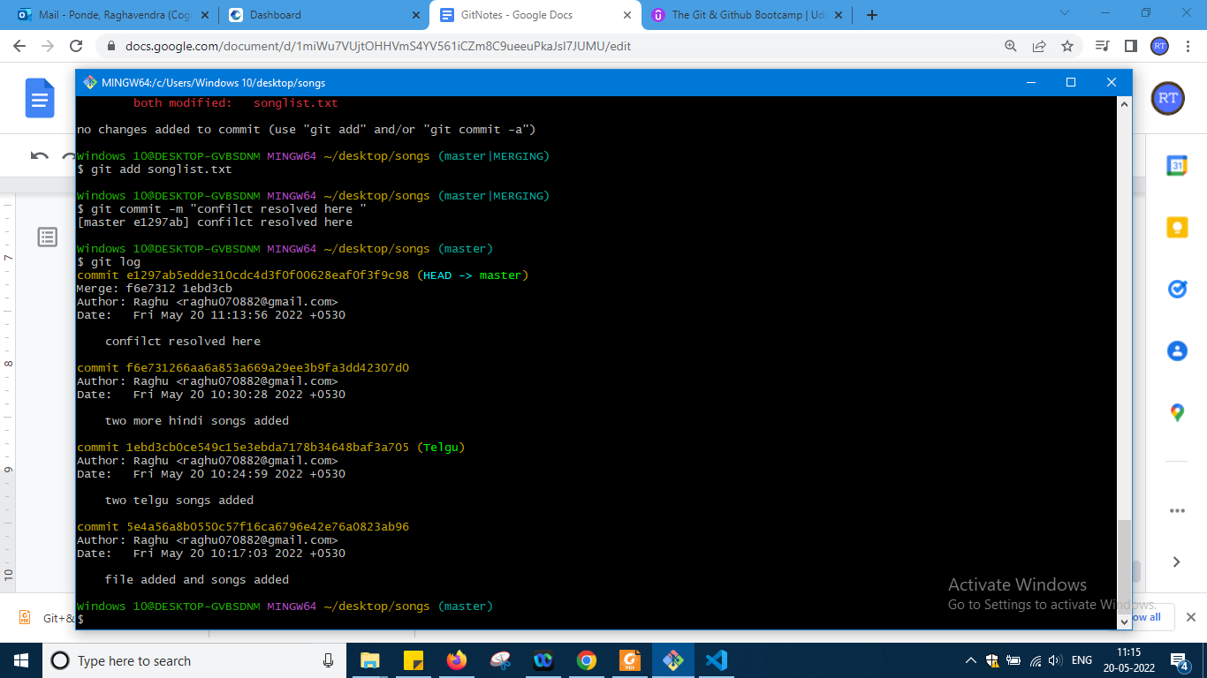

<https://www.notion.so/Git-Merging-Exercise-0236a17f04c847159a38f5efa978ce2c>

So above some merging exercise he has given u can check the video for that

So upto this enough to get basic idea of git and now i will move to git lab section

Some mark down extensions examples syntax

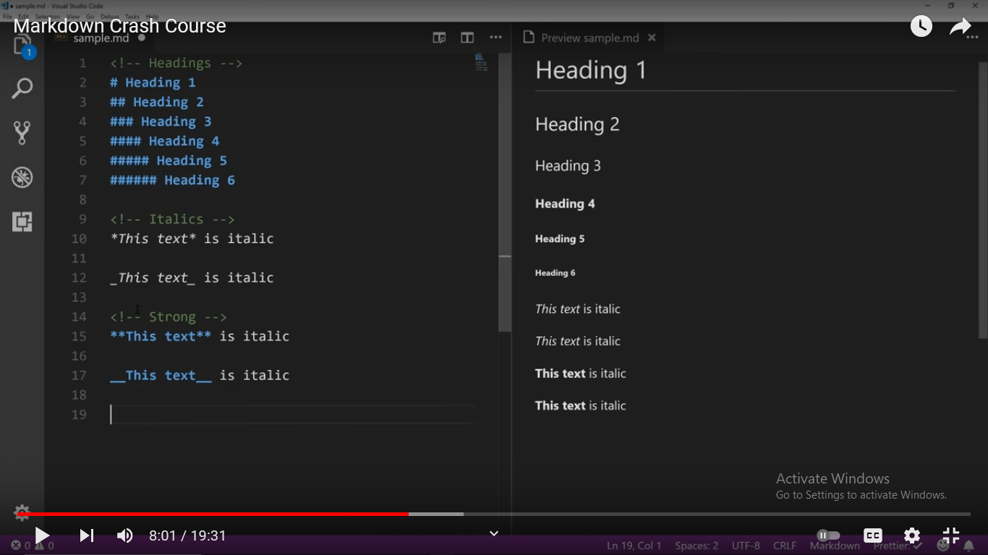

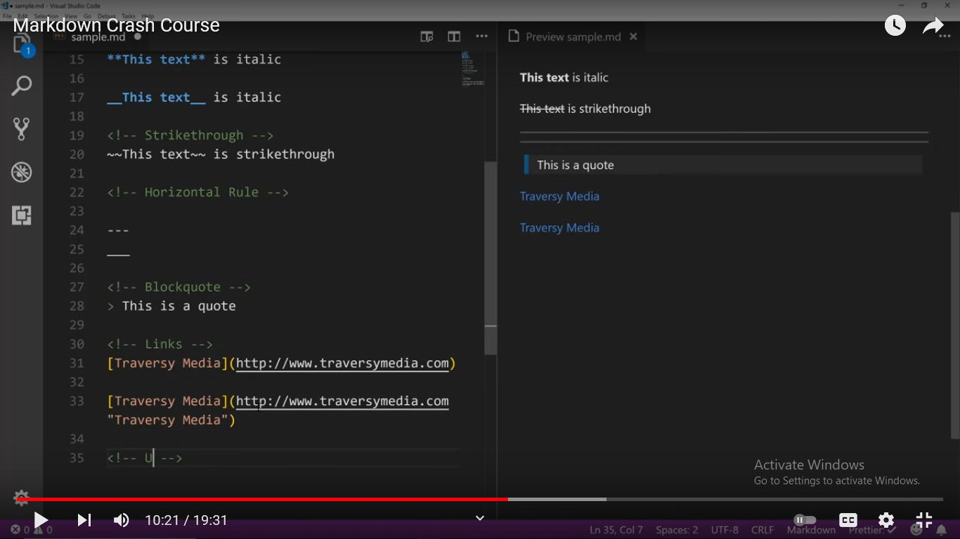

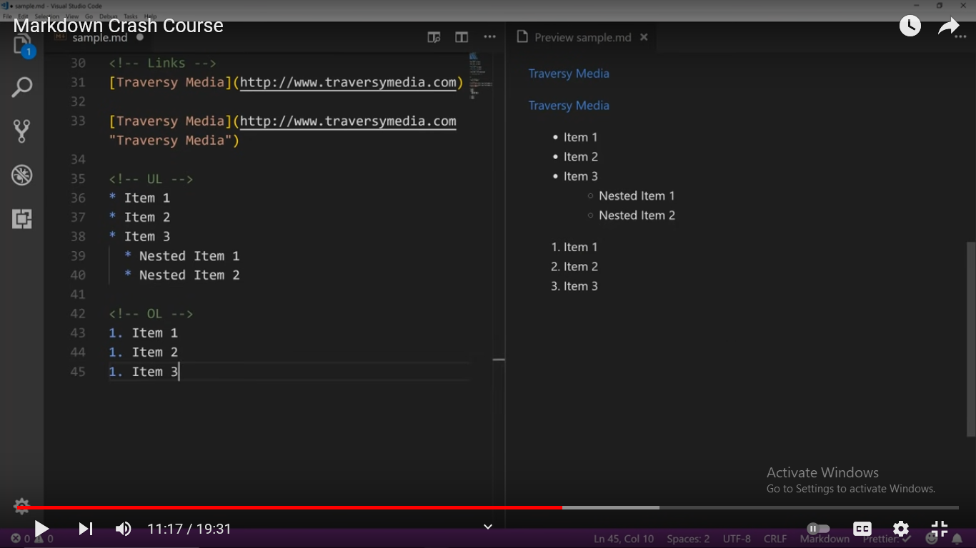

So these are some markdown basic things not required but now what I want to do is what u have done in git locally I want to do the same in git lab online means online I want to create a project or u can say folder online and in that adding files or anything default is there modifying and doing commit to them and then creating branch and merging branch etc stuff okay

GitLab Notes :

------------------

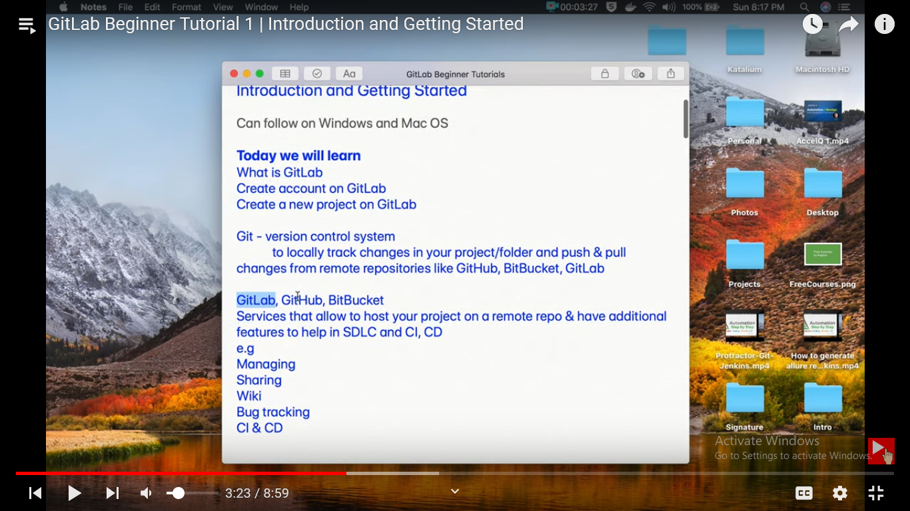

Now first create an account here

Go to gitlab.com

After typing in google

<https://about.gitlab.com/>

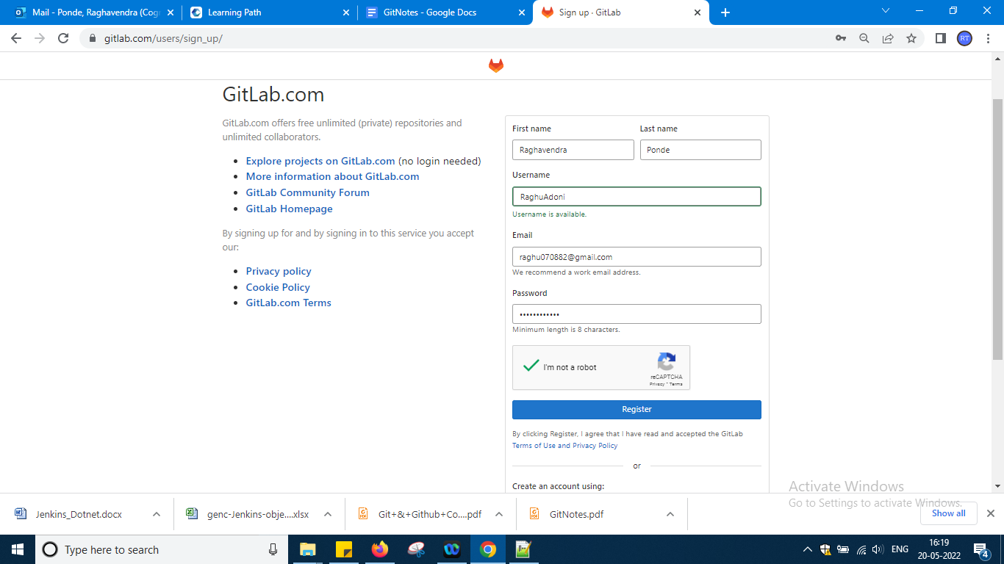

Password is RaghuGit#123

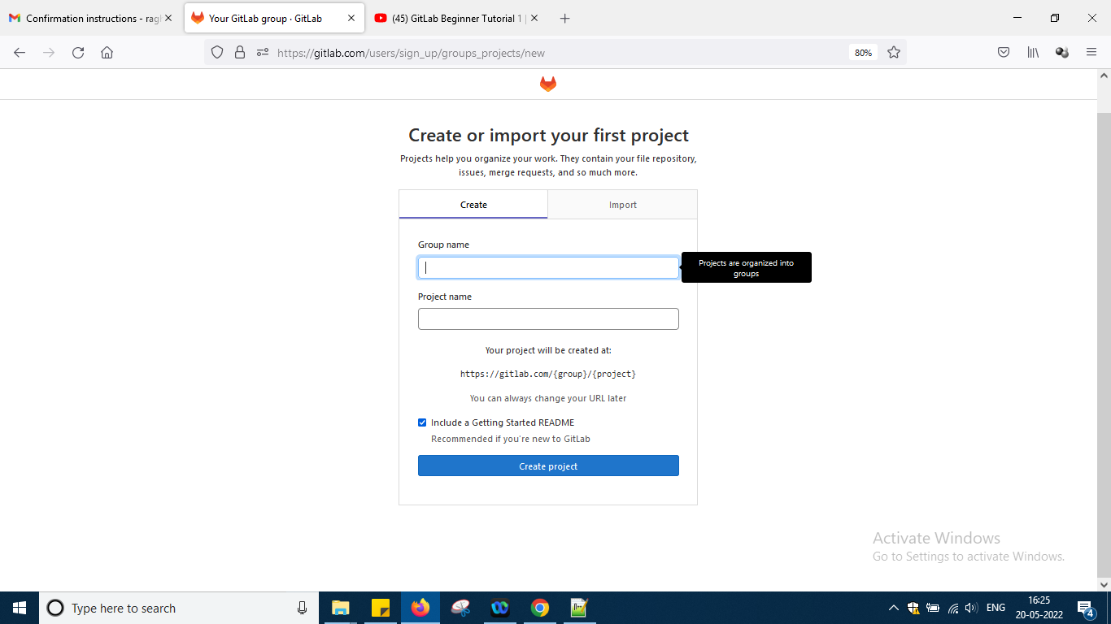

Ask for project so

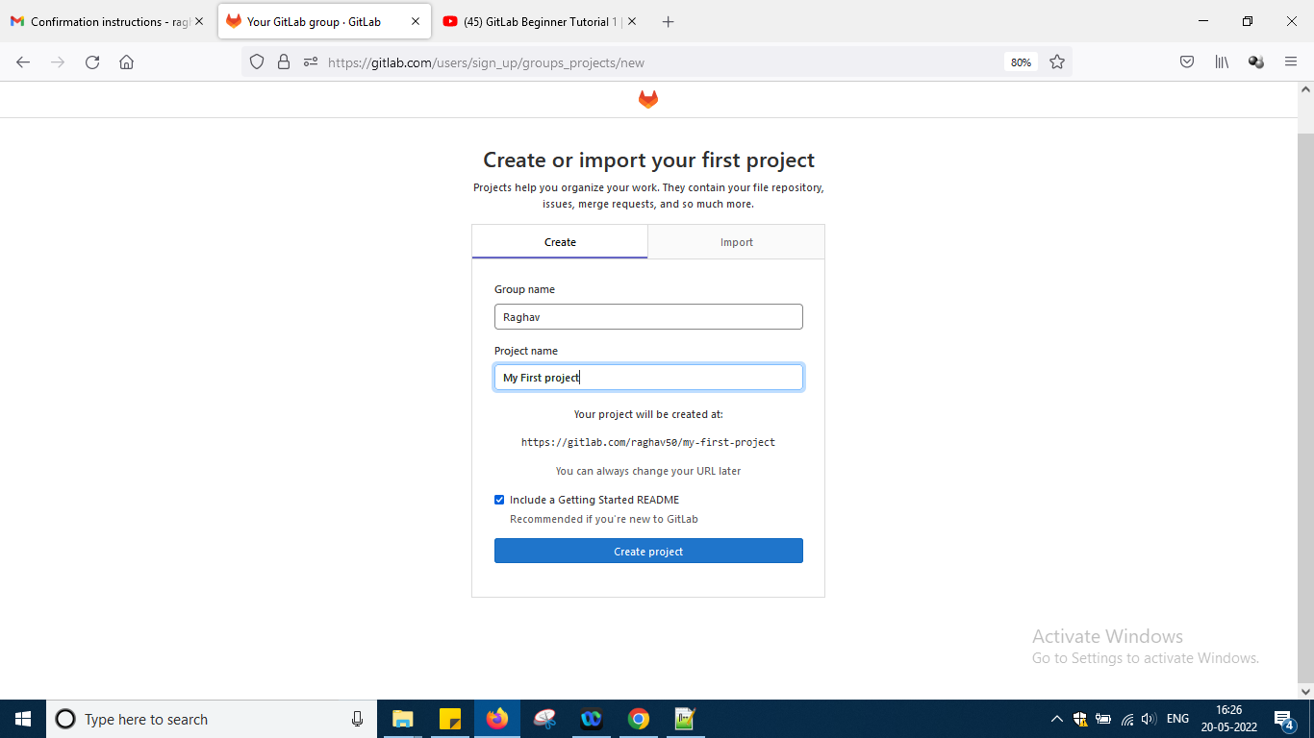

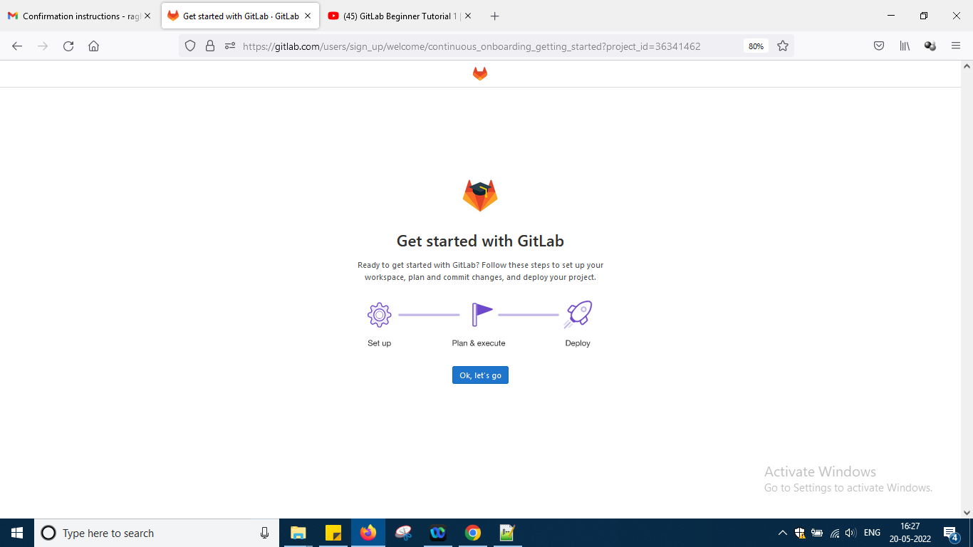

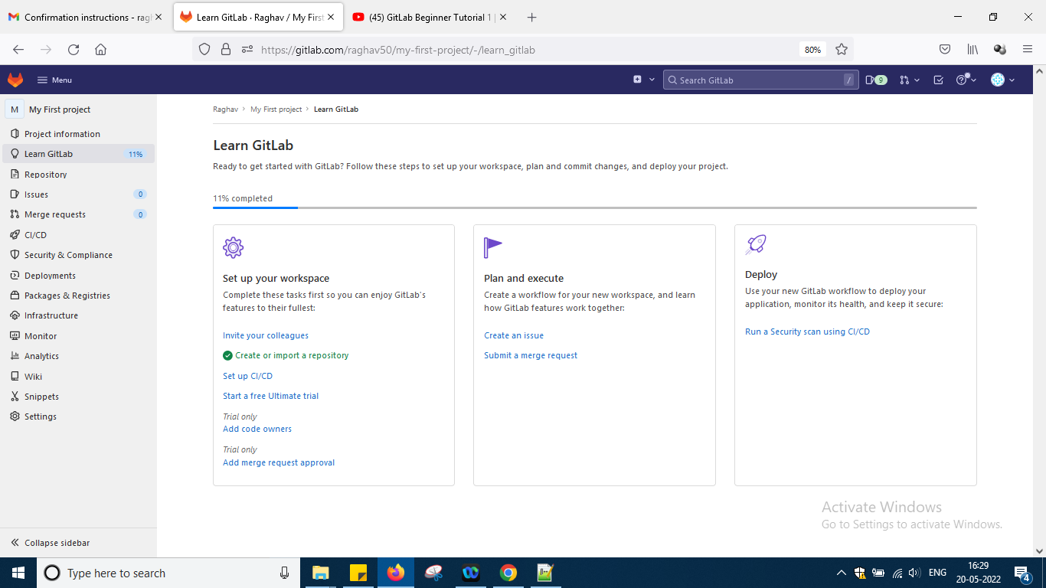

Here some notes have been provided by them if u want go through otherwise this notes is fine okay

Go back little

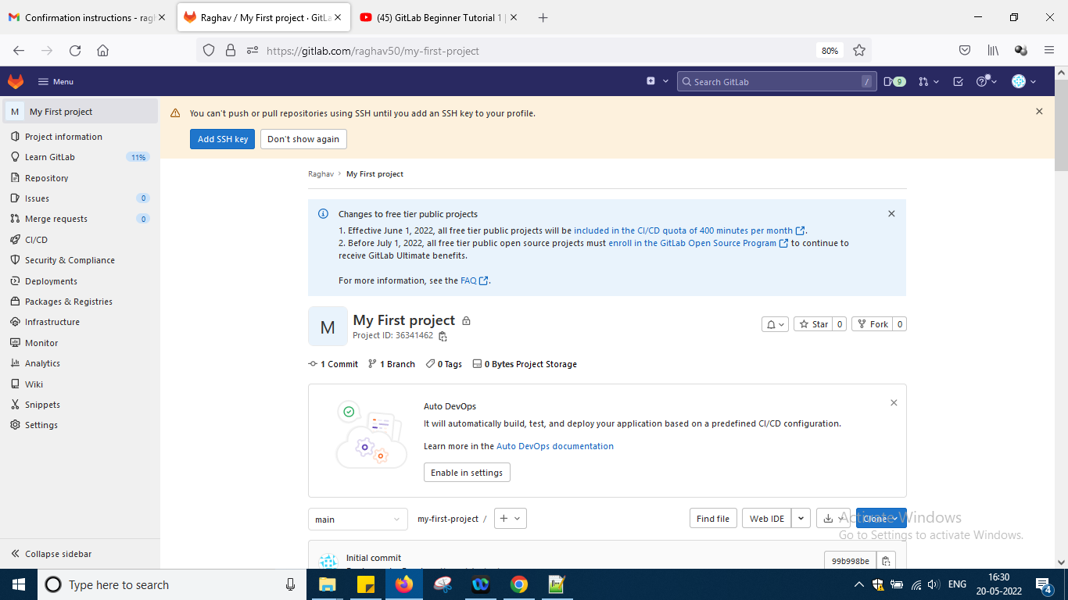

Now as per the video his name is markdown something my name is myfirstproject u can say so now move forward as per the video

Now again i am creating a new project as per his way in another way while regsierign i have done but again i want to do it okay

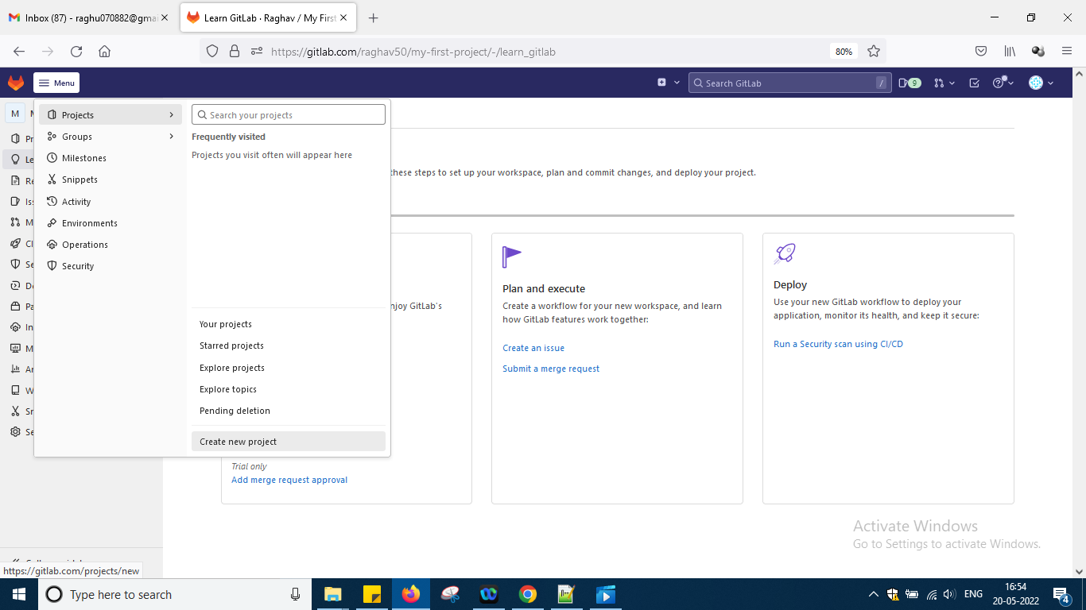

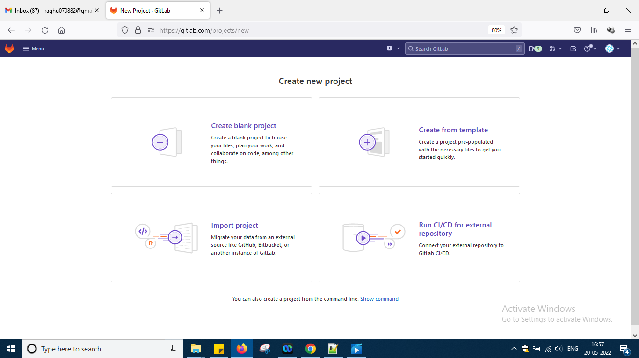

Going with the option blank project

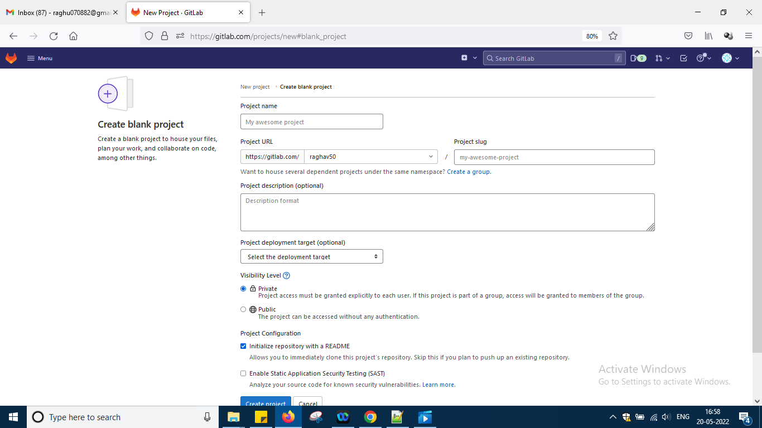

Fill the details and click create project

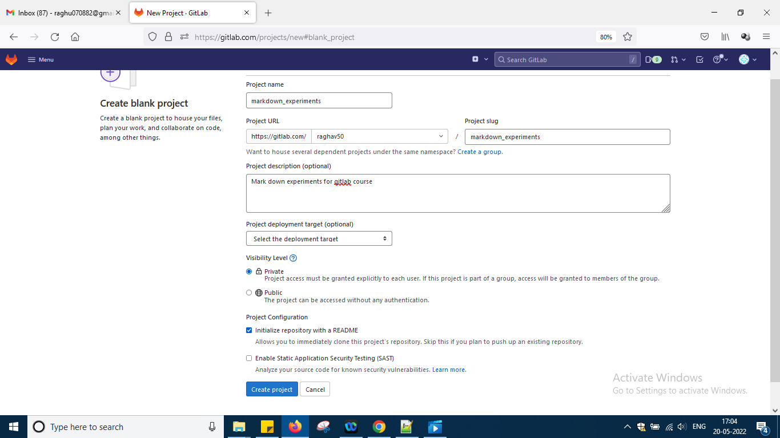

And in this we have option where to deploy also target

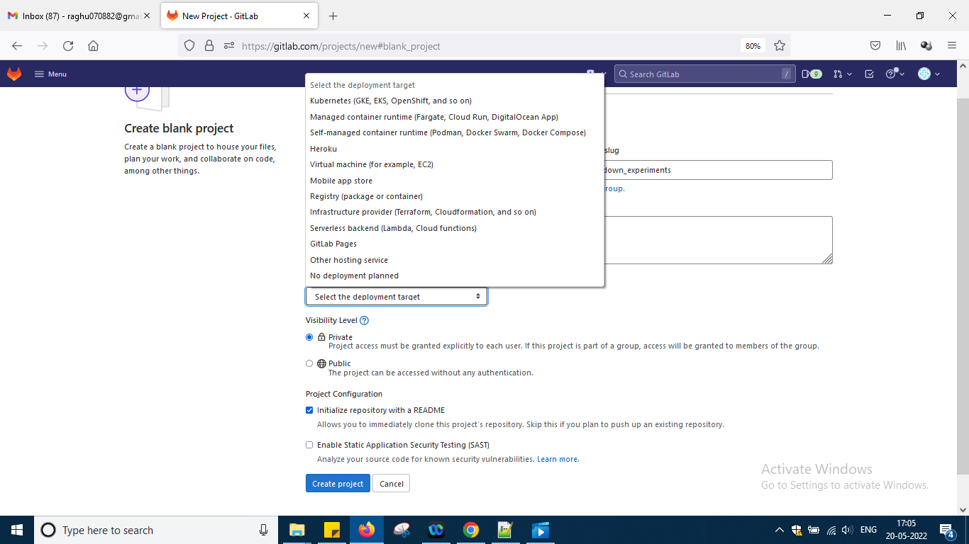

But not required just say create project

So now here another project is created like this

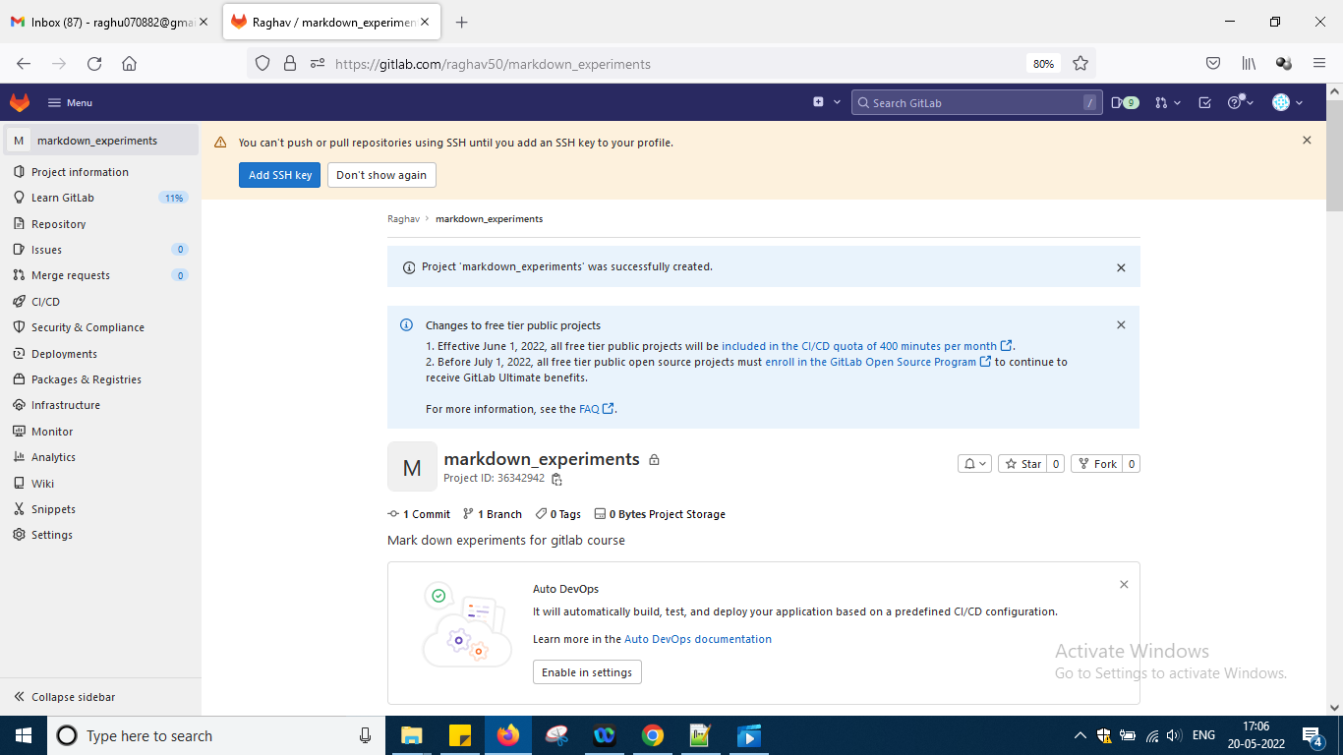

Now go to readme file and edit it and write the following stuff into it like this u can check the video for how to edit so git what i have learned same thing in gitlab i am doing the basics okay

Somewhere options will be there in gitlab as new version i am using it and video is little bit old only not too old okay u just check all possibilities menu options it will be there

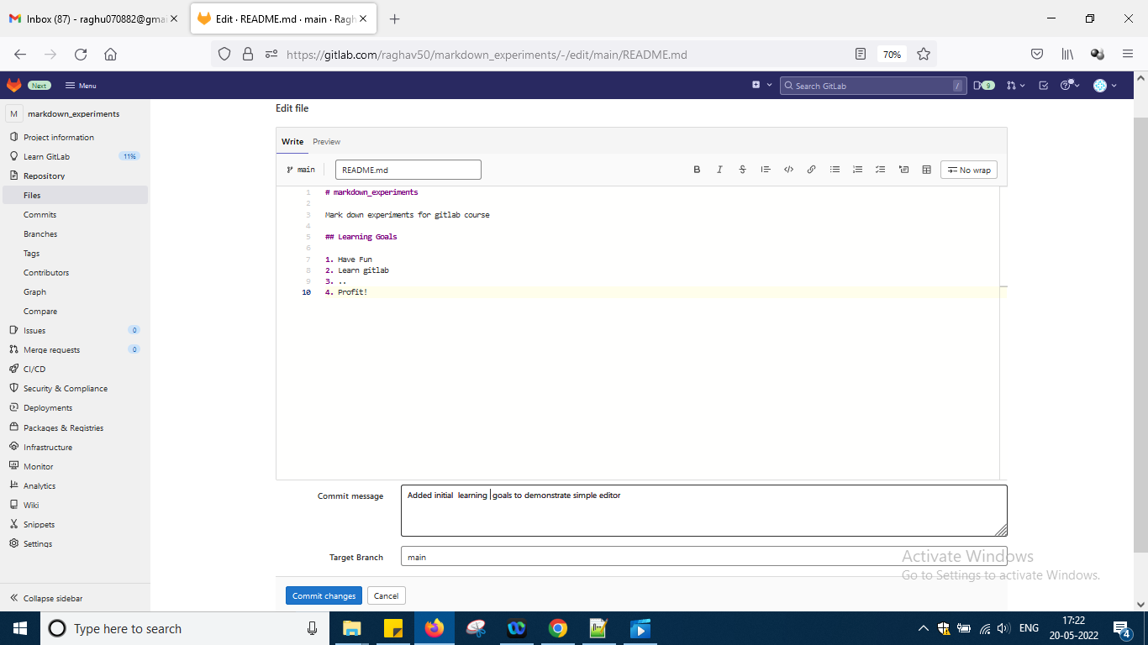

So some coding as per markdown written and then added commit and i am in main branch and say commit changes

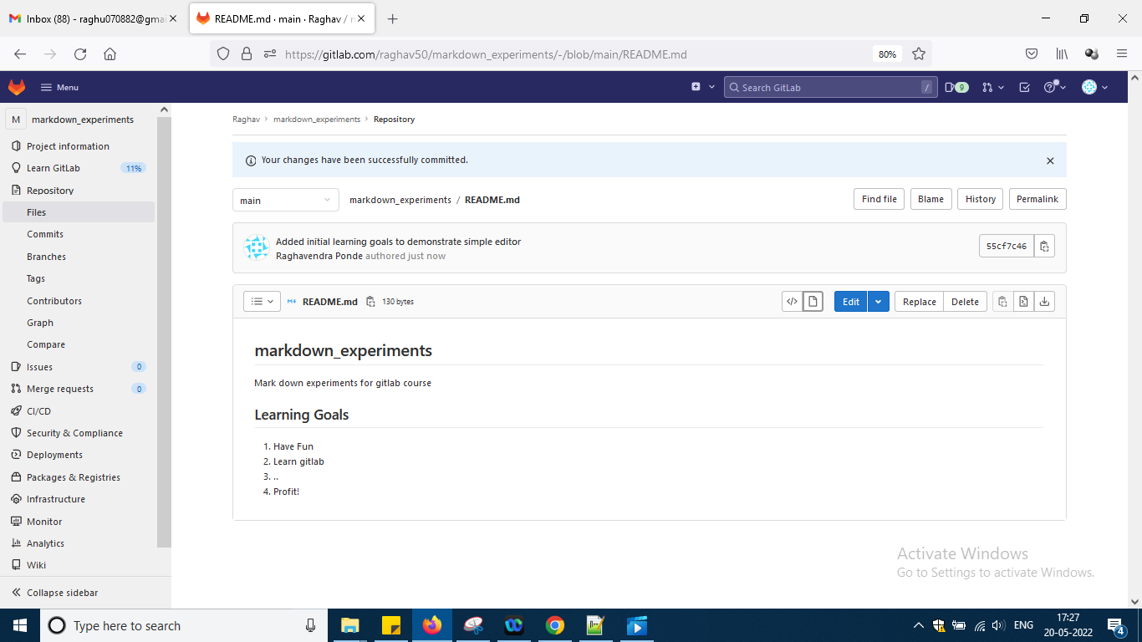

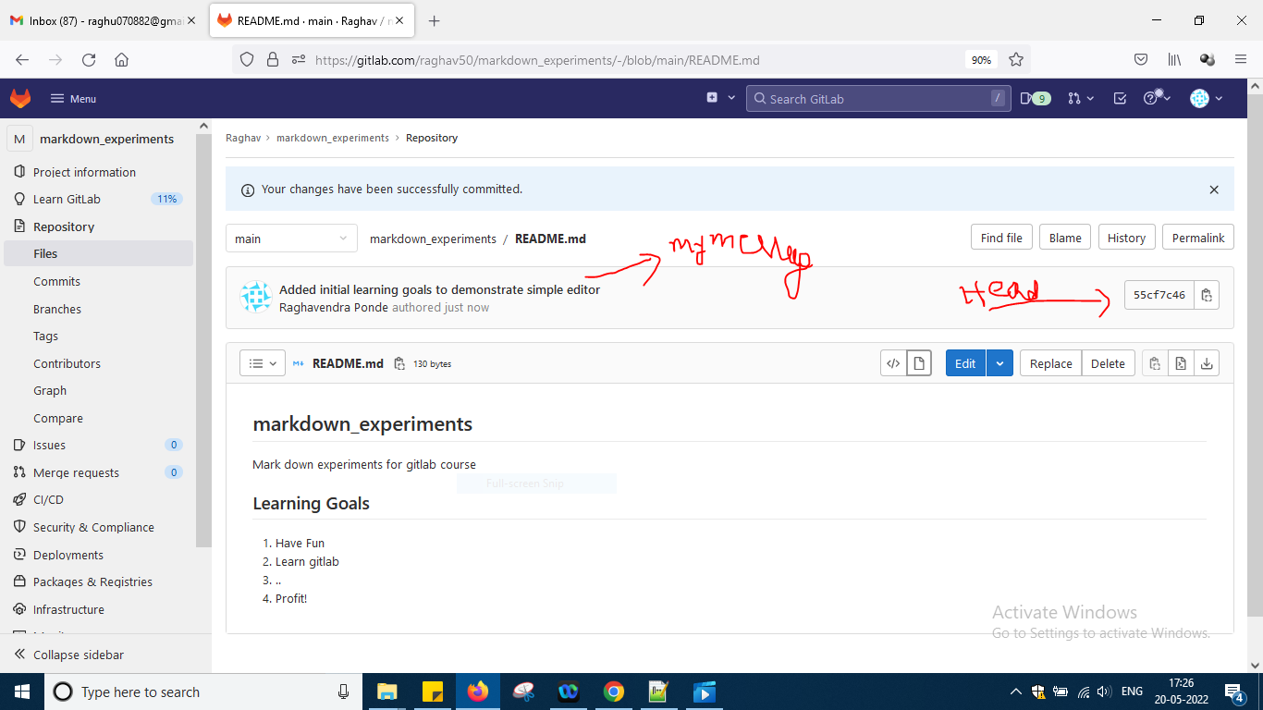

To know more detail click blame button over there

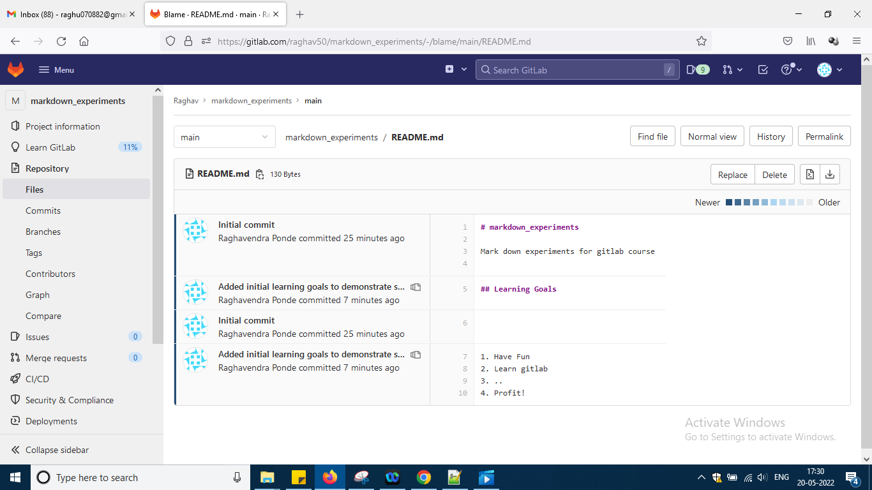

So in more detail we can check what is related to what okay

Now let us create one branch now …

Go to repsoitories and branches okay

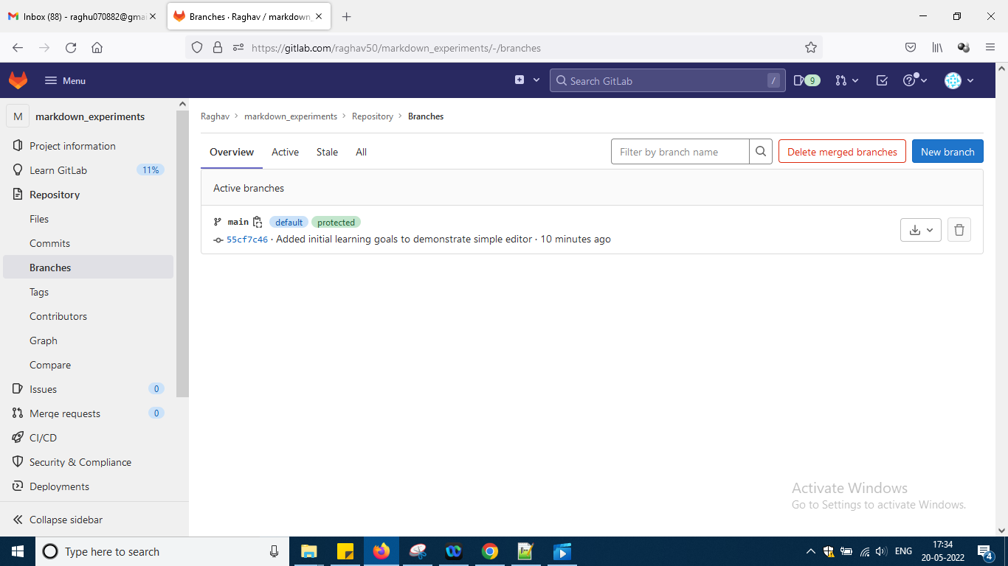

Ckcik that 8 character code

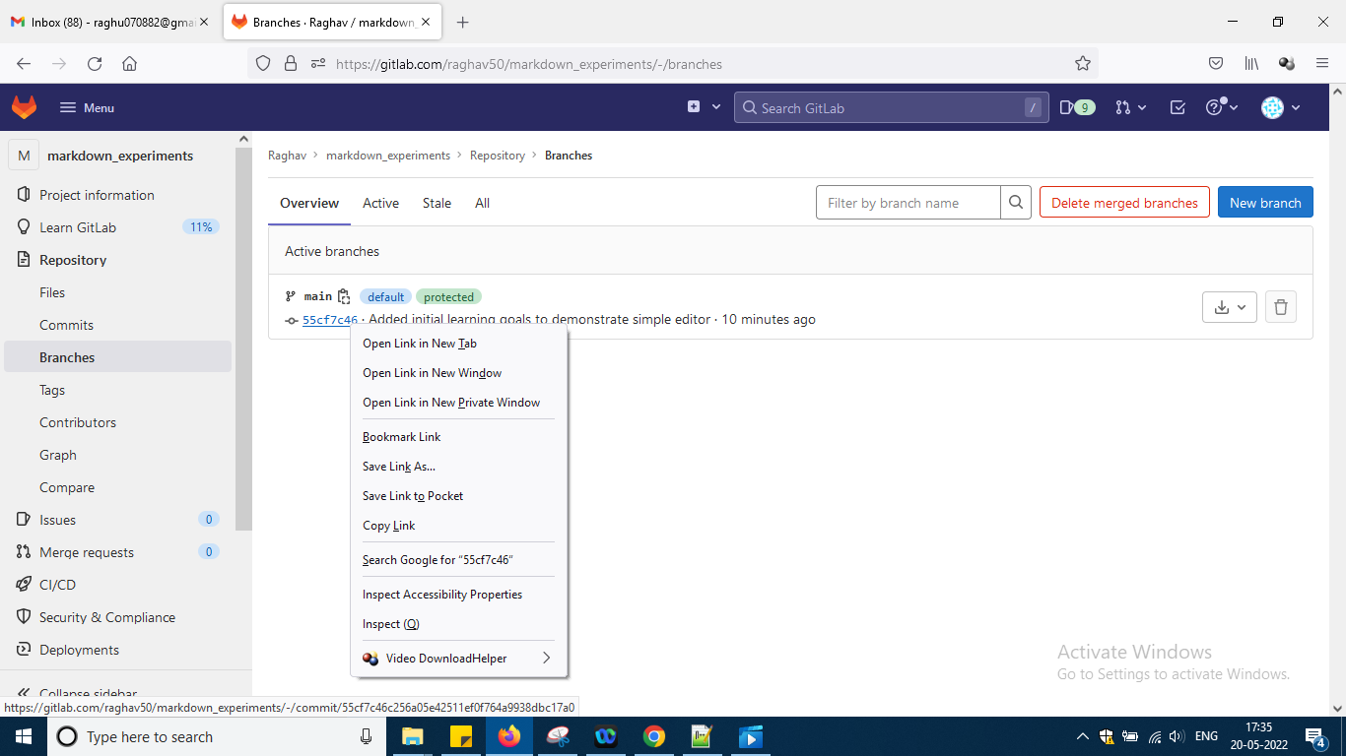

In the new tab after link gets open okay

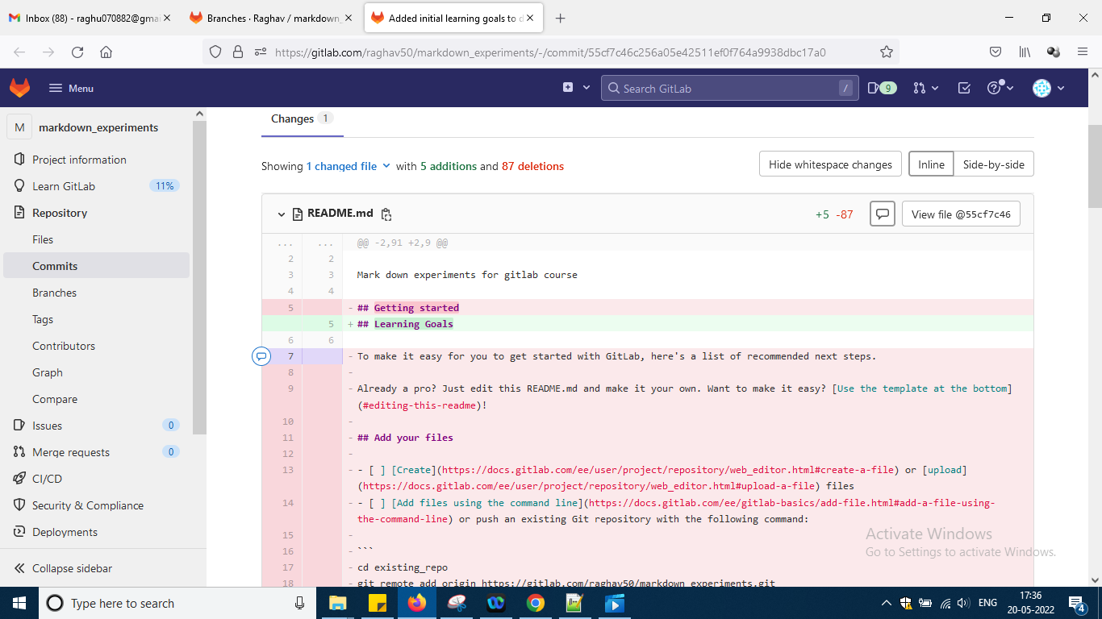

And path is like this

<https://gitlab.com/raghav50/markdown_experiments/-/commit/55cf7c46c256a05e42511ef0f764a9938dbc17a0>

So these are the ids for your commit for every small commit also it will create the cmmit/hash code code as above

Go back to main branch

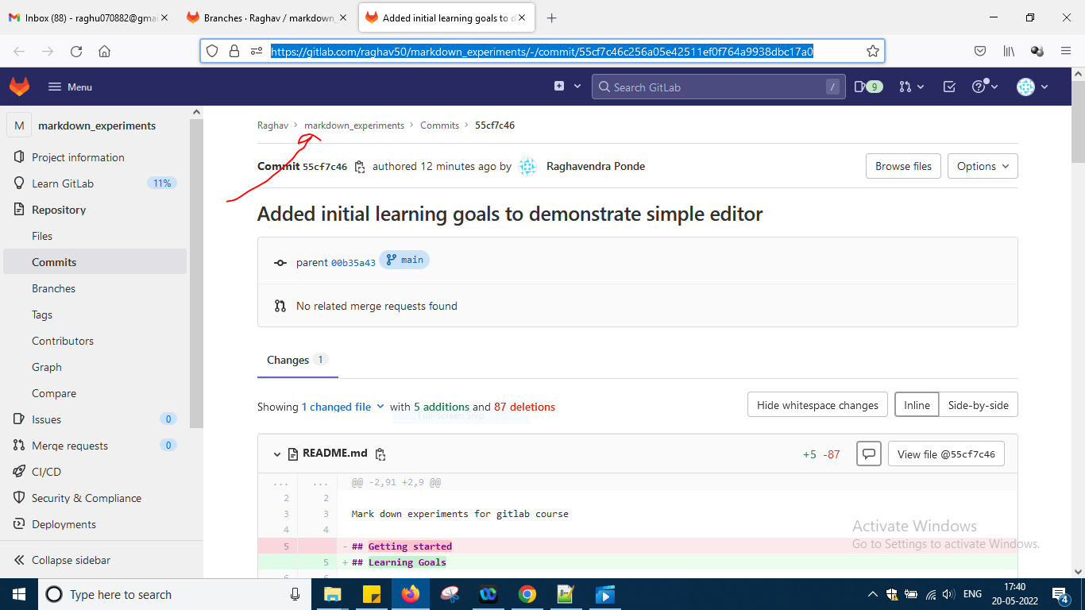

And then same repositories and branches and now try to create a new branch

Click button new branch and name is changes

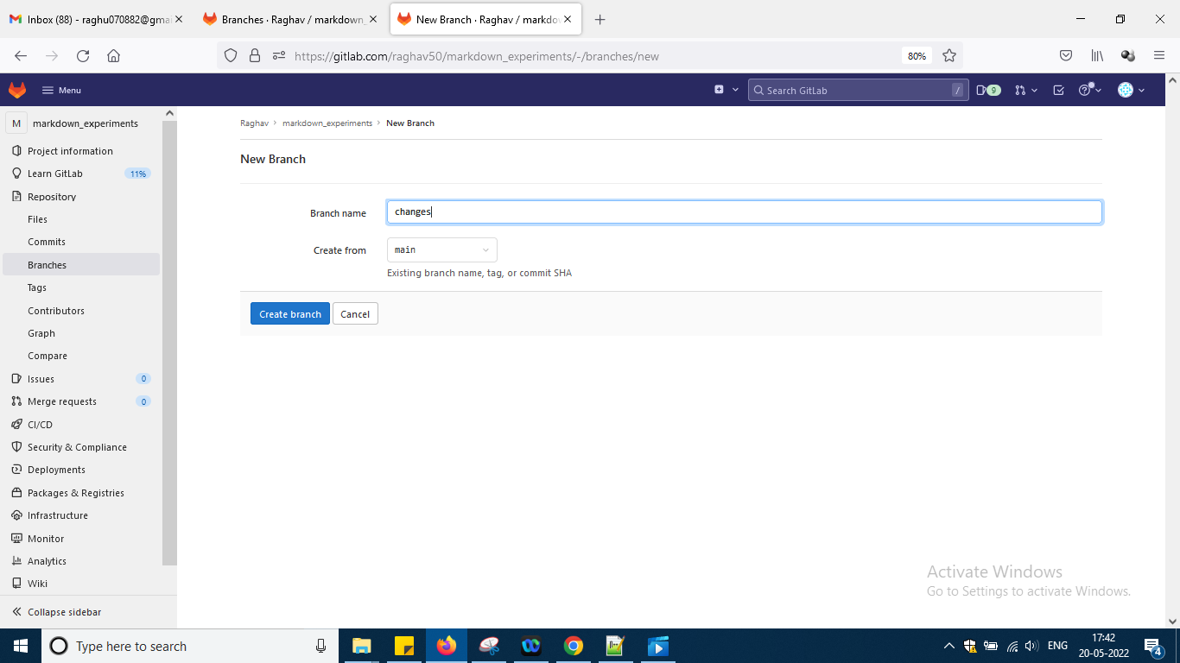

Say create branch

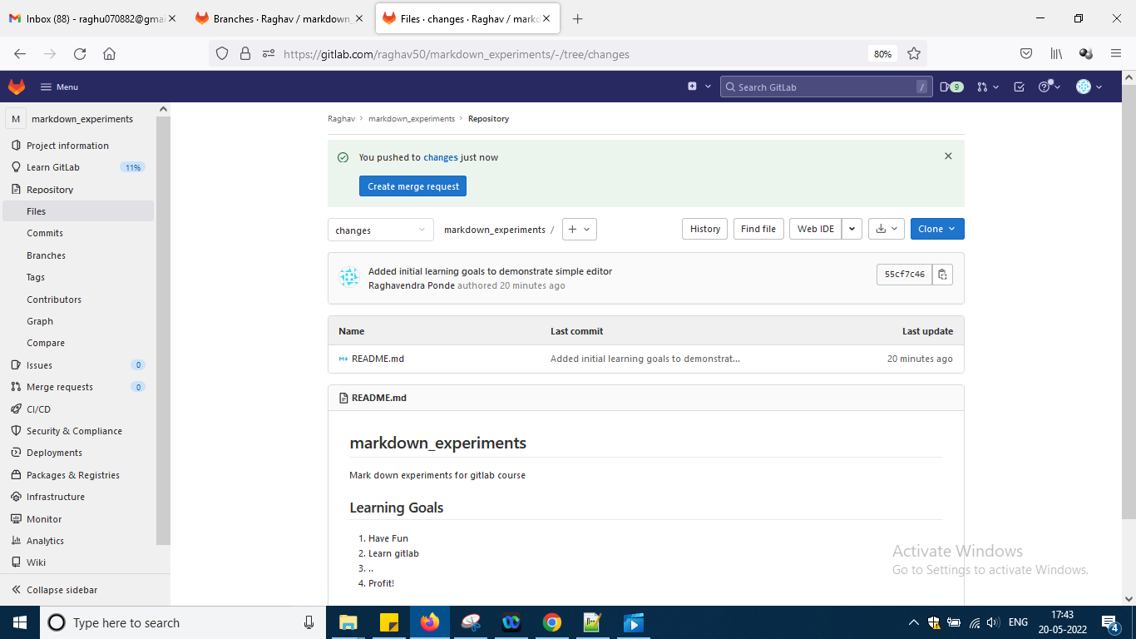

Now go back to branches view nav left section and

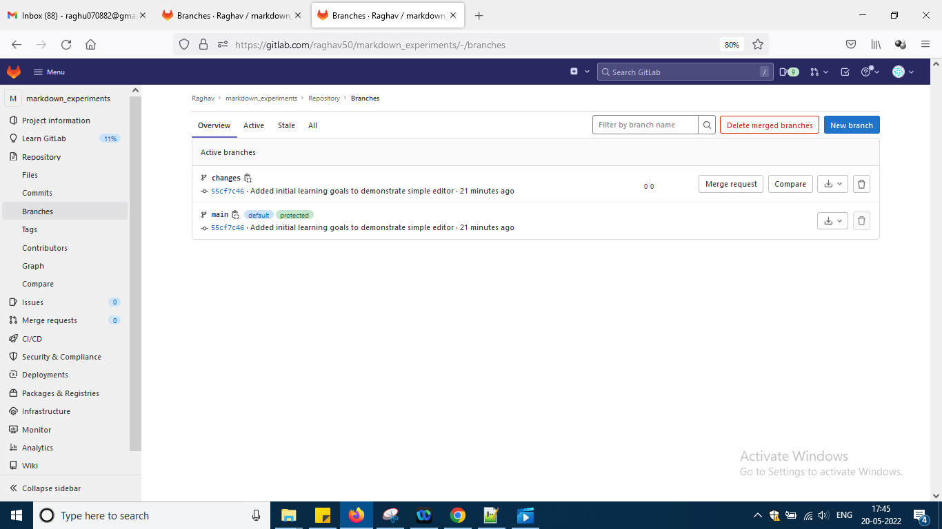

As u can see both are having same 8 char id as still in branch i have not done or added and or commit just empty branch created after doing that id will change

Now go to markdown experiments and again click readme.md file and now change branch to changes okay

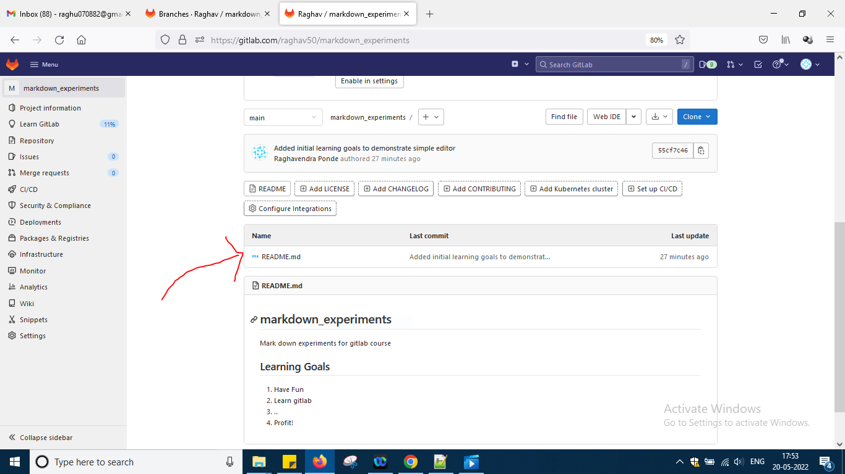

Now u are in main branch

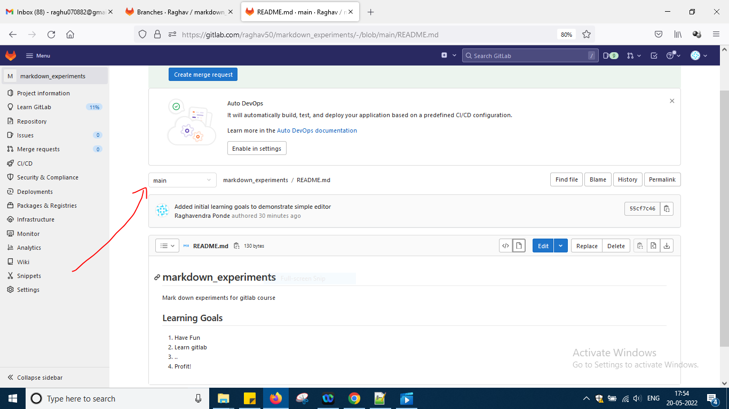

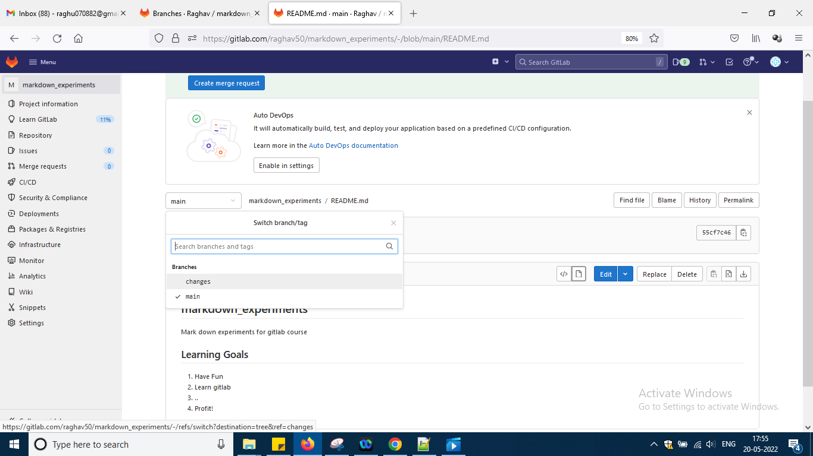

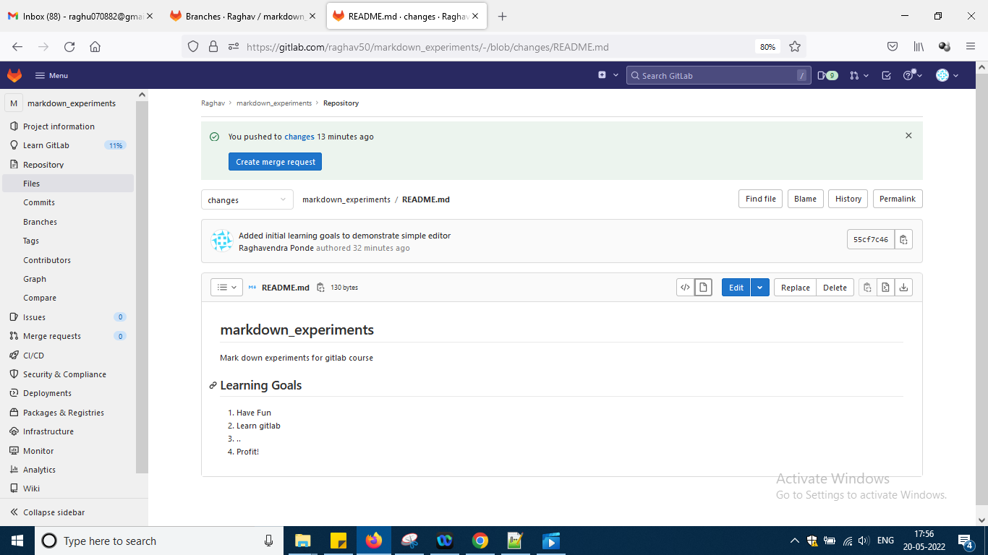

So now i am in changes okay

Now select to open in web ide

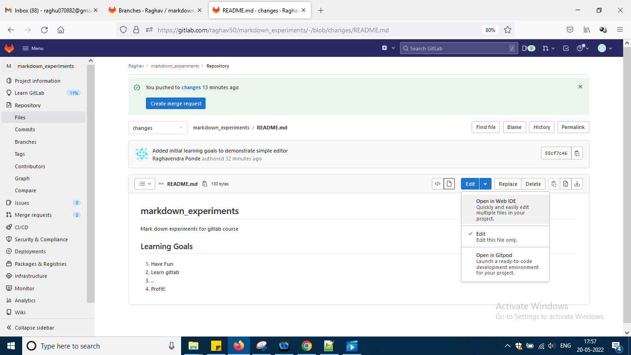

Again say open in web

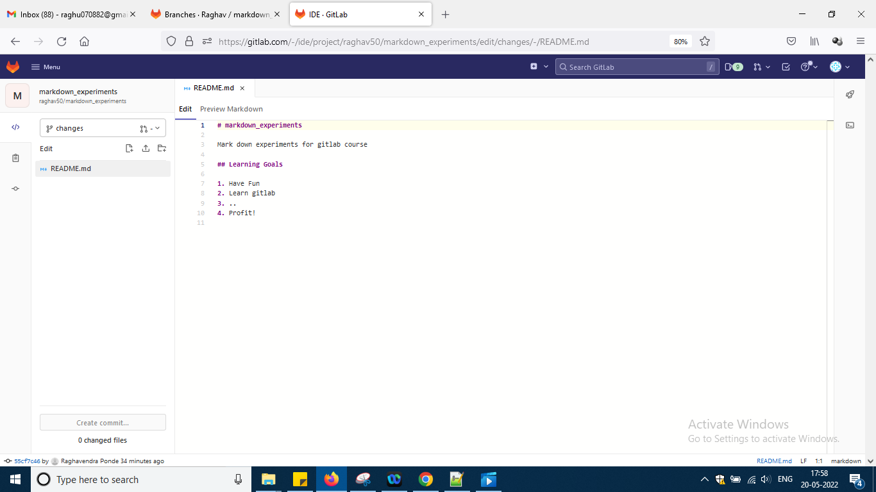

So it is a little bit more powerful than the earlier basic editor okay ..

Now written one and two in code of editor

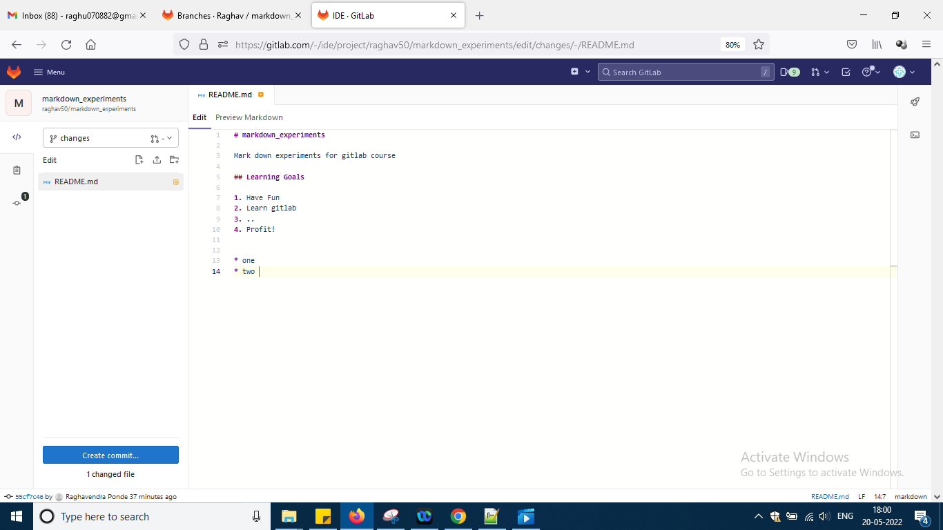

And preview markdown is like this

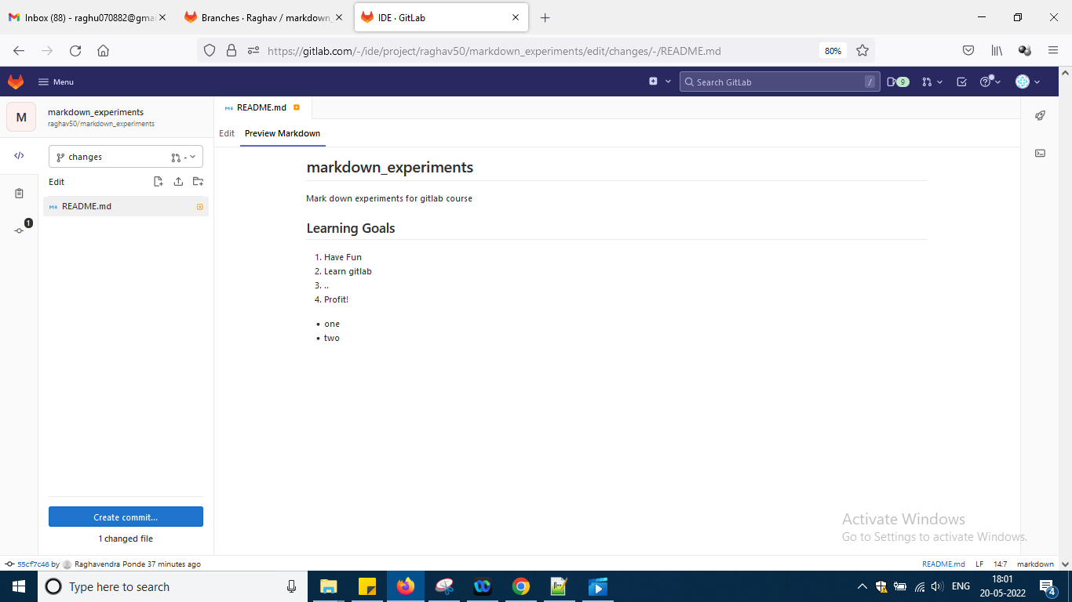

Now click this to create a new file

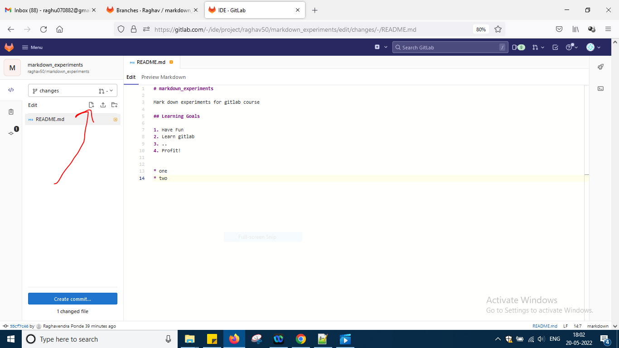

And write name as web_ide.js

Okay remove all path and write the name as above and write in js file

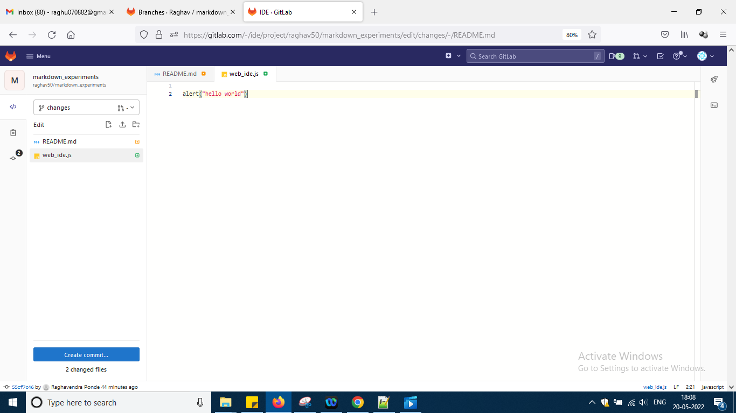

Hello world so till now i had done some changes in read me and added new js file okay now using web ide i need to commit those changes okay

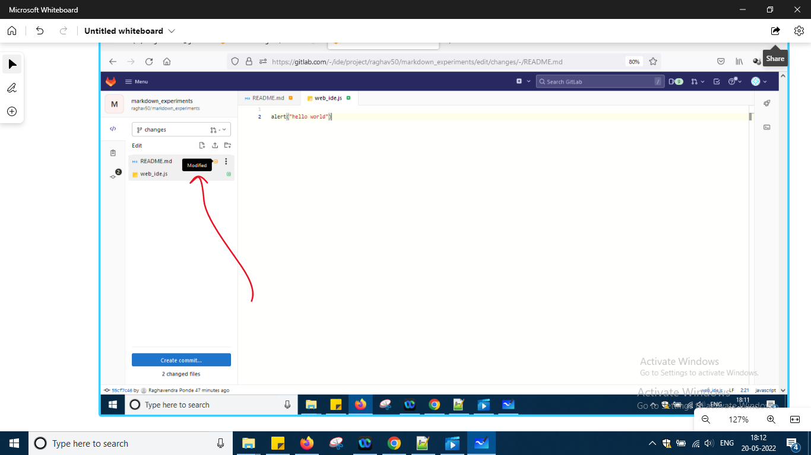

It is showing there i modified and also added down if u put cursor okay

Down create commit button click it

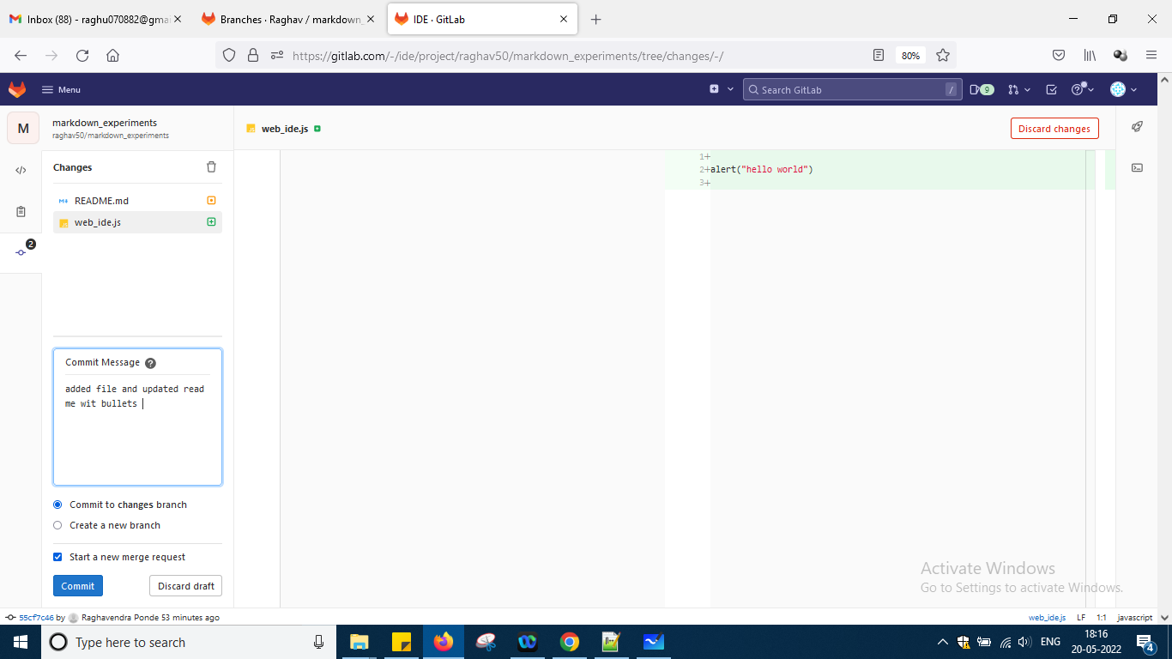

So it is showing all the things here u want to create new branch or start a merge request all those things i don't want to do so uncheck start a new merge request and say commitnow okay

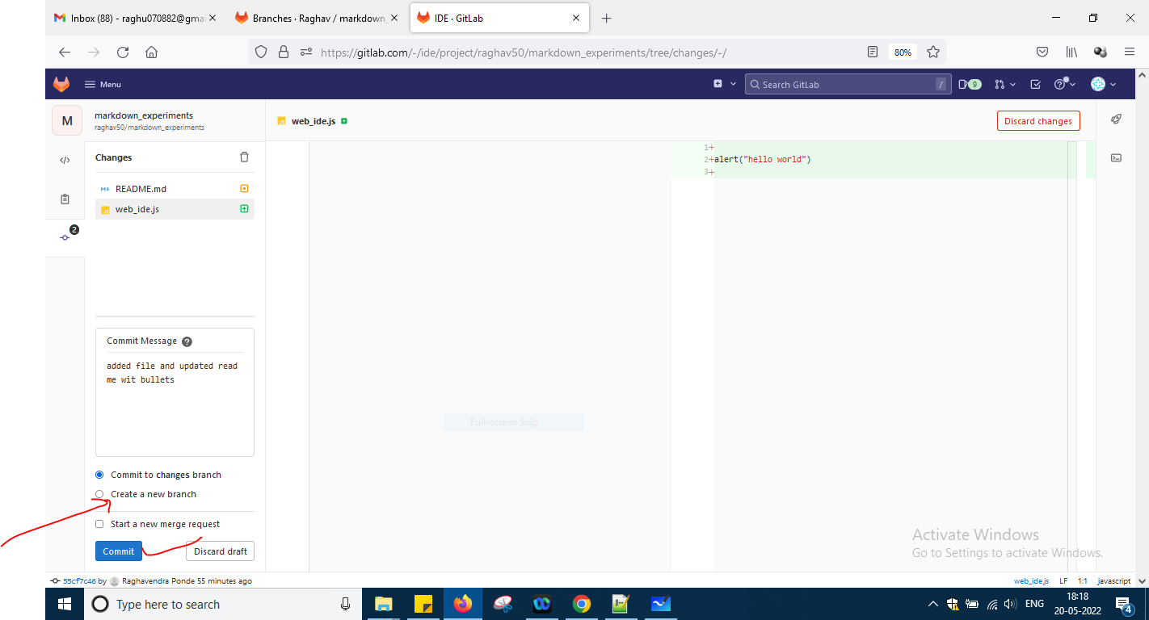

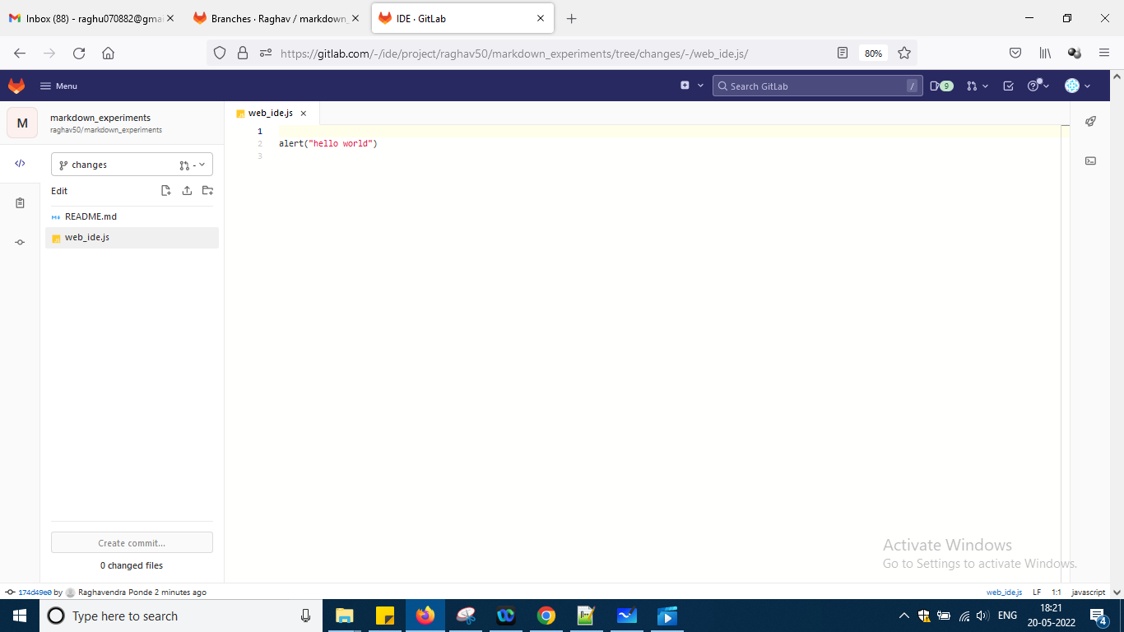

Next after clicking dashboard

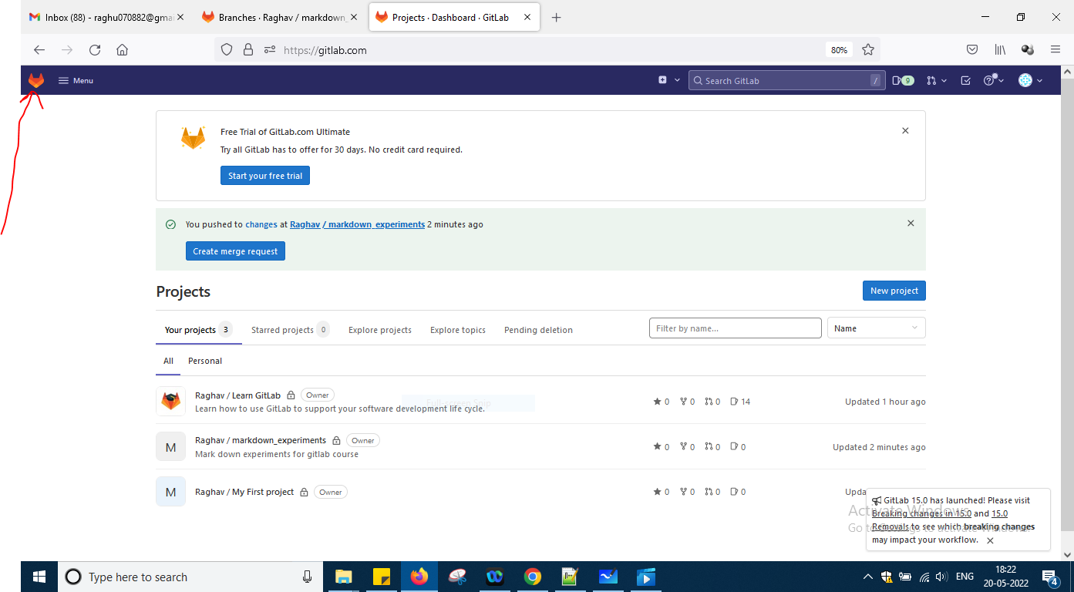

I am getting like this above means before this slide i clicked there only and i can see above image okay

Now create merge request

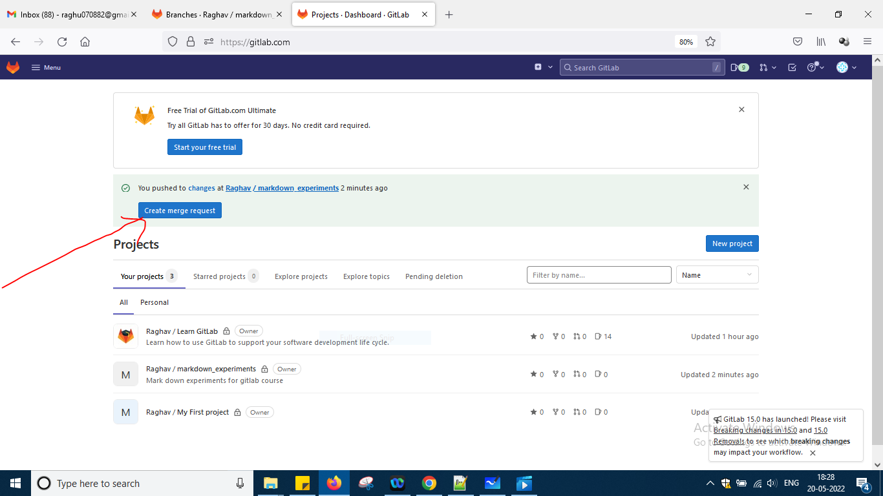

One window will come fill the details and after merging u want to delete changes branch for that already check option is given okay

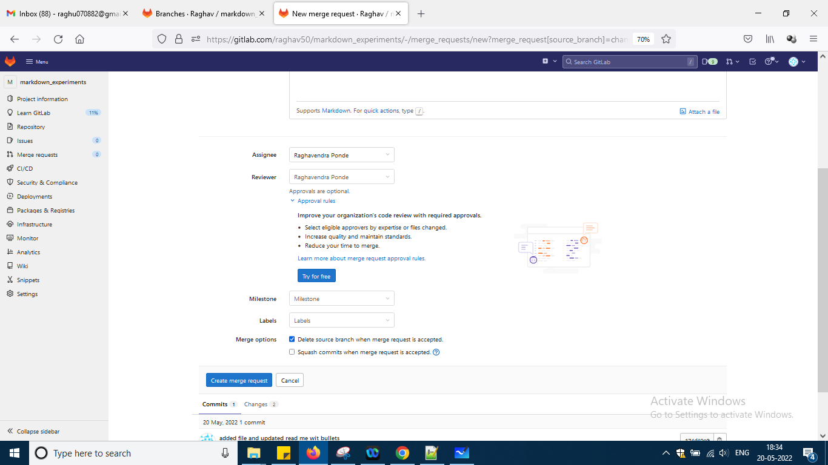

And just click the button okay

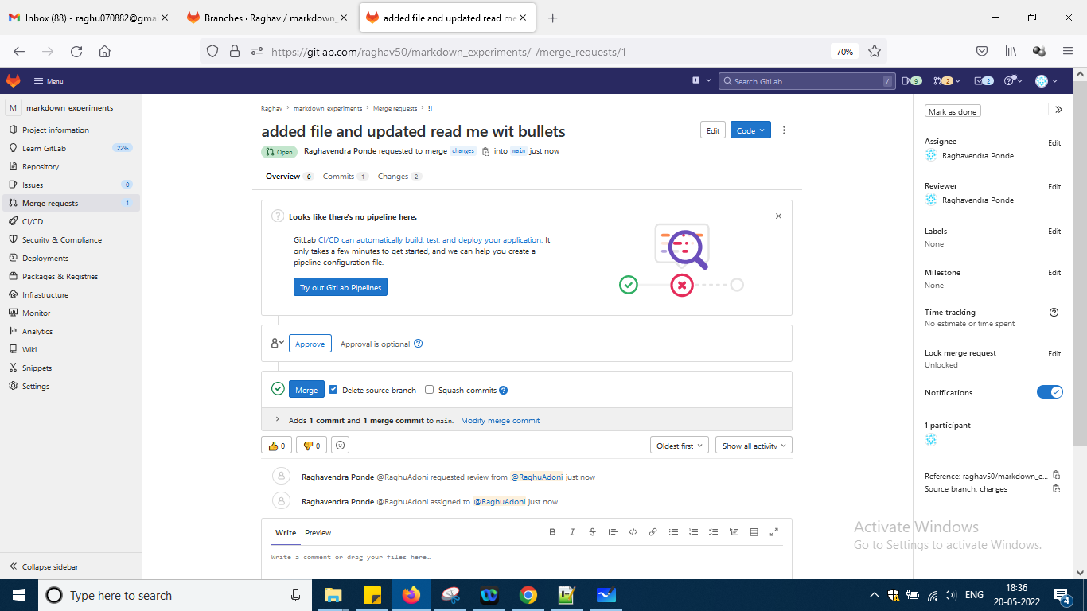

Now go to merge requests

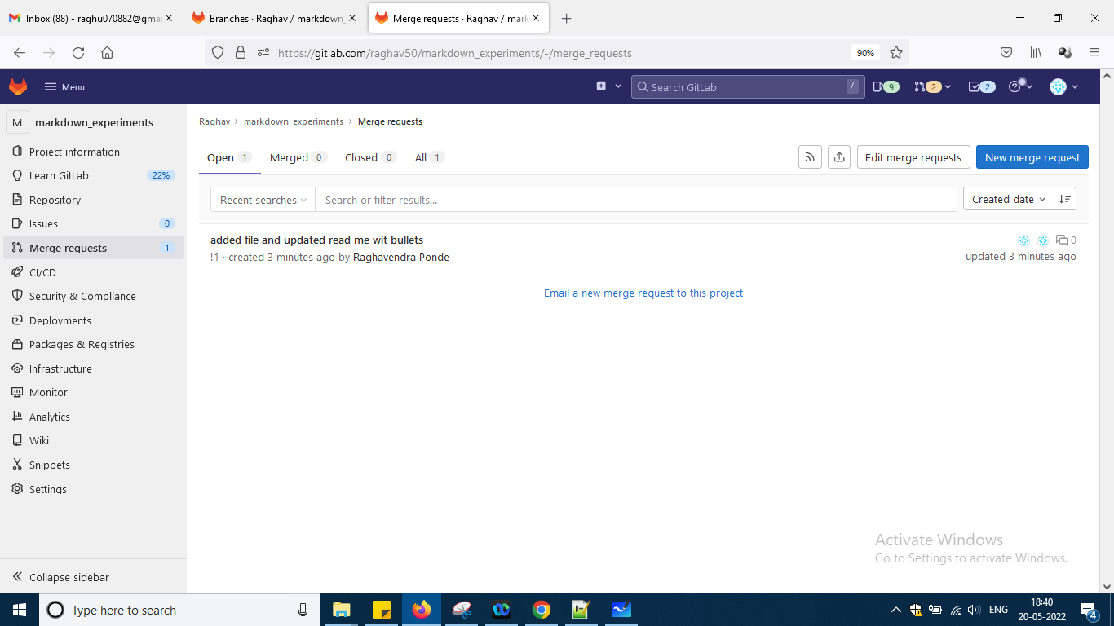

So u can see it and also can send mail also

Now click the merge request to be reviewed okay click it

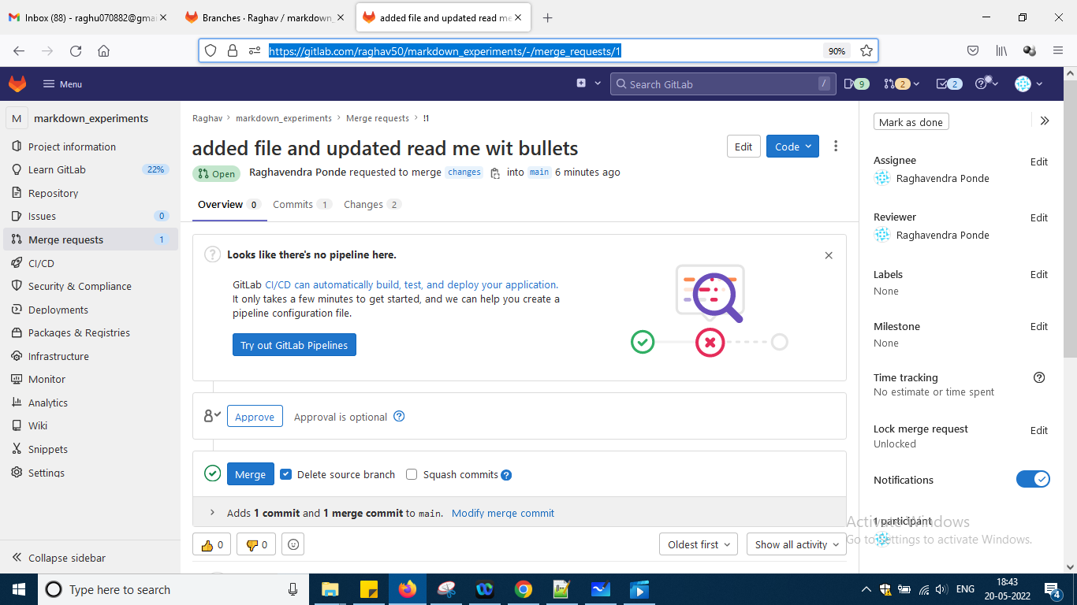

Means some body should review it and add some features if needed okay

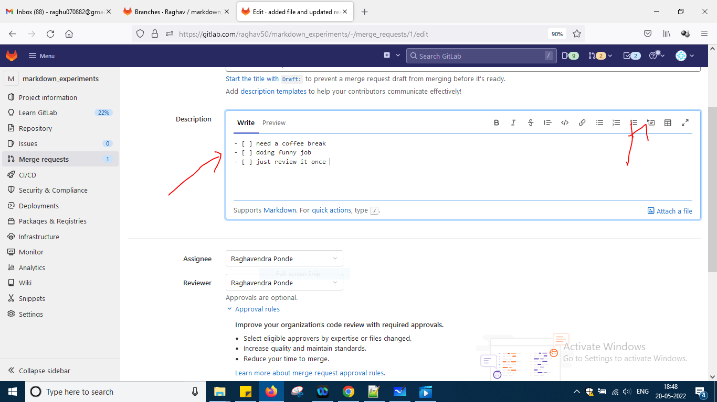

Click save changes

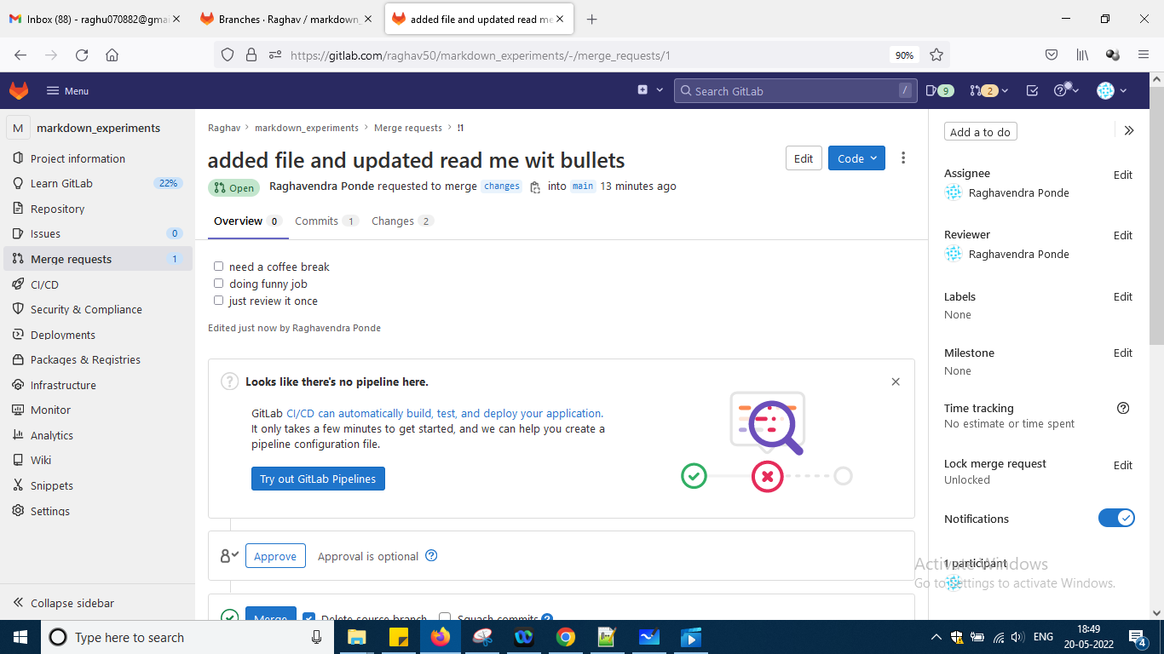

Now check the box once and down it will shown as done

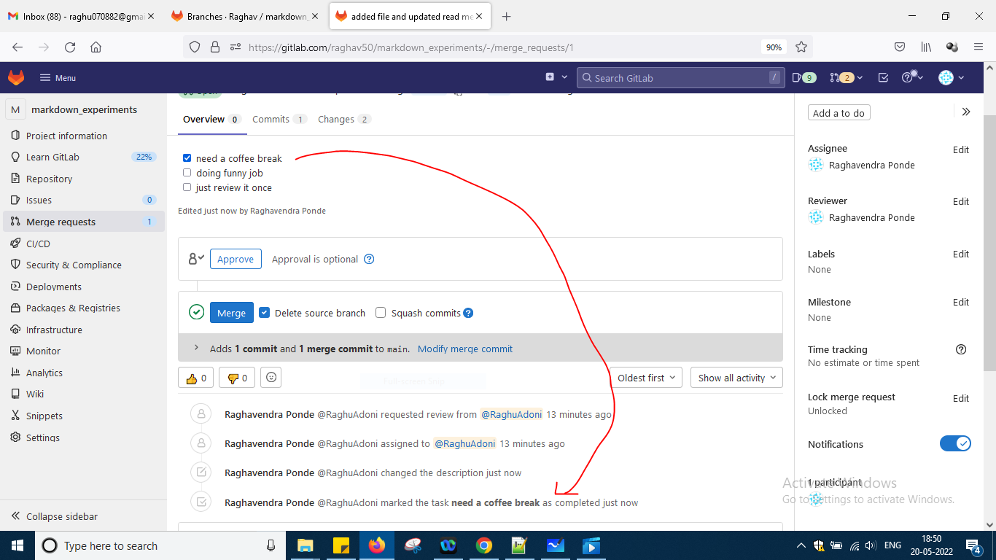

So something in description i am doing it good way we are saying it okay

And finally click the approve button okay

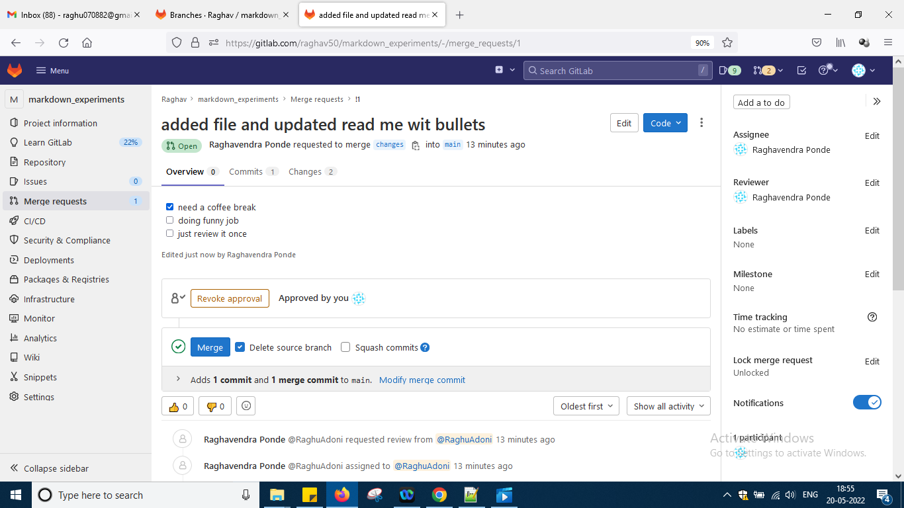

And commit tab

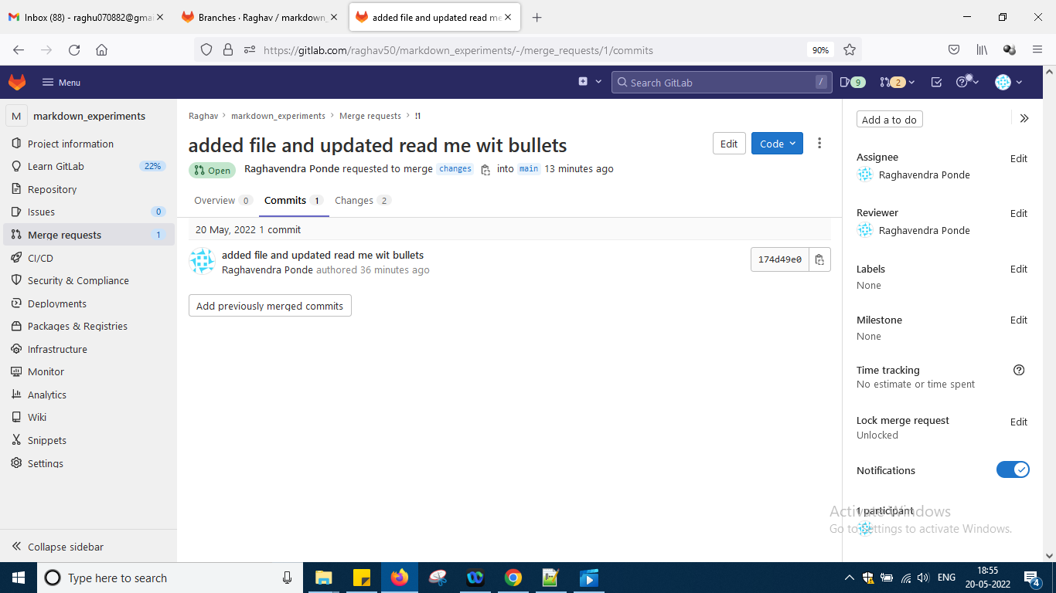

And click that link and see it okay

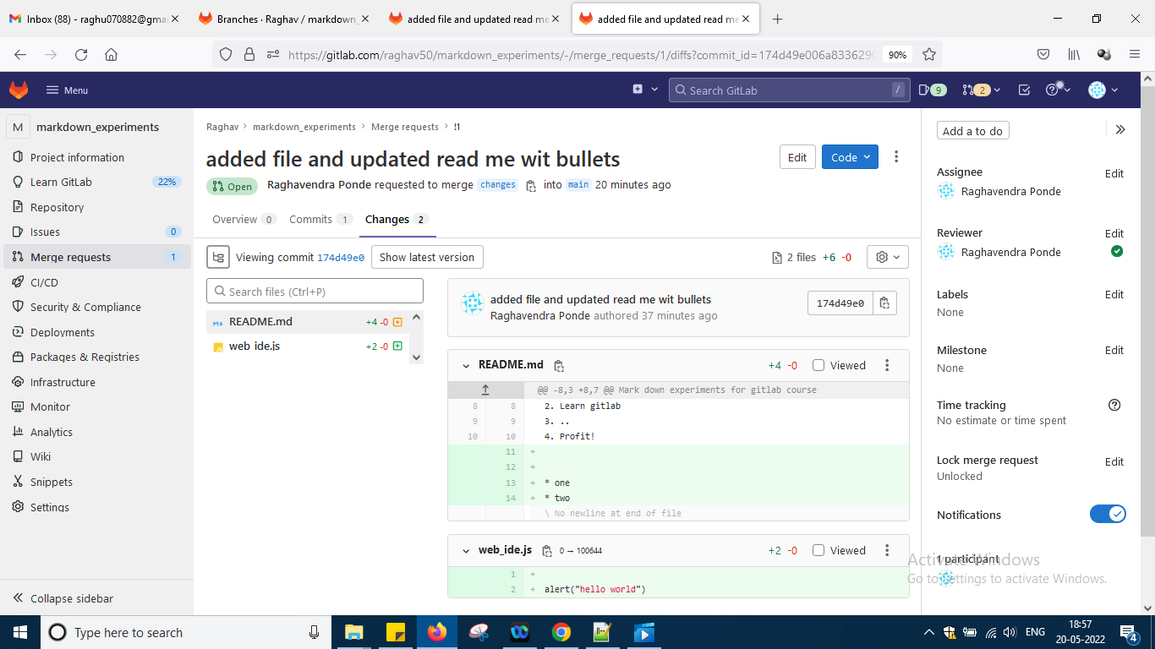

So somebody reviewed and done changes and i can add comment that good changes done and i think it is okay and come to overview tab click merge button

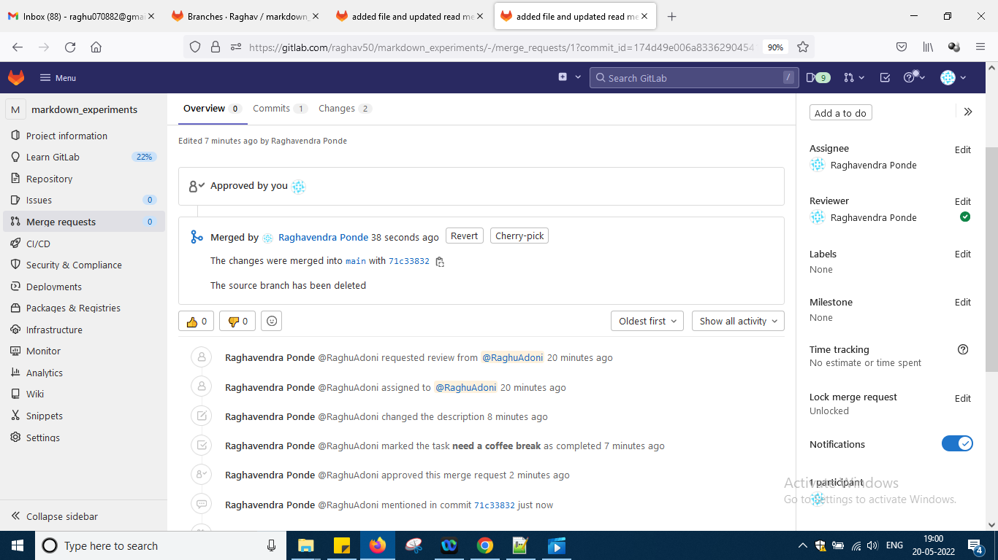

It is then having revert option also which will revert okay

Next is Git history

Now go to main tab markdowncommits and click the commit button

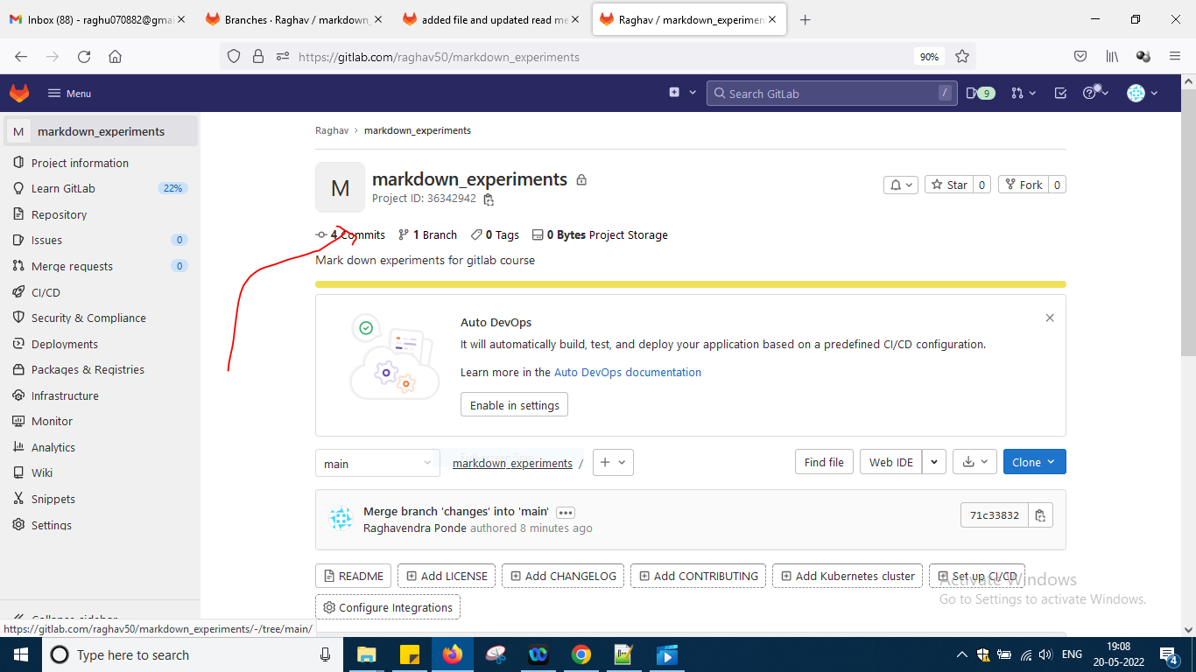

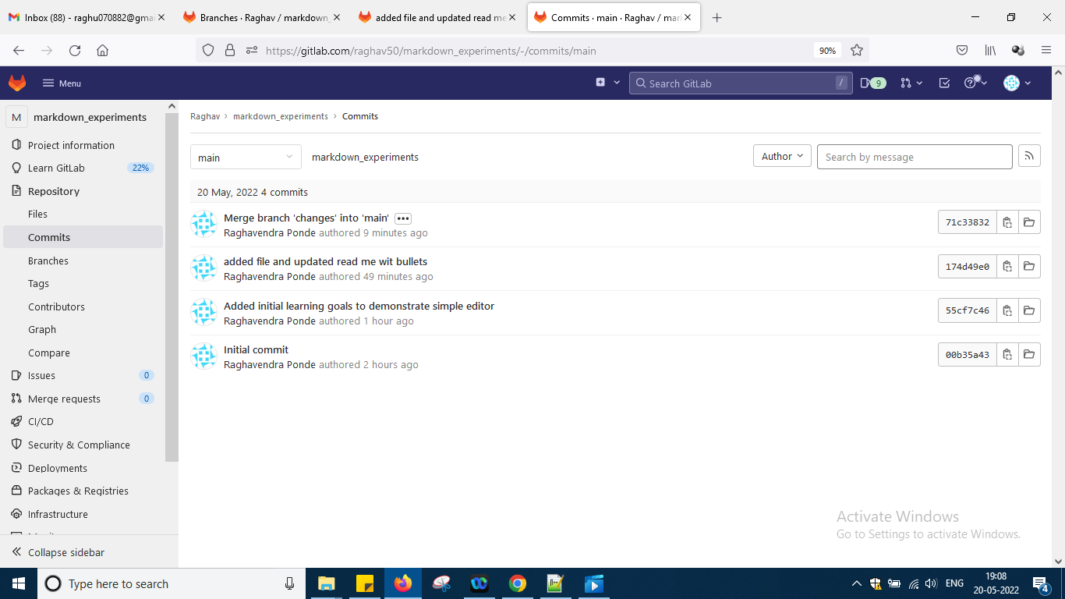

So shows commit message for each one

So click this folder u can go to the actual code which u have written before doing a commit

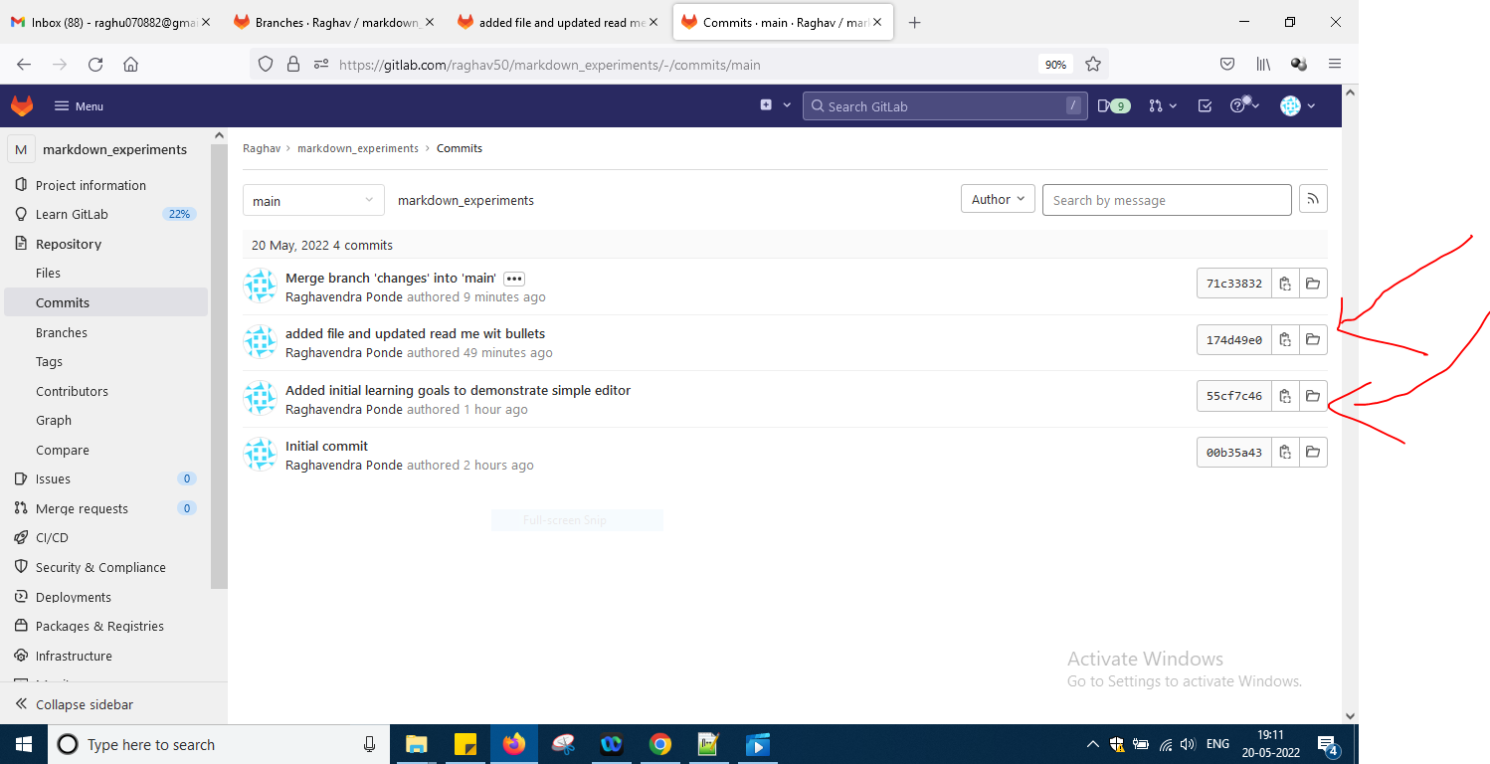

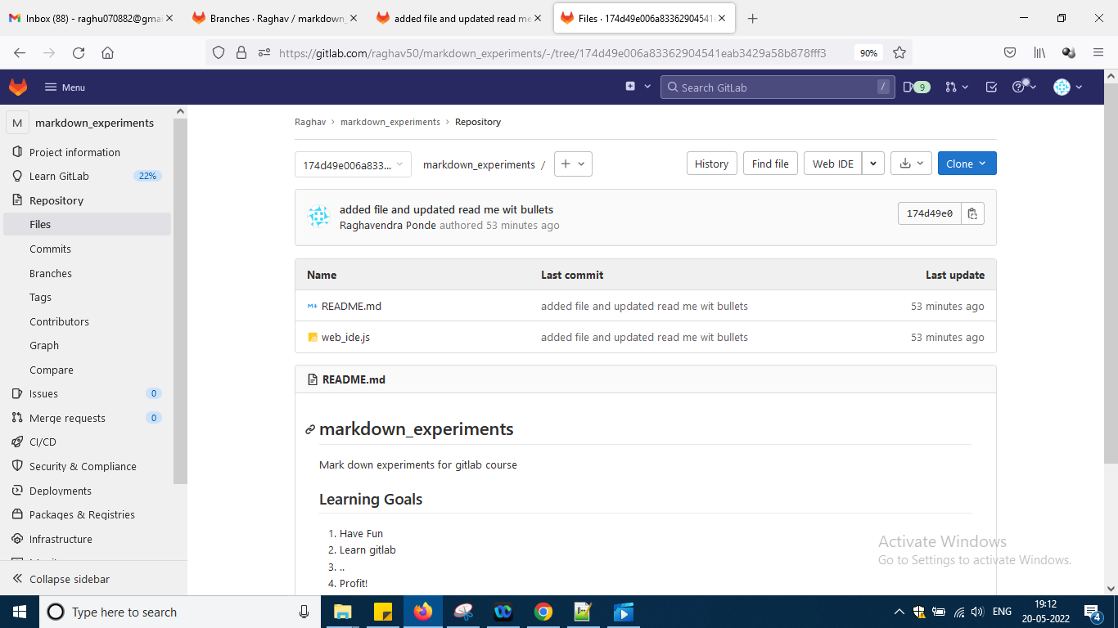

Go to graphs to visualize the things more better

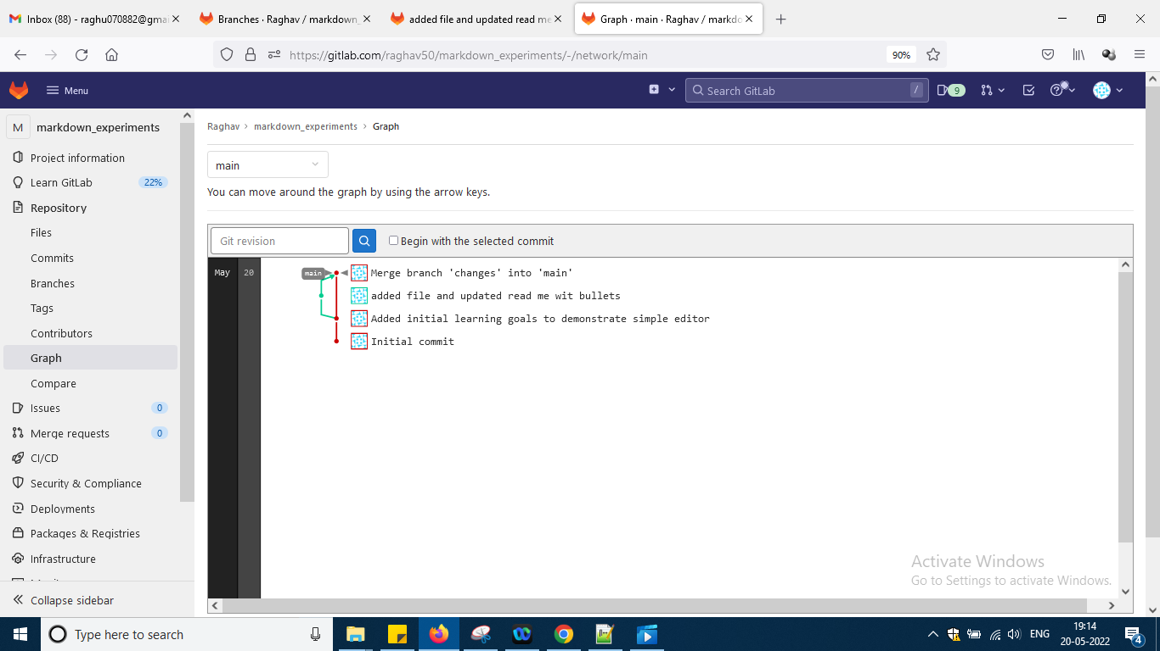

Take the cursor there u can check in main branch how many commits and other branch how many commits

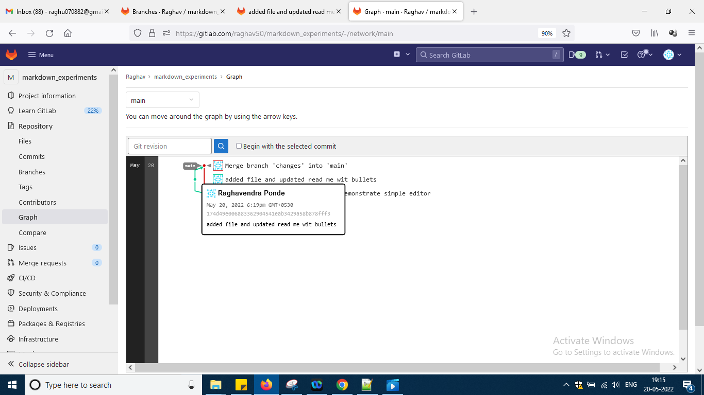

Suppose u want to create tags click to dot there in graph and one page opens and side by select tab and say add tab and suppose u are realsing a product or like that

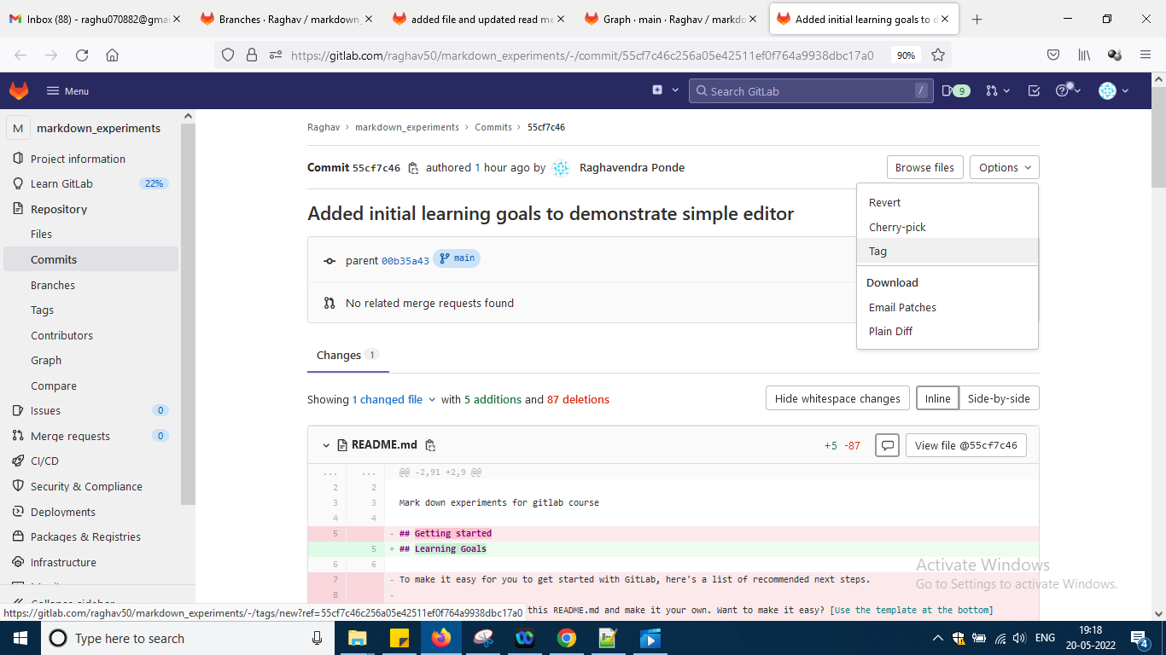

After adding tag say 1.0 and some message and again go to graph

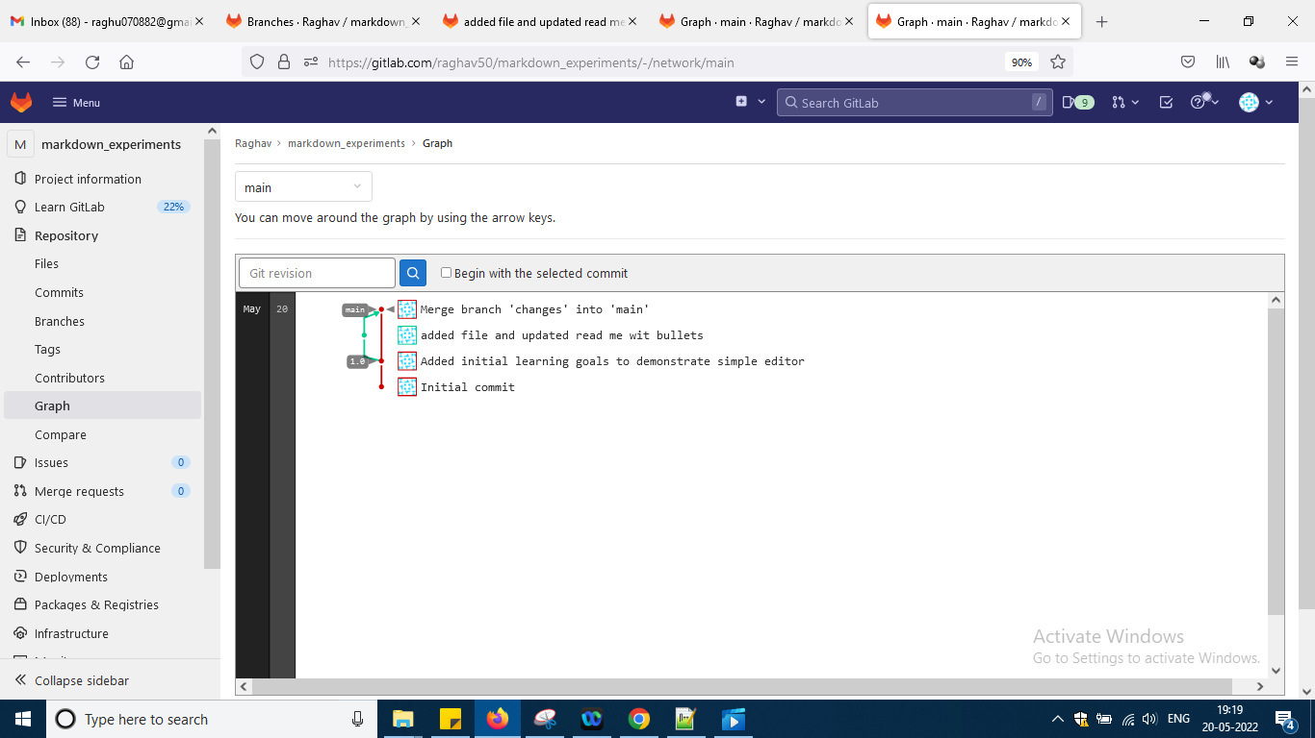

U can see that 1.0 release like that

Next topic is gitlab collaboration as per the video which is last video okay

Which u can check with the video notes i am not writing for it so above things u need to practise and come into flow okay

Now i am moving to video section git lab for beginners automation step by step youtube videos and as per him i had already created a folder in gitlab which is my first project okay click dashboard and last project click it okay

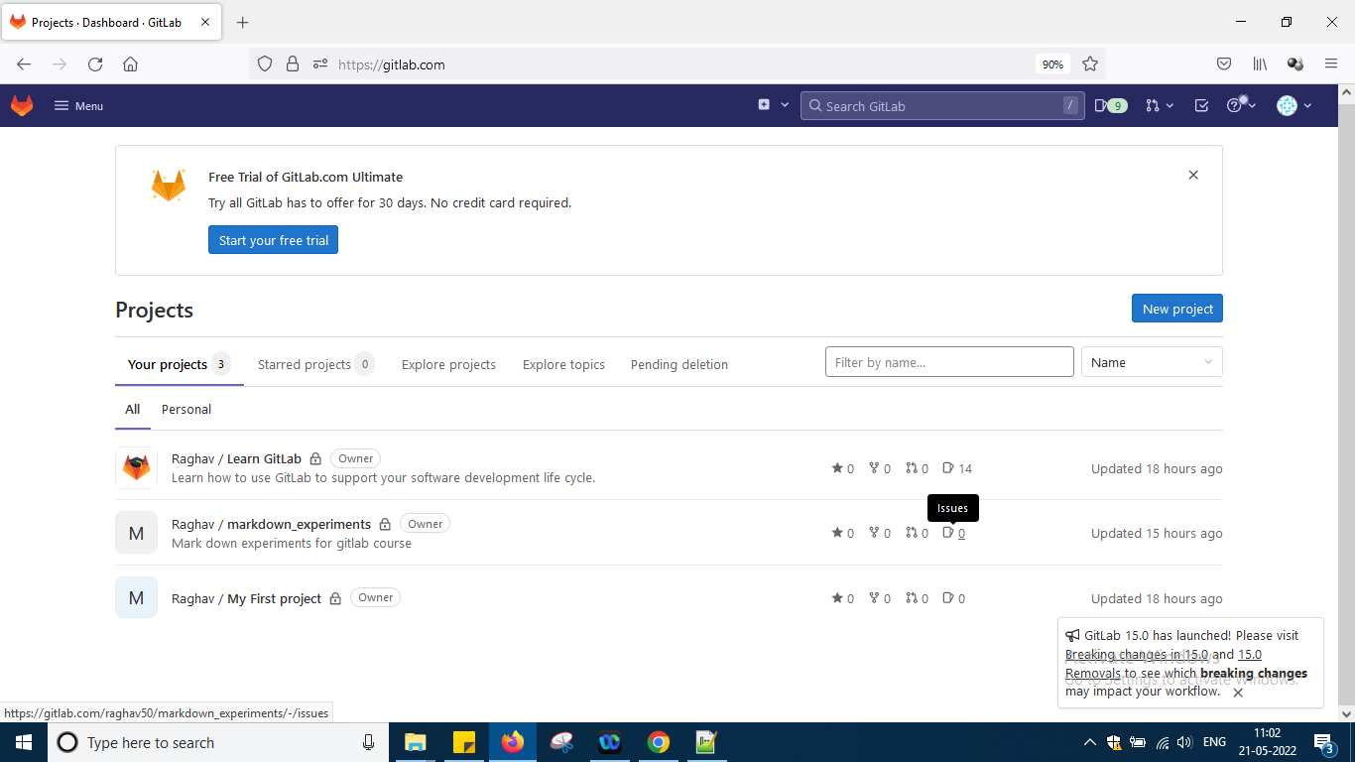

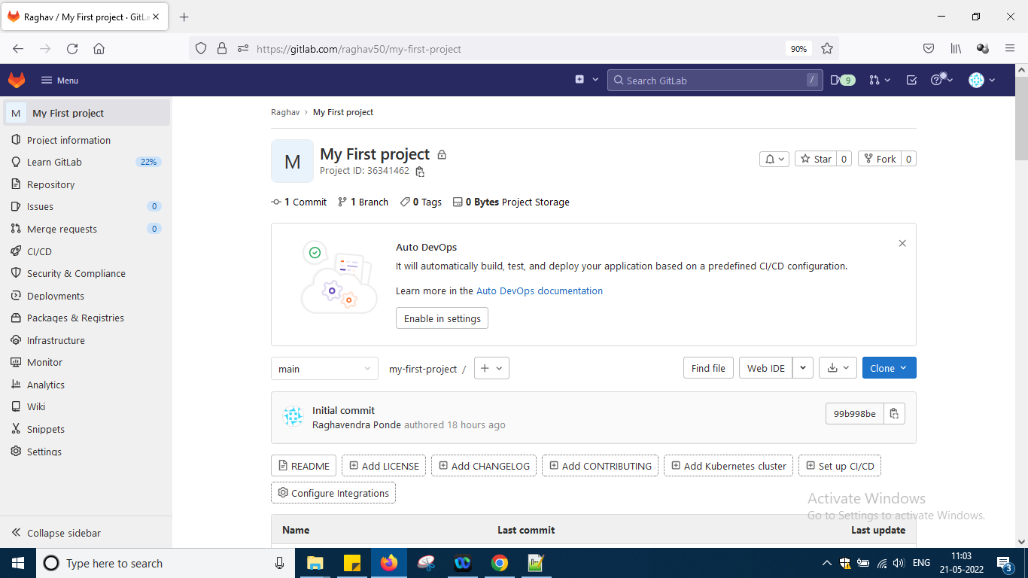

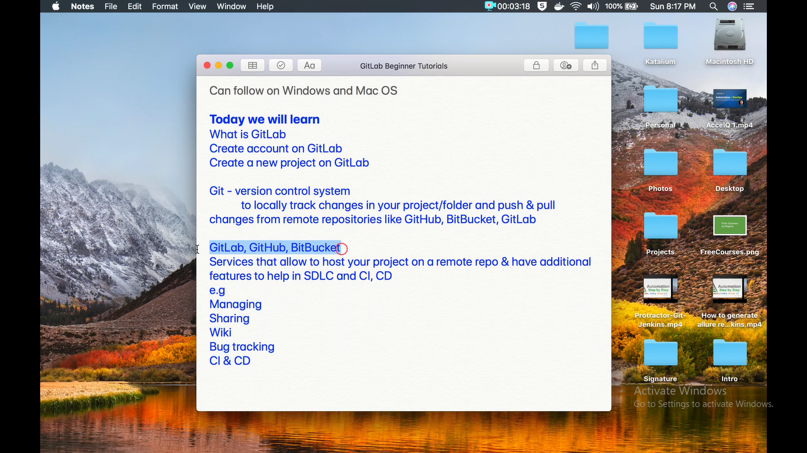

Here two steps are done like creating an account and a project okay and the url of the project is

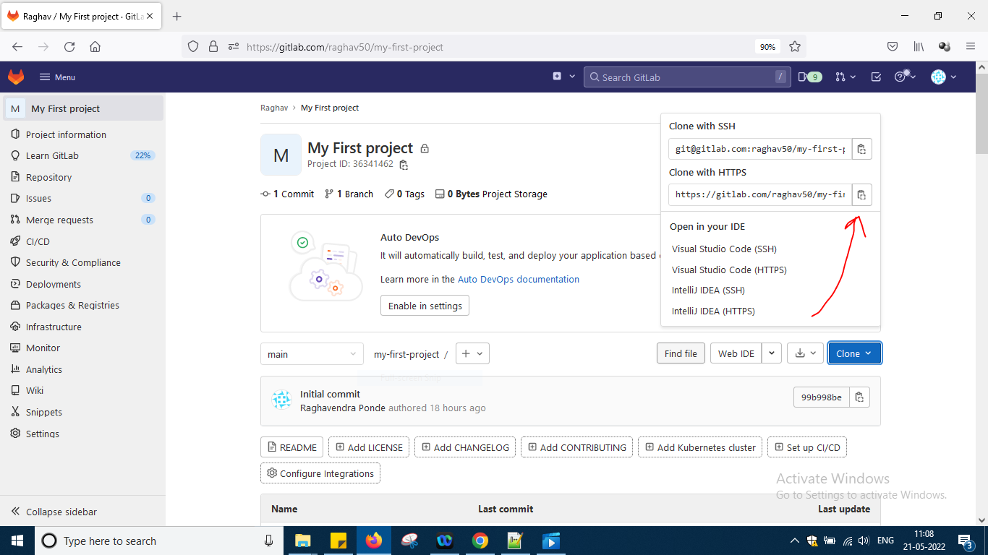

<https://gitlab.com/raghav50/my-first-project.git>

Here raghav50 is some namespace or domain it has created for me by default and in that i can add users but i have not added and i am only there over there okay

Next as per second video of him

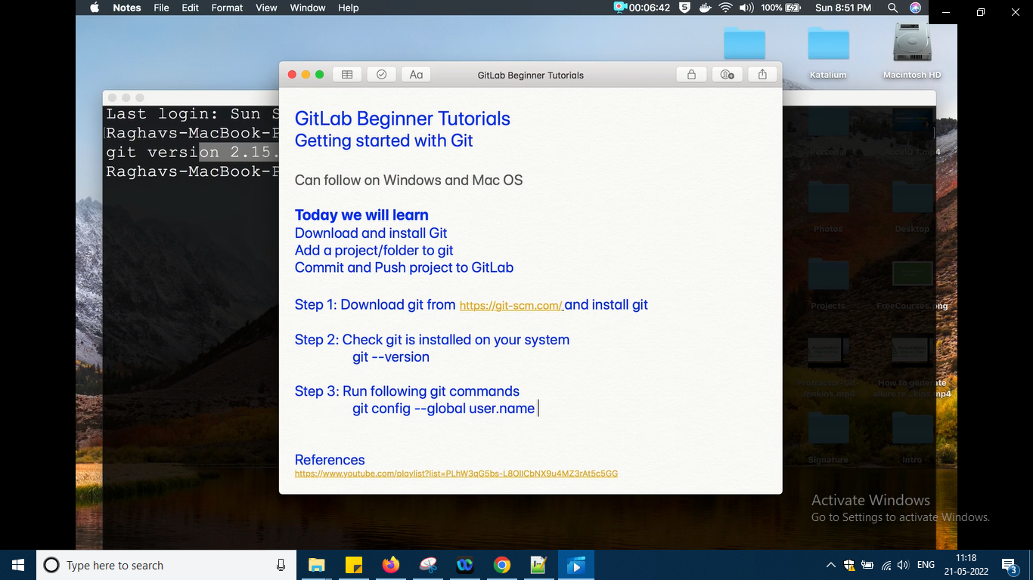

First two steps are done i had long back installed git and version also i can check now

Next i will do it from 3rd step okay

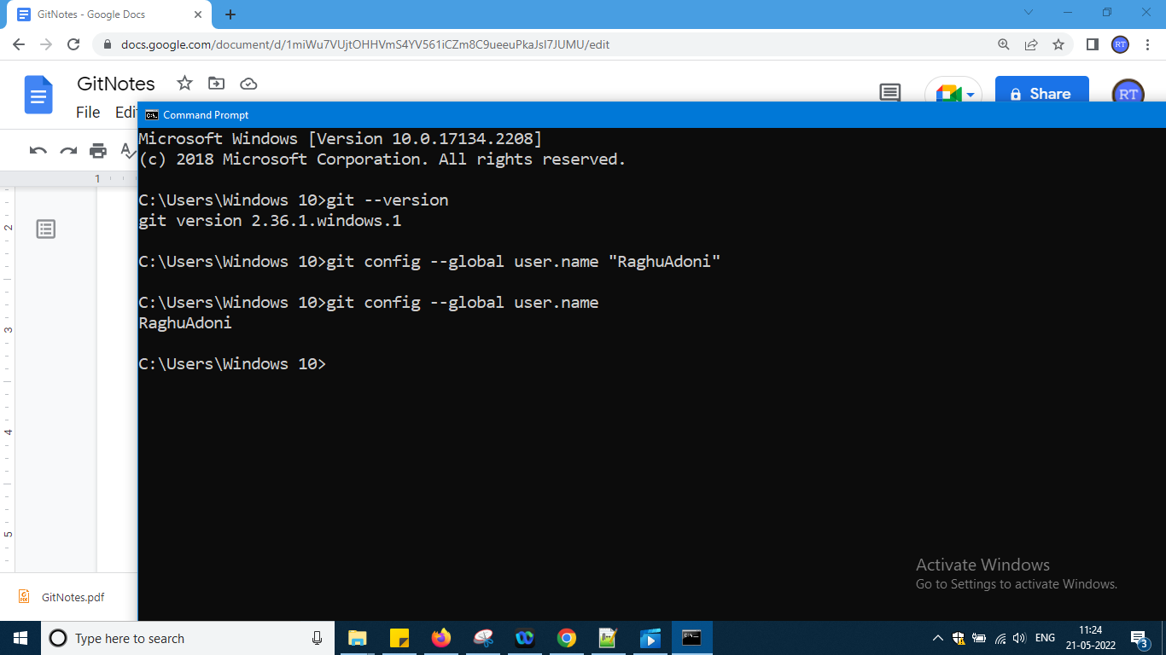

In my system opening cmd I am writing the command to register the gitlab id into my system

And to know really whether my system has taken the value or not write second command without name it is showing my name okay

And in the same way for email also

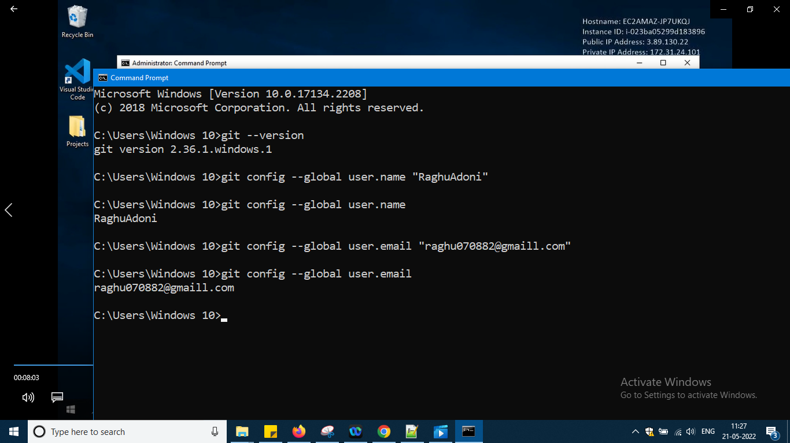

You can type the list command to see all details

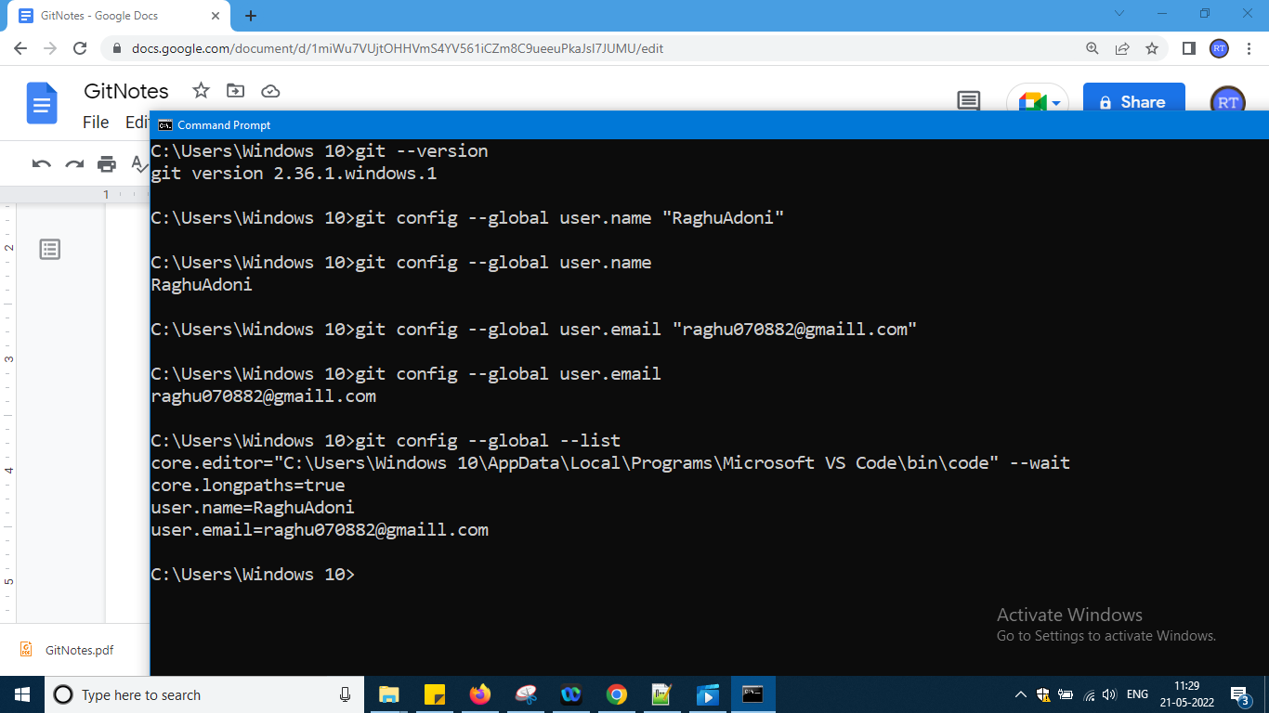

Next step is i need to create a demo project or folder so project means folder only it will be there

And we have to add our local project folder to git okay and finally push that to gitlab okay

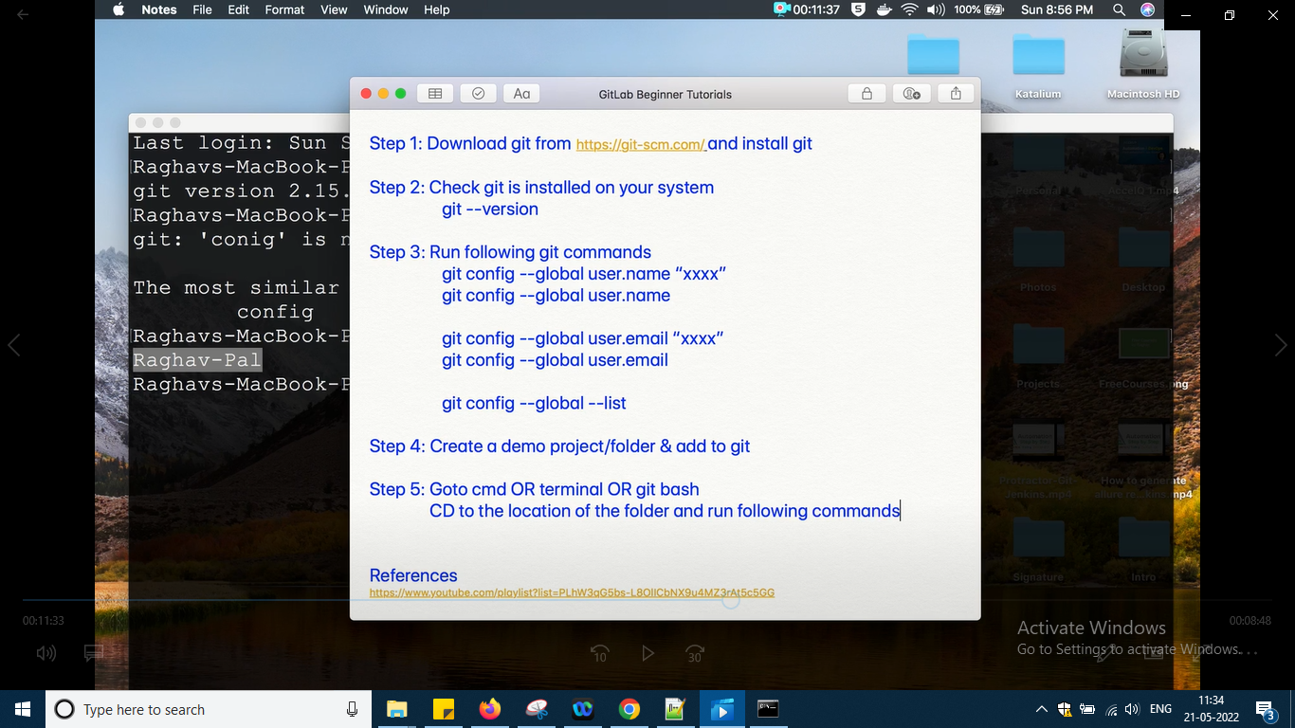

So

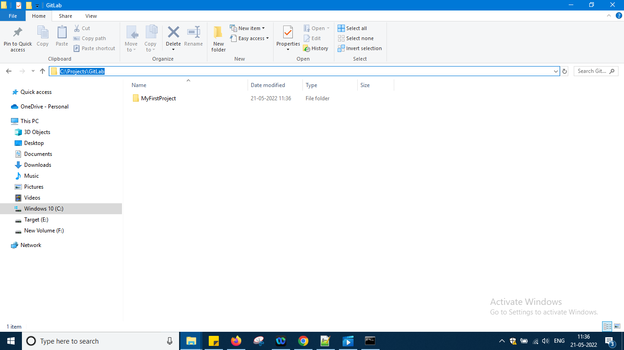

So in c: drive created folder projects and in that like this projects /Gitlab/MyFirstProject folder created okay

Now go to that folder

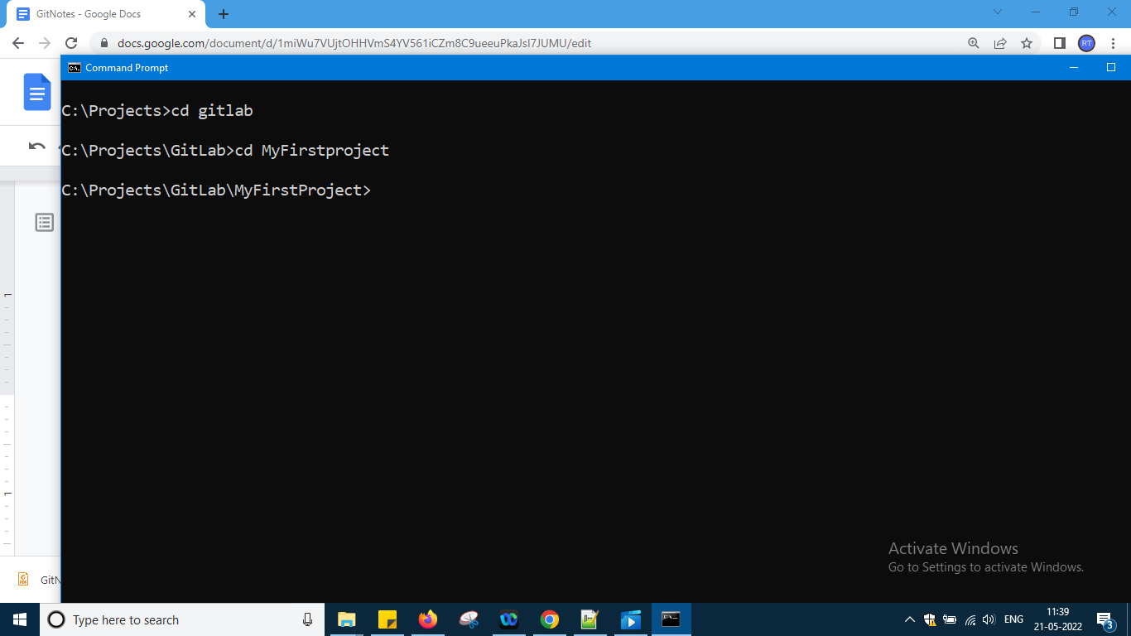

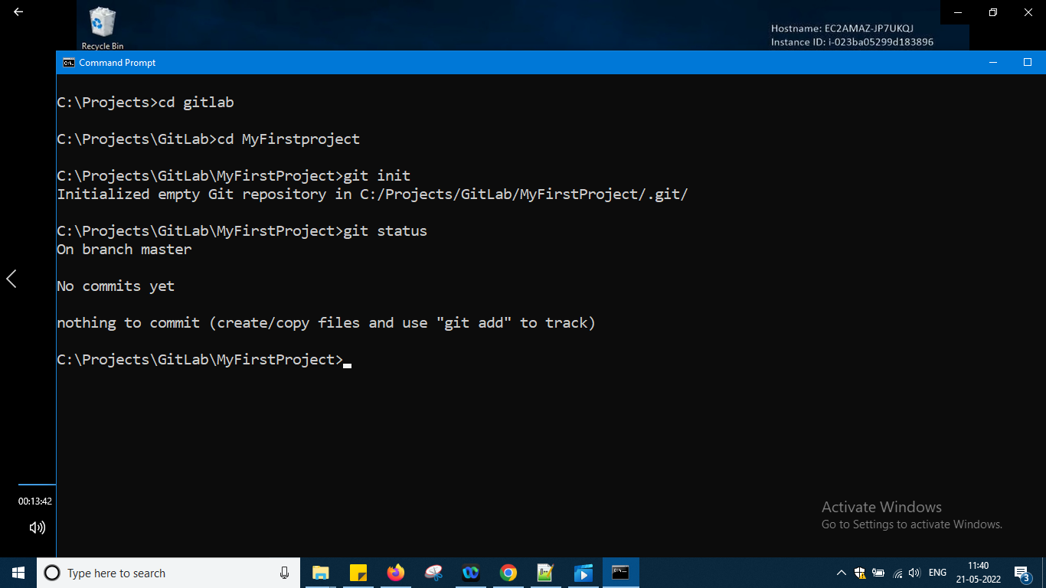

Same command which i had typed earlier in git bash i am typing here that's all

Now create a simple text file readMe.txt and now again go back

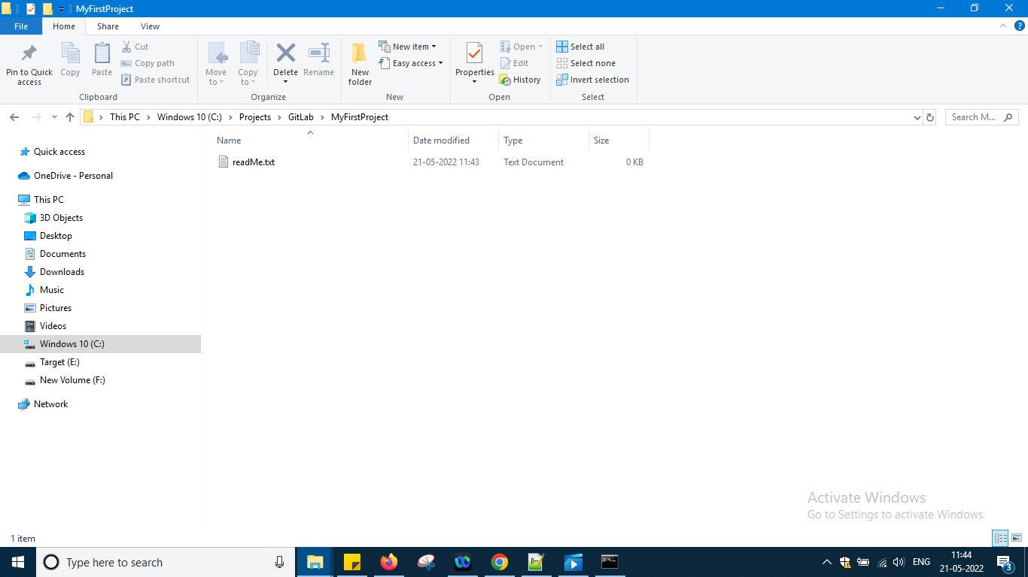

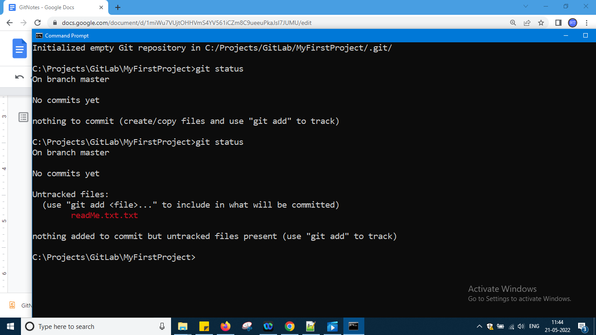

Put to staging and finally give a commit

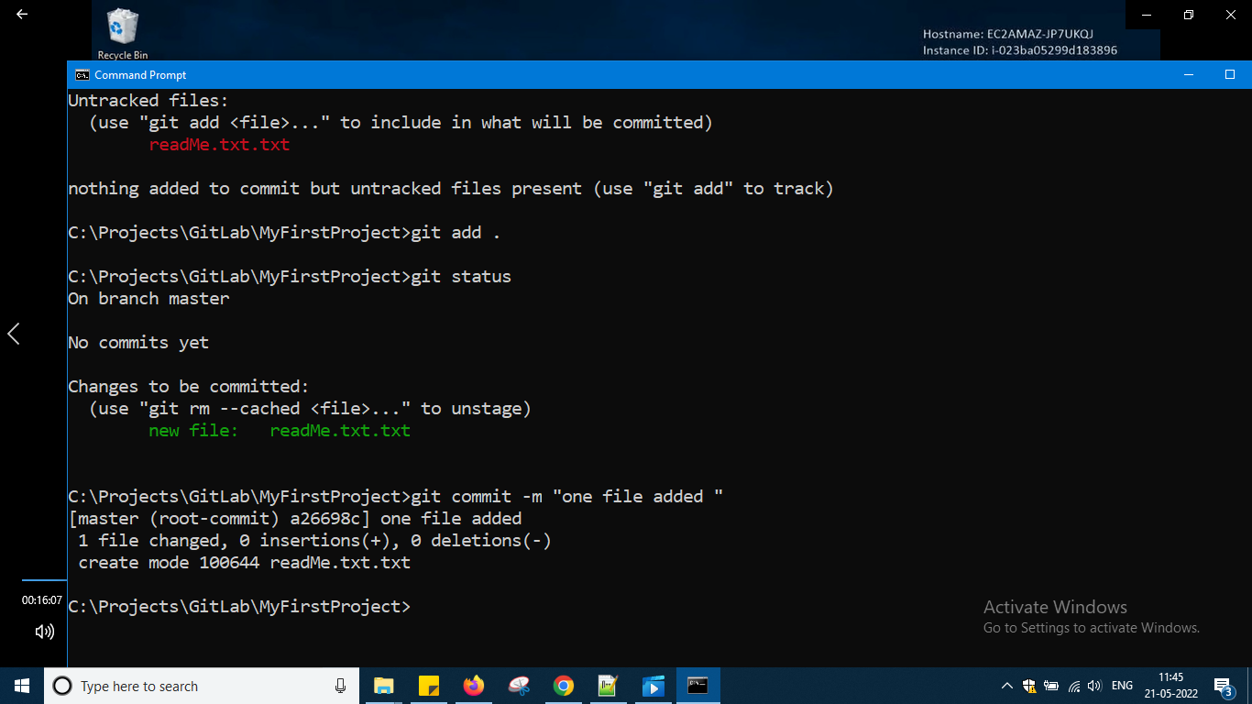

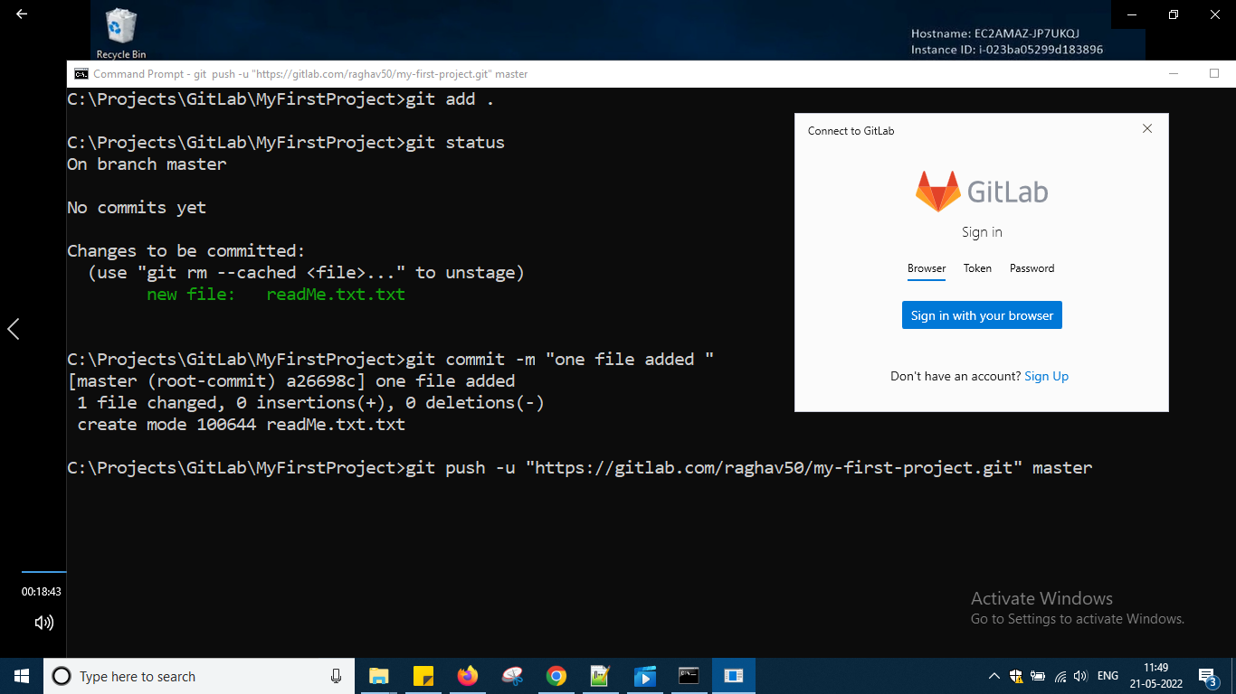

Login with browser

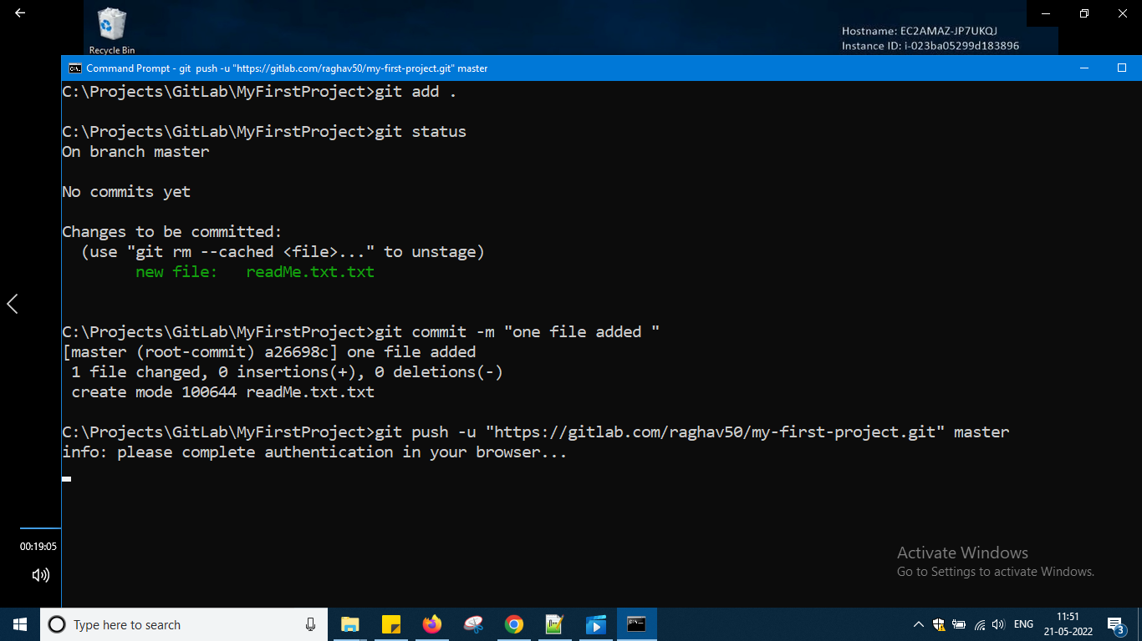

And it will ask to authorize click it and and it will ask to close the browser and in cmd we will see

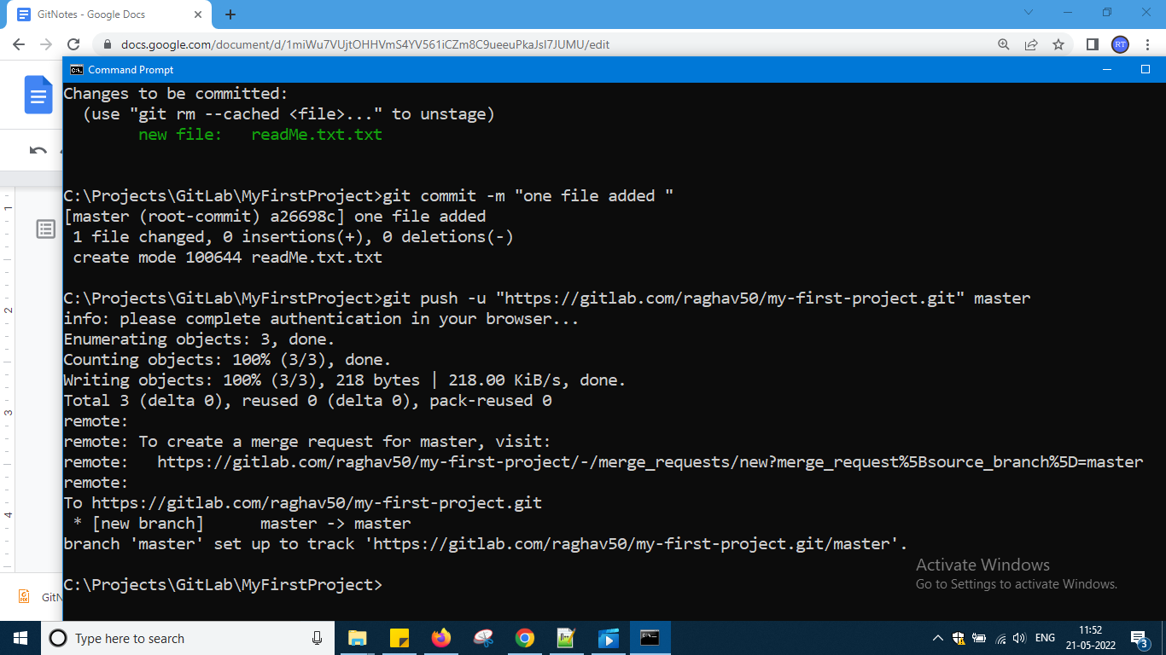

Below slide is from some other video here which I am not trying it here origin means alias name to that complete url okay and from that url what u want to do means –v we will type which means u can either fetch or push that is what u can do it

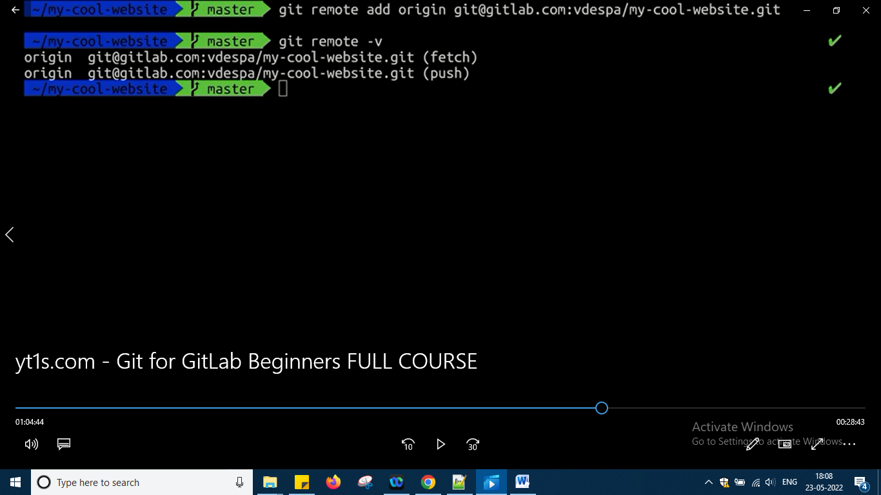

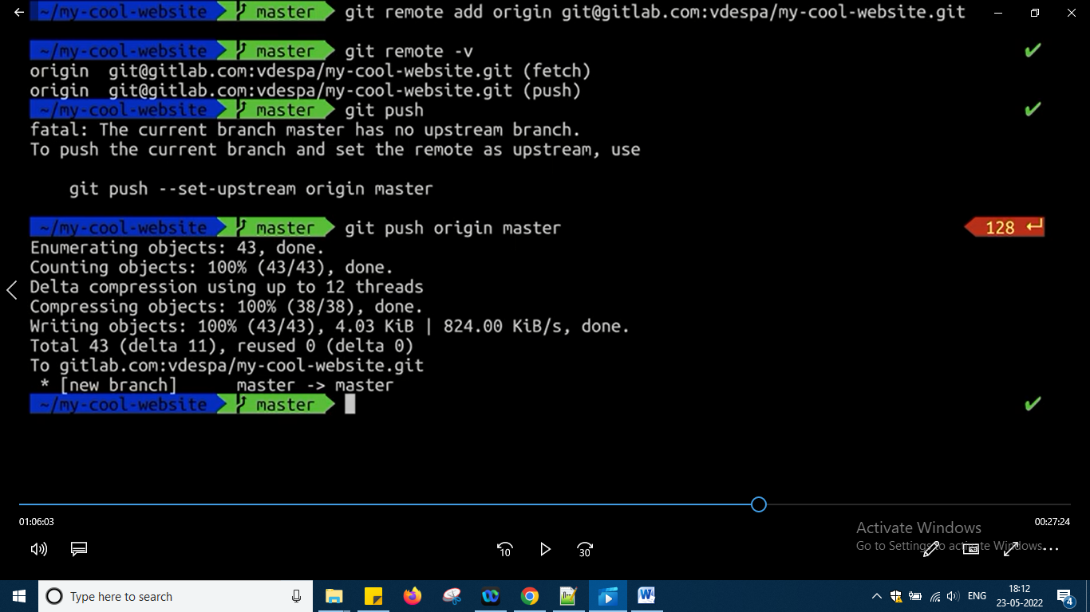

And now u can go to respositoy in gitlab do some modification that modification u want to see in local means u have to pull it

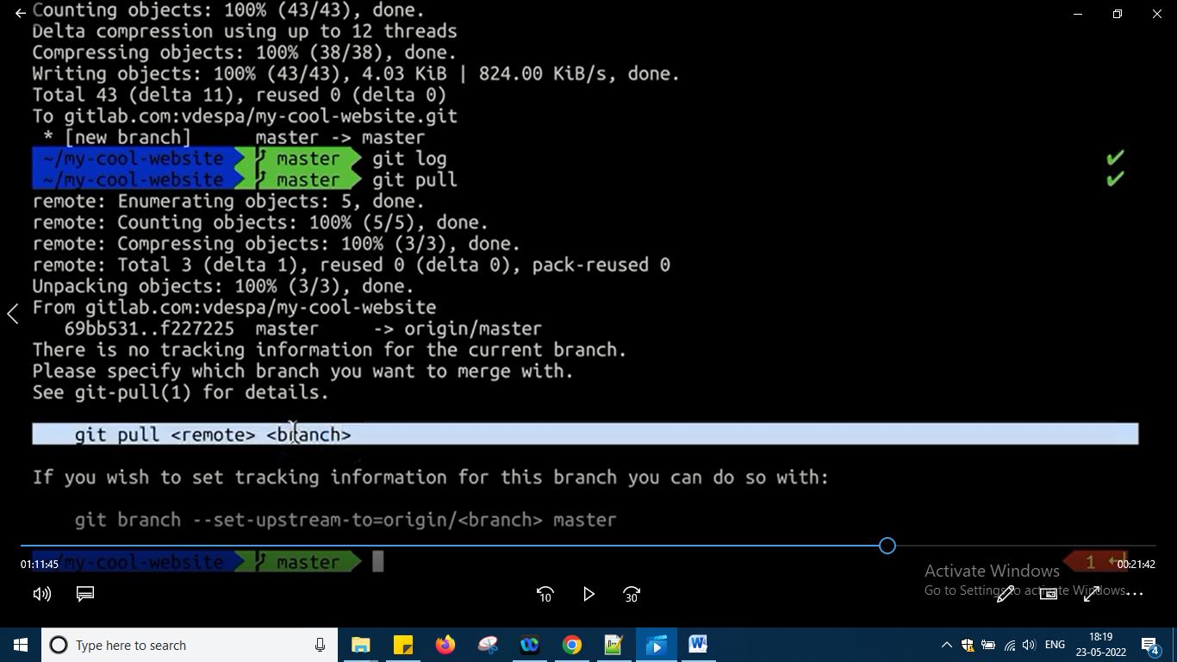

Tried the command but it is telling write it properly

So correct way is

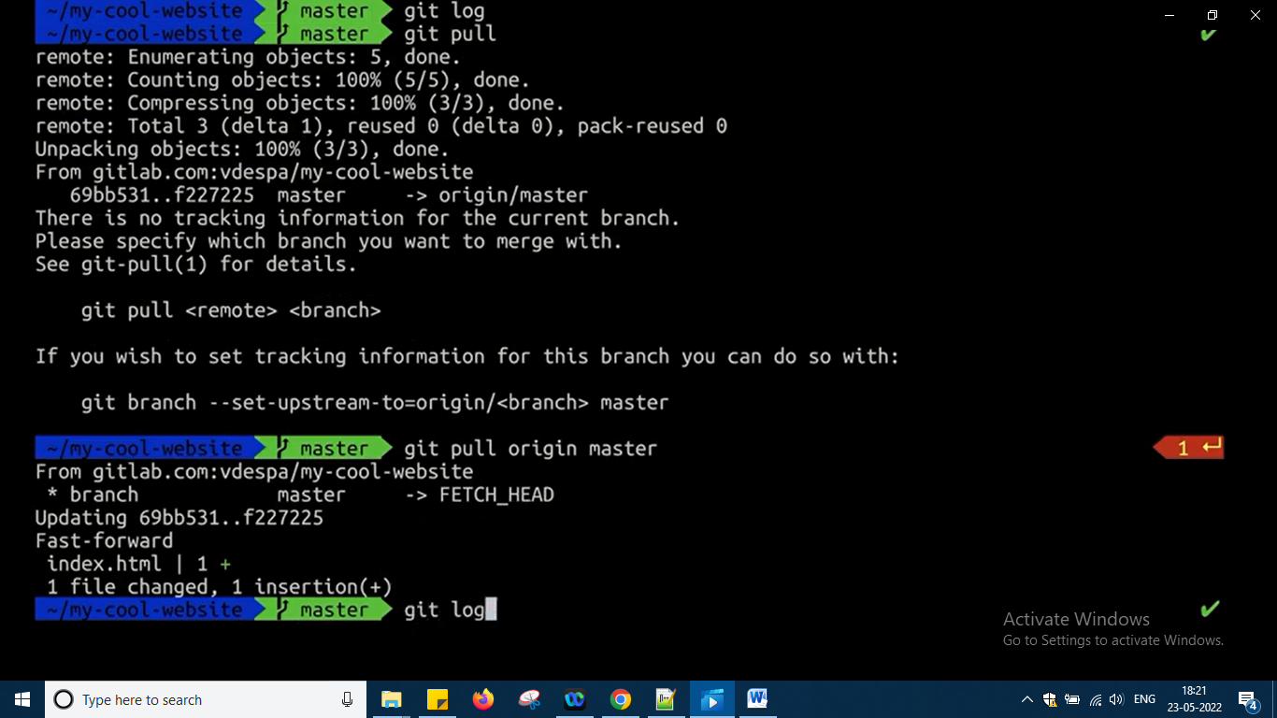

So now check log the changes will be added okay …

Now suppose from local try to change the file some file and same thing to the same file do it in gitlab now

So error will come now when I am pushing

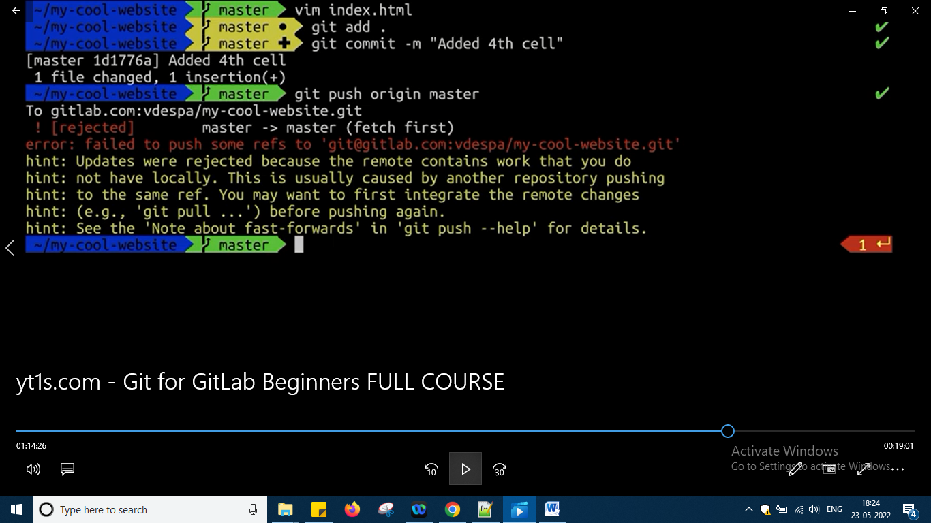

The above things means it has pushed

No go and refresh your repository on gitlab okay

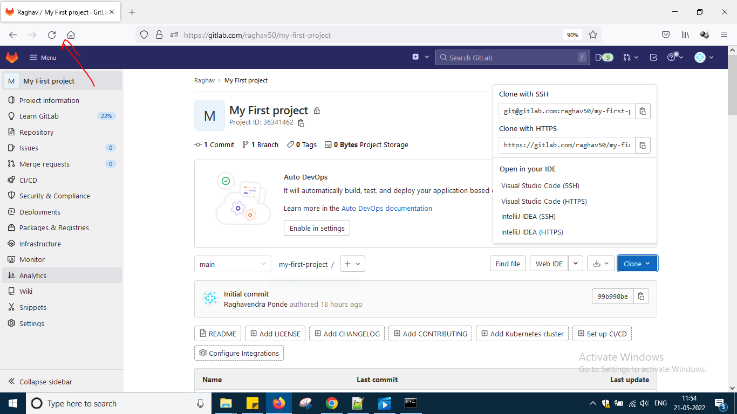

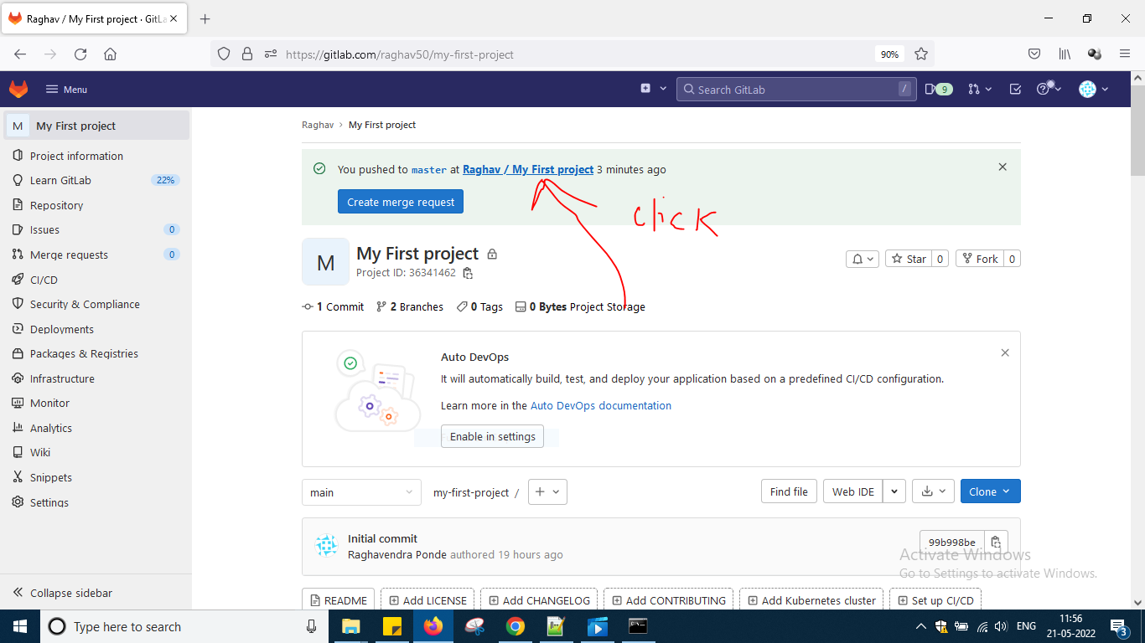

Sorry click the master link

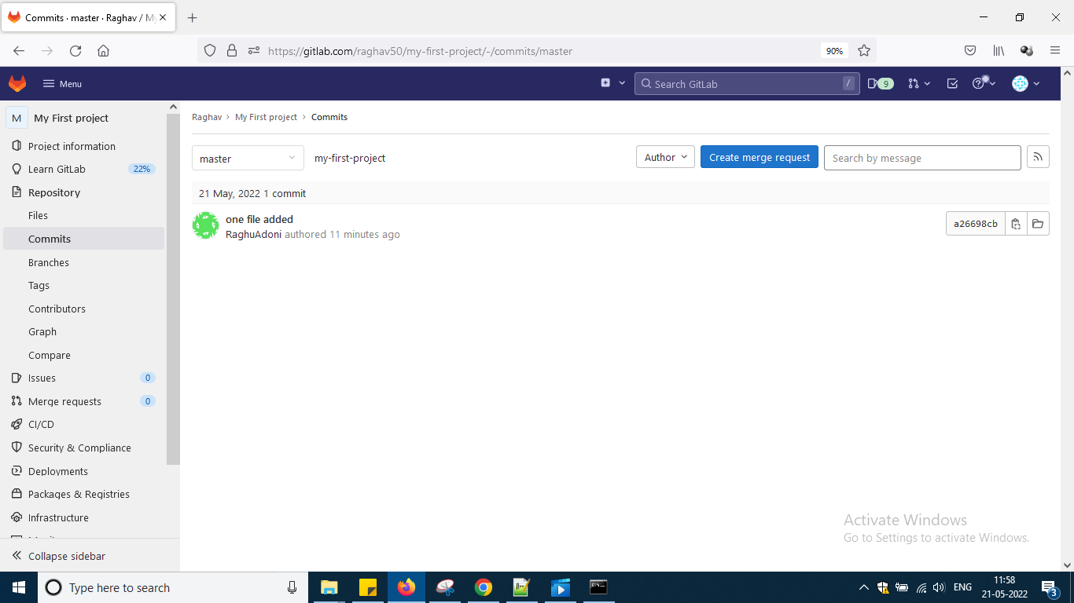

Click side folders

U can see the file u created

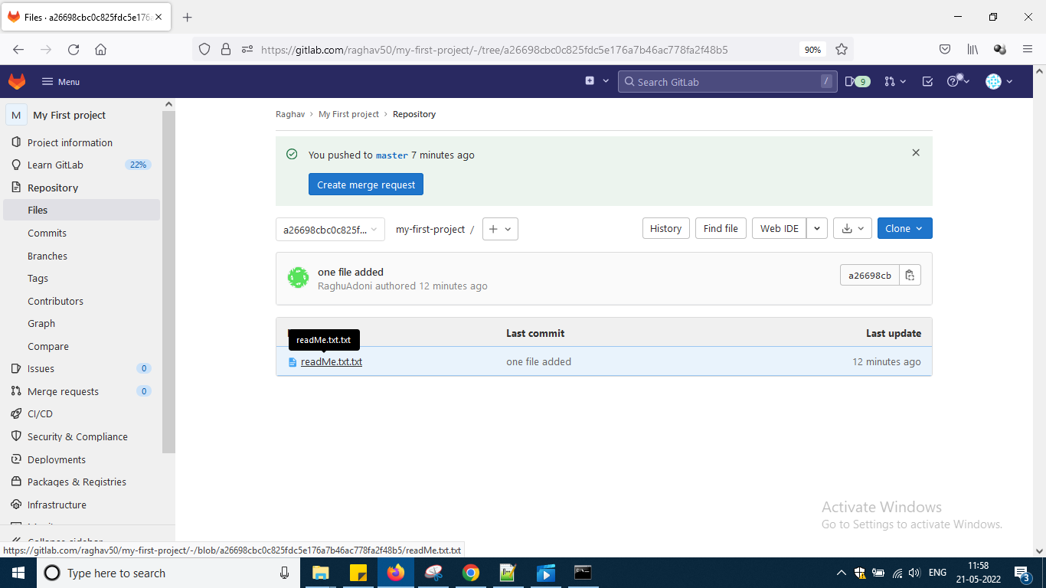

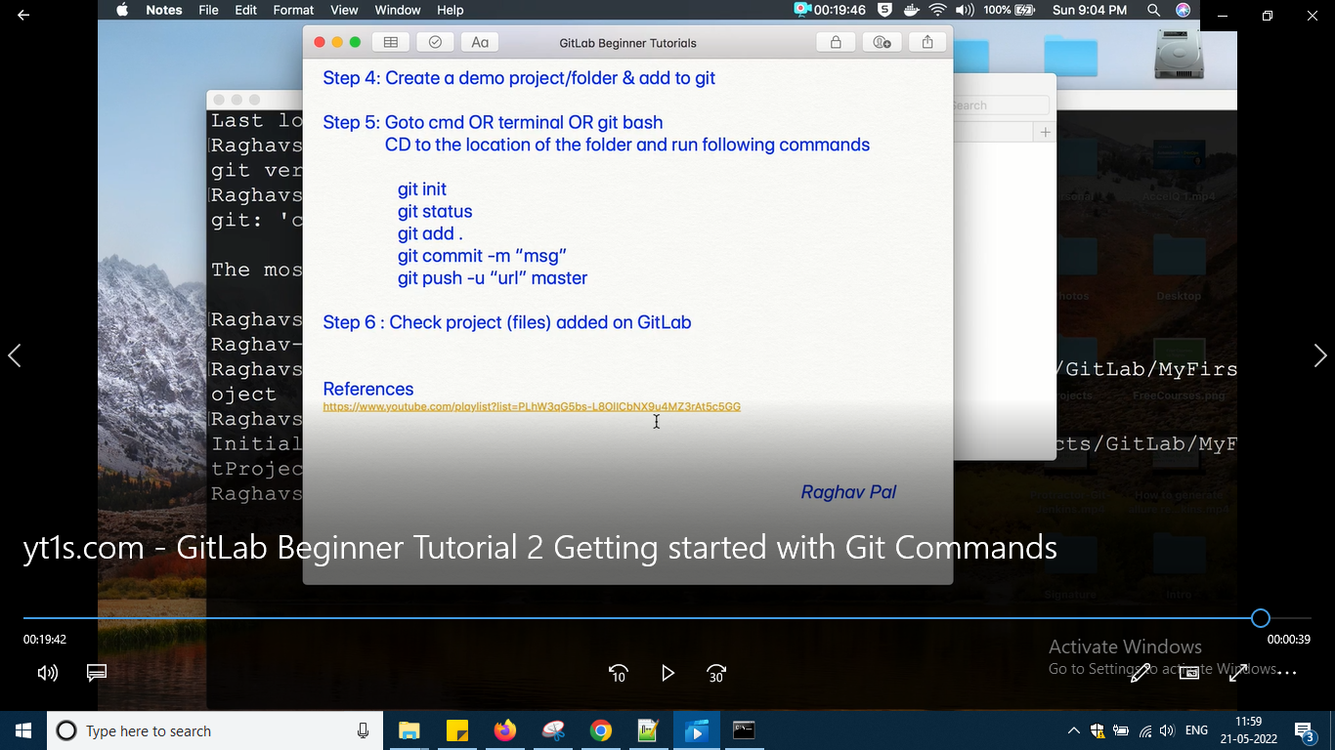

So this is the step 6 which i have done it okay

Check in internet different options of pushing to gitlab like here I create an empty project and pushed okay and existing one with empty pushing and etc just check it once okay and another thing by mistake I had given wrong name to branch good name not given then also graphically I cannot do locally do change it and push it again and all varieties of check it so after doing all this things u just need to refresh the repository in git lab okay .

And now moving to third video which is creating a fork and here fork is not equal to branch fork is a clone and branch is not clone it is another direction where user will go and work on project u can say

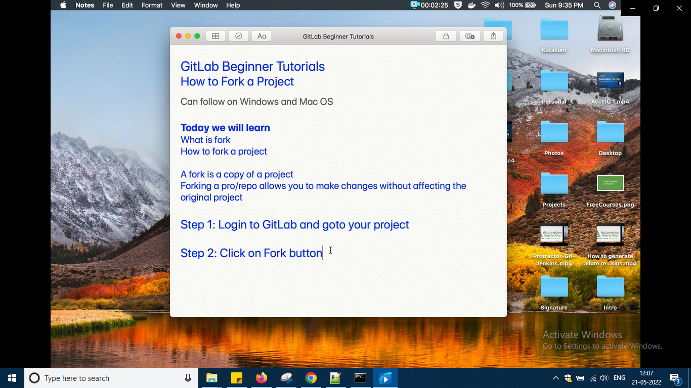

So my clicked on fork

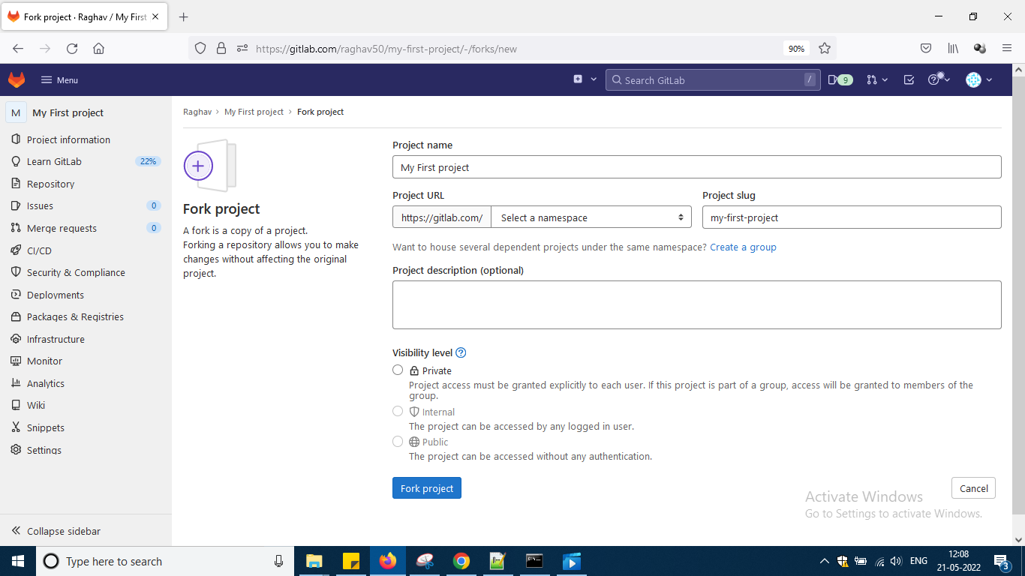

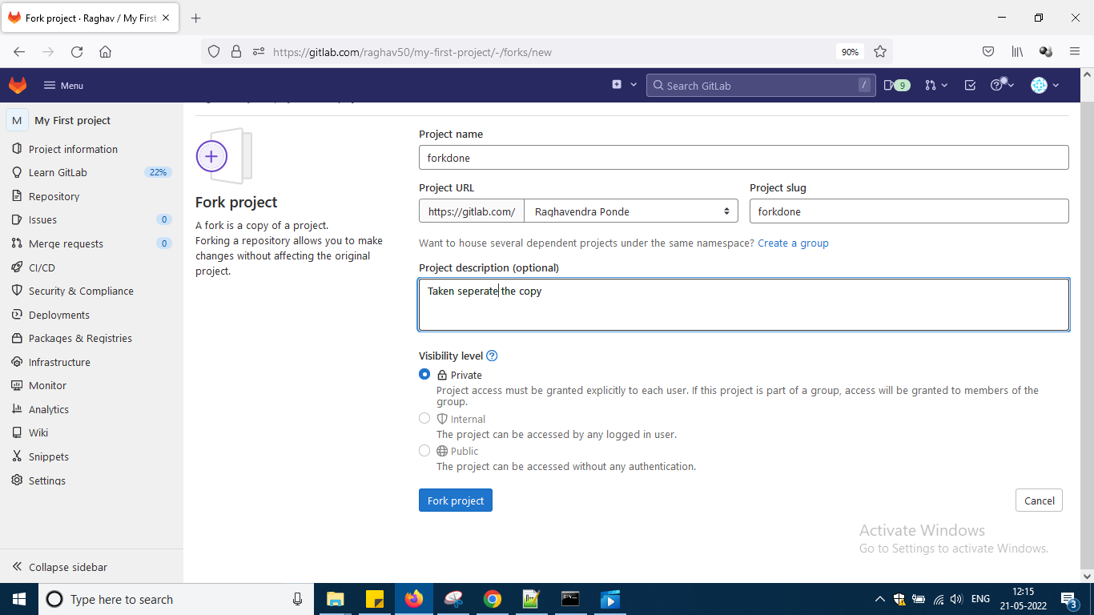

Give some name and default namespace selected and clicked button fork project

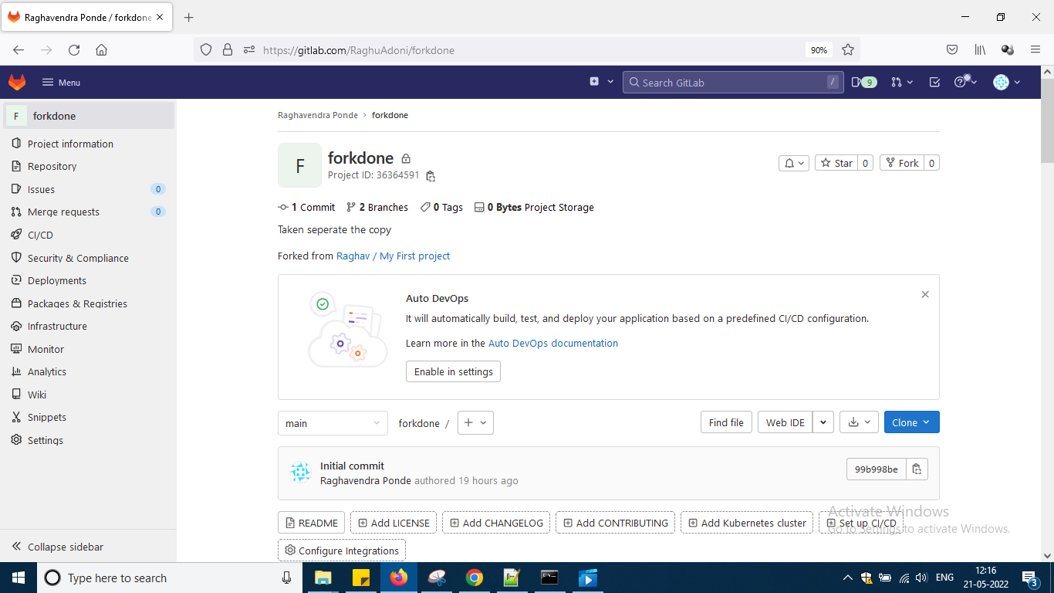

So separate copy is created here later on i can merge with master but i have not much change okay so will merge later

<https://gitlab.com/RaghuAdoni/forkdone>

This is the url of fork

And in this url also i can do some changes in my folder and can push like how i have done earlier in main branch okay

Next move to video 4

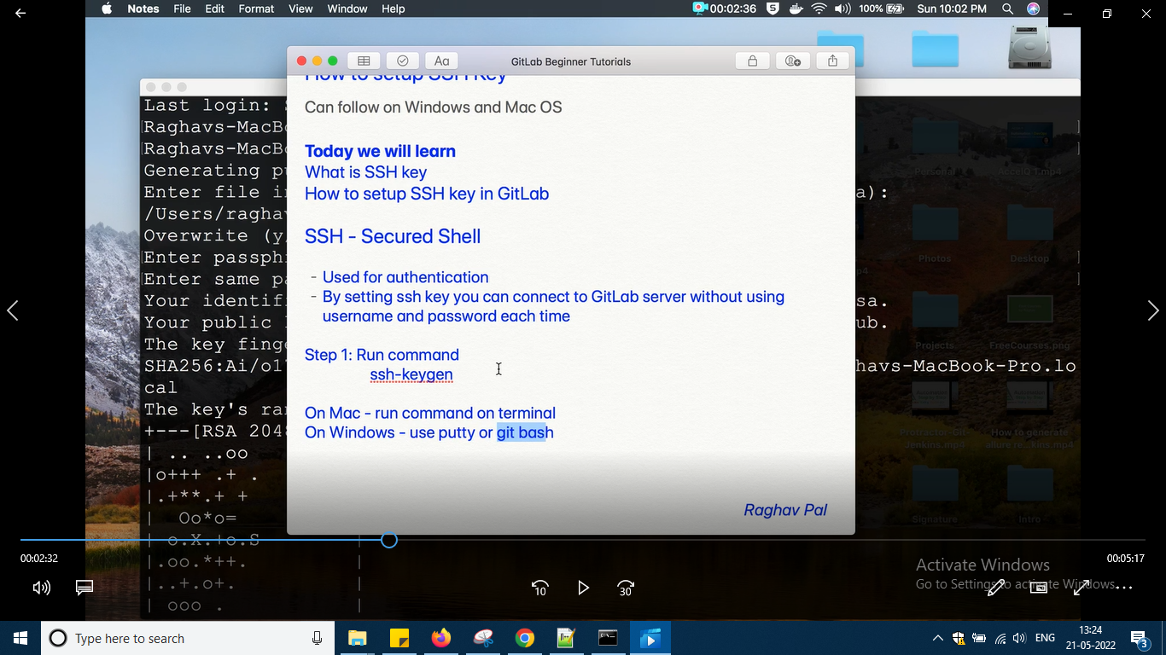

After open git bash just type the first command and after just keep on pressing enter

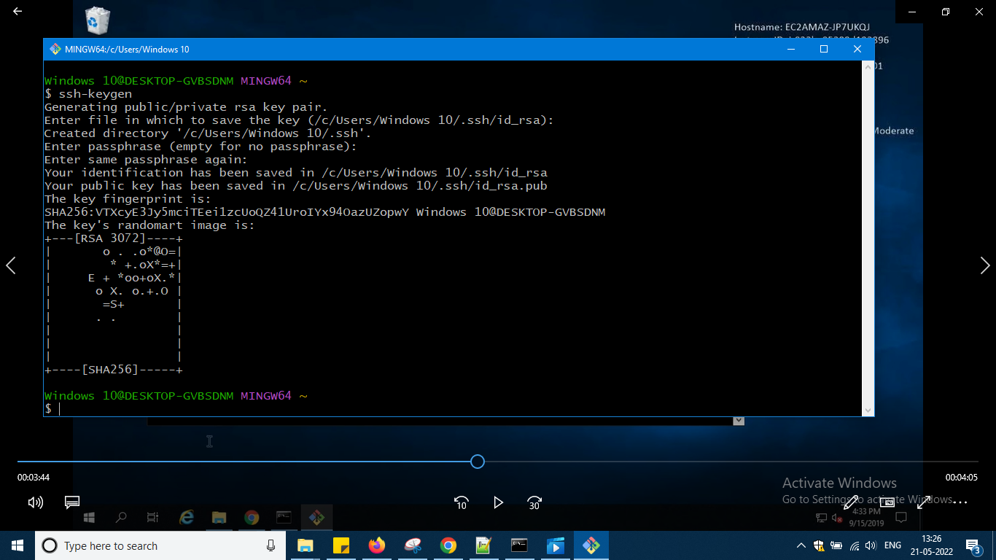

And let me go to the folder and check it

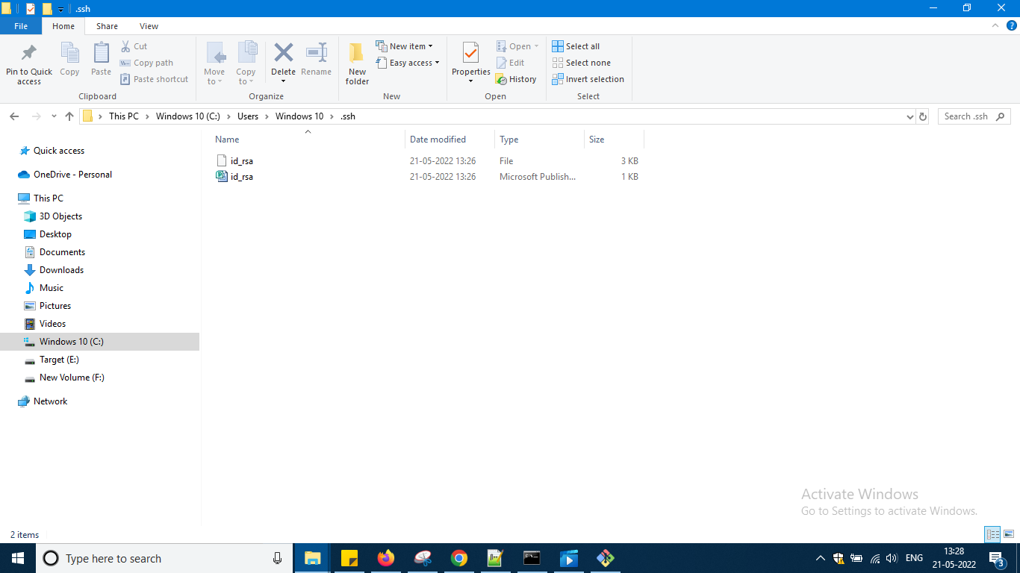

So it has created two files okay

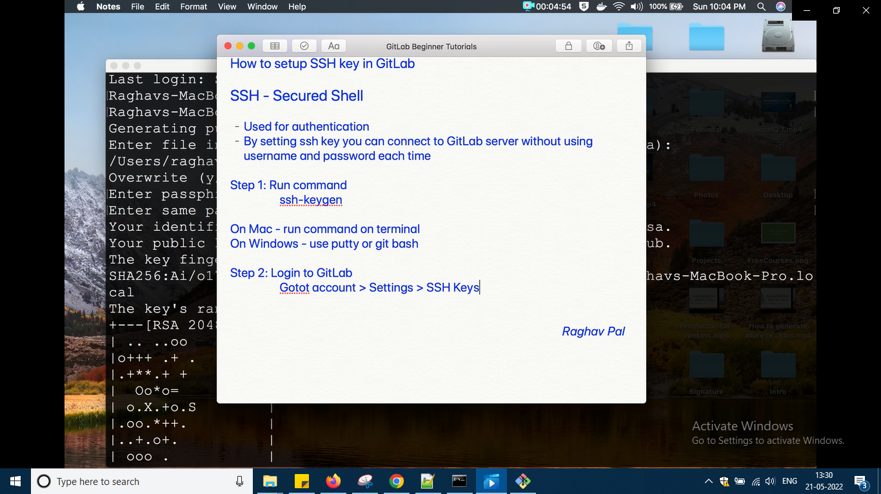

But this has changed now so go to preferences

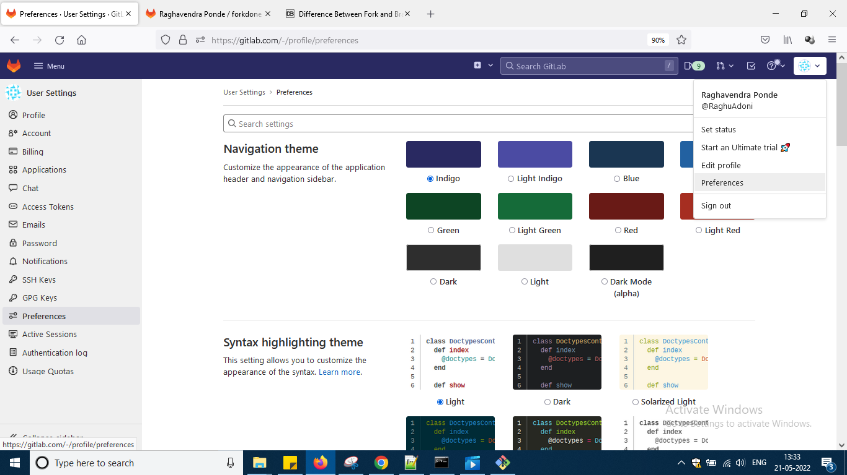

And then side by ssh keys

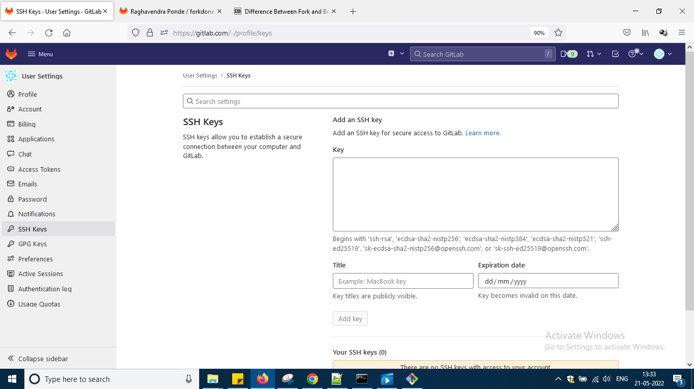

Now open that .pub file with any text editor

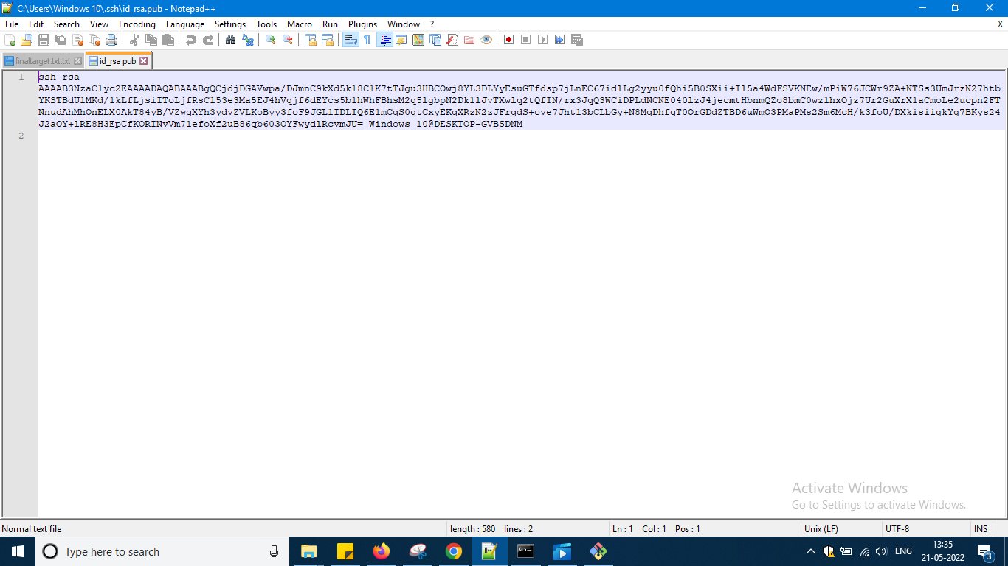

So some code like this i can see

Copy this code here

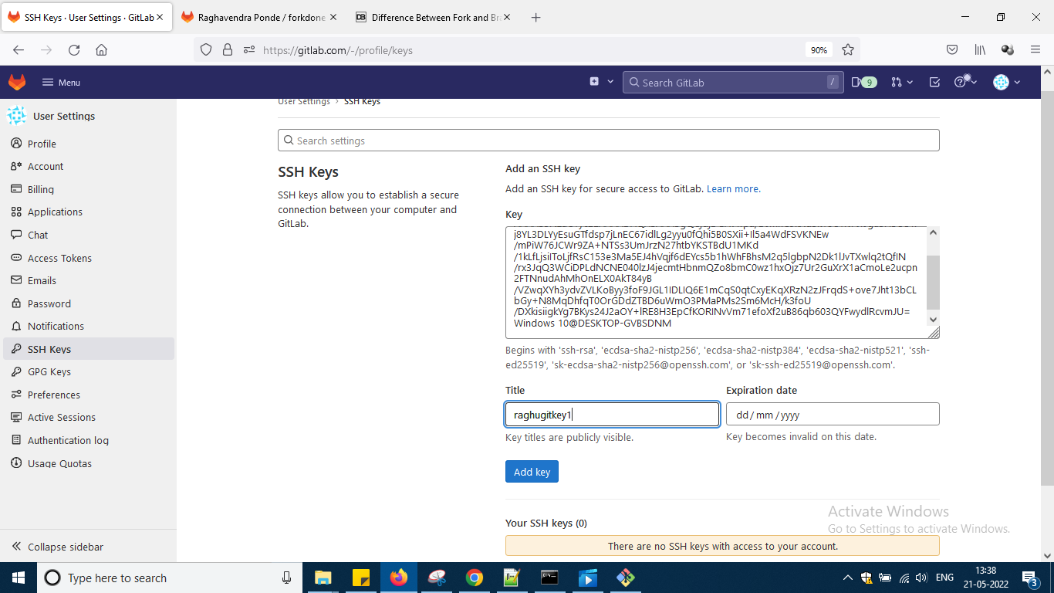

And give some name to key and say addkey

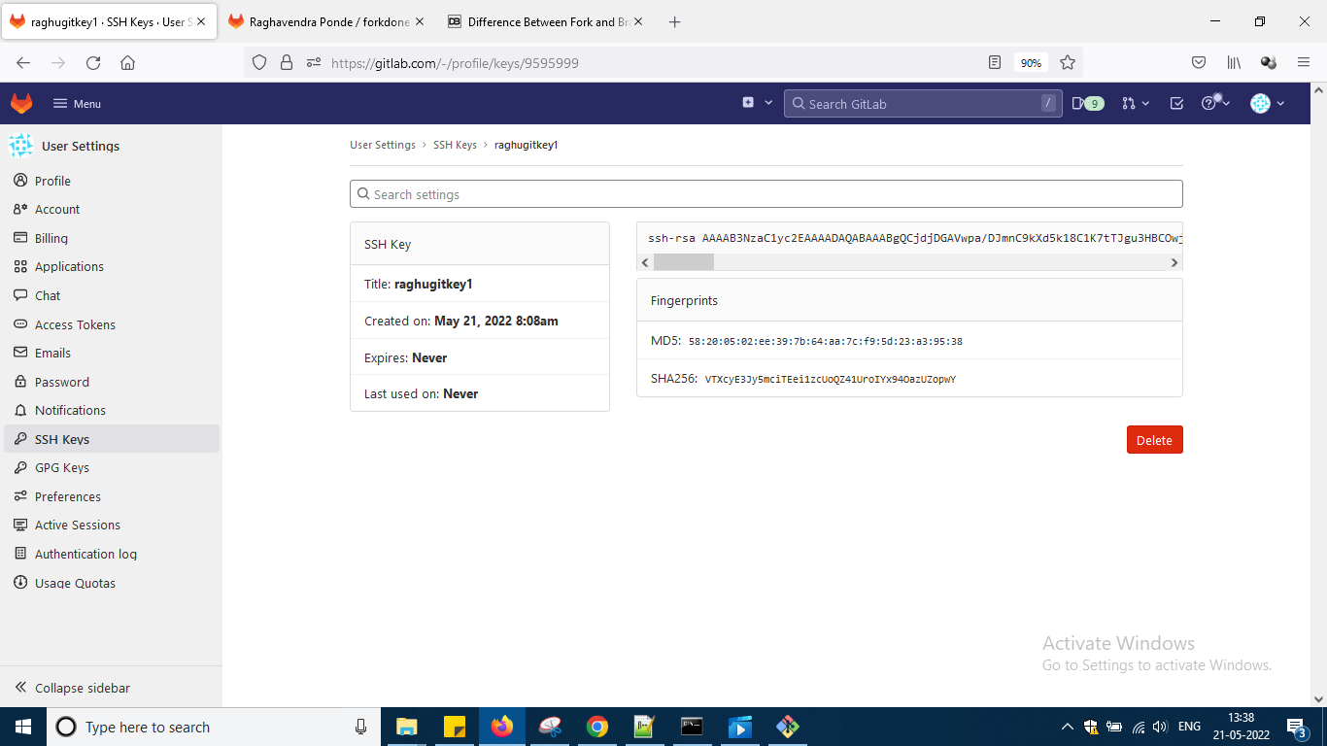

Something like this i am getting

So according to him steps

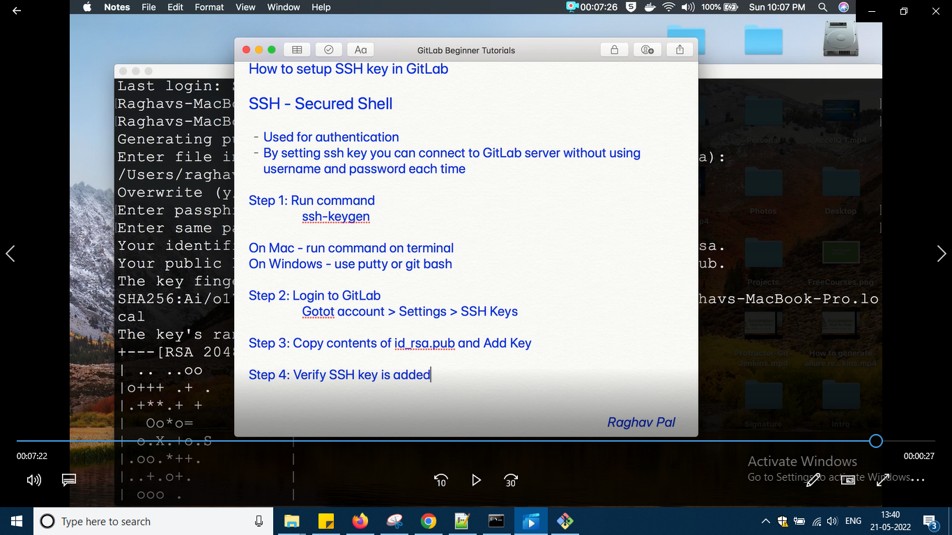

Which i had done

Now in the coming session we will discuss how we can use this ssh key .

Next video is on

How to install Git lab runner on windows os

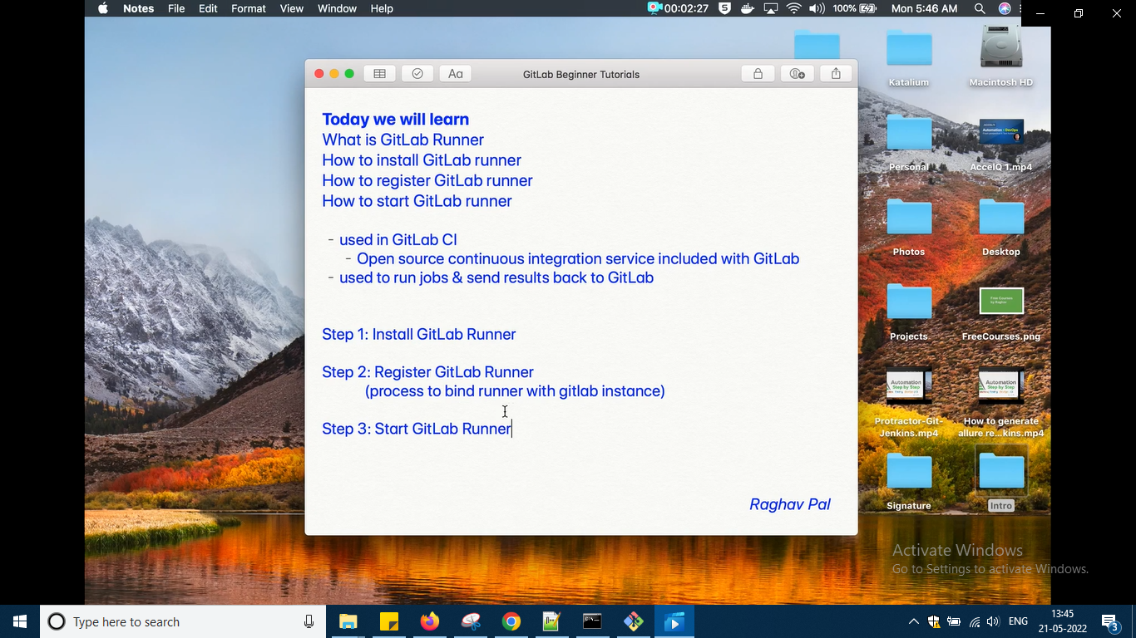

CI means i need not have to do modification and again upload in github or gitlab if i put in gitlab ci any changes will take effect automatically and for this CI gitlab runner is needed and but what is git lab runner to create some jobs check jobs in sql okay

So steps are given i am doing the steps now

Go to google and write gitlab runner

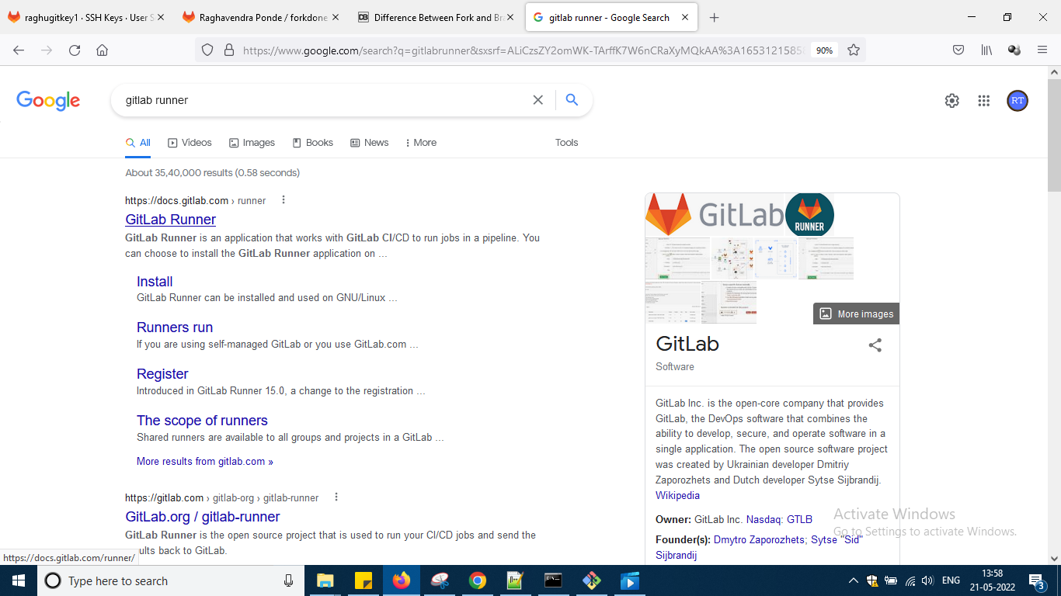

Come to documentation page

<https://docs.gitlab.com/runner/>

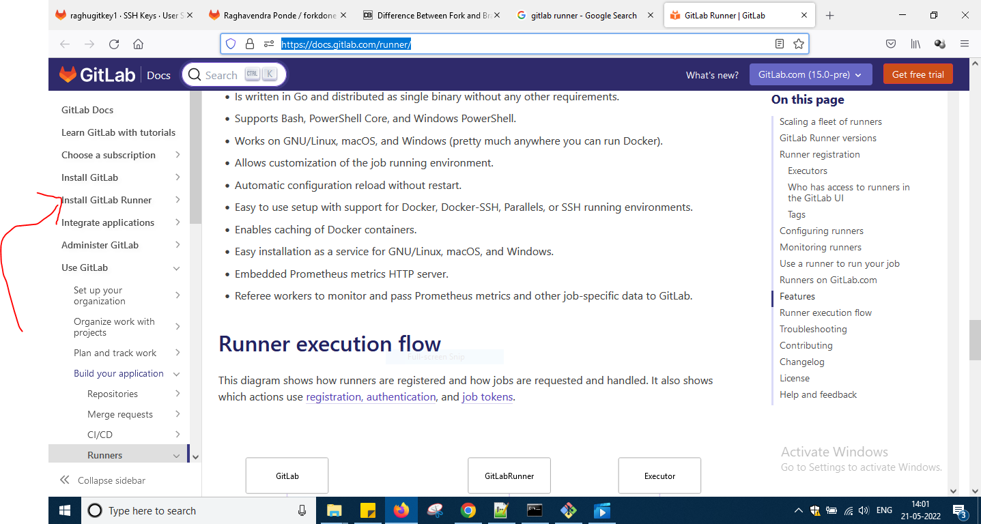

So click that section now

<https://docs.gitlab.com/runner/install/>

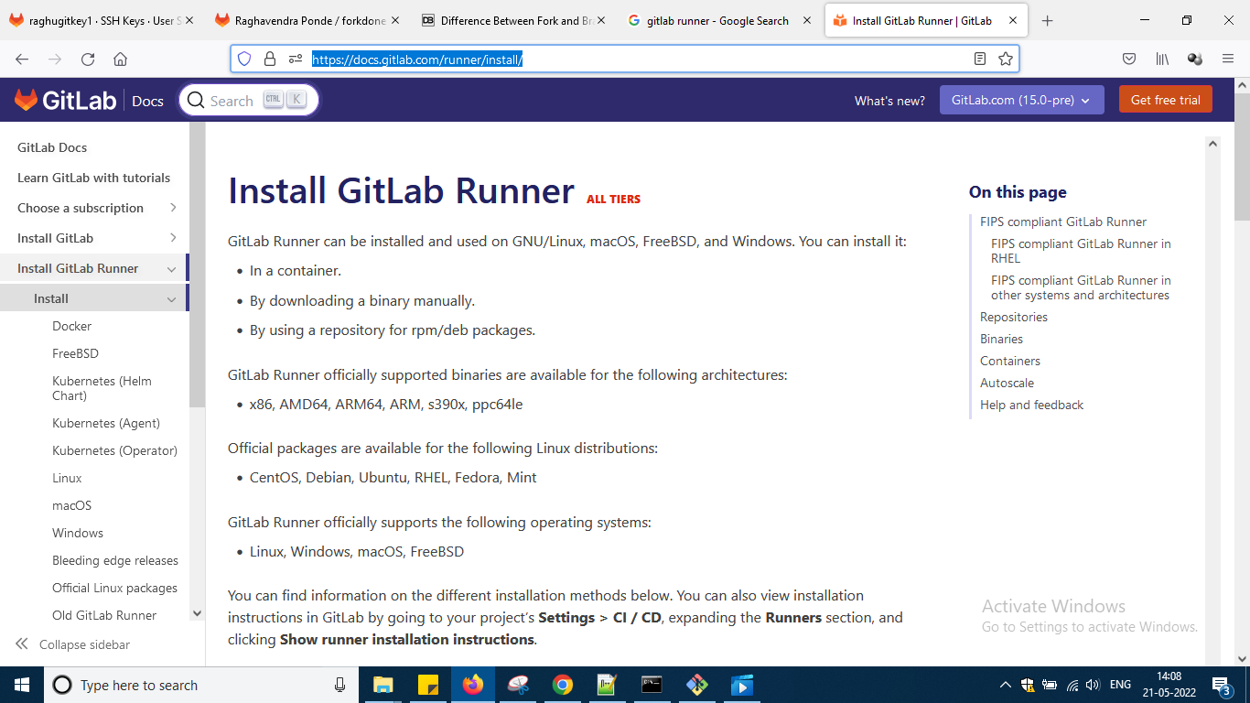

Still scrolling down the page we can find different options

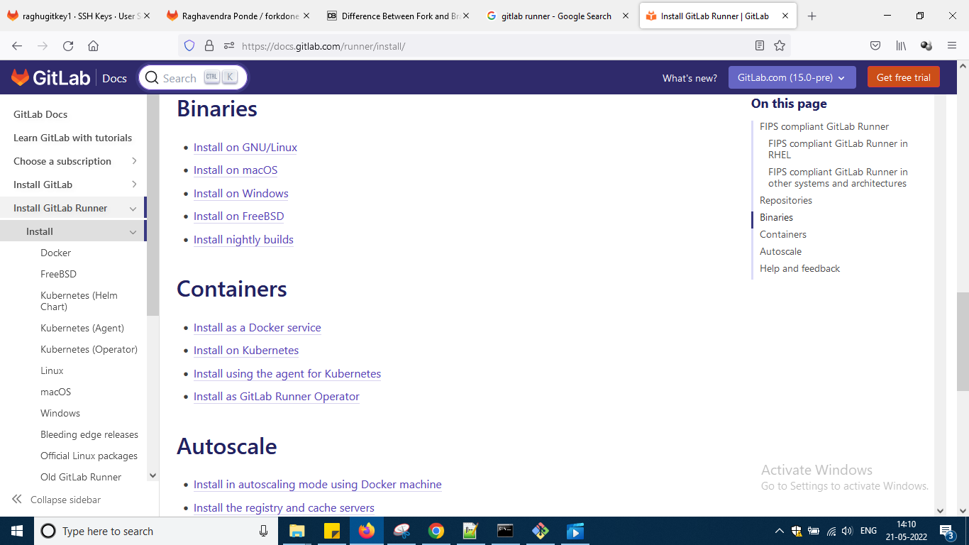

Click on the link install on windows in binaries

<https://docs.gitlab.com/runner/install/windows.html>

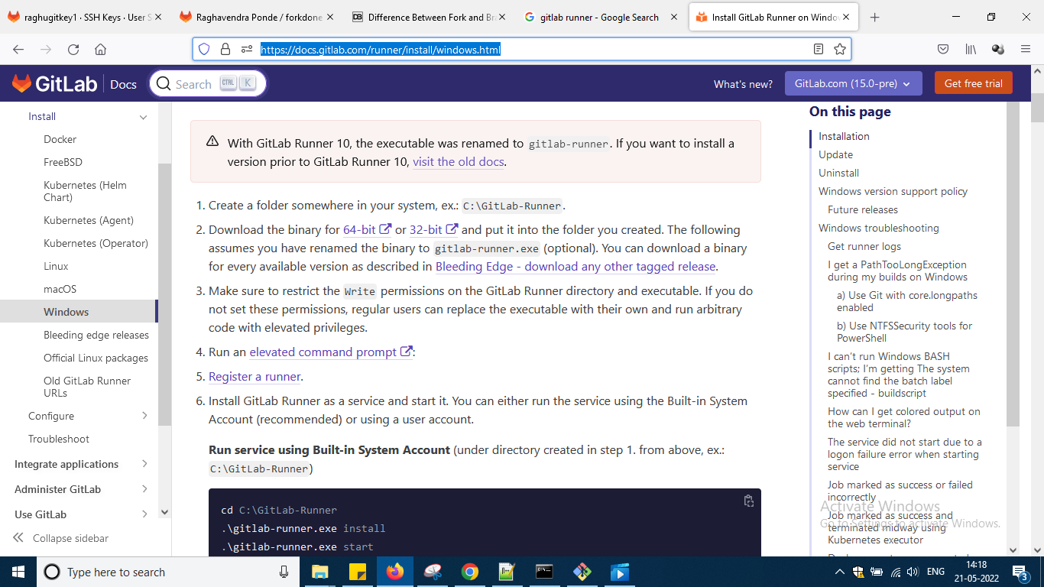

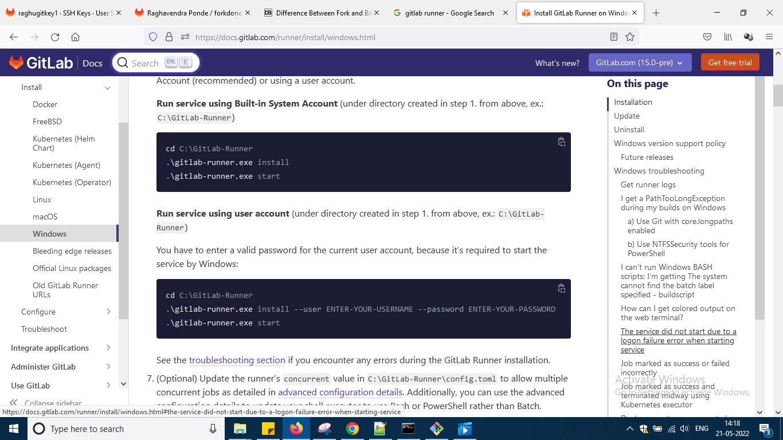

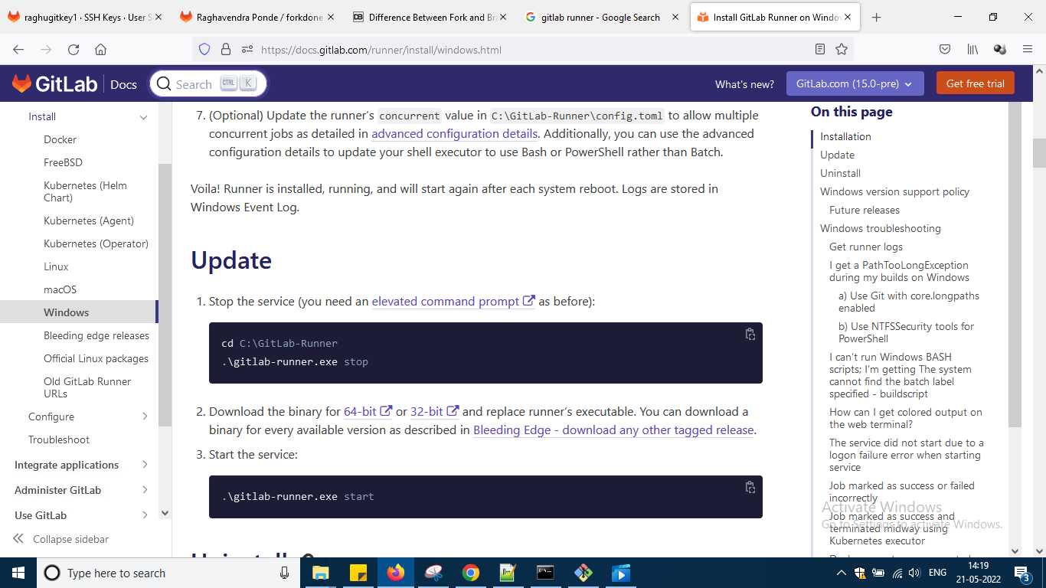

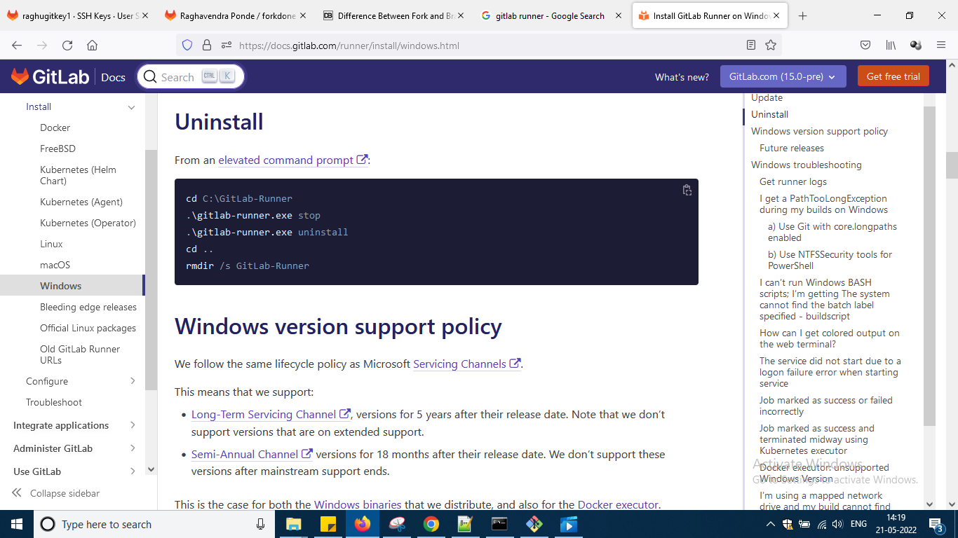

So all i had pasted here

So as per instructions

Go to c drive and create a folder like this and u can create anywhere okay

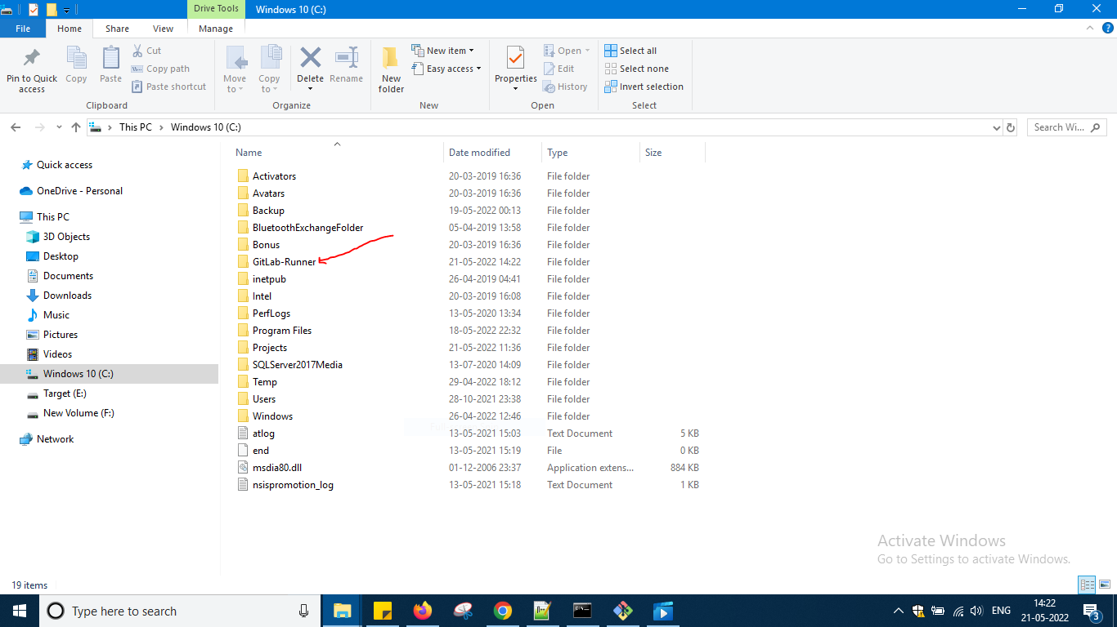

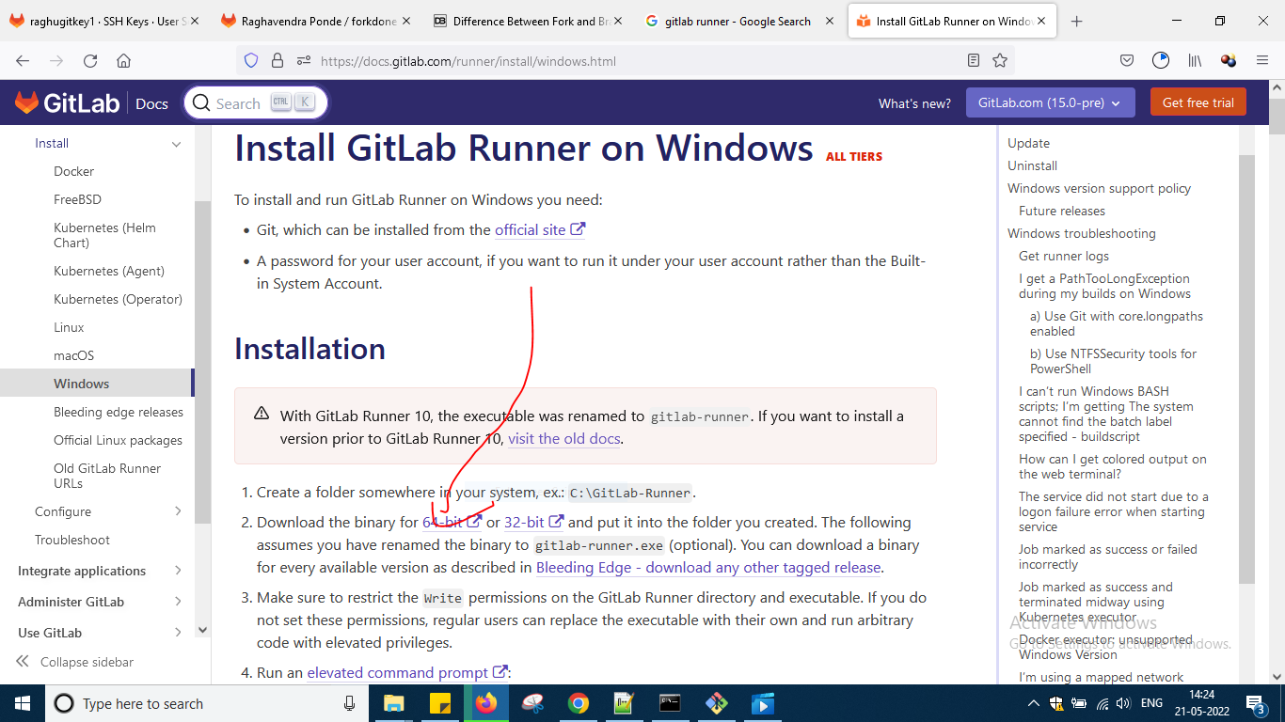

So download the binary for 64 bit

And paste it in GitLab-Runner folder the binary exe

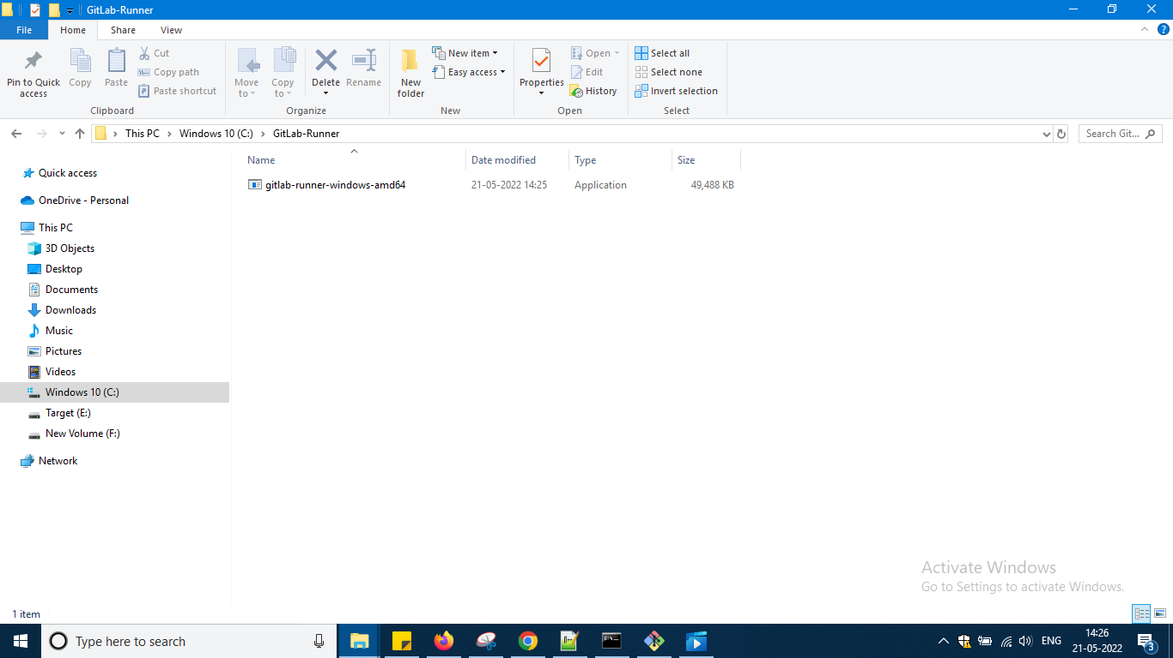

And renamed to

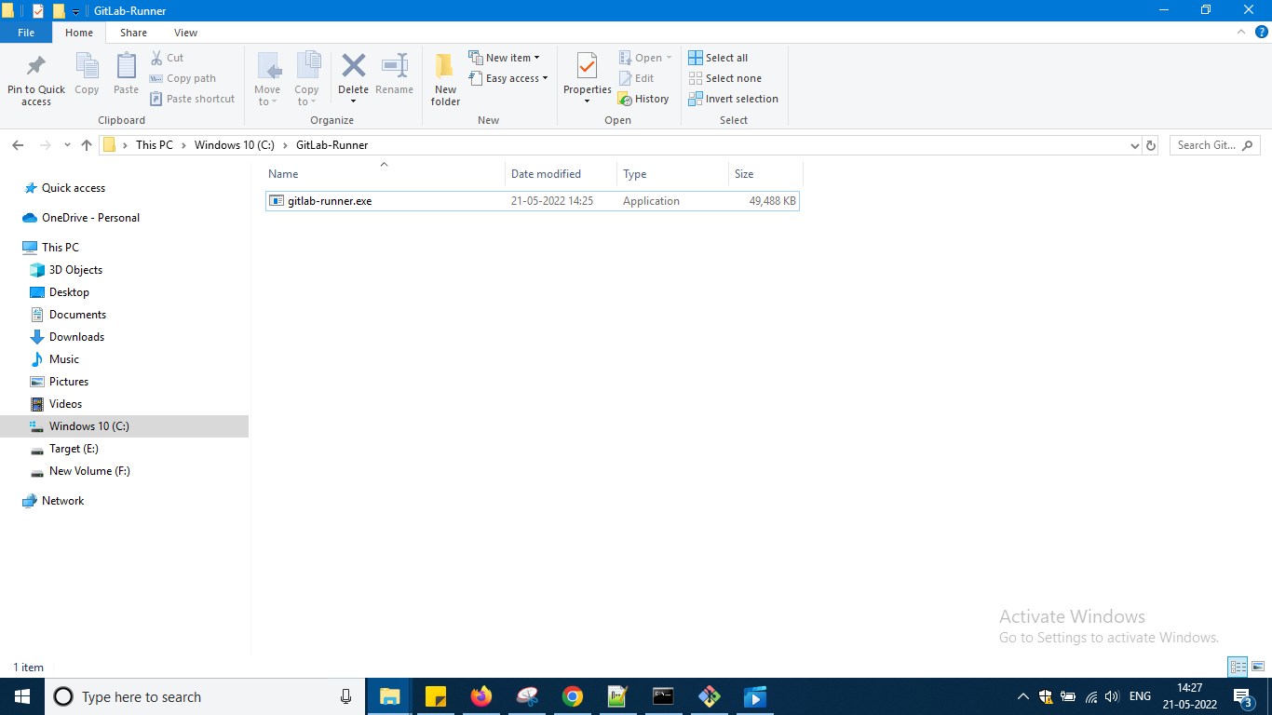

Next open command prompt as administrator that is what elevated means i guess

And type the following command



And the version command is not working

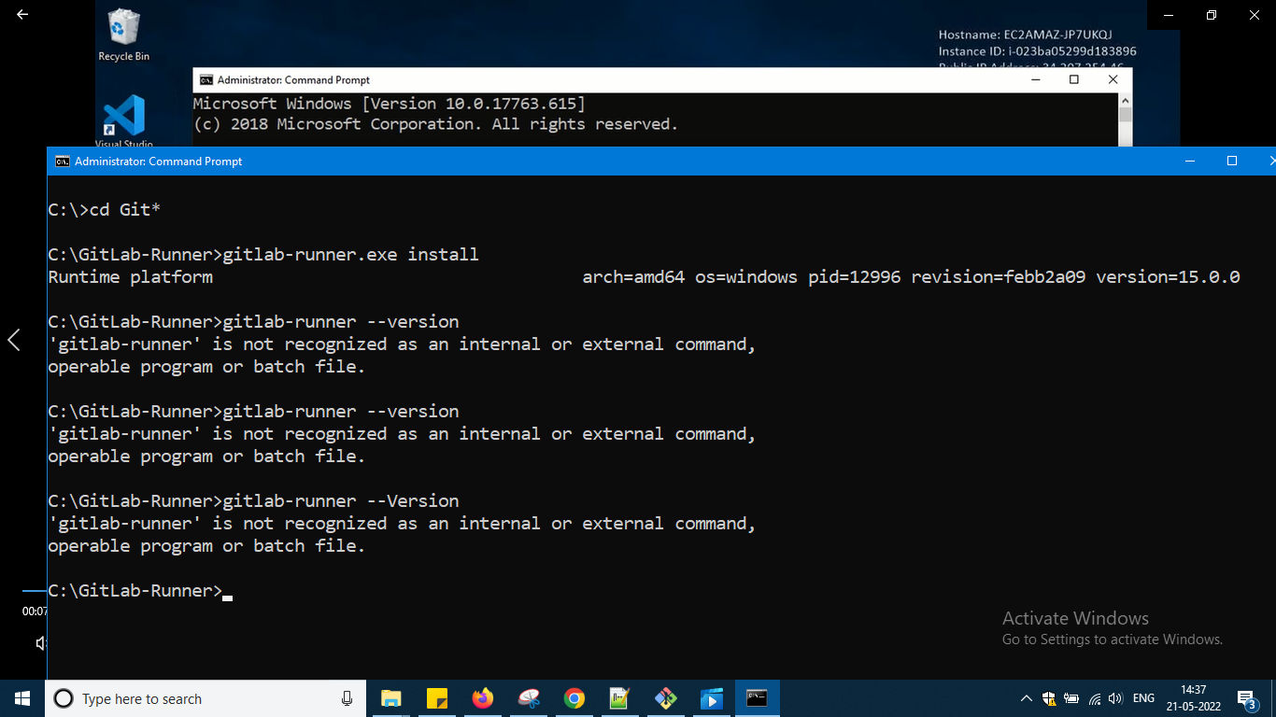

Let it be

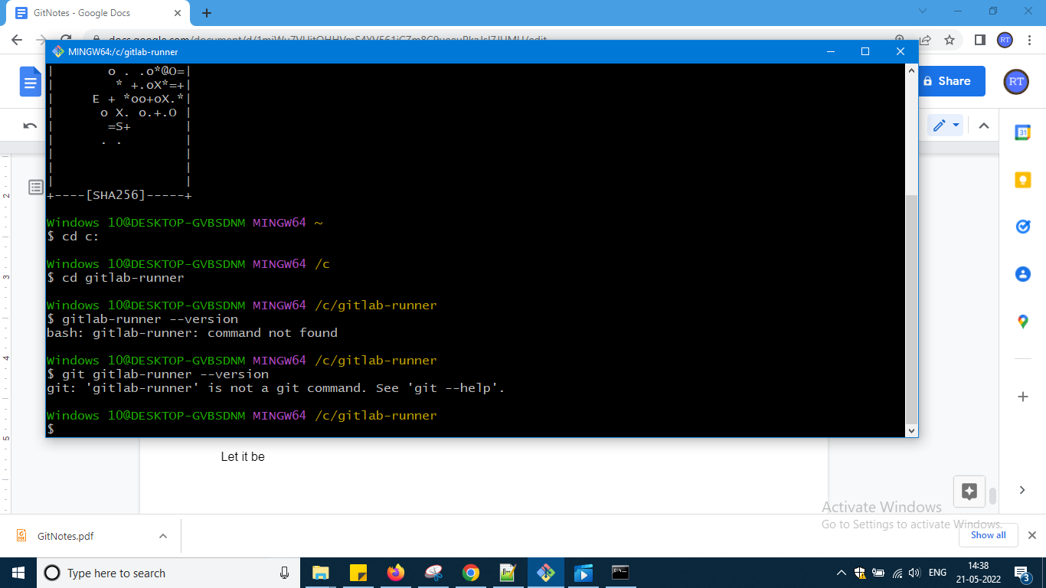

In git bash also version command is not working let it be but it has got installed

And then i tied this

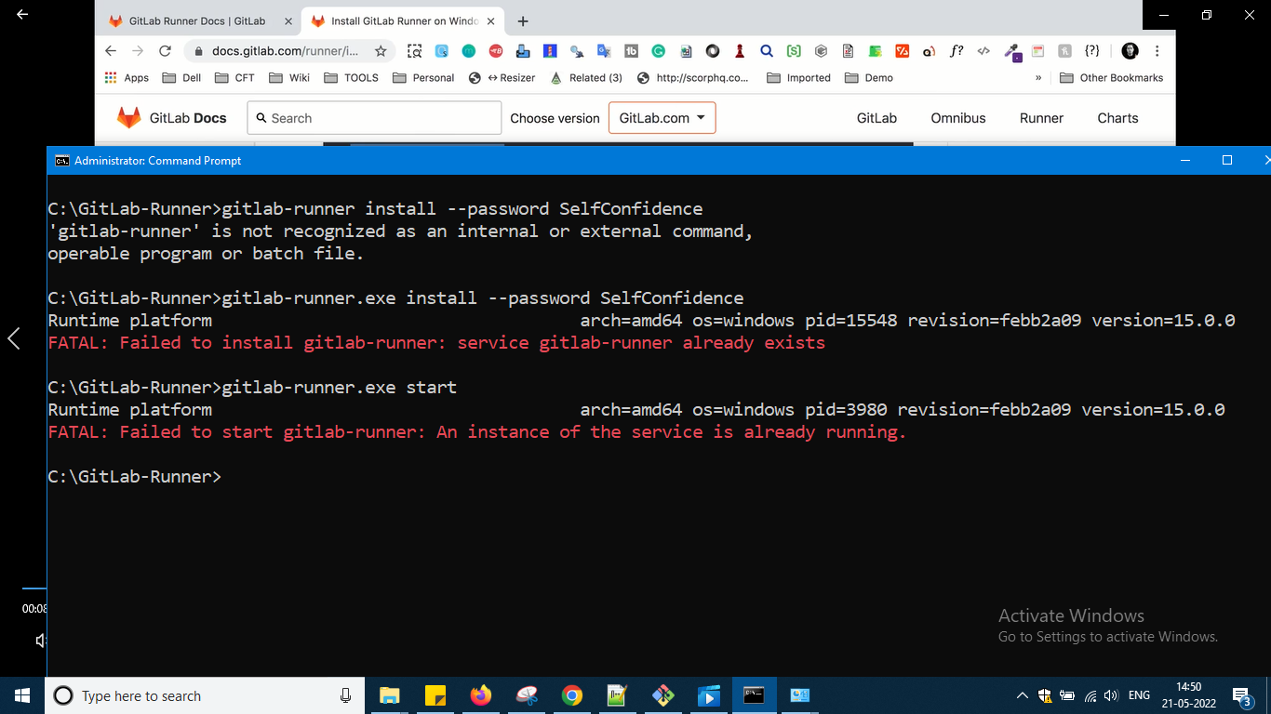

And done some troubleshoot from the documenaiton

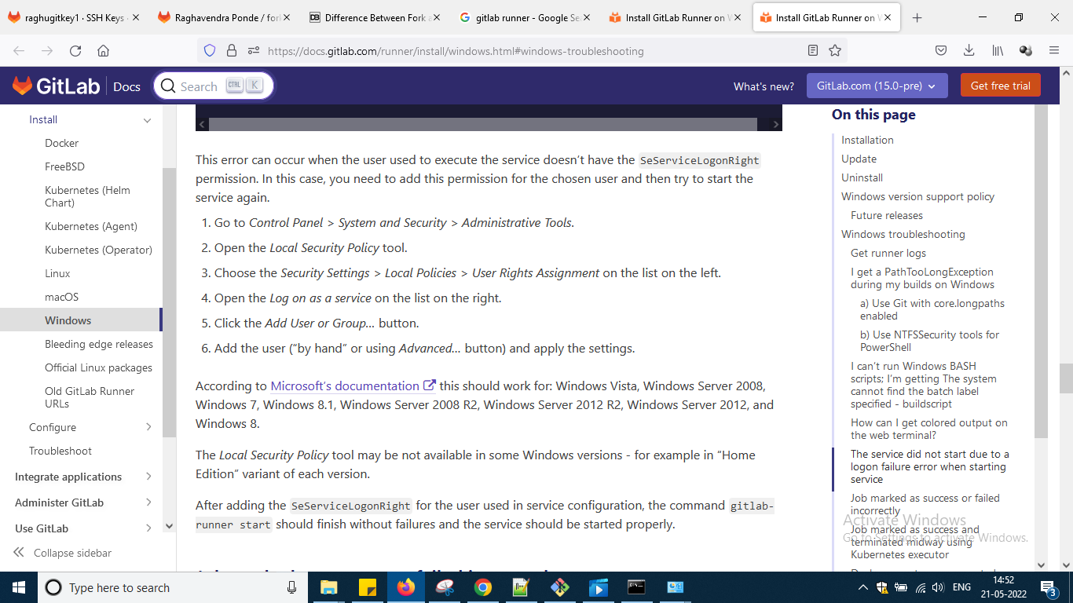

And then it is saying already running so it is running now now let me do other tasks

Now i need to register gitlab runner

So there is a link for that

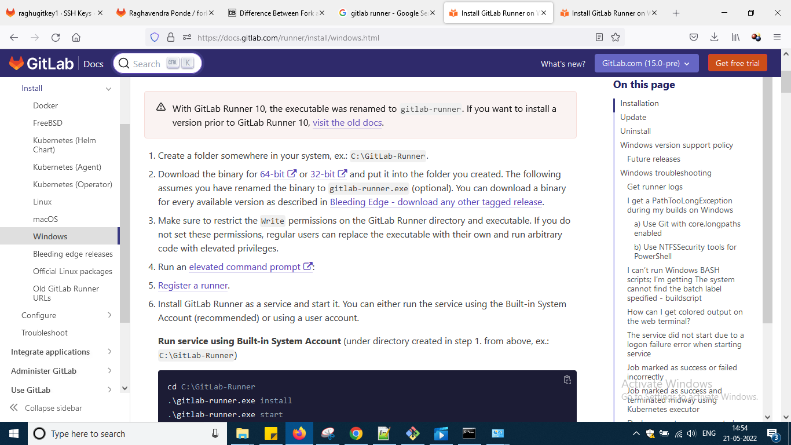

Click that

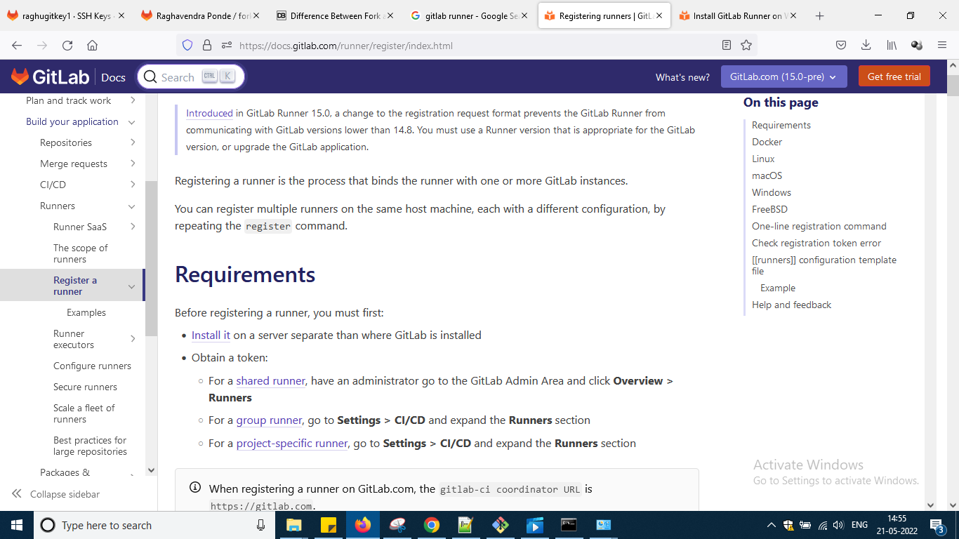

Scroll down and look for windows

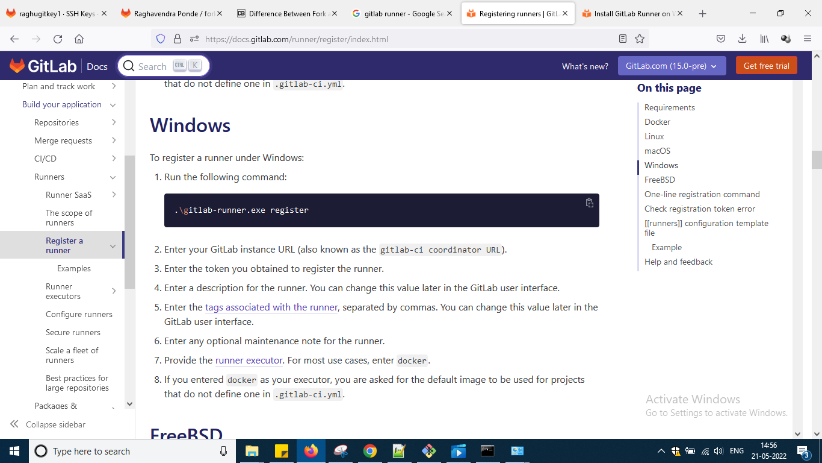

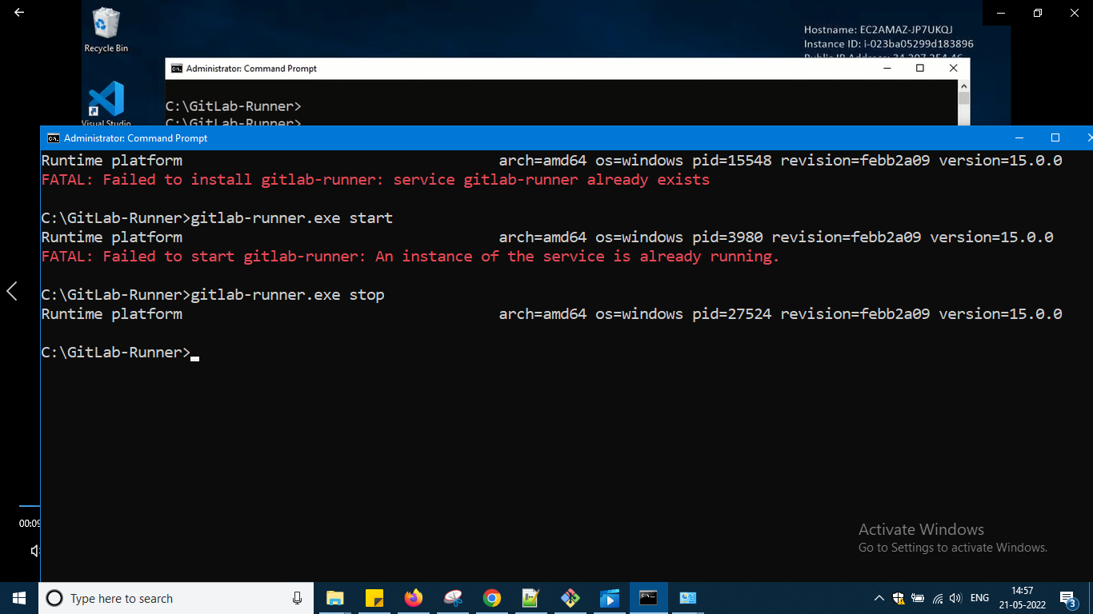

Once stop it and then

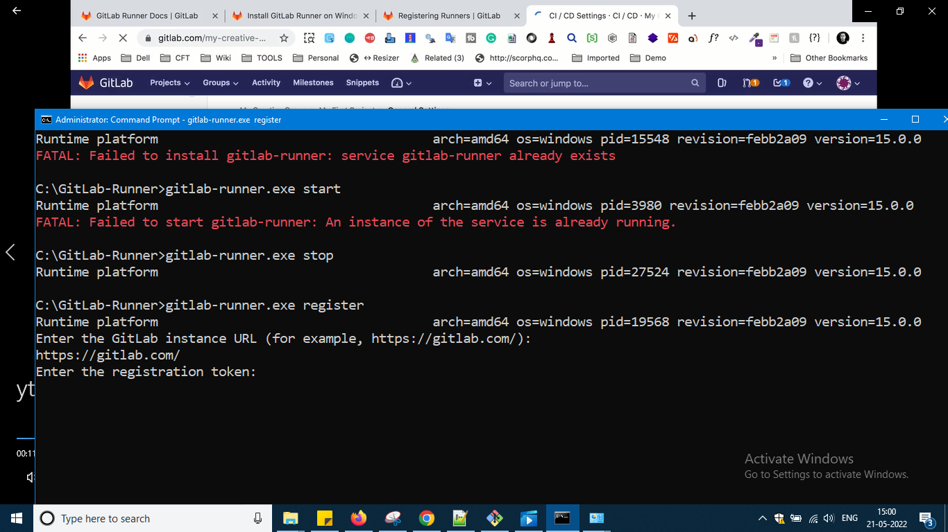

So now typed register and gitlab url pasted and now token asking so go to gitlab

Got to project and in that setting and in that ci cd

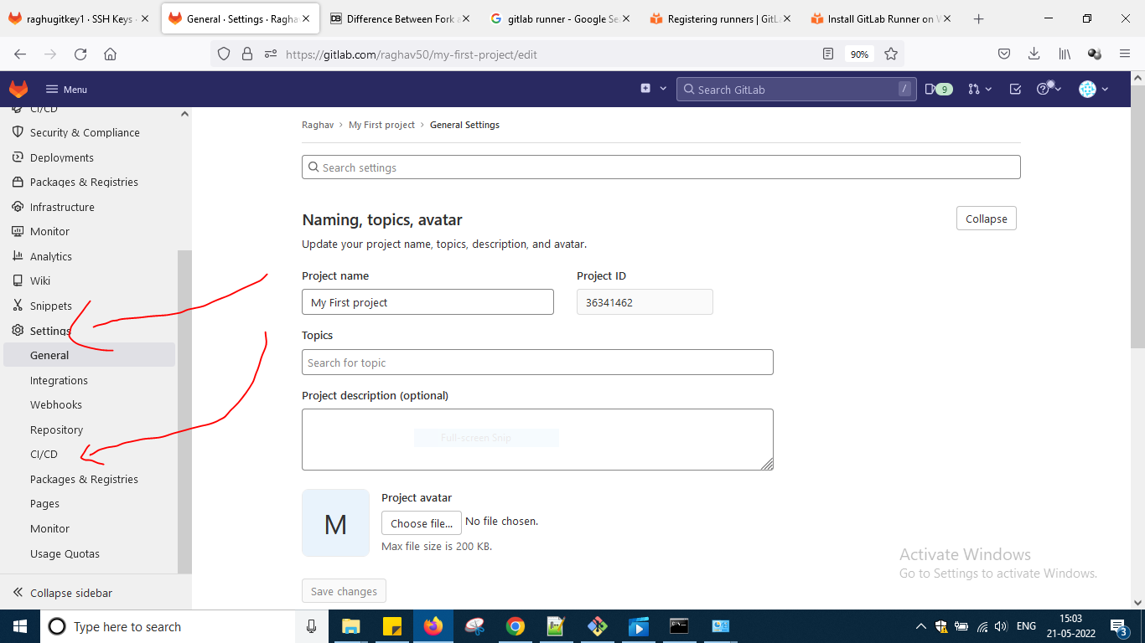

And in that runners and expand

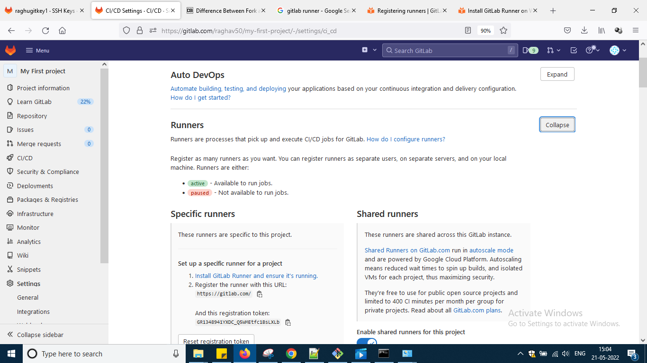

After scrolling

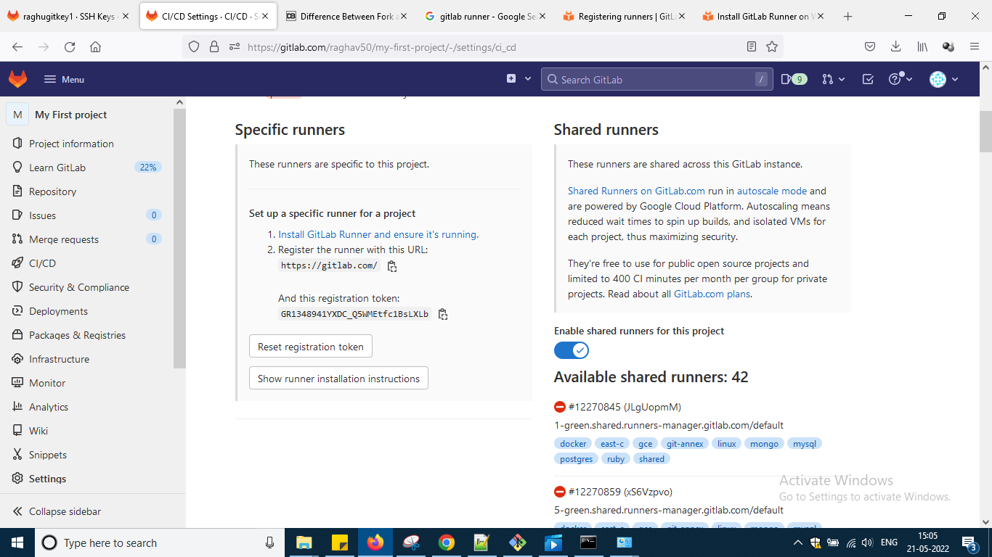

So u can see there the token

Paste the token and after pasting the token

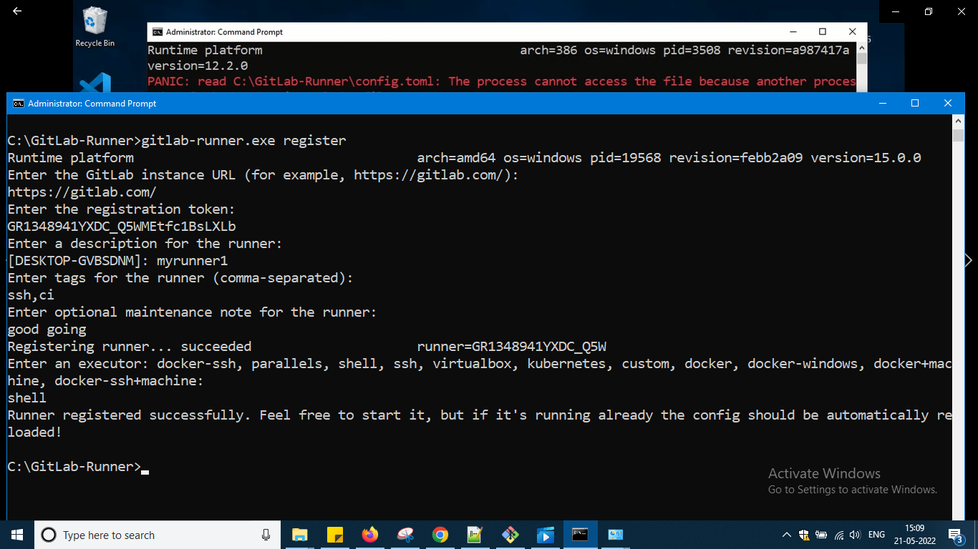

Some name i have given and this technology ssh,ci i will using said and optional note given as a new question they are asking and then chosen shell to execute okay

And now again i written this command which is there at the last okay u can check the flow i am in sequence of steps only

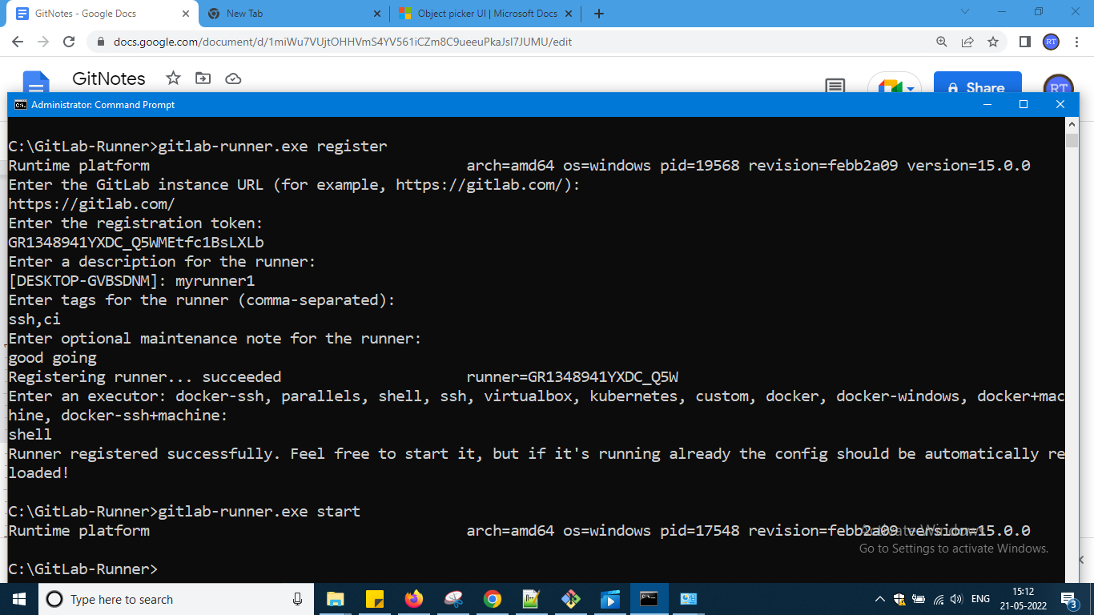

His slide

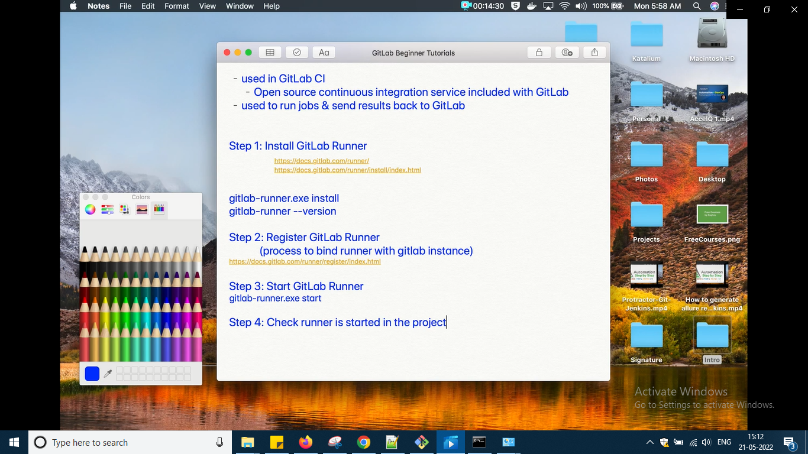

And now it is running in the project or not means go to setting and ci cd of settings and there down scroll where u have taken the token to copy

So under runners tab

It is there

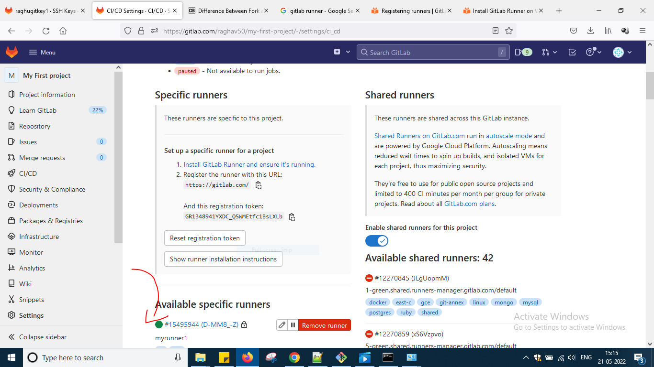

So this runner can run the job which we will c in the next video session which is the last one of this okay .

Now let us do CI CD demo last one

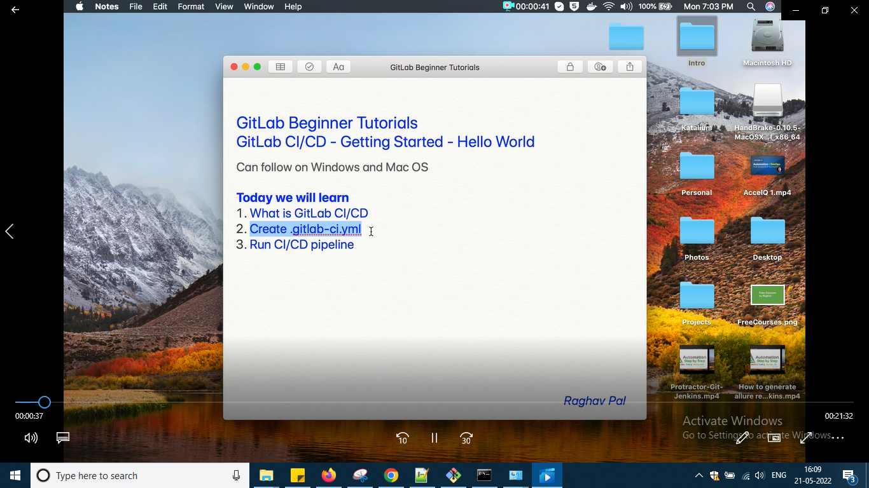

Look at the image

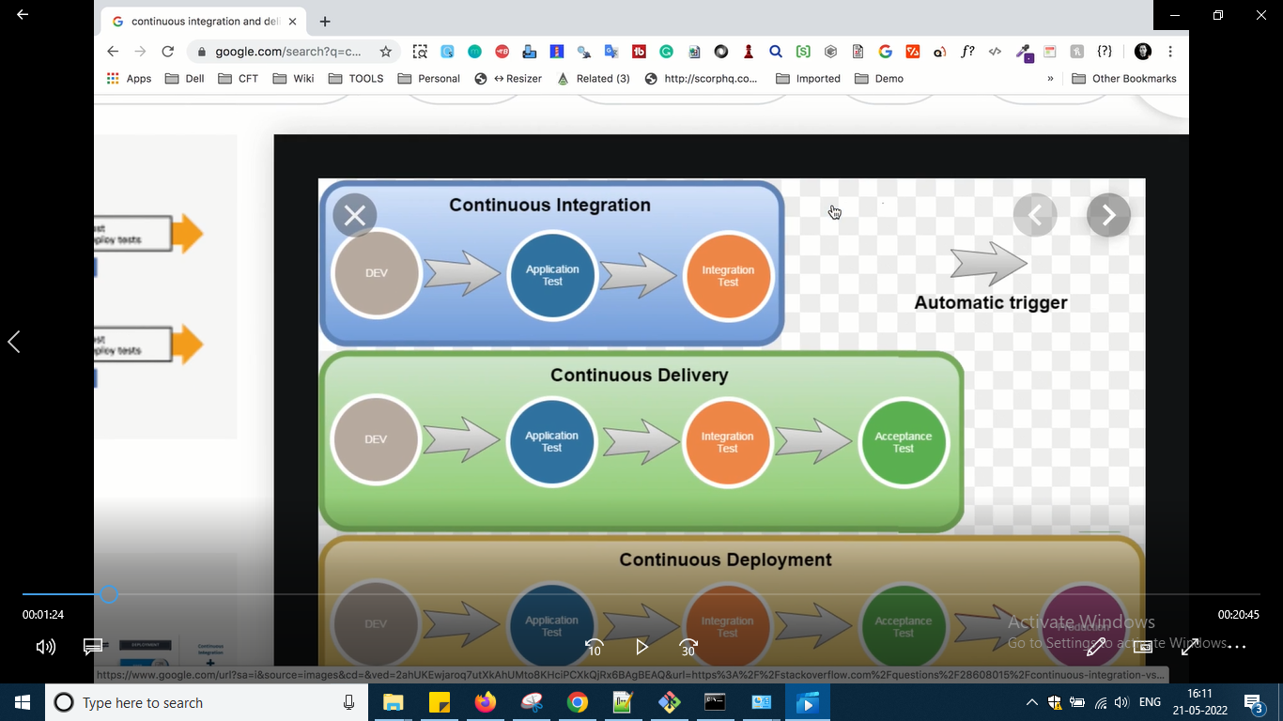

Check in google what is CI and CD

Here different jobs will be there after one passed it will trigger next and if another passes it will trigger next and they are pipeline so this is called continuous integration and same way if we added acceptance phase means continuous delivery we can call it okay later on we will google and youtube more go into theoretical parts okay

Here things will be automated and triggered okay …

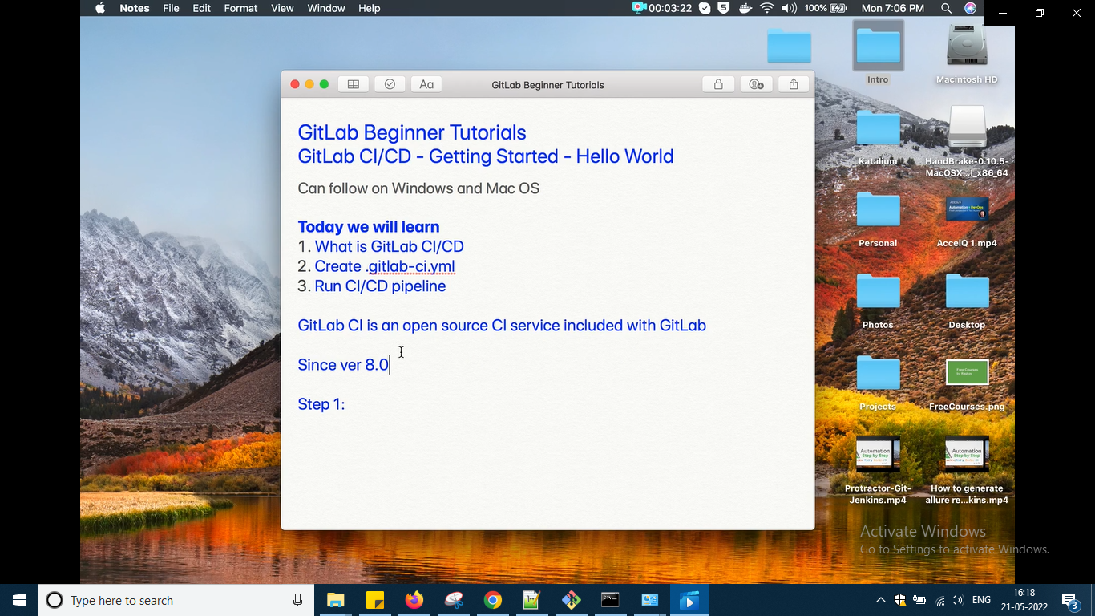

You should be owner for the project in order to run ci and cd okay

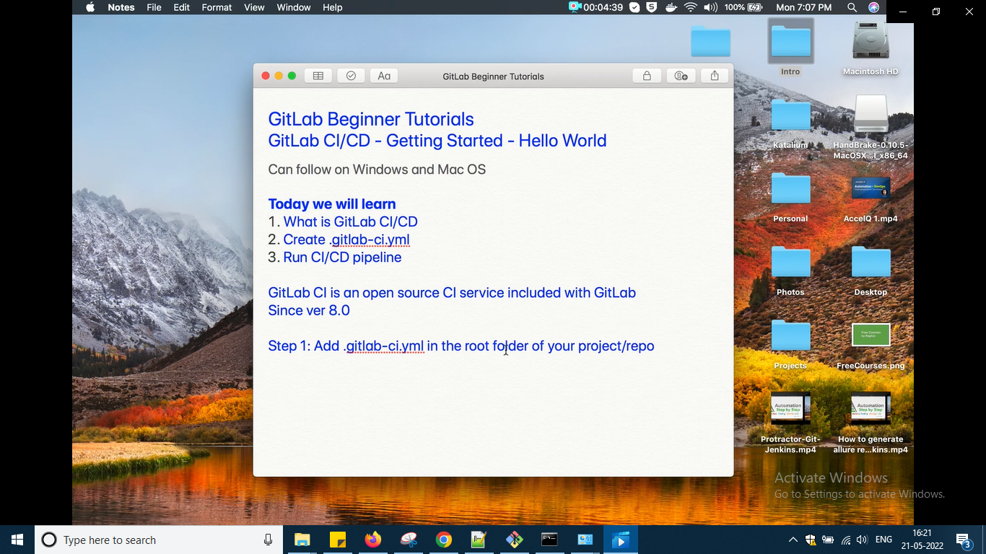

Yml is a format to write text files just like we have json ,xml and all

This is used to configure our pipeline and in every project we will add it okay .we will add the details and it will define the structure and order of the pipeline okay

So now in windows u can use any editor to create this file i am using notepad++ for this

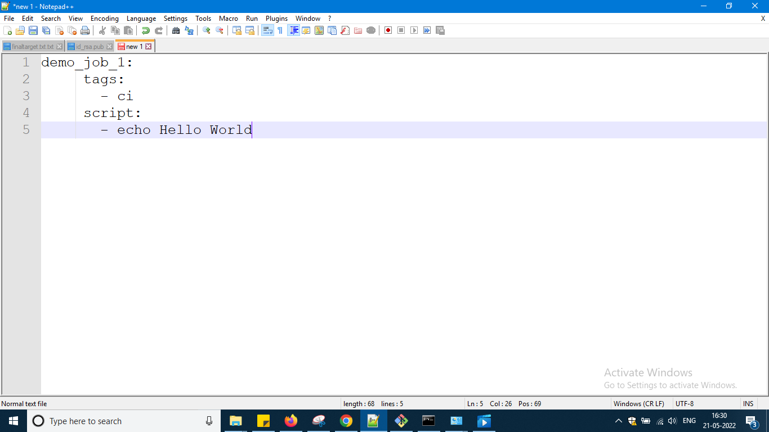

Here i am creating a job with the name demojob and tags earlier ci i have used in runner so so ci I am using it and one code hello world should run that's all i have written

To check whether the code is written as per the standards of yml go online paste the code and check it like babel earlier i had done

<http://www.yamllint.com/>

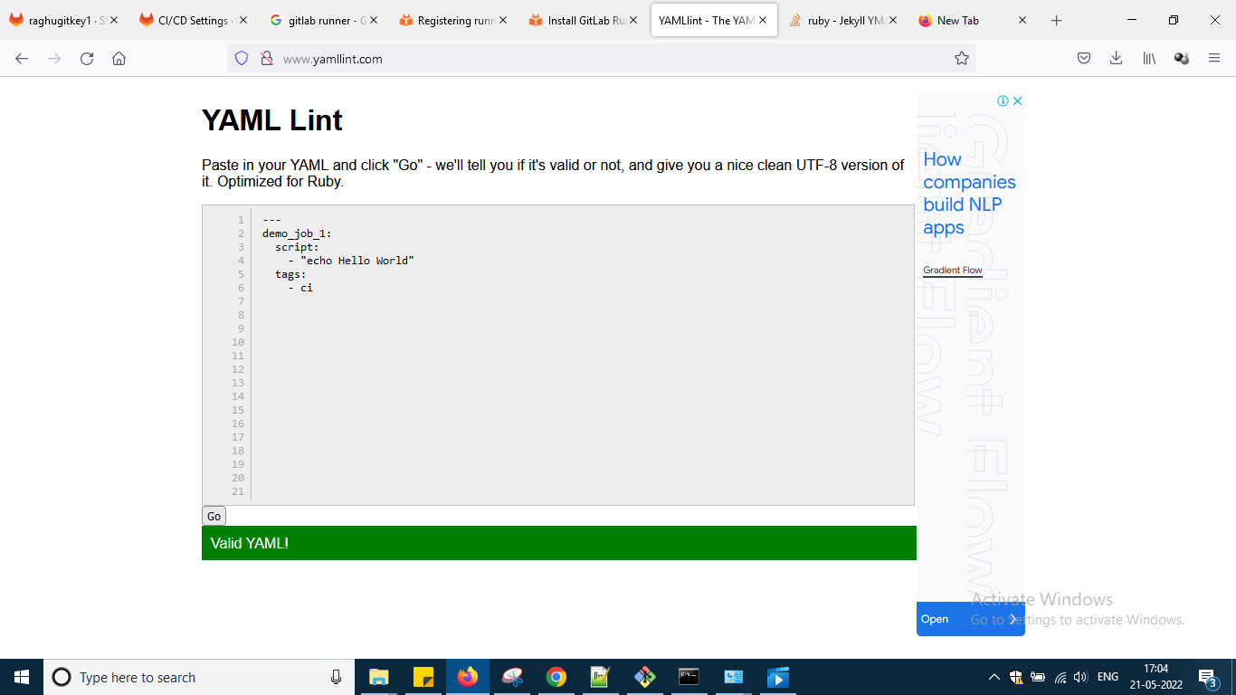

So tried writing it finally like his it worked

Now what

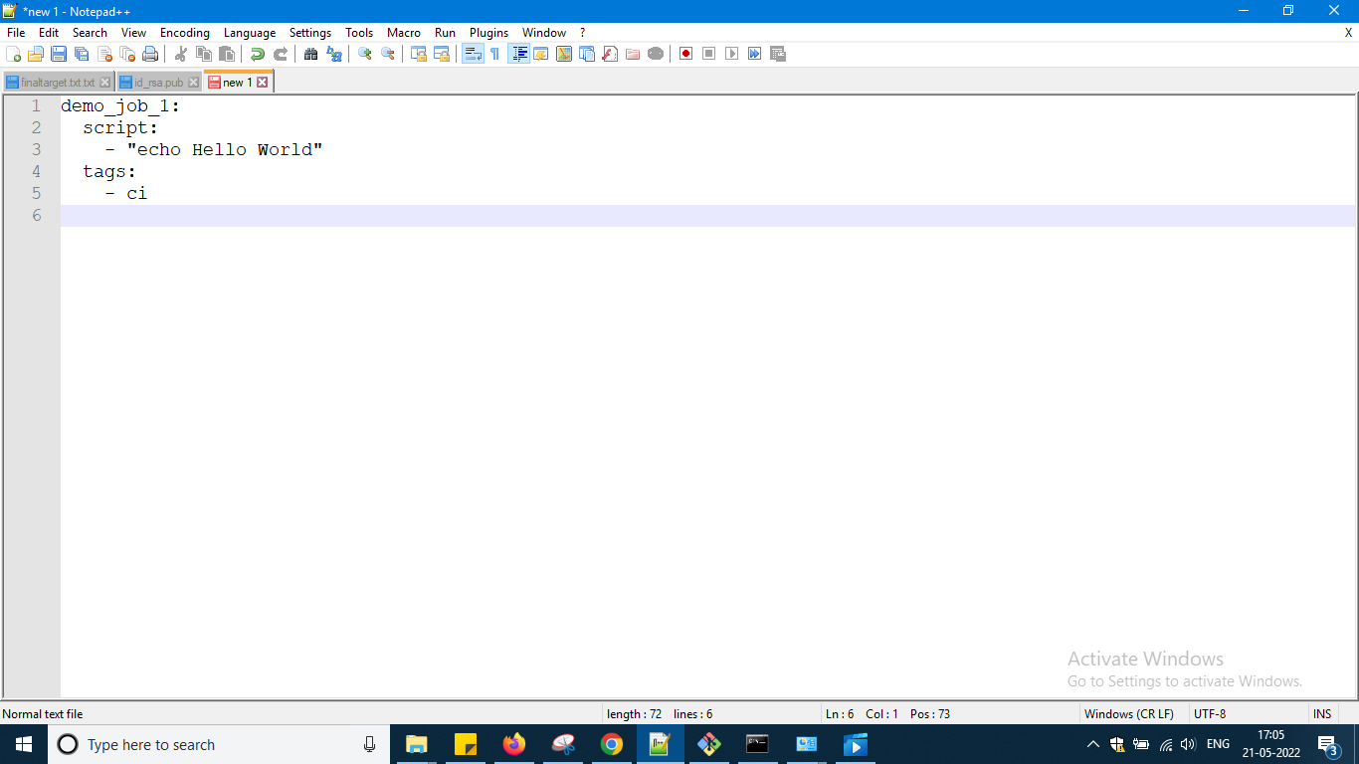

And now copy the file into my first project

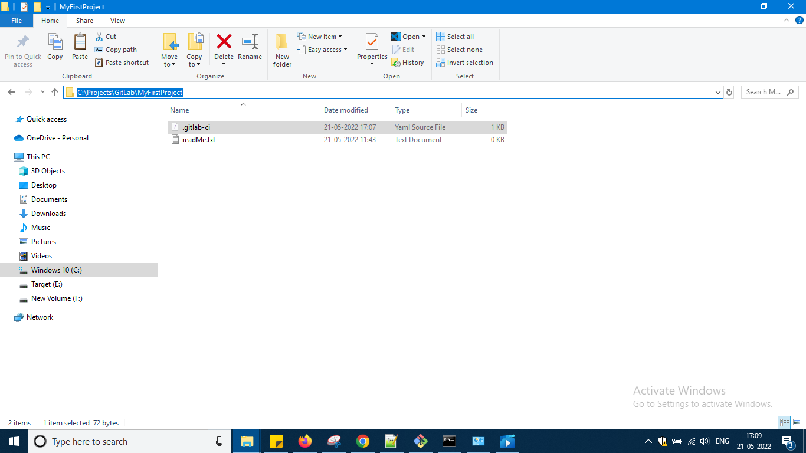

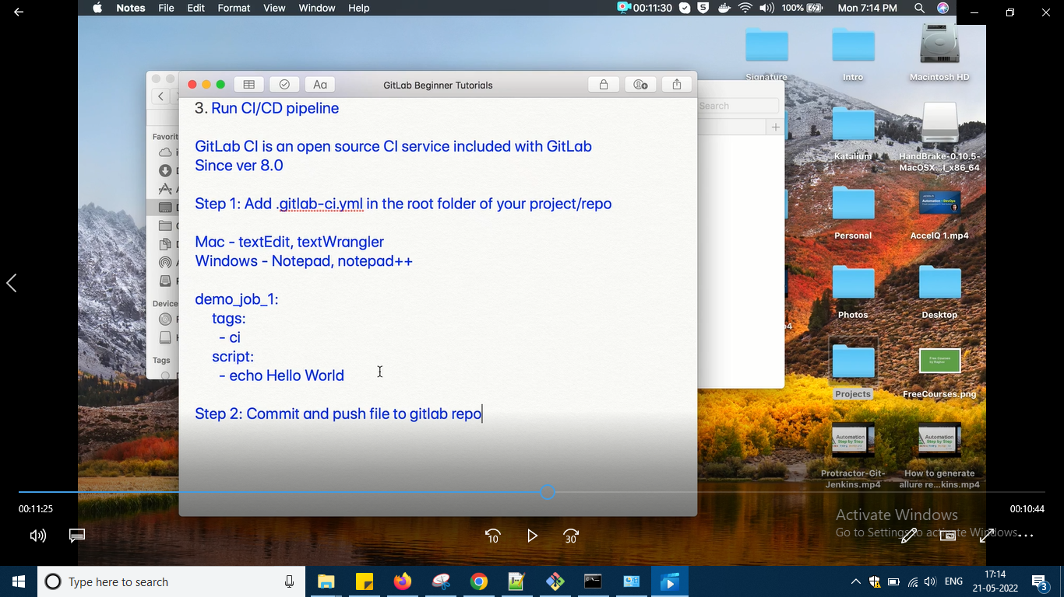

So next step is commit and push

C:\Projects\GitLab\MyFirstProject>git status

On branch master

Untracked files:

(use "git add <file>..." to include in what will be committed)

.gitlab-ci.yml

nothing added to commit but untracked files present (use "git add" to track)

C:\Projects\GitLab\MyFirstProject>git add.

git: 'add.' is not a git command. See 'git --help'.

The most similar command is

add

C:\Projects\GitLab\MyFirstProject>git add .

C:\Projects\GitLab\MyFirstProject>git status

On branch master

Changes to be committed:

(use "git restore --staged <file>..." to unstage)

new file: .gitlab-ci.yml

C:\Projects\GitLab\MyFirstProject>git commit -m "added .yaml"

[master ab94f16] added .yaml

1 file changed, 5 insertions(+)

create mode 100644 .gitlab-ci.yml

C:\Projects\GitLab\MyFirstProject>git push -u "https://gitlab.com/raghav50/my-first-project.git" master

Enumerating objects: 4, done.

Counting objects: 100% (4/4), done.

Delta compression using up to 4 threads

Compressing objects: 100% (3/3), done.

Writing objects: 100% (3/3), 343 bytes | 171.00 KiB/s, done.

Total 3 (delta 0), reused 0 (delta 0), pack-reused 0

remote:

remote: To create a merge request for master, visit:

remote: https://gitlab.com/raghav50/my-first-project/-/merge_requests/new?merge_request%5Bsource_branch%5D=master

remote:

To https://gitlab.com/raghav50/my-first-project.git

a26698c..ab94f16 master -> master

branch 'master' set up to track 'https://gitlab.com/raghav50/my-first-project.git/master'.

C:\Projects\GitLab\MyFirstProject>

Now go to the project u can see that ..it is working but now latest they are asking me to validate using credit card

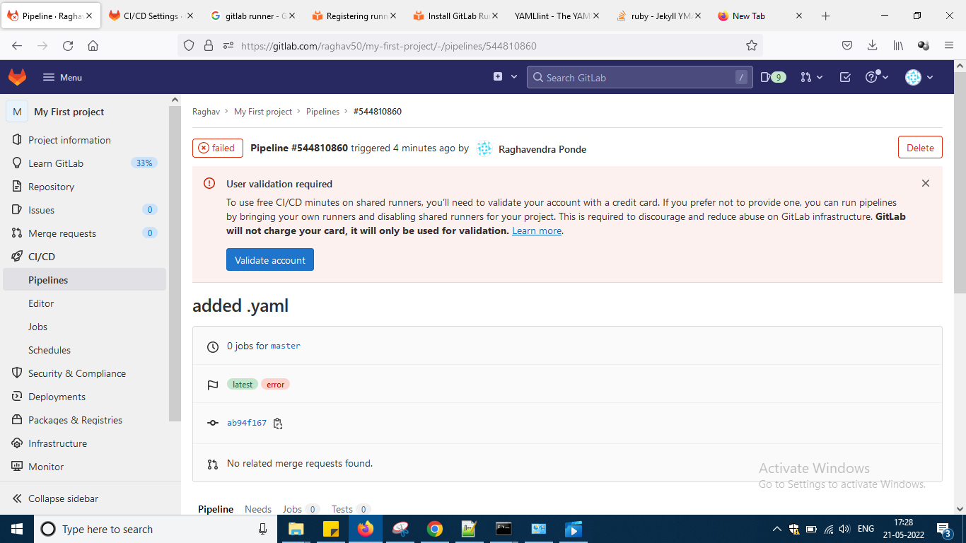

Now what u can do is while creating the project make it public and i tried doing it change it from private to public then it was not working it is disabled okay so now what is best option is do it using public in the video git mastery with github and gitlab he has done pipeline using public or not i don't know but when i tried creating a sample project using public mode it worked now so now i am moving to that video session only of gitlab only and will do demos from that session okay

Yes he had done it using public now what i will do better no time now so i will just try to implement his CI CD video of gitlab okay

Now create a new project like this with the name batch20 okay and keep the domain as public

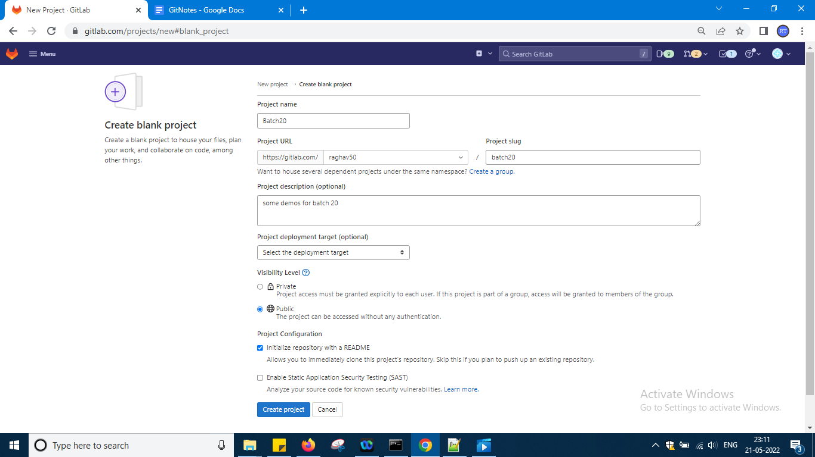

Now in order to work with the project and create ci cd pipeline yaml file is needed okay

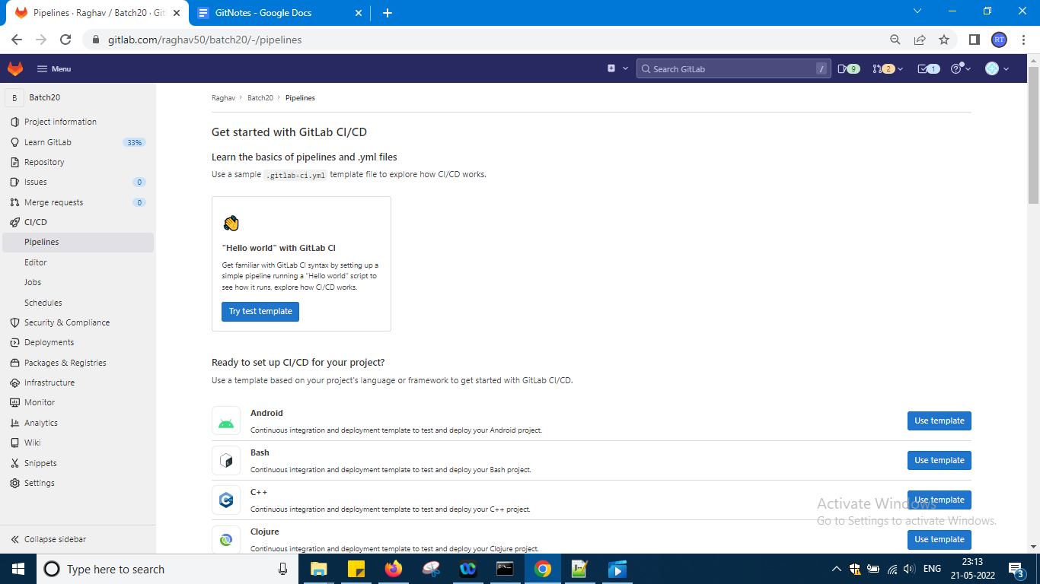

So it is asking to create nothing is there in this project then what i will do is and some documentation he has given it okay

Better go to project now

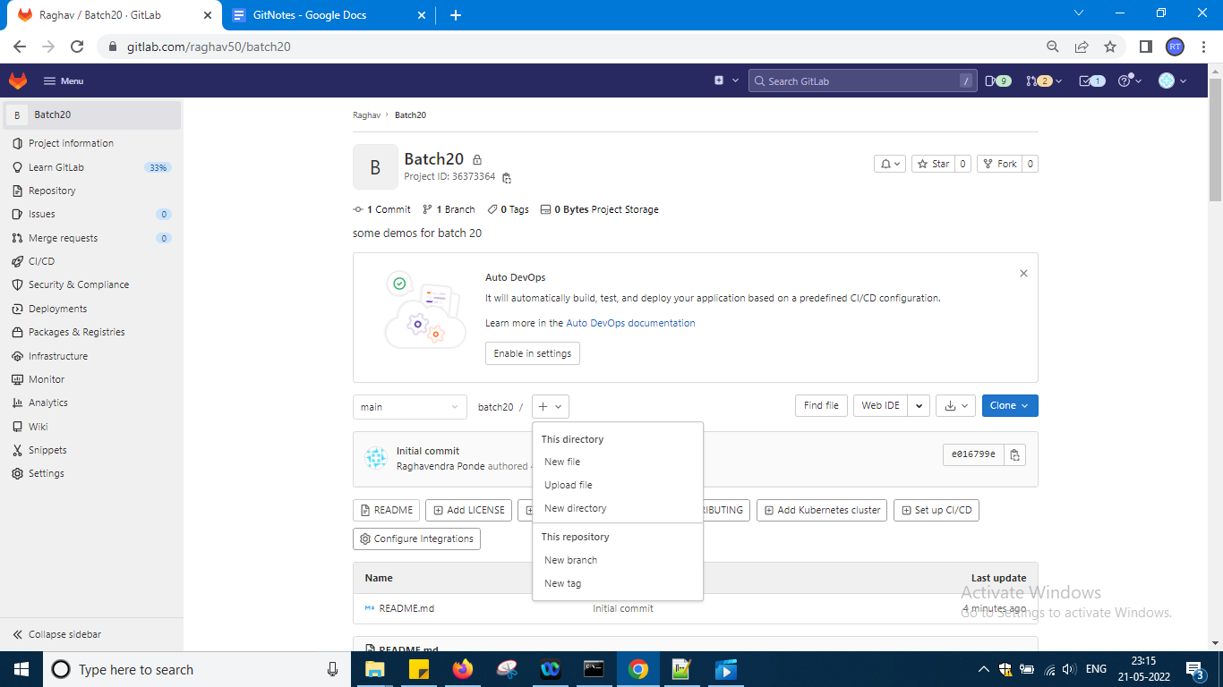

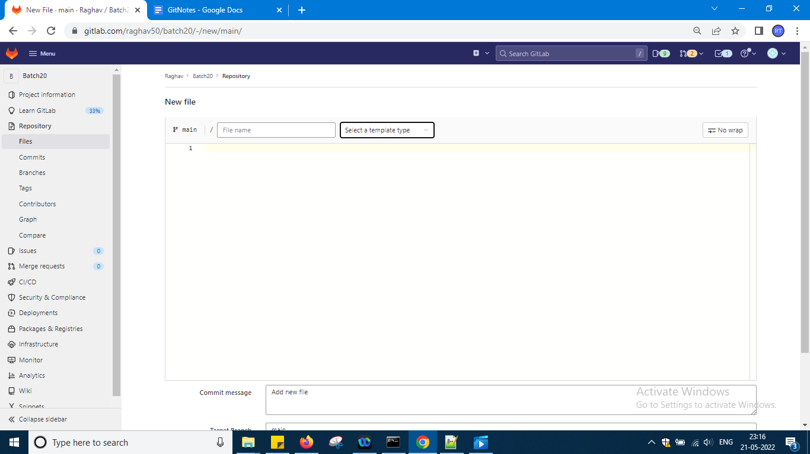

From the second drop down select yaml file it is like hidden file okay

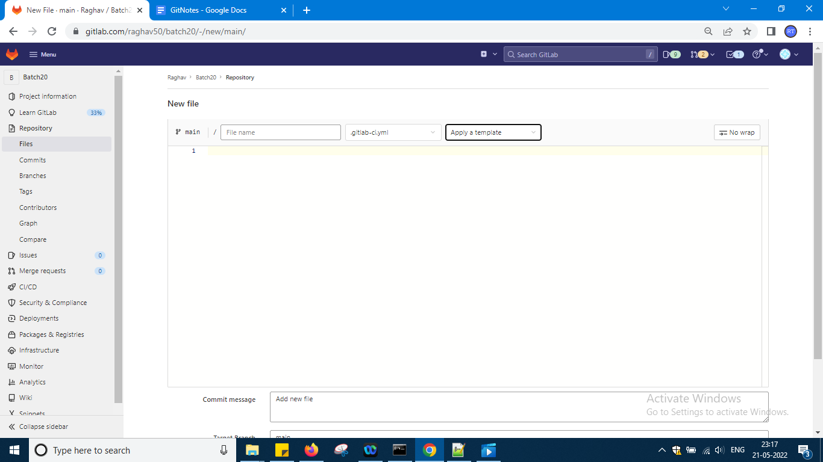

If u see the template i have added bash template but again i will delete it as it is looking complicated for me okay …

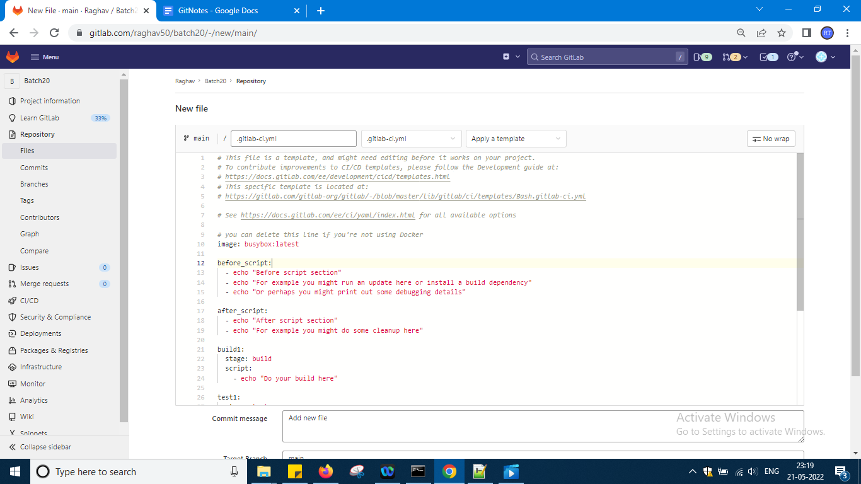

I am not seeing learn ci cd syntax so i am using this only not chaning bash okay

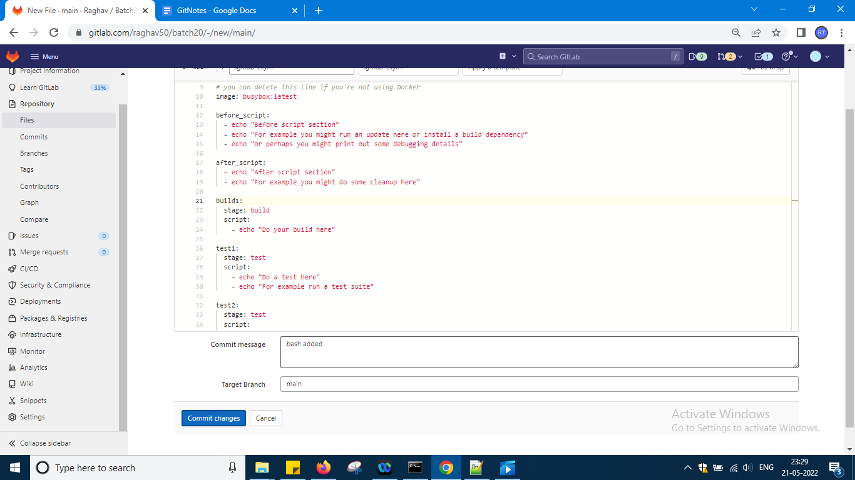

Add comment and commit change

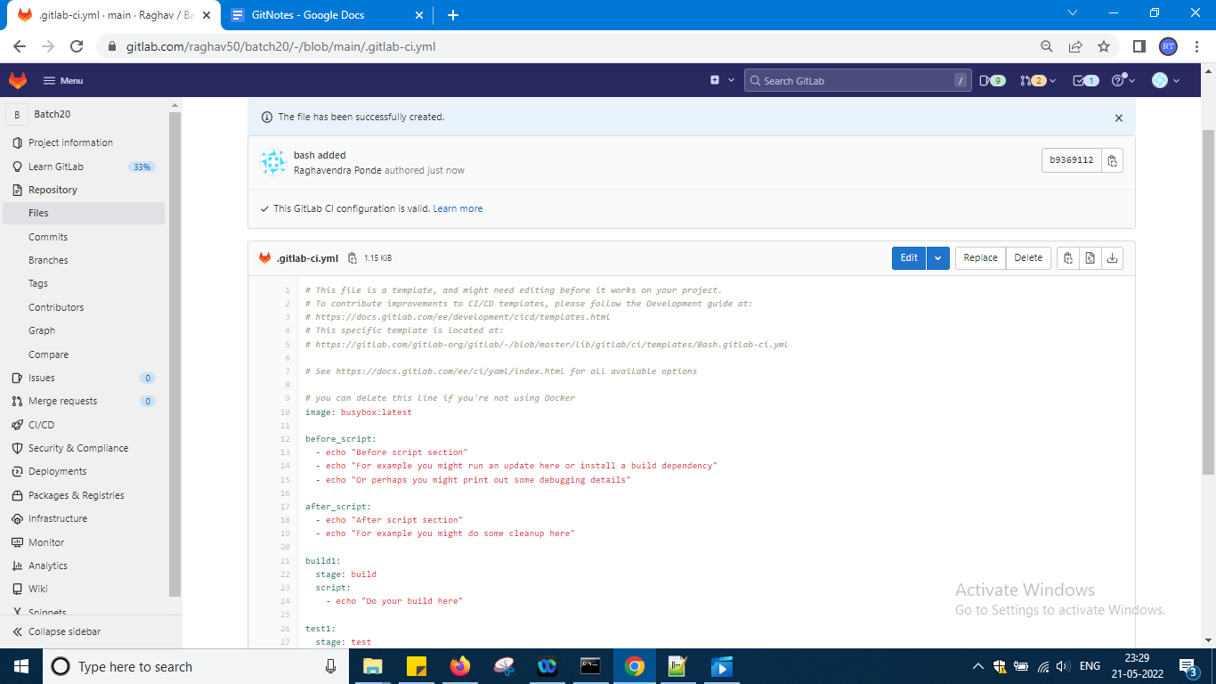

Go to ci cd piple lines

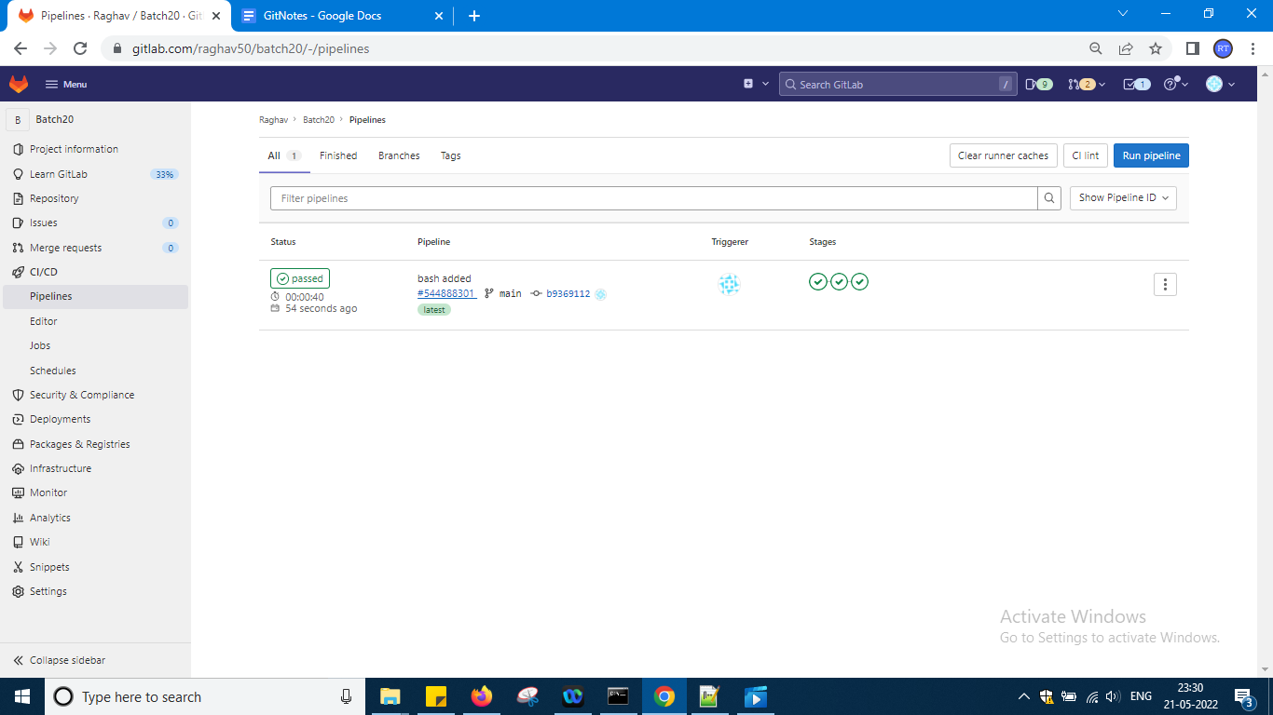

So it is passed now and clock the head id

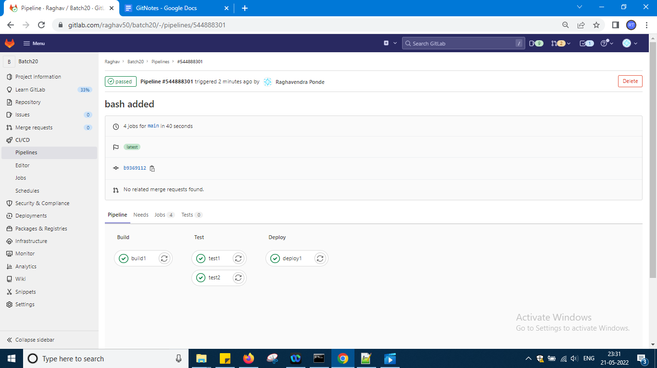

So u can see like this okay

Click on each job inside and see what is happening i clicked build 1

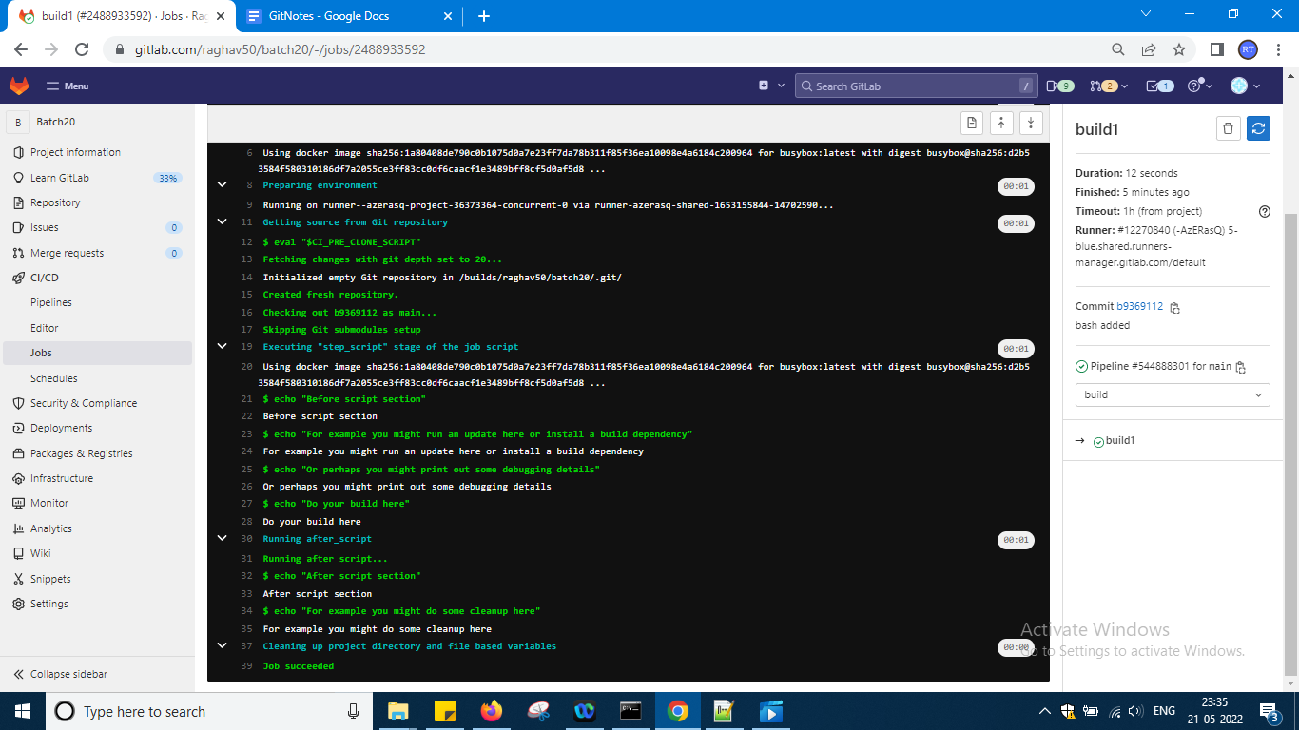

Just check all the pages and click the link etc and etc we will not understand okay but

Now go to project and and yaml file again

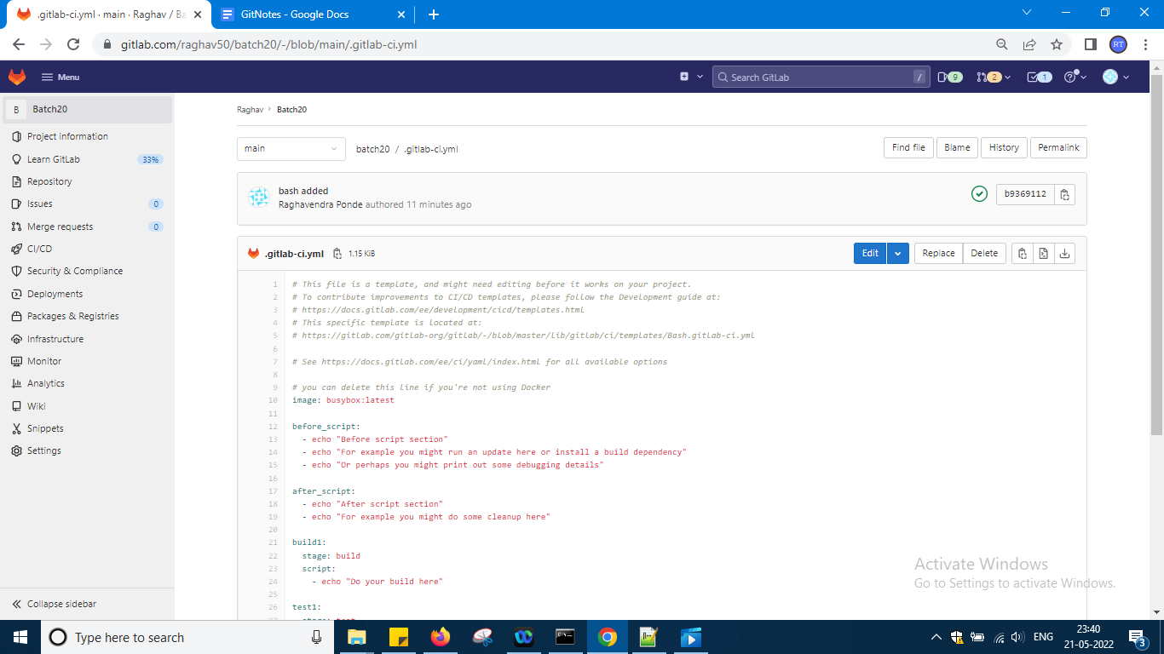

So again i have taken a yaml file from project and added new template and again gogin in ci cd and checking it okay

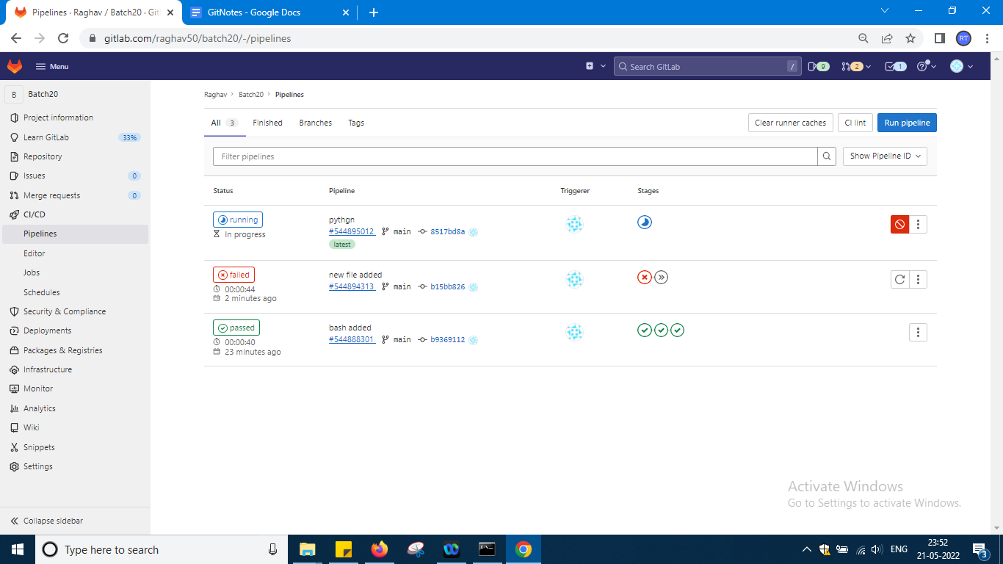

It is running python added as per the script okay …

But errors u are getting so better don't try to change just open one thing and show that as per syntax if u write modules using some yaml and that syntax u will know it means core has to be written as per yaml u dont know it so this is the end of git with git lab session with CI and CD pipeline examples

See u can do one thing yaml file code if u want means u can take it from docs of gitlab or in this application in local repo my first project some yaml defiend that u can take it if u want to work from gitlab ui okay try all possibilities okay